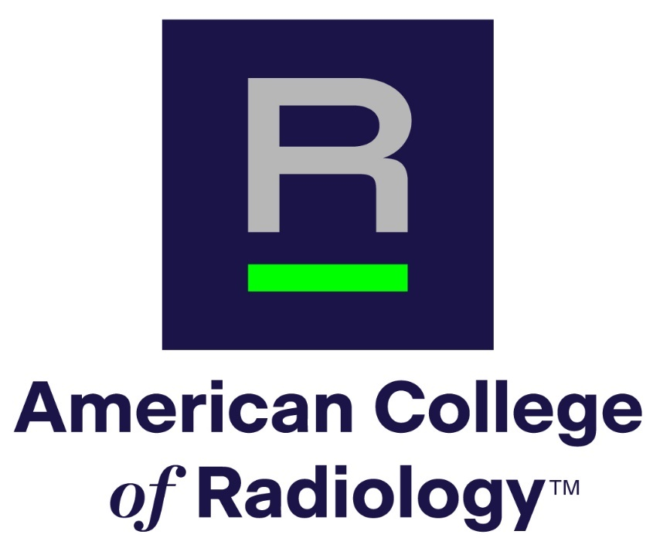
APPLICATION FORM
American College of Radiology

Richard L. Morin, PhD
Fellowship in Medical Physics

- General Information
- Name:
- Institution and/or residency program:
- E-mail:
- City & state:
- Phone:
- Subspecialty (if applicable):
- Name of Program Director:
- Department Chair (if applicable):
- Current year in residency:
- Expected year of residency completion:
- Please identify two current top areas of interest
- Area 1:
- Area 2:
- Please choose at least one accreditation modality or program of interest:
- Program 1:
- Program 2 if applicable:

- Personal statement describing how this fellowship relates to your career goals. Please do not exceed 500 words.

- What prior experiences (activities, courses, and jobs) have best prepared you for this fellowship? Please do not exceed 300 words.

- Why are you applying for this fellowship and what do you hope to gain from it? Please do not exceed 300 words.

- Please save and submit this application as a pdf through the Application Portal, linked on the Morin Fellowship landing page.
- Please include a copy of your CV, as indicated on the submission page.
- Please have a professional portrait available in case of selection for the award.
- Please have your two (2) Reference Letters submitted through the Reference Letter Portal, linked on the Morin Fellowship landing page.

Questions? Please email Dustin Gress, ACR Senior Advisor for Medical Physics:
dgress@acr.org

