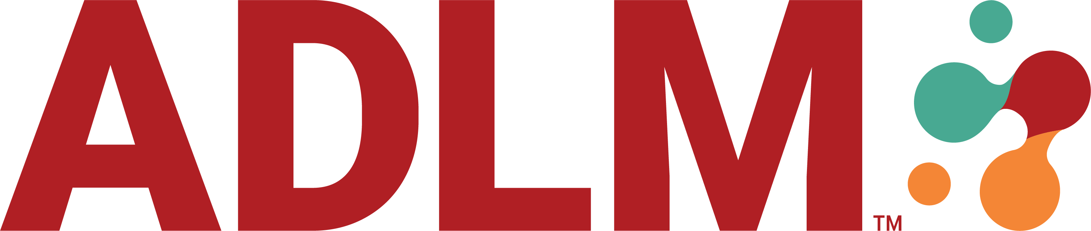  ADLM POCT Division WEbinar  Join ADLM’s joint Point of Care Testing and Health Equity & Access Divisions for a lecture featuring Dr. Octavia Peck Palmer, and Mr. Ryan Dial on “Alternative Care Models with POCT: A Focus on Equity and Access.” This online activity is open to all Division members and will take place on July 8th from 12:00-1:00pm EDT.  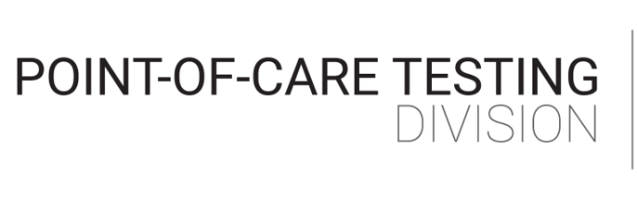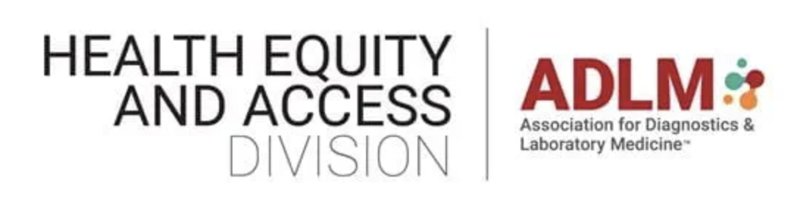  This online activity is currently seeking ACCENT continuing education credits.
  Joint POCT and HEA Webinar
  Alternative Care Models with POCT: A Focus on Equity and Access
  July 8th 2026 from 12-1PM EDT
  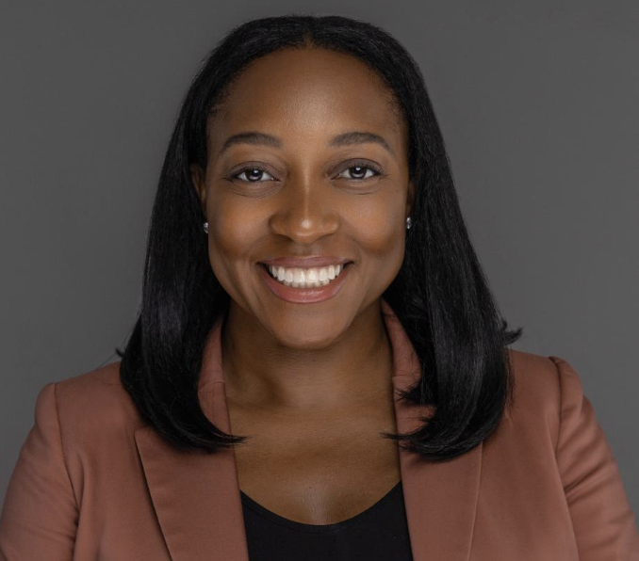 | Octavia M. Peck Palmer, PhD  Division Director, Clinical Chemistry  Vice Chair of Population Health  & Organizational Culture  Associate Professor of Pathology  University of Pittsburgh, Pittsburgh, PA
  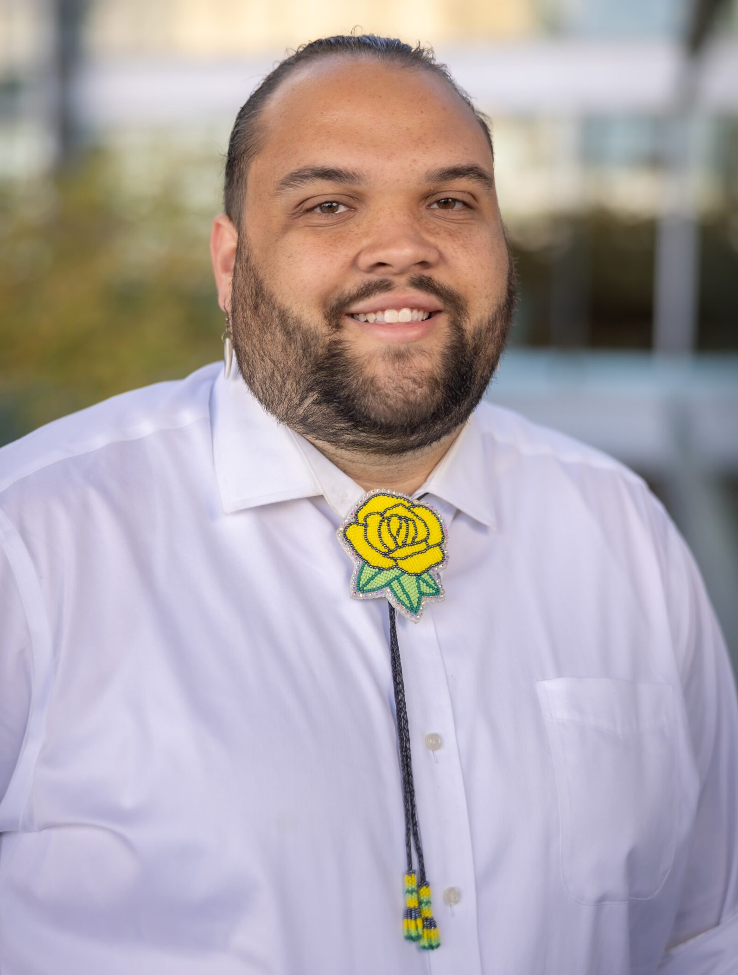 | Ryan Dial (Lumbee) MCLS, MLS (ASCP)^{cm}  Project Manager, American Indian Health  American Indian Center (AIC) and the Southeastern American Indian Cancer Health Equity Partnership  University of North Carolina and UNC School of Medicine, Chapel Hill, NC
  Learning Objectives :
  Identify and describe health disparities and the associated social determinants of health that medically underserved communities experience.
  Describe actionable ways that the laboratory medicine field can mitigate health disparities that Indigenous communities experience.
  Explain how point-of-care testing and other strategies can help reduce disparities in access to tests and timely diagnosis and care.
  POCT & HEA division
  LIVE WEBINAR
  Tuesday, July 8th 2026
  12:00pm – 1:00pm (EDT)
  Register via the QR Code or the link below:
  
  Registration Link

