UW Seattle South Campus Room 301
May 8th, 2025, 5:00-6:30 pm
Hybrid Meeting: Virtual and In-Person Options
Optional Network Event: Magnuson Brewery
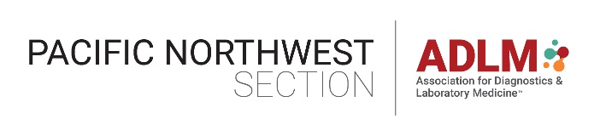


Method Validation
Speaker: Anthony A. Killeen, MB, BCh, PhD, MSc
ADLM President, Invited Lecture
Professor of Laboratory Medicine and Pathology; Director of Clinical Laboratories, University of Minnesota Medical Center
🔬 Attention Students, Technologists, Technicians, Lab Operations, and Directors!
📢 Mark your calendars for May 8th! Join us for an engaging and insightful session on Method Validation—a fundamental and essential process in every clinical laboratory!
✅ Why Attend? Discover how method validation ensures accuracy, precision, and compliance in lab testing.
Gain expert insights on CLSI guidelines—the gold standard for regulatory adherence.
Enhance your skills with practical knowledge that applies to every clinical lab setting. One CE will be credited.
Two PNW student awards will be announced during the event.
📅 Don't miss this opportunity to elevate your expertise and advance your lab practices! See you there!
RSVP for more details! https://forms.office.com/r/LRCZmUSyhL

