Provider Guides and E-learning
LANDING PAGE CONTENT
As of 05/31/23

Provider Guides and E-Learning

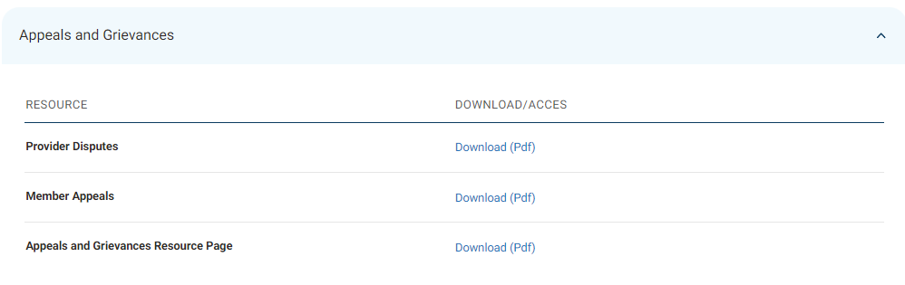
Please remove the table and simply list the links in this order:
Appeals and Grievances (Resource Page) [link to the A/G landing page at https://www.azblue.com/healthcareprofessionals/resource-center/appeals-and-grievances]
Provider Disputes (PDF) [link to Provider Op Guide, Section 22]
Member Appeals (PDF) [link to Provider Op Guide, Section 23]

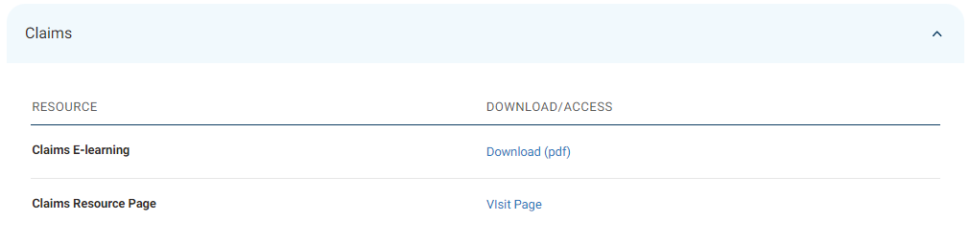
Please remove the table and simply list the links in this order:
Claims and Remits (Resource Page) [link to the Claims and Remits landing page at https://prod.azblue.com/provider/resources/claims-and-remits]
Claims E-learning (Slides PDF) [deep link to PDF in secure portal at https://provider.azblue.com/~/media/azblue/files/healthcare/elearning-module-claims.pdf?la=en]

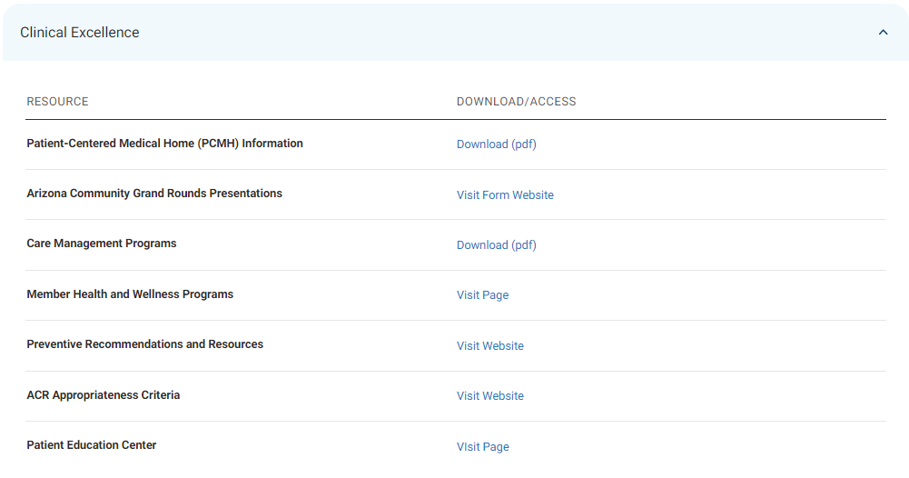
Please remove the table and simply list the links in this order:
Care Management Programs (PDF) [link to Provider Op Guide, Section 12 - excerpt]
Health and Wellness Programs (BCBSAZ Webpage) [Link to BCBSAZ Health and Wellness page for providers at https://prod.azblue.com/healthcare-professionals/live-healthy]
Preventive Services Recommendations (USPSTF Webpage) [link to external USPS Task Force Recommendations page-published at https://www.uspreventiveservicestaskforce.org/uspstf/topic_search_results?topic_status=P ]
Patient Education Resources (BCBSAZ Health Library) (link to BCBSAZ page at https://library.azblue.com/)
BCBSAZ Patient-Centered Medical Home (PCMH) Program (PDF) (link to program brochure)
Arizona Community Grand Rounds Presentations [Link to external NARBHA Institute site at https://narbhainstitute.org/endeavors/Community-Grand-Rounds.php]
ACR Appropriateness Criteria (ACR Webpage) [link to external page at https://www.acr.org/Clinical-Resources/ACR-Appropriateness-Criteria)

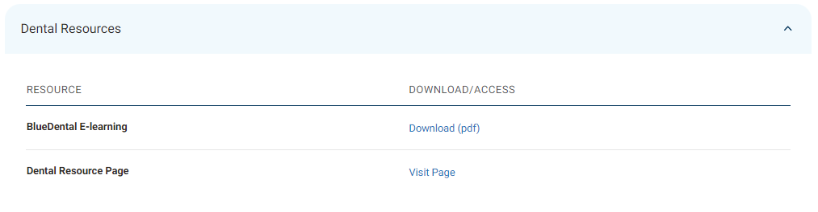
Please remove the table and simply list the links in this order:
Dental Products and Networks (Resource Page) (link to Dental Resources page at https://prod.azblue.com/provider/resources/dental-products-and-networks
BlueDental E-learning (Slides PDF) [deep link to PDF at https://provider.azblue.com/~/media/azblue/secureportalfiles/provider/bluedental-provider-elearning.pdf?la=en]
BlueDental Resources (BlueDental provider portal) [link to the BlueDental landing page at https://azbluedentalprovider.dominionnational.com/]

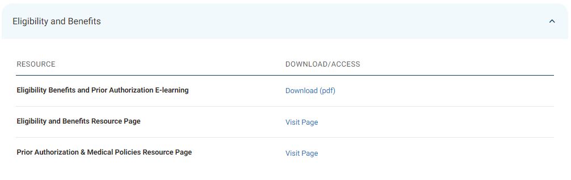
Please remove the table and simply list the links in this order:
Eligibility and Benefits Resources (Resource Page) [link to the Eligibility/Benefits landing page]
Eligibility, Benefits, and Prior Authorization E-learning (PDF) [deep link to PDF at https://provider.azblue.com/~/media/azblue/files/misc_pdfs/elearning-module--eligibility-and-benefits.pdf?la=en)

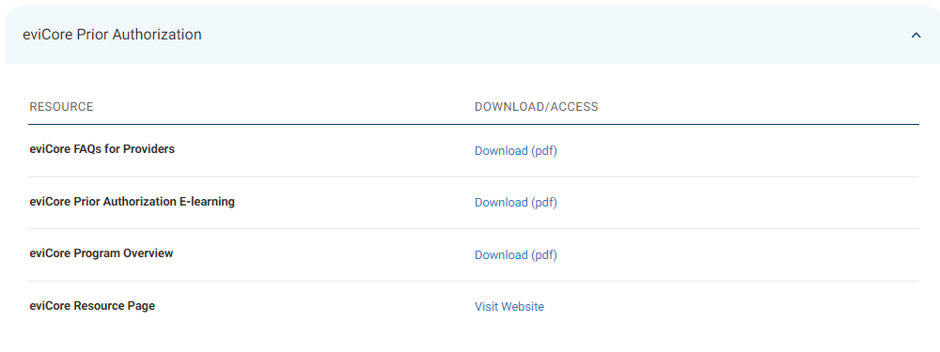
Please change the accordion menu title to read: Prior Authorization-eviCore
This will put it in a different order on the page (after Prior Authorization and Medical Policies).
As with the other tables, let’s remove the table and list the links in this order:
eviCore Program Overview (PDF) [link to PDF]
eviCore FAQs for Providers (PDF) [link to PDF]
eviCore Resource Page (eviCore Webpage) [link to our page on eviCore website at https://www.evicore.com/resources/healthplan/blue-cross-blue-shield/arizona]

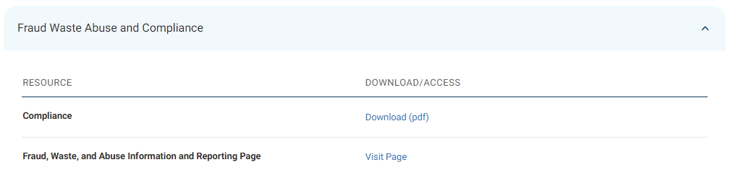
Are you able to insert the commas in the title? Fraud, Waste, Abuse, and Compliance
Please remove the table and simply list the links in this order:
Compliance (PDF) [link to Provider Op Guide, Section 6] login or not?
Fraud, Waste, and Abuse-Information and Reporting Tool (Resource Page) [link to the FWA landing page at https://prod.azblue.com/provider/resources/fraud-and-abuse]
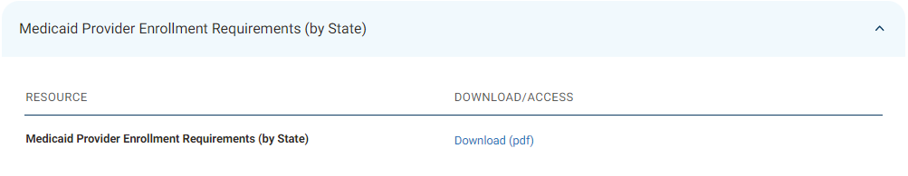
Please remove the table and simply list the link:
Medicaid Provider Enrollment Requirements-by State (PDF) [link to Association-generated reference document]

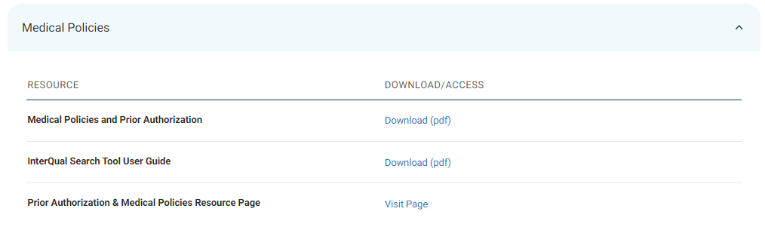
Please remove the table and simply list the links in this order:
Medical Policies-Overview and Access Guide (PDF) [link to excerpt of Provider Op Guide, Section 11]
InterQual Search Tool User Guide (PDF) [link to User Guide]
Prior Authorization & Medical Policies by Benefit Plan Type (Resource Page) [link to resource page at https://prod.azblue.com/provider/resources/prior-authorization-and-medical-policies]

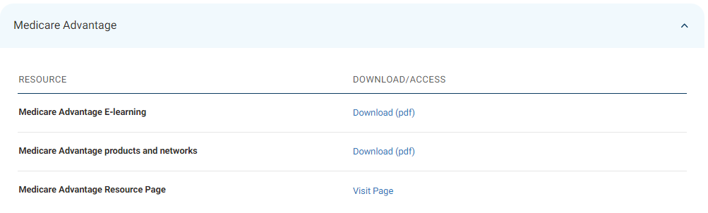
Please remove the table and simply list the links in this order:
Medicare Advantage Products and Networks-Overview (PDF) [link to excerpt of Provider Op Guide Section 8]
Medicare Advantage E-learning (Slides PDF) [deep link to PDF at https://provider.azblue.com/~/media/azblue/files/misc_pdfs/elearning-bcbsaz-medicare-advantage.pdf?la=en]
Resources for Medicare Advantage Plans (Resource Page) [link to the BCBSAZ MA landing page at https://prod.azblue.com/medicare/resources/provider-resources]

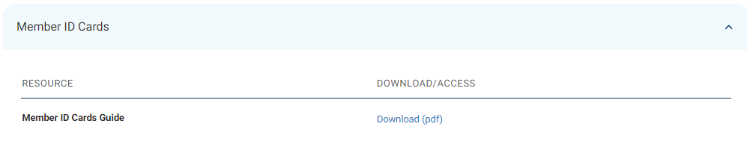
Please remove the table and simply list the link:
Member ID Card Information and Samples (PDF) [link to Provider Op Guide, Section 10] login or not?

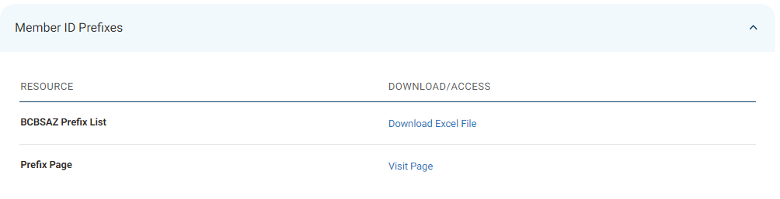
Please remove the table and simply list the links in this order:
BCBSAZ Prefix List (Excel) [link to current Excel file]
Prefix Information and Tips (Resource Page) [link to the prefix landing page at https://www.azblue.com/healthcareprofessionals/resource-center/prefix-lists]

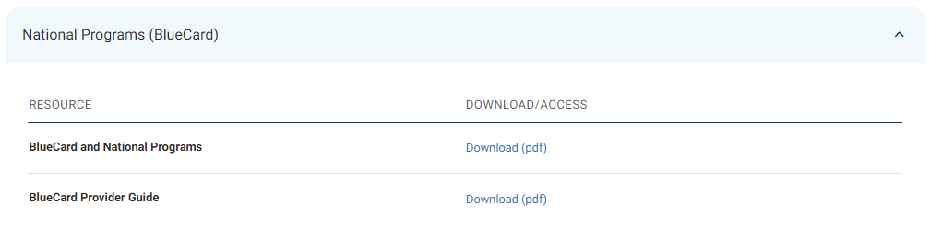
Please change the accordion menu title to read: BlueCard and Other National Programs
This will put it in a different order on the page (after Appeals and Grievances).
As with the other tables, let’s remove the table and list the links in this order:
BlueCard and National Programs (PDF) [link to Provider Op Guide, Section 9] login or not?
BlueCard Provider Guide (PDF) [link to BlueCard Guide]

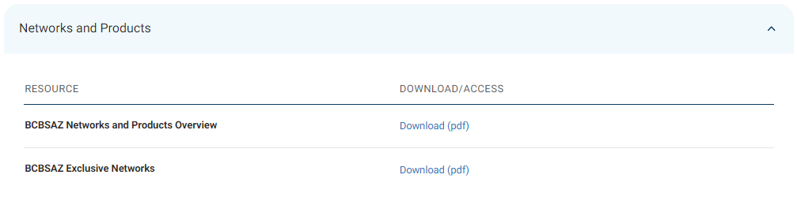
Please remove the table and simply list this link:
Networks and Products Overview (PDF) [link to excerpt of Provider Op Guide Section 8] excerpt or entire section??

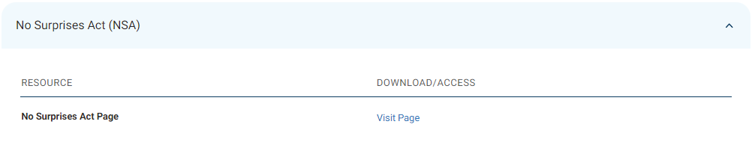
Please remove the table and simply list this link:
No Surprises Act Information and Forms [link to the NSA landing page at https://www.azblue.com/healthcareprofessionals/resource-center/no-surprises-act]

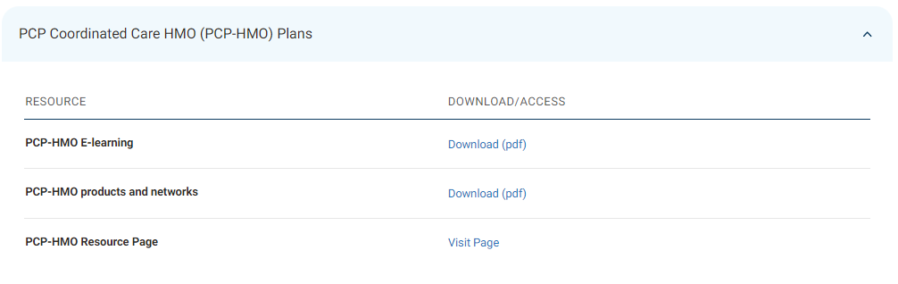
Please remove the table and simply list these links in this order:
PCP-HMO Products and Networks (PDF) [link to excerpt from Provider Op Guide Section 8]
PCP-HMO E-learning (Slides PDF) [deep link to PDF at https://provider.azblue.com/~/media/azblue/files/healthcare/resources/2023-pcp-coordinated-care-hmo-plans-bcbsaz-elearning.pdf?la=en]
PCP-HMO Auth/Referral Request and StatusTool-User Guide (Slides PDF) ) [deep link to PDF at https://provider.azblue.com/~/media/azblue/files/healthcare/resources/2023-pcp-hmo-auth-request-status-tool-bcbsaz-provider-e-learning-1192023.pdf?la=en]
PCP-HMO Information and Resources (Resource Page) [link to the PCP-HMO landing page]

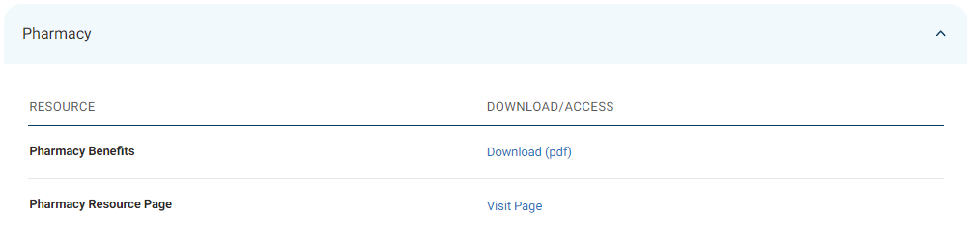
Please remove the table and simply list the links in this order:
Pharmacy Benefits (PDF) [link to Provider Op Guide, Section 24] excerpt or entire section??
Pharmacy Formularies, Coverage Guidelines, and Prior Authorization (Resource Page) [link to the Pharmacy landing page at https://prod.azblue.com/pharmacy/qualified-health-plans]

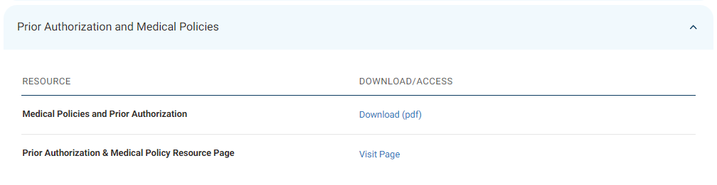
Please remove the table and simply list the links in this order:
Medical Policies and Prior Authorization (PDF) [link to Provider Op Guide, Section 11] excerpts or entire section?? login or not?
Prior Authorization & Medical Policies by Benefit Plan Types (Resource Page) [link to webpage at https://prod.azblue.com/provider/resources/prior-authorization-and-medical-policies]

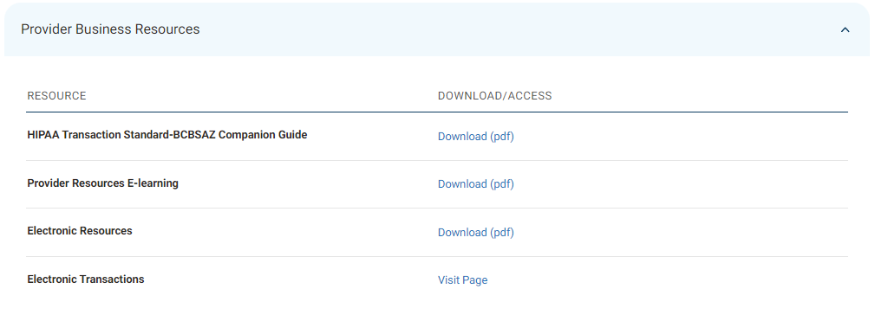
Please remove the table and simply list the links in this order:
HIPAA Transaction Standard-BCBSAZ Companion Guide (PDF) [link to guide at https://www.azblue.com/~/media/azblue/files/resources/providerhipaatransactionguide.pdf]
Electronic Resources (PDF) [link to Provider Op Guide, Section 3] excerpt or entire section?? login or not?
Electronic Transaction Options (Resource Page) [link to landing page at https://www.azblue.com/healthcareprofessionals/electronic-options/electronic-transactions]
EFT and ERA Information (Resource Page) [link to landing page at https://www.azblue.com/healthcareprofessionals/electronic-options/eft-and-era]
Provider Resources E-learning (Slides PDF) [deep link to PDF at https://provider.azblue.com/~/media/azblue/files/healthcare/provider-resources-bcbsaz-elearning.pdf?la=en]

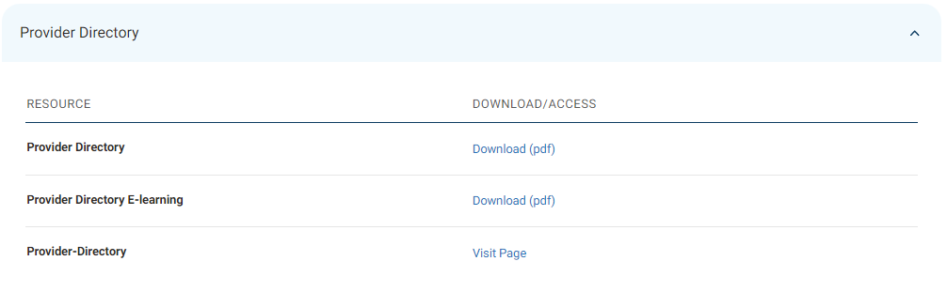
Please remove the table and simply list the links in this order:
Provider Directory E-learning (Slides PDF) [deep link to PDF at https://provider.azblue.com/~/media/azblue/files/healthcare/provider-directory-2019.pdf?la=en] login or not?
Provider Directory (Directory Access) [link to directory at https://www.azblue.com/individualsandfamilies/find-a-doctor/healthcare-provider]

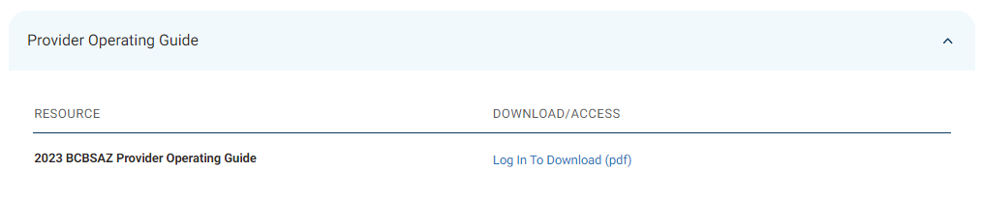
Please remove the table and simply list this link:
2023 BCBSAZ Provider Operating Guide (Complete Guide or Sections) [deep link to Op Guide page at https://provider.azblue.com/home/provider-resources/guidelines/provider-operating-guide/2023-bcbsaz-provider-operating-guide]

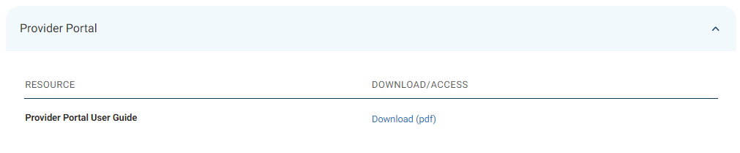
Please remove the table and simply list this link:
Provider Portal User Guide (PDF) [link to portal guide]

