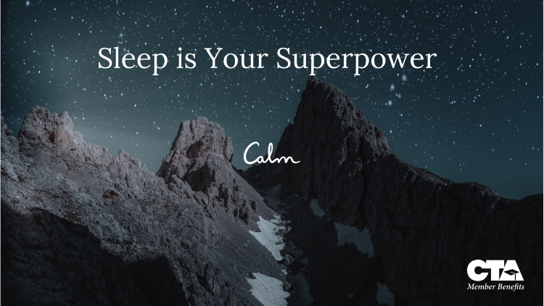
CTA Member Benefits and Calm will be hosting a workshop: Sleep Is Your Superpower. Sleep is often viewed as a luxury. However, sleep powers our minds and our bodies. There is no tenant of health that sleep doesn’t affect. Even a few hours of lost sleep can impact our thinking, mood, and memory. During this session we will learn about the effects of poor sleep and share practical tools to unleash the power of rest.
Use this link to register: https://calm.zoom.us/meeting/register/YLVPJTGpSQC_tpgDwIvMEQ
Date March 27, 2025
Time: 4:00pm – 5:50pm PST

