Now Available: 2025–2026 CTA Member Benefits Materials
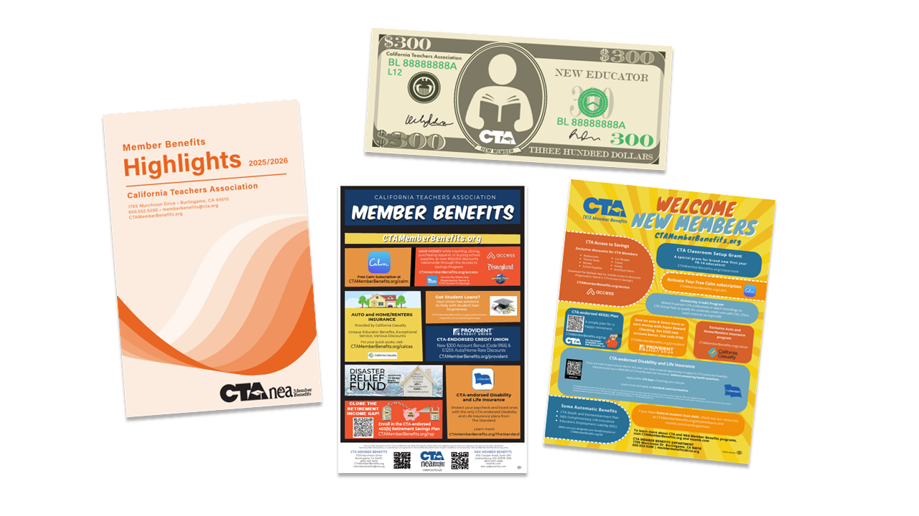
Have you checked out the materials available for ordering? You can order The CTA Member Benefits Highlights brochure (2025-2026 will have an ORANGE cover), folders, posters for the union bulletin board, and the “$300 Classroom Set Up Grant Thank You Card” for brand new educators. In addition, CTA MB also has downloadable PDF flyers that can be e-mailed to members throughout the year making them aware of their benefits.

