2025 New Educator Weekend – North
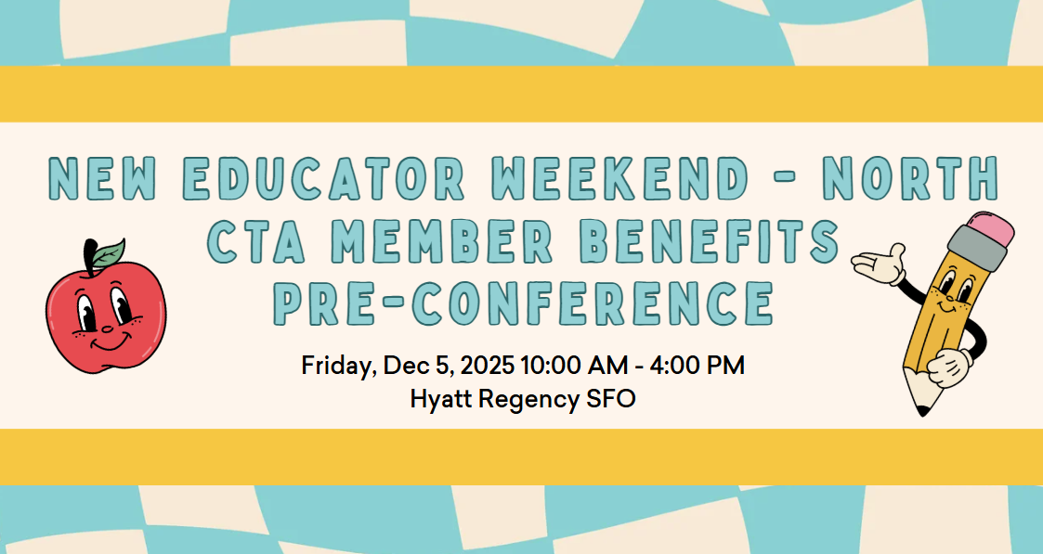
Get ready for an interactive, full-day training built to energize, inspire, and equip new educators with everything you need to thrive. CTA is here to back you up with resources, benefits, and strategies that make a real difference in your career and your life.
What You’ll Experience:
- Calm in the Classroom – Simple strategies to bring mindfulness and balance to your day and in your classroom
- Maximize Your CTA/NEA Membership – Unlock the full range of benefits designed for educators
- Boost Financial Wellness – Learn tips and tools to strengthen your financial future
CTA Member Benefits will provide release time for this pre-conference, when registering, please ensure you are requesting release time and meet the requirements for CTA Member Benefits to reimburse your employer for your substitute on Friday. Register here!

