Member Benefits Good Teaching Conference North Pre-Conference
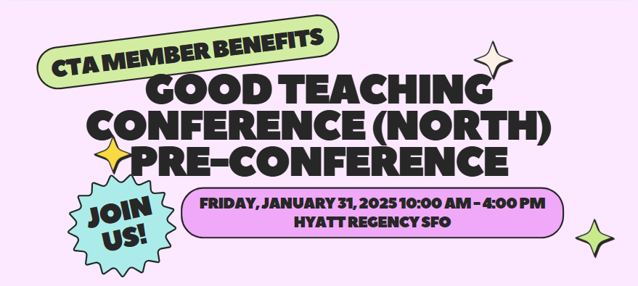
Join us for an engaging, full-day training designed to equip educators with the essential tools for success. Learn how CTA supports educators with valuable resources and Member Benefits to help you excel in your career.
- Calm in the Classroom
- Student Loans
- Maximize your CTA/NEA Membership
- Boost Financial Wellness
Register at https://www.cta.org/event/2025-gtcnorth

