- Log into your QuickBooks Online file.
- In the upper right of the screen, select the gear icon.
- In the gear menu, select “Manage Users’, located under “Your Company” on the left-hand side of the gear menu drop-down.
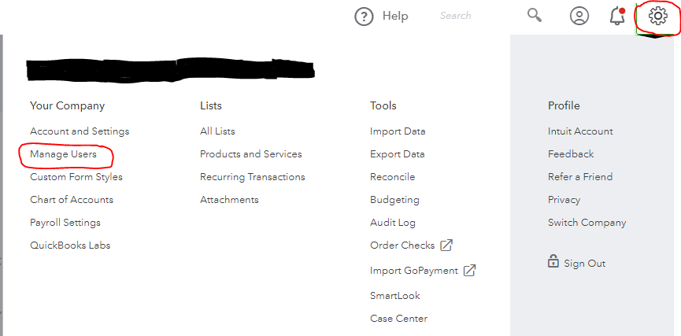
- In the Manage Users screen, click on the “Accounting Firms” tab across the top.
- Click on the green “Invite” button.
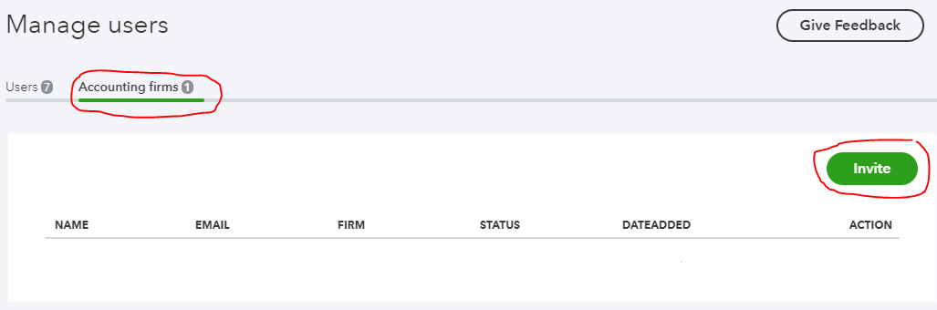
- In the invite screen, make sure you are adding an accounting firm, and then input Eide Bailly’s information. The email address is: qbbos@eidebailly.com
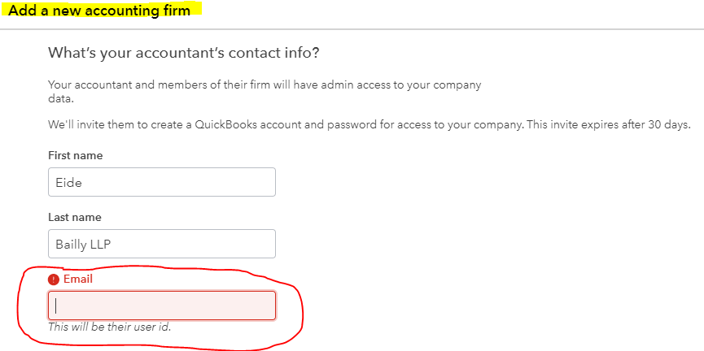
If you have issues or questions, please reach out to your Eide Bailly professional or Jillian Robison at jrobison@eidebailly.com or 509.789.9154.

