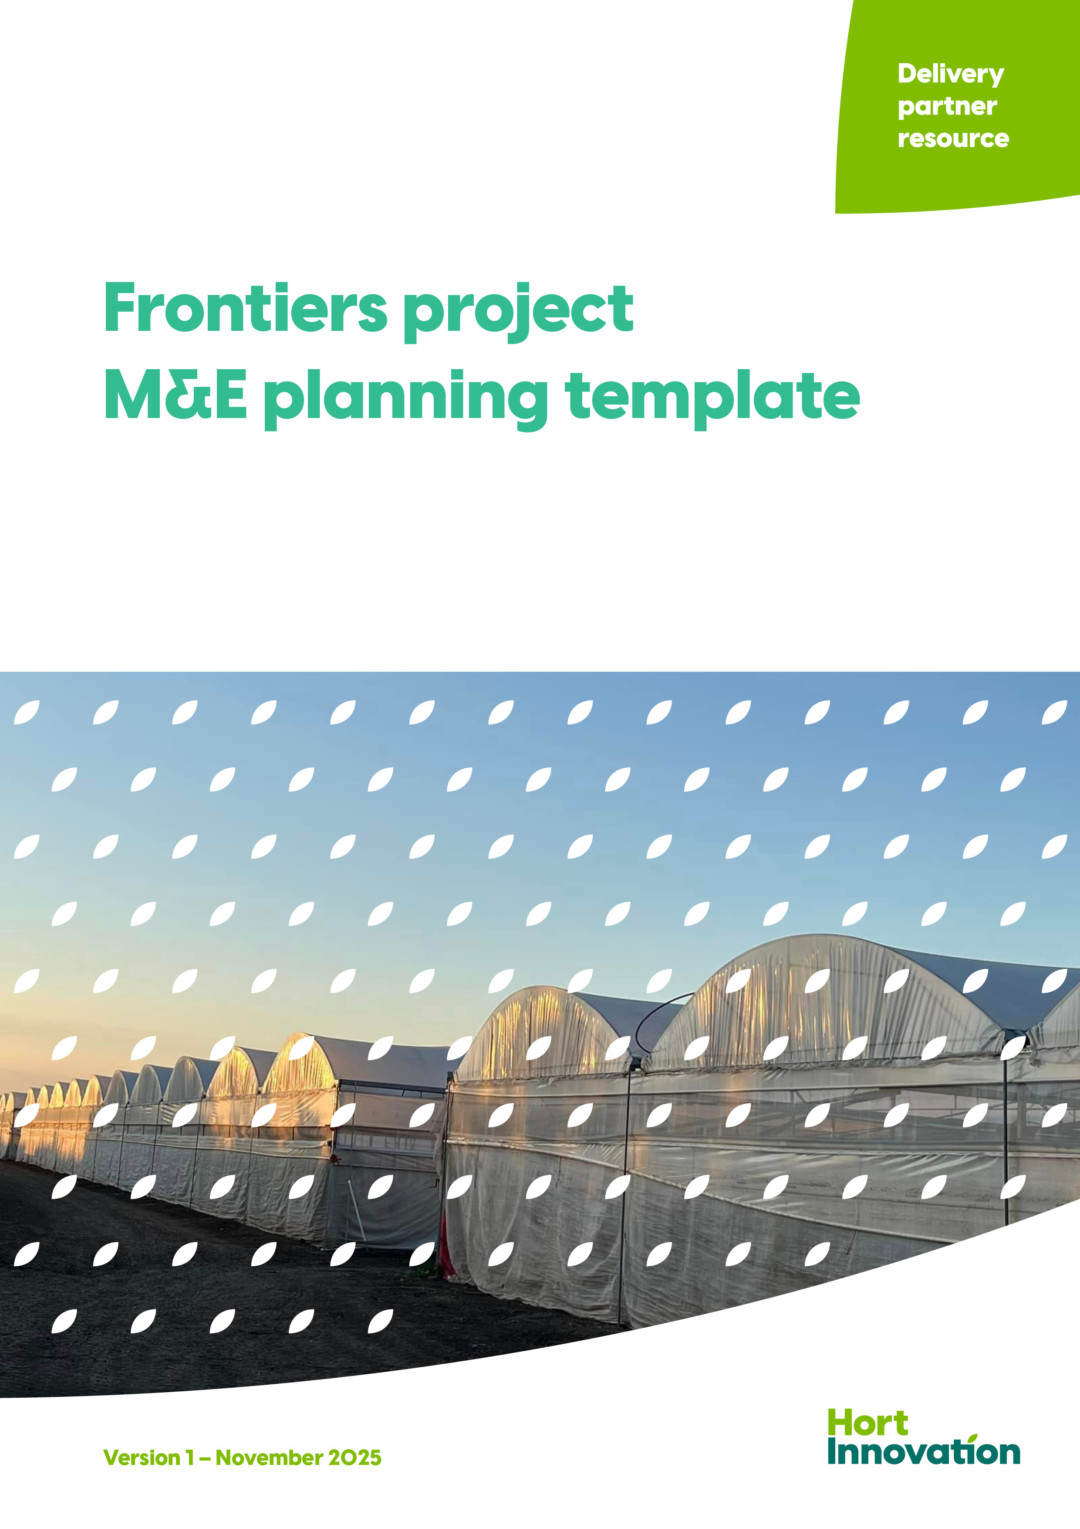

Template structure
The template consists of several sub-sections that collectively form a comprehensive Frontiers project monitoring and evaluation (M&E) plan:
- Program log
- Project M&E scope
- Performance expectations, data collection and analysis
- Reporting, learning and improvement.
Tips
Each sub-section in this template is cross-referenced to the corresponding ‘how to’ instructions in the Frontiers project M&E planning guide. Please read these instructions to support your completion of the template and refer to the Frontiers M&E framework for further guidance.
Instructions
Delete the cover page of this document
Create your own cover page using the next page as a template
As you complete the template, remove all guidance and help text, including on this page
Name your document to comply with this naming protocol: ‘Your organisation-project code-Frontiers project M&E plan.doc’ e.g., Hort Innovation-XX000000-Frontiers project M&E plan.doc.

Frontiers project M&E plan

Project and delivery partner details
Project title | What is the project title?
Project code | What is the project code?
Investment pathway | What is the Frontiers investment pathway?
Delivery partner (Organisation) | What is the name of the organisation(s) with the contractual agreement to deliver the project?
Lead researcher/team member | Who is the lead researcher/lead team member?
Date completed /updated | What date was this Frontiers project M&E plan completed?

1. Program logic
Purpose
Show how your project’s activities lead to outcomes and align with the Frontiers investment pathway.
What to include
An updated program logic diagram (refer to the template provided in Table 1 and Figure 3 on pages 4 and 5 in the Frontiers project M&E planning guide. Include a brief description of the core elements and overall focus for the project.
The program logic diagram should identify:
- The ‘end-of-project’ outcomes your project expects to achieve (below the line)
- The Investment pathway outcome your project contributes to (above the line)
- The activities and outputs that the project will deliver
- The intermediate outcomes, how the activities and outputs are expected to lead to the end-of-project outcome.
Tips
Where possible, refer to the Frontiers M&E framework and appropriate Frontiers investment pathway when crafting the program logic.
Add or remove boxes in the program logic as needed, to capture all core elements from foundational inputs through to relevant investment pathway outcomes.
End-of-project outcomes
Intermediate outcomes
Outputs
Activities
Foundational Inputs
The desired final result of your project and which represents your project’s unique contribution to the relevant investment pathway outcome. Sometimes there is more than one end-of-project outcome
Short- to medium-term outcomes
brought about through project activities,
and which describe the cause-and-effect pathway through which the activities
support the achievement of the
end-of-project outcome(s)

Short- to medium-term outcomes
brought about through project activities,
and which describe the cause-and-effect pathway through which the activities
support the achievement of the
end-of-project outcome(s)
Tangible deliverables as a direct result of your activities; i.e. publications, marketing collateral, growers trained
Tangible deliverables as a direct result of your activities; i.e. publications, marketing collateral, growers trained
Tangible deliverables as a direct result of your activities; i.e. publications, marketing collateral, growers trained
Project administration
Baseline data collection
Establishing partnerships
Project
planning
Funding
Relevant end-of-investment pathway outcome
Investment pathway and outcome that the project contributed to
What you do i.e., work performed including experiments, field trials, extension events, training, technology development, etc.
What you do i.e., work performed including experiments, field trials, extension events, training, technology development, etc.
What you do i.e., work performed including experiments, field trials, extension events, training, technology development, etc.

2. Key evaluation questions
Purpose
To guide data collection and evaluative inquiry by identifying the key questions that will help assess whether your project is achieving its intended outcomes and contributing to the Frontiers investment pathway.
What to include
Key evaluation questions (KEQs) that are relevant to your project in Table 1, align with the Frontiers M&E framework (Framework) and where appropriate, expand the project-specific questions to reflect your project.
Tips
KEQs guide analysis, they are not survey questions - use only KEQs that are relevant to your project to support reporting and help assess its merit, worth, and the “so what?”.
Consider how KEQs link to your project program logic model, especially the intermediate and end-of-project outcomes.
In Table 1, include only the KEQs that are relevant to your project. Where appropriate, expand the project-specific questions to reflect your project.
The Hort Innovation process owner of your project can help you craft and select the KEQs relevant to your project.
Refer to page 6 of the Frontiers project M&E planning guide for guidance.
Table 1: Project key evaluation questions
Key evaluation questions  Found in the Frontiers M&E framework | Project-specific questions  To be adapted for each project, based on the relevant KEQ
Effectiveness
1. To what extent has the project achieved its expected outcomes?  Note that while several examples have been provided, there is usually only one overarching effectiveness question. | Example: To what extent has the project improved grower knowledge?
 | Example: To what extent has the project enabled innovation?
 | Example: Has the project developed new technology that is now available for industry uptake?
Relevance
2. How well does the project activities align with the current needs and priorities of the horticulture industry, or individual business needs? | Example: To what extent has the project met the needs of industry levy payers?
 | Example: To what extent has the project prepared adopters to adapt to the emerging trend and changes in the horticulture sector which the project intended to address?
 | Example: Has the project addressed the intended market failure?

Process appropriateness
3. How effective are the projects’ governance and management structures in supporting project implementation? | Example: Are governance structures clearly defined and consistently applied across the project?
 | Example: Have regular project updates been provided through linkage with industry?
 | Example: How well are timelines, risks and resources managed to meet milestones and deliverables?
Efficiency
4. What efforts did the project make to improve efficiency? | Example: What efforts did the project make to improve efficiency?
4. What efforts did the project make to improve efficiency? | Example: Were project resources (time, budget, personnel) used effectively to deliver outputs and outcomes?
4. What efforts did the project make to improve efficiency? | Example: What lessons were learned and used during implementation to refine and improve the projects' delivery?
Value for money
5. How does the project contribute to the long-term financial sustainability and value creation of the horticulture sector? | Example: To what extent has the project led to innovations or practices that reduce input costs or improve profitability for growers
 | Example: To what extent has the project demonstrated measurable economic benefits?
 | Example: To what extent has the project built industry capability that supports long-term value creation in the horticulture sector?
Impact
6. Have growers/industry participants/supply chain stakeholders seen a measurable benefit resulting from the project? | Example: To what extent has the project led to the adoption of new technologies, practices, or information by growers and supply chain markets?
 | Example: To what extent has the project led to measurable improvements in on-farm sustainability?
 | Example: To what extent has the project contributed to broader industry growth, such as increased Gross Value of Production or export volumes?

3. Key performance indicators, data collection and analysis
Purpose
Explain how you will measure your project’s success and how you will collect the data. This table will form the main part of your monitoring plan and help you track and demonstrate project effectiveness.
What to include
In this template, describe any performance expectations against the activities, outputs and outcomes of your project in Table 2, as well as the data collection details (method, source, timing and responsibility).
For further assistance, refer to the project monitoring plan section on pages 7 and 8 in the Frontiers project M&E planning guide.
Tips
You don’t need to monitor all activities, outputs and outcomes – focus on what the primary audience wants to know.
Where possible, refer to the Frontiers project M&E framework and appropriate Frontiers investment pathway when crafting performance expectations/KPIs.
Discuss with your Hort Innovation process owner what Core and Dynamic Pathway Frontiers KPIs to include and if they are best placed for inclusion at the intermediate or end of project outcome logic level.
The project monitoring plan will be used as the basis to ‘check in’ on project performance throughout the project lifecycle.
Table 2: Project monitoring plan
Logic level | What to monitor | Performance expectations (KPIs) and/or monitoring questions | Data collection method (e.g., survey) and source  (e.g., growers) | Timing of, and responsibility for, data collection
Foundational inputs | Example: Provision of data or development of a new management protocol in a related project; Formation of project tea; project metrics established | Example: Monthly provision of data | Example: Record keeping (Delivery partner of related project) | Example: Monthly (Project leader)
Activities and outputs | Example: Field trials; Technology development; International engagement; Workshops; Publications; Training packages; Number of growers accessed training/attendance at extension events; Industry development services; Minor use permits; New varieties; New standards or protocols; partnerships established; business plans developed | Example: Extension participation (number of growers and other stakeholders) | Example: Record keeping (Industry Development Officer) | Example: Ongoing (Industry Development Officer)

Intermediate outcomes | Example: Changes in knowledge, attitudes and skills of growers on a specific best practice; Access to new information for business decision making; commercial outcomes met, Increased EOI from investments | Example: Number of growers indicating an increase in knowledge of how and why a best practice should be implemented | Example: Event questionnaire (Growers) | Example: Intermittent and as required for Milestone Reports (Project team member)
End-of-project outcomes | Example: Uptake and adoption of a specific best practice by growers; Implementation of a new protocol; A change in value/volume/quality; Increased investment in high growth early stage start up | Example: Practice change by a target percentage of production base (and result of that practice change) | Example: Surveys and case studies (Growers) | Example: Annually and at end of project for Final Report (Project leader)

4. Reporting, learning and continuous improvement
Purpose
To ensure the evaluation findings are used not only for accountability, but also to foster adaptive learning, inform future investments and improve project delivery across the Frontiers program.
What to include
A clear reporting schedule for M&E results, covering both milestone reporting (i.e., updates on progress) and final reporting (i.e., end-of-project outcome results).
Tips
Consider the end audience and what the project is achieving. Tailor reporting to the audience (technical vs. summary).
Consider mechanisms for feedback and adaptive changes during the project lifecycle.
Present this section in plain English, rather than a table (e.g., M&E progress will be submitted every six months, aligned with project milestones outlined in the project plan or Annual project review meetings will be held to discuss key findings, and agreed execution adjustments incorporated into subsequent project milestones and reflected in each Milestone as achievement criteria.)
Share your thoughts
We strive to provide the best experience possible for our delivery partners. Please share your feedback on how we can improve this document for you and other delivery partners in the future by emailing us at communications@horticulture.com.au

