The Payback of Sustainable Practices

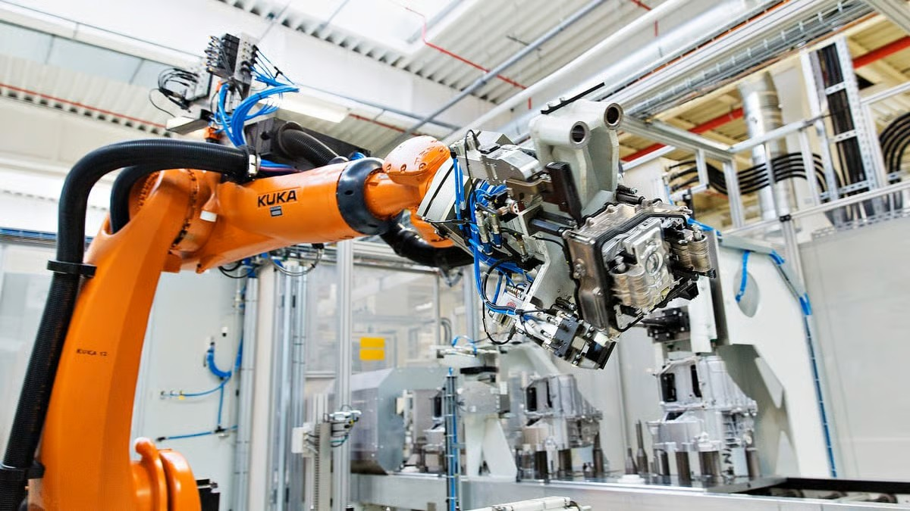

[Insert Quote]



OFFICE OF MANUFACTURING AND ENERGY SUPPLY CHAINS:

INDUSTRIAL TRAINING AND ASSESSMENT CENTERS

On April 6th, 2023, a team of 6 students and 2 faculty from Michigan State University Industrial Training and Assessment Center (MSU ITAC) visited KUKA’s Warren, Michigan facility. While there, the team took note of energy saving opportunities within the building and associated processes. KUKA then went on to implement 70% of MSU ITAC’s recommendations, with annual saving estimated at $127,975 in costs, 277,842 kWh in energy, and 12,196.7 MMBTU in natural gas. KUKA also implemented these recommendations at several of their other facilities.

**Summary**

Under the supervision of Dr. Kristen Cetin, the MSU team visited the Warren site and identified ten energy savings opportunities that were articulated into assessment recommendations (AR). KUKA’s staff were receptive to the assessment and implemented seven ARs within 6 months (listed in Table 1).

New Energy Efficient Air Compressors

Plant Description

The Warren, Michigan KUKA plant is a 500,000 sq ft building that was constructed in 1939. The plant’s process changes based on clients’ needs. Their process consists of constructing the costumer’s desired assembly line, conducting quality testing and customer approval, and then shipping and assembling at customer’s site for use.

During the assessment day, the MSU ITAC team identified that one of the facility’s air compressors did not have a Variable Frequency Drive (VFD). Compressors without VFDs are less efficient, and more costly to operate. Rather than installing a new VFD on their old air compressor, KUKA decided to switch to a new and more efficient model that includes a built-in VFD. KUKA also purchased several other compressors with VFDs for their other facilities and were able to incorporate this recommendation quickly following the 2023 assessment.

Company Background

Founded in 1898 by Johann Keller and Jakob Knappich, the KUKA Group is an international automation company that specializes in intelligent industrial, autonomous mobile, and automotive robotics manufacturing. Its headquarters reside in Augsburg, Germany with its largest facilities in the USA, Germany, China, and Hungary.

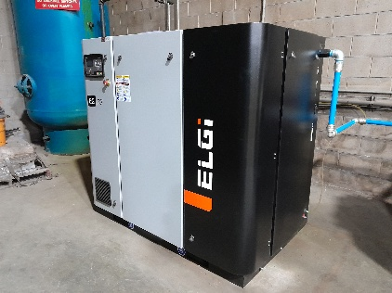

New VFD Air Compressors for Multiple KUKA Sites

Monitoring Air Leaks

Although KUKA had a compressed air leak study conducted once prior to the ITAC assessment, the team found several additional leaks during the site visit. These findings led the facility to schedule additional, and more frequent, air compressor leak audits through their utility, DTE. These practices have additionally been adopted by KUKA’s six other Michigan facilities and have shown promising cost and resource savings.

Company Wide Impact

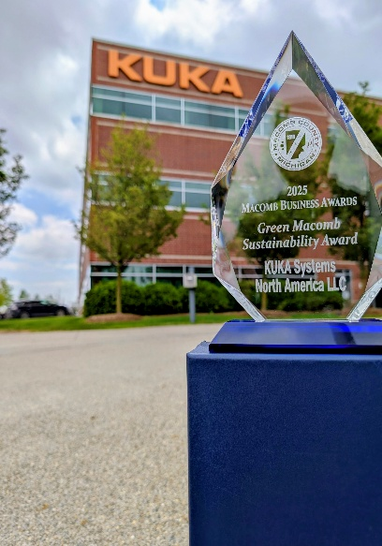

2025 Macomb Business Awards - Green Macomb Sustainability Award Winners

OFFICE OF MANUFACTURING AND ENERGY SUPPLY CHAINS

Not only did the Warren KUKA facility improve their energy effieciency, but other locations around Michigan did as well. KUKA plants located in Livonia, Clinton, and Sterling Heights have additionally implemented some of the recommendations in the MSU ITAC report. One recommendation that was widely used among other locations was implementing office temperature setbacks. This process involved lowering temperatures during the winter season and increasing temperatures during the summer during unoccupied hours. Applying this recommendation resulted in an estimated $4,405 annual cost savings, and 31.1 tonnes of carbon dioxide reduction per facility.

For more information:

<https://www.energy.gov/mesc/office-manufacturing-and-energy-supply-chains>

Michigan State University ITAC

https://iac.msu.edu/



|  |  |  |  |  |
| --- | --- | --- | --- | --- |
| Implemented Recommendations | | | | |
| Assessment Recommendations | Annual Resource Savings* | Total Annual Savings* | Capital Costs* | Simple Payback* |
| Install VDF on Air Compressor | 240,300 kWh/yr | $18,370 | $6,347 | 0.34 years |
| Fix Leaks in Compressed Air System | 9,387 kWh/yr | $906 | $133 | 0.2 years |
| Decommission Suboptimal  Radiant Heaters | 12,171 MMBtu/yr | $101,263 | - | Immediate |
| Install Energy Efficient Exit Signs | 5,694 kWh/yr | $419 | $2,000 | 4.77 years |
| Implement Further Office Temp Setbacks | 22,466 kWh/yr | $4,405 | - | Immediate |
| Install Insulation on Unused Loading Dock Doors | 25.7 MMBtu/yr | $214 | $522 | 2.44 years |
| Apply for Tax-Free Status on Energy Purchases | - | $2,402 | - | Immediate |
| **Total\*\*** | **290,018 kWh/yr** | **$127,979** | **$9,002** | **1.1 Years (avg)** |
| **12,196.7 MMBtu/yr** |

*\*Values based on report-provided recommendations; ** For Warren facility*

Green Macomb Sustainability Award

In May of 2025, KUKA Systems North America LLC was awarded the Green Macomb Sustainability Award for their dedication to environmental responsibility and sustainability. By taking steps, including partnering with MSU ITAC and MI Green Power Program, they have reduced their electricity consumption by 21%, increased recycling rates by 35%, and reduced water consumption by 25%. KUKA’s commitment to sustainable practices has been upheld through energy management strategies and targeted facility upgrades.