Committee on the Institutional Support for Research and Creative Activities (CISR)

January 2026 Final Report
Committee Members:
- John Aerni-Flessner (Vice-Chair Faculty Senate, Residential College in the Arts and Humanities; Chair)
- Dave Ewoldsen (Communications)
- Rebecca Anthony (Engineering)
- Victor Rodriguez-Pereira (Arts and Letters)
- Riyad Shahjahan (Education)
- Michael Williams (Human Medicine)
- Megan Halpern (Lyman Briggs)
- Lissy Goralnik (Ag and Natural Resources)
- Jeff Conroy-Krutz (Social Science)
- Shahnaz Masani (Lyman Briggs and Natural Science)
- Angela Wilson (Natural Science)
- Siddarth Chandra (James Madison)
- Kathleen Fitzpatrick (Arts and Letters)
- Liz Ivkovich (University Advancement)

This report is dedicated to Marilyn Amey, who served on this committee in Spring 2025. She is fondly missed on and off campus, and her sage wisdom helped shape this report.

Background:
The committee was created by a resolution passed by the Faculty Senate at MSU on the 19th of November 2024. The remit was to investigate the ways that departments, schools, colleges, and other offices at MSU internally support and fund research and creative activities for faculty across campus. Faculty is defined as tenure-system, academic specialists, fixed-term faculty, and non-tenure-track faculty. The committee consisted of 13 faculty from 11 colleges and also included (at various times) representatives from the Office of the Vice-President of Research and Innovation (VPRI), University Advancement, and the Office of Faculty and Academic Staff Development (FASD).
After the committee was formed, events on and off campus upended the original plan. The dramatic and drastic changes in the federal funding landscape have rendered obsolete some of the previous funding models. Further budget cuts announced at the end of the Spring 2025 semester have further put into flux some of the funding mechanisms that had previously supported research and creative activities on campus. However, the committee decided that to document the funding situation “as it was” in late 2024 and early 2025 still retains some value.
We are optimistic that this document can be used as a baseline moving forward. It will document what was effective in providing support for research and creative activities in the previous federal and local funding landscapes. It also documents what was not working well, even in the pre-2025 era of federal research funding and before MSU’s budget cuts. Thus, we hope this will serve NOT as a model for how to recreate pre-existing structures, but rather as a starter for the conversation on how to build BETTER structures once the new funding models that will power higher education research and creative activities in the middle decades of the 21st century—locally, at the state level, nationally, and internationally—come into better focus.

Executive Summary
- Research/creative activities is one of two central pillars of the mission of MSU and needs to remain, alongside teaching, the focus of what we do and what we are known for. Thus, getting our model for funding research/creative activities is crucial to the success of the overall institution
- New funding paradigms are emerging that will reshape the way research and creative activities are funded at MSU (and other campuses) in the coming years
- This report will, hopefully, serve as a baseline for what was in the pre-2025 years—both what was working well and what needed some rethinking even then
- MSU faculty (tenure-system, non-tenure-track, fixed-term, and academic specialists) are doing amazing work across campus, and are often doing so with very limited budgets
- MSU faculty could be doing even more amazing and impactful work with better funding and the suggestions at the end of the report document some places to start to rethink how these funding changes might make the greatest impact
- The decentralized system that allows units to create their own models for research funding works on some parts of campus. That model, however, might be shifting under both the new federal dispensation and the new budget model that is coming soon on campus. Therefore, it will be important to keep support for research at the center of these budget discussions going forward. There are many units, however, where this decentralized model brings only the barest of funding for research/creative activities. Thus, a centrally designated “backstop” that ensures every faculty member a minimum amount of funding should be created
- There is an opportunity with the early 2026 appointment of a new Vice-President for Research and Innovation to reevaluate and rethink the ways that the central administration supports the breadth and depth of research/creative activities on campus
- MSU is well-positioned to continue to support research/creative activities for the “common good” and for the good of local communities, the state of Michigan, the country, and the broader world deep into the heart of the 21st century. Faculty are eager and willing to take on this work, despite the headwinds facing higher education

Methods and Considerations
To understand unit and MAU practices, and faculty needs and experiences, the committee drafted and received approval to send out two separate surveys. The first went to the sixteen Research Deans, from which we received fourteen responses. The second went to the 91 Department Chairs and School Directors. From this group, we received 54 responses spanning all degree-granting colleges on campus. We also conducted interviews with key representatives from the Office of the VPRI, MSU Extension, and MSU Advancement as we thought through different ways that research and creative activities are funded on campus.
The committee drew on its expertise from various units across campus to evaluate the data we collected. We have included some of the data in appendices that will hopefully allow the reader to dive deeper into particular areas of concern. The data resides with the committee chair (along with the members of the Data Task Force who were instrumental in helping collect, consolidate, and analyze this data), so if you have further questions please get in touch. The deidentified data can be made accessible to others with legitimate reason to analyze and learn from it.

Summary of Data and Analysis
Department Chair/School Director Survey:
As of the time of the Spring 2025 survey, the four key pillars of support for research and creative activities on campus were:
  - Central support from units’ base budget and Office of the Vice President of Research and Innovation funds (with much of this money coming courtesy of the MSU Research Foundation)
  - Grant support via indirect costs (IDC money) returned to colleges/units
  - Revenue-based initiatives (RBIs)
  - Philanthropy/Corporate/Foundation partnerships

Units’ access to these different sources varied widely. Even within colleges that primarily depended on one or another source of funding, there were often departments or schools that did not have access to the same sources of funding. It was, thus, difficult to make generalized statements about research funding. This led to some key observations:
- Given the variability within colleges, looking at research/creative support at that level in terms of trying to make comparisons was not very useful.
- There are very real differences between units that could rely on grant funding (and IDC returns) and those that do not have similar opportunities. Those units sometimes relied more heavily on central support (VPRI Office and base budget). These differences broke out, very generally, along lines of STEM/Health Sciences and Arts/Humanities/Social Sciences.
- Even still, across most disciplines there was frustration that funding for research/creative activities seemed to be dropping (even before the latest rounds of 6%/3% budget cuts were announced and prior to the full scope of federal funding changes being known).
- Many survey respondents (Research Deans, Chairs, Directors, etc.) noted that the paucity of research funds was not just harming research productivity but was contributing to worries about faculty retention, about their ability to fulfill departmental teaching obligations (due to a lack of RAs/TAs/grad students/post-docs), as well as their competitiveness in seeking external grants.
- In addition to the current funding crisis, many unit leaders also identified long-term worries that, even with enough funding for individuals, scarce funding might make it harder for their units to compete in the research environment with institutions making better investments in facilities.

The gaps in funding seen across campus did not fall neatly into a STEM/other fields bifurcation. Unit leaders from, among others, postdoctoral affairs, social science, osteopathic medicine, and more noted that many of their faculty members were forced to fund professional development and conferences entirely out-of-pocket. This was clearly also true of many other disciplines given the small amount of money devoted to professional development funds (see appendices below). In other cases, units reported that their funds were primarily focused on tenure-system faculty, and their research active non-tenure-track faculty/academic specialists/fixed-term faculty with research appointments did not have the same access. More attention should be paid to ensuring basic equity in units that assign faculty off the tenure-track to research.

In the survey of unit leaders, the four top concerns around funding were all directly tied to the research/creative mission of the university and are in areas where extending support could directly lead to more productivity/output and/or national/international leadership in fields. These were:
- More support for travel to present at conferences/symposia
- Purchase of research supplies/equipment/resources
- Personnel support (RAs/TAs/Technicians/Undergraduate research assistants)
- Travel for research

Another area that Chairs/Directors noted issues in was financial models that, they felt, shortchanged their ability to fund faculty research/creative activities. Relatively recent changes to the Off Campus Credit Instruction (OCCI) model gave the money in a fixed amount to colleges rather than the units generating the money. This has led some unit leaders to struggle to generate adequate funds for research/creative support. In a similar vein, the rules around carryforward were reported to hinder the ability of some unit leaders to plan larger research expenditures. This, again, varied widely between colleges and even sometimes units within colleges, so it should not be read as a full-throated criticism of any of these changes, but should be noted as challenges for some in funding research/creative activities. A reexamination of the effects of OCCI changes and carryforward policies should be wrapped into an evaluation of the overall research enterprise.

In terms of how research/creative funds are distributed within units, there is wide divergence across campus. Allocation decisions across units were handled through a range of governance models, from chairs’ discretion to more consultative or criteria-driven approaches, or simply first-come-first serve. Models that incorporate elected unit-level bodies and/or transparent criteria offer clearer guardrails for decision-making and helped foreground equity, merit, and transparency as shared values.

The issue of funding for non-tenure-system faculty (defined as academic specialists, non-tenure-track faculty, and fixed-term faculty) is also one that highlights the diversity of ways that funding is distributed on campus. While some units reported that all research-active faculty, regardless of appointment type, were eligible to receive funding, other units noted that only tenure-system faculty had such eligibility. While the diversity of appointments on campus makes it hard to define strict policies around this issue, the salience of non-tenure-system faculty having research/creative appointments but lacking access to research/creative funds should make this a priority to investigate. Whether policies are changed at the university, college, or unit level, there should be an expectation that if faculty in any system have research/creative activities in their job description, they should have access to research/creative funds from their unit in a way similar to tenure-system faculty.

Research Deans Survey:
In line with the decentralized way that MSU funds research/creative activities, there were three colleges that did not distribute college-level funds directly to faculty for these endeavors: ENG, CHM, and CANR. All the rest did. While endowed chairs are important, and relatively standard asks in most comprehensive campaigns, the Research Deans noted that what they really needed was endowed and expendable money that could be used to support the diverse research needs within their respective colleges. Currently, a majority of responding colleges reported having access to at least some of these funds. However, the ones that did not (Briggs, RCAH, Nursing, Law, Arts and Letters) were ones that, largely, also reported struggling with funding all faculty research/creative activities. Thus, as the current comprehensive campaign continues, University Advancement should strive to ensure that all MAUs with faculty on research appointments have access to endowed funds to support research/creative endeavors.
At the college level, however, most leaders reported that they both funded units (for distribution for individual research/creative activities) and retained some funds centrally to support individuals and units with innovative proposals—a system that seems to give both stability and flexibility at the same time. Some MAUs, especially colleges with heavy grant activity, also reported needing to hold back significant sums of money to cover future and potential cost-sharing provisions within their units, which impacted their ability to directly fund faculty.
Several research deans noted that it was difficult to access funds for medium-sized projects. They noted that larger projects were sometimes covered from VPRI funds (such as the relatively new Shared Research Infrastructure Program) or capital expenditures, and that smaller projects could often be covered from existing funds. Proposals or needs that fell in the medium range often “fell through the cracks.”
On a similar note, Research Deans noted that in many places there was a lack of congruence between the spaces they had available for research and the desires of faculty to expand into new areas. An audit of spaces that engages with unit-level concerns, college-level planners/administrators, and the central administration (via the Provost’s Office and the VPRI’s Office) would allow for better medium and long-term planning around the space necessary to continue our work in areas of current strength and to expand into new areas.

Conclusion
While this survey consisted of a “snapshot in time,” it turns out it was taken at an important time. It was taken just as the existing funding models on campus were being upended. Thus, it documents “what was” prior to 2025. This was before MSU mandated a 9% budget cut over two years. These cuts have certainly harmed research budgets in many units, as research funding is typically an easier expenditure to cut than personnel. It was also before the full scope of the changes in federal funding for agencies like NIH, NSF, NEA, and NEH were apparent and had trickled down into unit-level budgeting. While on the one hand, this makes the report less useful than something that would document how these changes have changed the research/creative apparatus at MSU, it also provides a baseline for documenting changes in the new funding landscape that is yet to fully emerge.

The survey was conducted by a volunteer committee of the Faculty Senate and was done with the desire to make the research enterprise at MSU stronger for the institution as a whole and more responsive to the needs and desires of those who work in it. We hope it will be received in the spirit in which it was conducted—that of attempting to document to allow us all to contribute to making the institution stronger and better. Any criticisms here, made visible or even just perceived, were proffered in that spirit. In the end, we contend that a strong overall institution benefits the faculty of individual units and makes better the on-campus experience for undergraduate students, graduate students, postdoctoral research fellows, faculty of all types, staff, and others. In short, our institution and society at large benefit when MSU research prospers.

Recommendations:
- The decentralized model of unit/college funding and has worked well in some spaces across campus. However, central admin should set and fund a baseline guarantee for all faculty with research appointments (tenure-system, non-tenure-track, fixed-term, and academic specialists) to ensure no one is funding conferences, research, and professional development entirely out of pocket.

- Units and colleges must ensure shared governance principles are followed in allocating money to faculty for research and creative endeavors. Decisions about discretionary funding of research/creative activities should incorporate elected unit-level bodies and/or transparent criteria to offer clearer guardrails for decision-making that can foreground equity, merit, and transparency as shared values.

- The provost and new VPRI should prioritize a facilities audit for all units on campus to better position MSU for excellence in the next quarter century.

- Revenue-based initiatives (RBI) should be evaluated as a way of funding research, but we must remain cognizant of the ways that RBI can also exacerbate inequalities on campus around research funding and look to mitigate that tendency. The university should move forward with encouraging units to development more RBIs, funds from which could be designated to support research.

- There should be another look at how Off Campus Credit Initiative (OCCI) funds are distributed to see if altering that formula might allow more units, especially those with fewer options for generating revenue, to better support their faculty.

- In the current comprehensive campaign, sincere effort should be put into creating explicit endowments and expendable funds to support research. Deans should add endowed and expendable research accounts to their campaign priority lists, and these lists should be encouraged especially among MAUs that currently lack access to such funds. This should include support for student-faculty research collaborations.

- In addition to endowed and expendable research funds at the college and unit levels, there should also be a central research endowment funded via the comprehensive campaign. This fund, which could be run through the VPRI Office in conjunction with the MSU Research Foundation, should help redress existing inequities on campus in funding for research/creative activities. Funds of this type will allow the VPRI more flexibility to grow successful programs and initiate new ones to better support emerging needs in research/creative activities.

- Research and creative support should be one of the “Presidential Priorities” in the current comprehensive campaign. It can encompass the initiatives listed above, but should go more generally toward broad-based, excellence-driven research and creative activities across the breadth of university units.

- Research support is, ultimately, both a retention and research/creative productivity issue. Finding ways to meet all the unique needs that faculty have across campus will improve faculty satisfaction and, thus, student experiences.

- Sources of funding on campus outside of departments/units/colleges like the Area Studies Centers were a key source of funding for research/creative activities. With their current federal funding revoked, there is a large hole in research/creative support, especially for international research that has bolstered MSU’s strong international reputation for more than 60 years. The University should prioritize funding initiatives to support internationally focused faculty and programs.

- Faculty and administrators noted that certain internal programs had significant issues, including the HARP (where the award amount has not changed since it was inaugurated in 2009) and the Tetrad, which required cost-sharing from colleges/units that made it inaccessible to some.

Gratitude:
The CISR Committee would like to thank all the Department Chairs, School Directors, and Research Deans who responded to our survey. The Committee would also like to thank Charley Hasemann of the MSU Innovation Center and VPRI Office, Adam Kingston of Foundation Relations, and Quentin Tyler of MSU Extension for making time in their busy schedules for an interview with the committee. We would also like to extend our thanks to Kay Connelly for serving on the committee in the Spring 2025 semester as an advisor on operations in the VPRI office. The Data Task Force (Dave Ewoldsen, Rebecca Anthony, Jeff Conroy-Krutz, Kathleen Fitzpatrick, Lissy Goralnik, Shahnaz Masani, and John Aerni-Flessner) should be singled out for particular thanks for the extra meetings they endured to help make this report possible.

Appendices

Data from Survey of Research Deans, School Directors, and Departmental Chairs, conducted in spring semester of 2025

Appendix 1: Overview of Research/Creative Funding

Units with More than $7 mil in Annual Grant Research Expenditures Summary
College | Annual Allocation? | Typical Amounts | Primary Funding Sources | Notes / Distinctive Policies
EGR | Some units | $0–$7k; one conference/year | IDC returns, endowments | IDC returns vary by PI
CVM | Yes | ~$1.5k | IDC + college funds | Endowed PD funds
CHM | Some units | $2.5–$4k (up to $50k) | Clinical revenue, salary savings, IDC | Multiple internal models
CSS | Some units | $1–$4k | General funds, IDC | Wide variation across units
CNS | Limited | ~$1k | General funds | Year-to-year variability
COM | Some units | $1k–$2.5k | General funds, HSRC | One conference/yr
CANR | Some units | $500–$2.5k | Endowments, unit general funds, grants | Extension scaled by FTE

EGR: Engineering; CVM: College of Veterinary Medicine; CHM: College of Human Medicine; CSS: College of Social Sciences; CNS: College of Natural Sciences; COM: College of Osteopathic Medicine; CANR: College of Agriculture and Natural Resources

Units with Less than $7 mil in Annual Grant Research Expenditures Summary
College | Annual Allocation? | Typical Amounts | Primary Funding Sources | Notes / Distinctive Policies
BUS | Some units | $4–$9k | General funds, RBIs, endowments | Varies by rank/type
RCAH | Yes | $1.5k | General funds | Universal support
OPA | Some units | $700–$1k | Provost/Grad School | Travel-focused
CAS | Yes | $1k—$2.5k | Dept PD funds | Consistent annual
CAL | Some units | $1–$2k | RBIs, general funds | Varies by department
LIB | Yes | Varies | Endowments, merit funds | Merit-based allocation

BUS: Eli Broad College of Business; RCAH: Residential College in the Arts and Humanities; OPA: Office of Postdoctoral Affairs; CAS: College of Communications Arts and Sciences; CAL: College of Arts and Letters; LIB: Libraries

Appendix 2: Data from Department Chairs/School Directors

Q1

Do you allocate funds on an annual basis to all faculty in your department, for research and professional activities (including conference travel)?

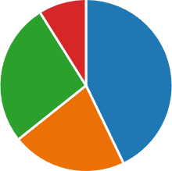

College / other unit
Out of pocket
N/A
Other
Chairperson

Q4 If your answer to Question 1 was "No" or "Only to some faculty members", how do faculty meet their professional obligations?
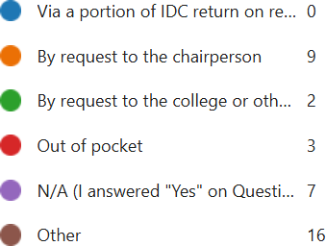
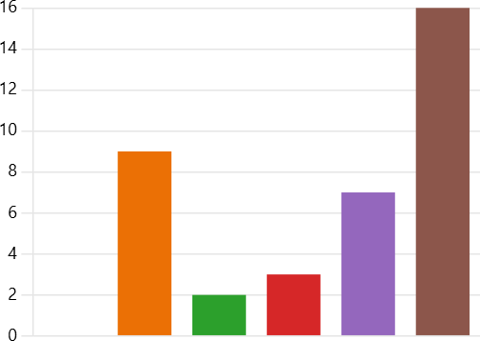

Q5

If you answered "Yes" to Question 1: Are there any department/unit-imposed restrictions on how faculty can spend their allocated funds?

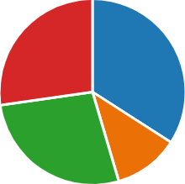

Q6


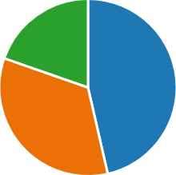
Does the chairperson or department make other funds available to faculty?

Donor wishes
Reg. dept. cttee
Ad-hoc cttee
Chairperson/unit lead
No endowed funds
other

Q9 If your department holds any endowed funds, how is their use determined?
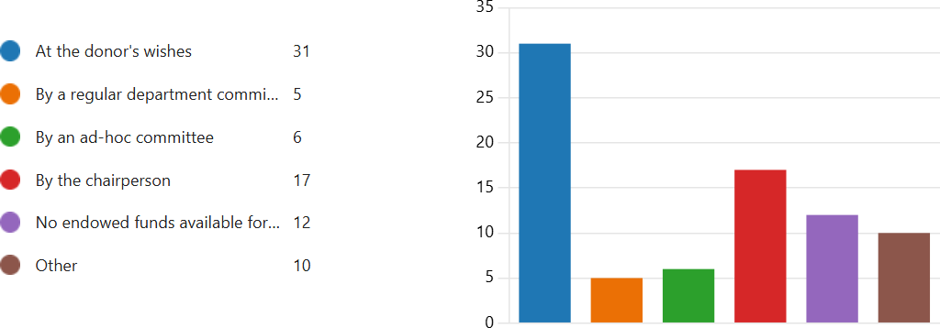

Q10

If your department holds endowed funds, what kind of reporting is done?

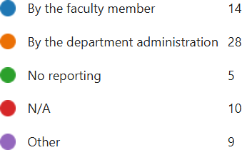
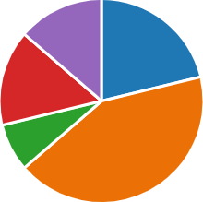

Q11
What expenses are the most frequently requested? Select the top 2-3 answers.

Conf. travel
Collab. travel
Research travel
Supplies/equip.
Teaching
Personnel
Pub. fees
Course buyout
Other

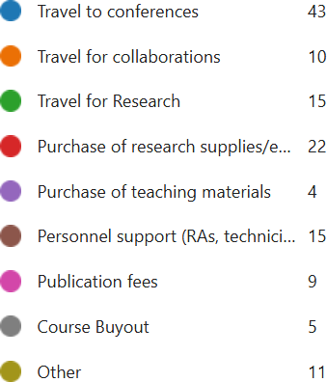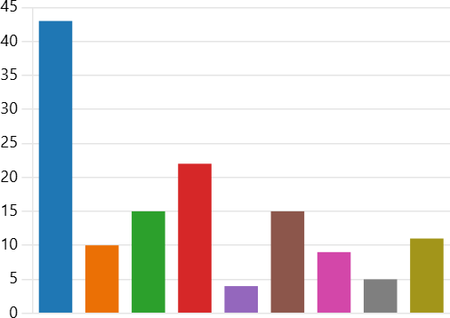

Q15

What role does the faculty voice play in funding allocation decisions in your unit?

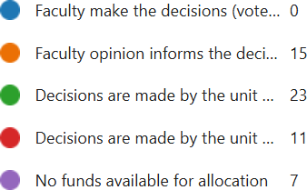
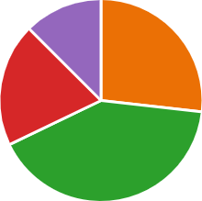

Q16

In Question 15 about faculty voice, is the non-tenure-track faculty voice considered in the process?

