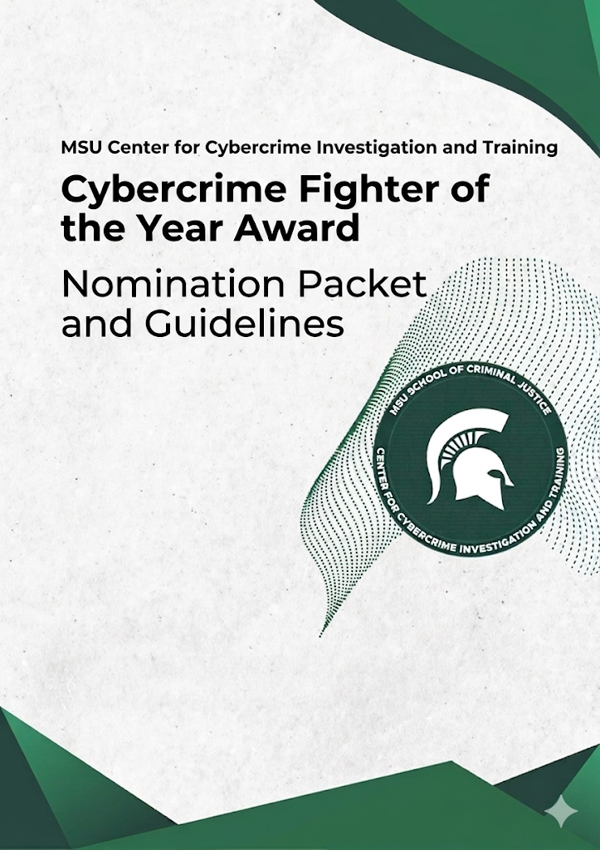
Cybercrime Fighter of the Year Eligibility Criteria

As cybercrimes and online threats grow increasingly complex, the criminal justice professionals protecting Michigan residents must work harder than ever to aid the public, and assist victims. To honor those who serve, the Center for Cybercrime Investigation and Training in the School of Criminal Justice at Michigan State University is proud to announce the first ever Michigan Cybercrime Fighter of the Year Awards.

This prestigious annual award recognizes the outstanding law enforcement, prosecutors, and specialists within the Michigan justice system who have demonstrated exceptional effort, innovation, collaboration, and a profound commitment to victim-centric care. Nominations are officially open to active practitioners employed in Michigan agencies and offices. We seek nominees from 1) Law enforcement, 2) Prosecutors and Legal Professionals, and 3) Victim Advocates and Specialists. To qualify, nominees must meet the following criteria:

1. Professional & Jurisdictional Standing

To qualify, nominees must be active practitioners within the Michigan justice system or supporting non-profits:

- Law Enforcement: Must be a sworn MCOLES (Michigan Commission on Law Enforcement Standards) certified officer, digital forensics analyst, or civilian investigator or analyst working for a local, county (Sheriff), State (MSP), or Tribal law enforcement agency within Michigan.
- Prosecutors: Must be an active Prosecuting Attorney, Assistant Prosecutor (APAs), or Assistant Attorney General (AAG) handling criminal dockets within Michigan’s District, Circuit, or Probate/Juvenile courts.
- Victim Advocates: Must be employed by or volunteering for a Michigan county prosecutor’s victim advocacy unit, a law enforcement victim assistance program, or a registered Michigan 501(c)(3) non-profit that offers victim services (e.g., CACMI, crime victim service agencies receiving VOCA funding via MDHHS).

2. Statutory Focus

The award should specifically recognize exceptional work utilizing or expanding enforcement under Michigan-specific statutes, rather than just federal laws. Nominees should demonstrate success in cases involving any MCL statutes related to cybercrimes.

3. Case/Initiative Scope & Timing

The primary case, investigation, trial verdict, or advocacy work must have reached a significant milestone or conclusion within the current evaluation period of 2025/2026. The criminal activity must have also directly targeted a Michigan resident, local business, municipality, or school district, OR the investigation must have been primarily executed by a Michigan-based agency.

Official Nomination Form Template

Instructions for Submitter: Please complete all sections of this form. All application materials should be submitted via email to holtt@msu.edu by no later than 5pm on Friday December 4, 2026.

Cybercrime investigations, prosecutions, and victim advocacy require a unique blend of technical, legal, and interpersonal skills. Your responses should clearly highlight how the nominee went above and beyond standard protocols over the past 12 months.

I. Administrative Information

Nominee Information
- Full Name & Title/Rank: _______________________________________________

- Agency/Organization: ______________________________________

- Primary Role Category (Select One):
  - [ ] Law Enforcement / Digital Investigator
  - [ ] Prosecutor / Legal Professional
  - [ ] Victim Advocate / Crisis Specialist

- Email: _____________________ Phone: _____________________

Nominator Information
- Full Name & Title: ____________________________________________________

- Agency/Organization: ______________________________________

- Relationship to Nominee: ________________________________________________

- Email: _______________________ Phone: ___________________

II. Executive Summary (Max 150 words)
Provide a brief summary of why this nominee should be named Cybercrime Fighter of the Year. This summary will be used in promotional materials and award programs if selected.

III. Narrative Response Criteria (Max 250 words per section)
1. Innovation & Adaptability
Describe a specific obstacle or challenge, a highly technical hurdle, or offender behavior (e.g., cryptocurrency laundering, complex online fraud network, unique use of online technology, etc.) the nominee encountered. How did they use creative problem-solving, novel digital forensics, or unique legal strategies to overcome it?

2. Cross-Disciplinary Collaboration
Cybercrime transcends borders and jurisdictions. Describe how the nominee broke down institutional silos to build a successful outcome. Provide examples of how they collaborated across agencies (e.g., local police partnering with federal task forces, prosecutors integrating digital forensic analysts, or investigators embedding victim advocates early in the process).

3. Community Impact & Scalability
How did the nominee's actions create lasting change over the past year? Did their work dismantle an active network, establish a new methodology for investigation, give a family comfort, or create a training program/resource that can be replicated by other jurisdictions to better protect the public? Provide measurable outcomes where possible.

4. Victim-Centric Approach
Cybercrimes can create deep financial and psychological trauma. Describe how the nominee demonstrated exceptional commitment to minimizing secondary trauma for victims, such as those affected by romance fraud, cyberstalking, non-consensual image sharing, or other offense. How did they ensure the victim was supported, informed, and treated with dignity throughout the investigation or legal process?

IV. Supporting Documentation Checklist
Please attach the following items to your submission packet:
- [ ] Endorsement Letter 1 (Required): A letter of support from the nominee's supervisor or agency head.
- [ ] Endorsement Letter 2 (Highly Recommended): A cross-disciplinary letter is encouraged (e.g., if the nominee is an investigator, a letter from a prosecutor or victim advocate who worked alongside them), or another co-worker or supervisor.
- [ ] Supplemental Materials (Optional, Max 3 items): Please provide any materials to support your nominee, such as news articles, anonymized victim impact statements, or other evidence of their efforts. Any information provided will be kept confidential by the committee.

All applications are due by 5:00pm on Friday, December 4, 2026. Please send the application package via email to holtt@msu.edu. If you have any questions regarding the application process, please contact Tom Holt via email at holtt@msu.edu or by phone at 517-353-9563.

