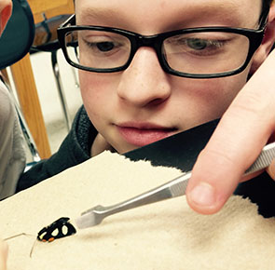
Science research & teaching program at MSU

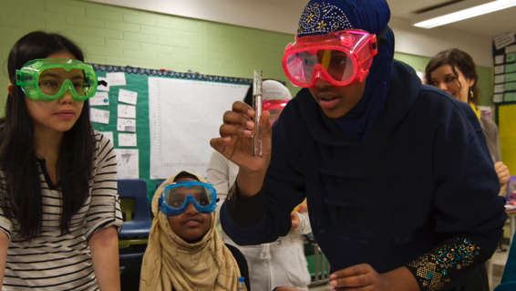
We are looking for students interested in teaching at the K-12 level as their career goal and motivated to improve their scientific training and their science teaching skills to take part in a NSF funded program. The students will take part in mentored and paid research and teaching experiences. The students will take biological research internship in the laboratory of Dr. Eva Farré (MSU, Plant Biology) and will be teaching assistants for a Plant Biology course in the following academic semester, mentored by Dr. Farré, Dr. David Stroupe (University of Utah,Teacher Education) and graduate student Matt Adams (MSU). Biological research internships can be either this spring (~10 h/week), summer (full time 10 weeks) or fall (~10h/week) and the teaching internships in the fall or spring semesters (~10 h/week).

Application Package
Please read carefully before sending. Failure to follow instructions given or incomplete packages will result in dismissed applications. Please send the following information:

1. Provide your resume (provide as a separate file in format of your choice)

Please provide the following as one Microsoft Word document.

2. Indicate which semester you will be able to do the research internship and in which semester you will be able to do the teaching internship. Please provide your tentative work schedule (not class schedule) for those semesters
3. Provide an unofficial transcript (if not a first semester Freshman)
4. List your major
5. List your current year (freshman, sophomore, junior, senior) and the year you expect to graduate and/or leave MSU
6. If known, indicate your teaching and scientific interests and long-term career goals (explain in no more than five, single-spaced lines, Times New Roman, 12)
7. Why do you want take part of this internship? (Explain in no more than five, single-spaced lines, Times New Roman, 12)
8. List two strengths you think you have for this program

Please send the application package to farre@msu.edu. We will evaluate your application within two weeks. Please let us know if you need more time to prepare your application or if you have any questions.

