Scholar Profile—Assel Izekenova

Lights blurred past the train windows as Assel Izekenova, her husband, and twin boys travelled through sleeping towns on their way from Chicago to East Lansing. It was the last leg of their trip, but the first step in Dr. Izekenova’s journey at Michigan State University (MSU) as a Bolashak International Scholar—Kazakhstan’s flagship, one-year scholarship program.

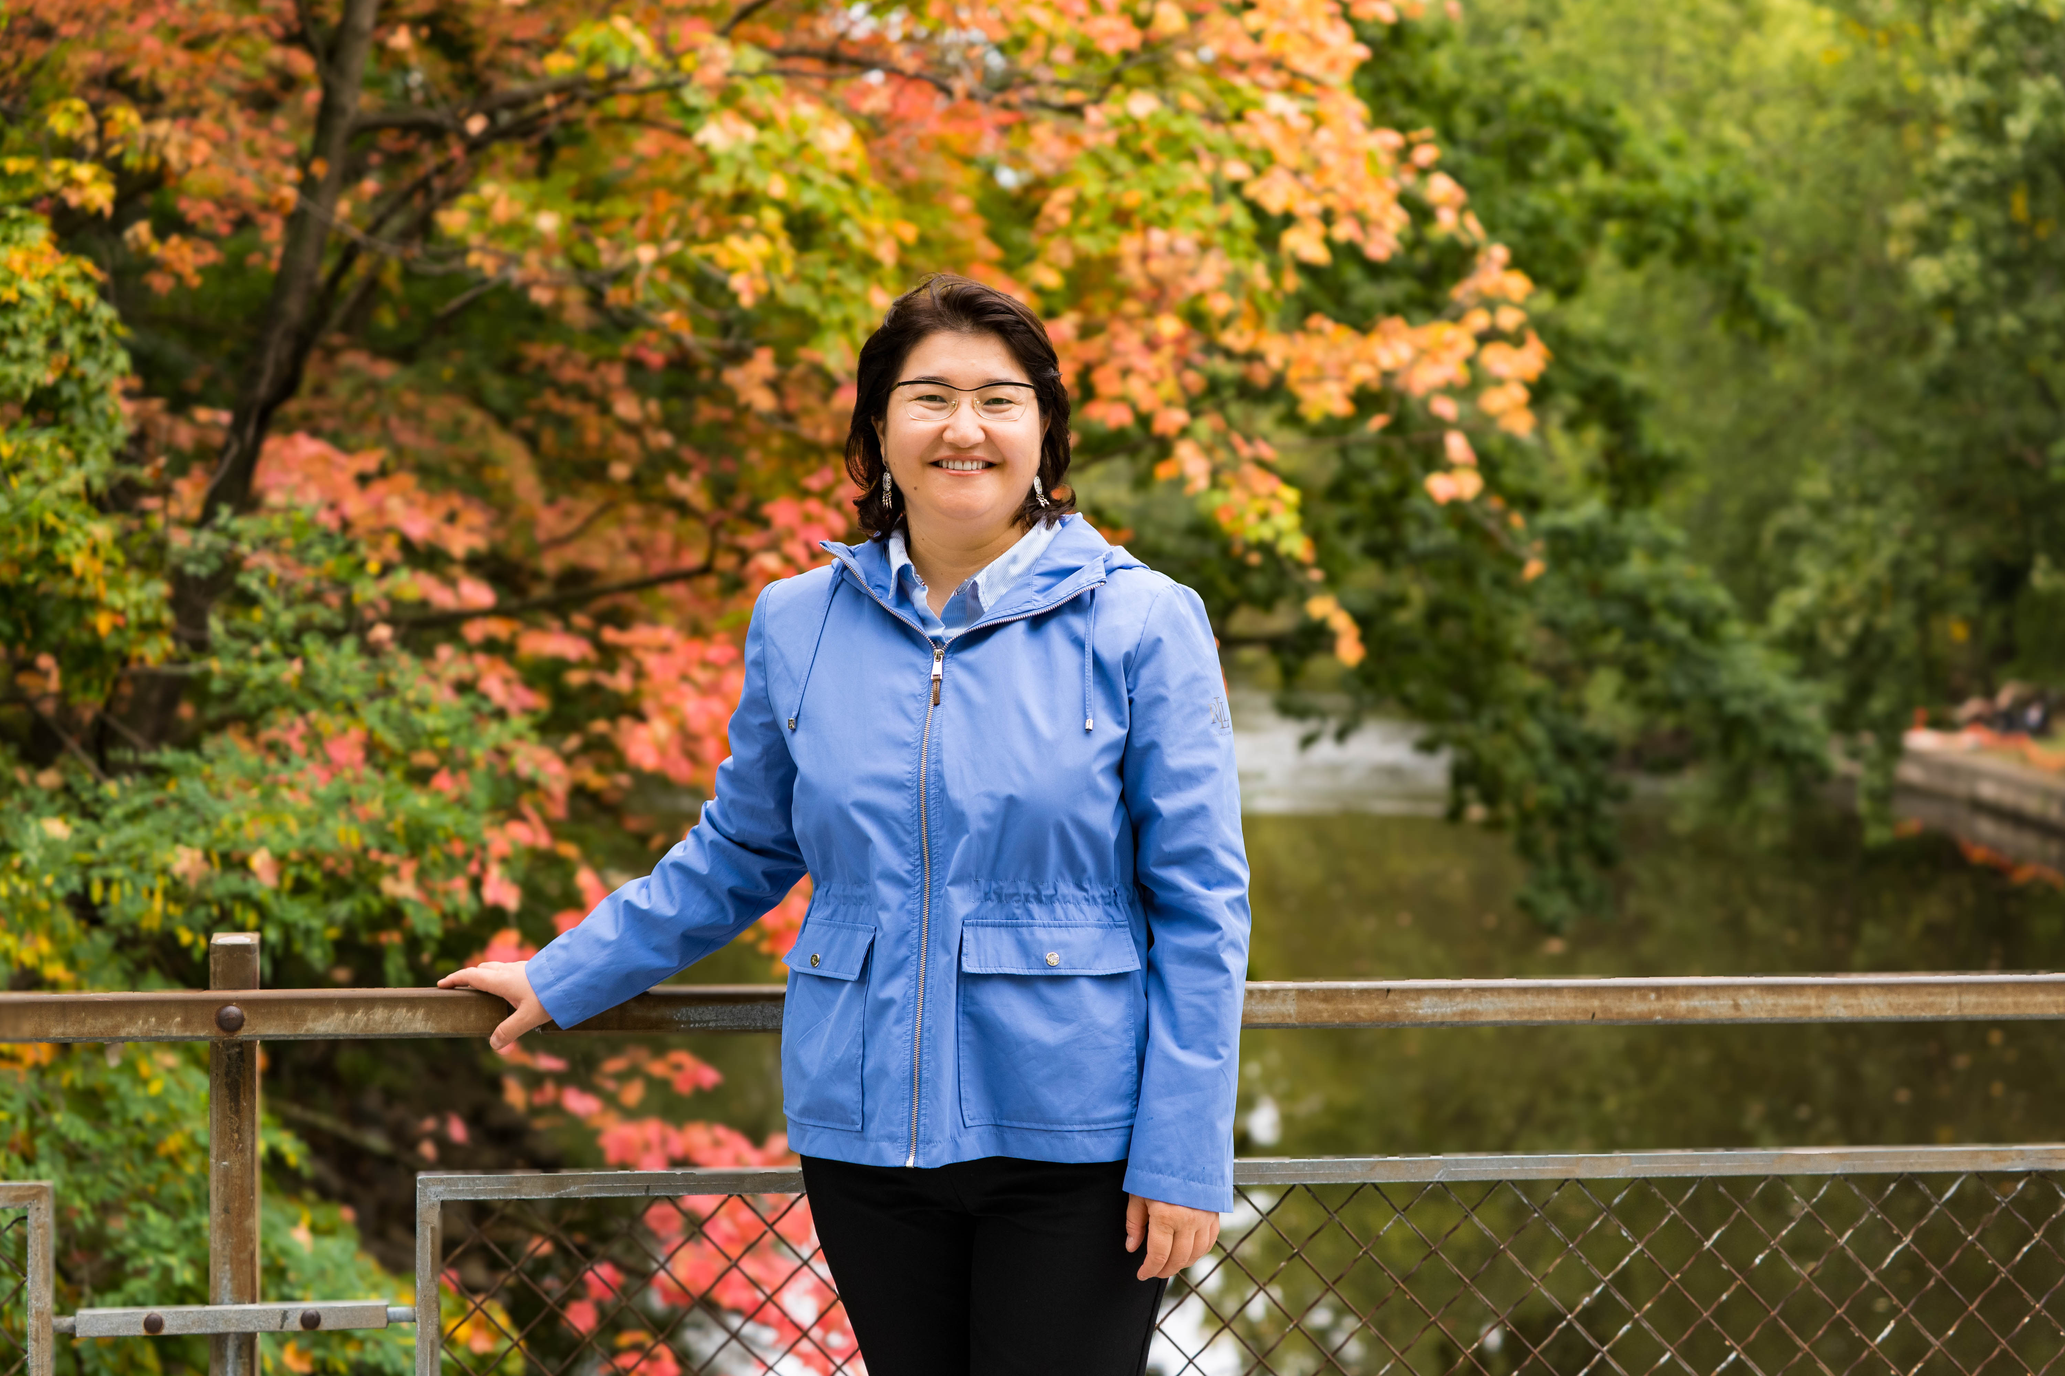
“While I’ve visited for internships, I had never been to the Midwest,” explained Izekenova. “I like that Michigan has four seasons. After arriving in January, seeing the magnolias bloom in spring, and experiencing summer, now I can’t wait to see autumn.” Izekenova selected MSU from 100 top universities around the globe. “MSU is known for agriculture and ranks number one for education,” said Izekenova, “but it was a visit by two wonderful [MSU] researchers that really impressed me.”

Through the Bolashak Program, she works with mentors in MSU’s Colleges of Education (Dr. Samantha Caughlan) and Social Work (Dr. Fei Sun). Given Izekenova’s extensive work on aging with international organizations and the UN, the mentors helped focus her research on digital financial literacy for older adults, especially financial fraud and financial inclusion. Thanks to them, she participated in workshops and seminars about tailoring teaching to adults; conducted field studies with older adults; and will co-author three to four papers in top quartile journals.

In reflecting on the program so far, Dr. Izekenova said, “I’ve been a busy professor myself, so I thought the work here would be largely self-directed. But the mentors have been supportive and generous with their time. Because of this, my plan when I return is even more ambitious.”

