**Grant Budget Preparation Guidelines for External Funding**

Identify all the costs that are *necessary* and *reasonable* to complete the work described in your proposal.

Throughout the budgeting process, round to whole dollars and use only U.S. dollars.

The best strategy is to request a reasonable of amount money to do the work, not more and not less because:

* Reviewers look for reasonable costs and will judge whether your request is justified by your aims and methods.
* Reviewers will consider the person months you've listed for each of the senior/key personnel and will judge whether the figures are in sync with reviewer expectations, based on the research proposed.
* Significant over- or under-estimating suggests you may not understand the scope of the work. Despite popular myth, proposing a cost-sharing (matching) arrangement where you only request that NIH support some of the funding while your organization funds the remainder does not normally impact the evaluation of your proposal. Only a few select programs require cost-sharing, and these programs will address cost-sharing in the funding opportunity

<https://grants.nih.gov/grants-process/write-application/advice-on-application-sections/develop-your-budget>

1. **PI effort salary per grant**

*Definition*

Defined as the percent effort (calendar months) included in the grant budget for the PI. Policy dictates that salary must be commensurate with effort (the grant must pay for the amount of effort dedicated unless expressly forbidden by the agency guidelines).

*Process*

PI effort is described in the budget justification.

*Guidance*

Budget effort must be aligned with actual effort (except in the case of cost sharing, see #2 below – includes salary cap). Second, while budget items cannot directly influence scores on most grants (e.g. NIH), grant reviewers may have feasibility concerns if PI effort is judged too low or too high relative to the project. Generally, PI budgeted effort on large grants would be in the range of 20-25% and might be lower in the case of smaller grants or in the case of multiple PIs (10-15%). Effort for PIs at 40% and higher would be unusual except in circumstances such as center grants or multi-center trials and might lead to scrutiny of support of other parts of the budget. Efforts for PIs are generally no lower than 10% for larger grants, 5% for small grants. Another suggested resource for PI effort determination is “[NIH Create a Budget](https://www.niaid.nih.gov/grants-contracts/create-budget)”; new investigators are recommended to include at least 25% effort on each application.  It is NOT advised to move effort to future years unless absolutely necessary.

**Emeriti faculty** – emeriti faculty can serve on a grant – Chair approval required - see guidelines here: <https://osp.msu.edu/PL/Portal/382/SalaryandFringeBenefits>

Proposal guidance – Budget emeriti faculty at the current salary cap and percent effort agreed upon.

Post-Award guidance - The emeriti faculty will be hired as a fixed-term faculty member at the salary cap budgeted on the grant. The amount paid will be what is budgeted and cannot go above this as the departments do not cover cost-share for emeriti faculty. This needs to be monitored closely in future years and processing cost redistributions for the awarded amount. The emeriti faculty base salary will not go up in the out years or a reduction of effort will be created (cost-share).

1. **No cost sharing without prior approval.**

*Definition*

What is cost sharing? Cost sharing is the financial support contributed by the university units (department/college/school/central office) to sponsored projects. Cost sharing could be mandated by the sponsor, voluntary committed (most common), or voluntary uncommitted. An example of voluntary committed cost sharing is when the percent of a faculty’s effort on an external grant does not equal the dollars budgeted for the effort. This can occur when a faculty’s salary is above the cap allowed by the funder, or when a request for an exception to the “commensurate with effort” rule is made (i.e., pilots, seed funding, etc.). Project costs not required by the sponsor but offered by the PI in the proposal is another form of cost share. There are also some grant applications that require cost sharing explicitly and others that expressly prohibit cost sharing.

*Guidance*

When might you reasonably request cost sharing? While these requests will usually be approved, you must first request department approval (see *Process* below.) An example of a request for an exception to the rule could be a very small grant (e.g. NIH R03 @ $50,000 directs) that requires senior and/or highly paid colleagues in order to be successful. Each situation will be unique, and we encourage you to work with your team before relying on cost sharing.

Remember that it is the responsibility of the department in which the investigator is appointed to fund any cost-sharing. If you have co-investigators outside of our department, the co-investigator must request this assistance from the department of his/her appointment.

*Process*

Faculty who need cost sharing for themselves or co-investigators must send a memo to the Associate Chair for Research to provide the rationale for the request no later than 2 weeks prior to the submission deadline (cost share that is above the salary cap does not need approval).

We do not encourage cost share unless required by the solicitation. Emeriti faculty are not authorized to commit cost share.

|  |  |  |  |  |
| --- | --- | --- | --- | --- |
| **COST SHARE** | **Definition** | **Cost Share Budget** | **Note in KR** | **Supplemental Information/Voluntary Cost Share info in KR** |
| Mandatory cost share | required by the sponsor as a condition of receiving an award. e.g. DFI | Required in KR | YES | N/A |
| Voluntary Cost Share | not required by the sponsor as a condition of receiving an award. | No | YES | YES |

1. **Equipment**

*Definition:* Per NIH, “Tangible personal property (including information technology systems) having a useful life of more than one year and a per-unit acquisition cost which equals or exceeds the lesser of the capitalization level established by the non-Federal entity for financial statement purposes, or $5,000.”

*Process:* PI should obtain a current quote for services to include with the proposal.

*Guidance –* In the budget justification indicate quote on file (attach to PD) and justify need/work to be done and how it benefits the project. The quote is not submitted to the Sponsor unless required by the solicitation but will be saved as an internal document.

1. **Materials & Supplies**

*Definition:* **Materials and Supplies:**In the budget justification, indicate general categories such as glassware, chemicals, animal costs, including an amount for each category. Categories that include costs less than $1,000 do not have to be itemized.

*Process:* PI should consider study related costs that may not otherwise be captured.

*Guidance – Providing* a line item for general supplies and materials is recommended in budgeting to ensure miscellaneous costs are accounted for upon award. There can be unforeseen costs, and this line item will be easy to rebudget upon award. Example: Funds are requested to purchase a project computer ($1,500), peripherals and software ($200), interview materials and specific project expenses such as copy charges, long distance telephone/fax charges, and a locked filing cabinet to store participant survey responses and other sensitive project information.

**Other Direct Costs:**

1. **Computers**

*Definition*

This includes desktop computers, laptop computers, and tablets of any size.

*Process*

Computers must be specifically requested in the budget. If the grant is funded, you are required to show documentation of the computer request in the budget justification. The budget justification should state that there are no appropriate devices available for use by the project.

*Guidance*

Generally, computers are expected to be purchased through department budgets or indirect cost accounts. Any computer/tablet need not be solely dedicated to the project.

1. **Postage costs**

*Definition*

A range of postage costs can be included in your grant application budget. Regular day-to-day postage is normally considered to be included within the university’s indirect costs and should not be in your budget. You should budget for these costs as part of your DIRECT costs if you anticipate study-related costs for shipments of specimens, other materials, a large number of mailings for subject recruitment, subject incentives, surveys, and correspondence.

*Process*

Use your budget justification to describe your expected costs in detail.

*Guidance*

See definitions above. Generally, if you can articulate the specific expected budget needs for your grant, you should plan to include those in your budget and justify those as grant-related costs. If you have an existing grant that did not include postage in the budget, contact your division director for information on how to charge postage to the department.

1. **Copying/printing costs**

*Definition*

This includes printing costs of printer supplies (toner, paper), and costs for offsite preparation of materials.

*Process*

Purchase of individual printers for a project could be budgeted in the proposal and purchased for the grant as could toner and paper if they are well-justified. However, these items would need to be dedicated to the grant and could not be used for other projects or purposes.

*Guidance*

Example of budget justification:

Research/Office Supplies. Supplies include data collection supplies, data storage supplies, software (SPSS, Filemaker Pro, etc.), and other consumables for exclusive use of the project (e.g. paper, toner and printer cartridges). $2,000 is requested for each year for supplies ($10,000 total).

1. **Cellular Phone Stipend and Wireless Phone Cards**

*Process*

Must be specifically requested in the budget and included in the budget justification.

Example of budget justifications:

Cellular Phone Stipend (cell phone minutes) is requested for project staff at $1800 per year for years 1-4 and $1000 for year 5 (approx. $50 per month) for 2 RAs and 1 PM. This will ensure constant and consistent communication (phone calls and text messages) between research staff and participants, as data collection and interventions will be conducted in the clinic or home. Research staff must be accessible during non-business hours; moreover, cell phones ensure safety during home visits.

Wireless Cards. At $50 per month, two wireless cards will be purchased for home-based data collection.

1. **Publication Costs**

*Definition*

Fees paid to peer-reviewed journals for publication of articles disseminating study findings.

*Process*

Must be specifically requested in the budget and included in the budget justification.

Example of budget justification:

Publication Costs are budgeted at $2,500 in Year 5 for publication of manuscripts to disseminate study results. It is anticipated that the project will publish at least one paper that year in a journal that charges fees to offset for publication expenses.

1. **Research Subject/Participant Incentives**

*Definition*

Common budgeted items are for participants in a study to receive reimbursement (e.g. store/amazon gift cards). Stipends are not to be mistaken with research subject incentives for recruitment or participation in a research study. Another example is, transportation for study participants (bus cards, Lyft/Uber) to ensure participants can participate in the project activity. Participants travel detailed information to ensure equality for participants (total participant incentive).

*Process*

Must be specifically requested in the budget. Be mindful of the type of card you purchase. Are there fees to purchase the card or load fees, etc. What is the plan for incentives? Do you plan to hand them to participants in person (cash/gift card), email an electronic gift card, mail a gift card (remember to add postage), etc.

NOTE: Not to be confused with Participant Support Costs (which is rarely used for NIH). If you are holding a training course/workshop or a conference, please discuss with your research administrator.

1. **Travel**

*Definition*

Travel for research assistants/project managers for data collection. Mileage, lodging, food (only if in overnight travel status). Does RFA specify a required visit to Washington DC or other?

Travel to conference/subaward sites – be as specific as possible (conference registration, mileage/airfare, lodging, subsistence (if overnight travel status).

If international travel, please include the countries you plan to visit and reason for visit.

*Process*

Must be specifically requested in the budget, using current rates. <https://travel.msu.edu/reimbursement/reimbursement-charts>

1. **Focus Group**

*Definition*

If your project intends to include focus groups for a portion of the project ensure proper accommodations are considered.

*Process*

Must be specifically requested in the budget. Be sure to specifically outline any food/snacks/beverages that might be necessary for in-person focus groups. You should also consider if room fees will be incurred for the focus group.

*Guidance*

For consideration, if faculty has start-up/salary savings/IDC return account, it is best to utilize the internal funds for these but if they do not, then advise to write into budget.

1. **Core Services**

*Definition: MSU has several research service cores available* [*https://research.msu.edu/srr*](https://research.msu.edu/srr)*. There are other Core services available at our collaborator sites (Henry Ford, Corewell, VanAndel, etc).*

*Process: PI should obtain a current quote for services to include with the proposal*

*Guidance – in budget justification indicate quote on file (attach to PD) and justify need/work to be done and how it benefits the project*

1. **Subawards vs Purchased Services vs Consultants**

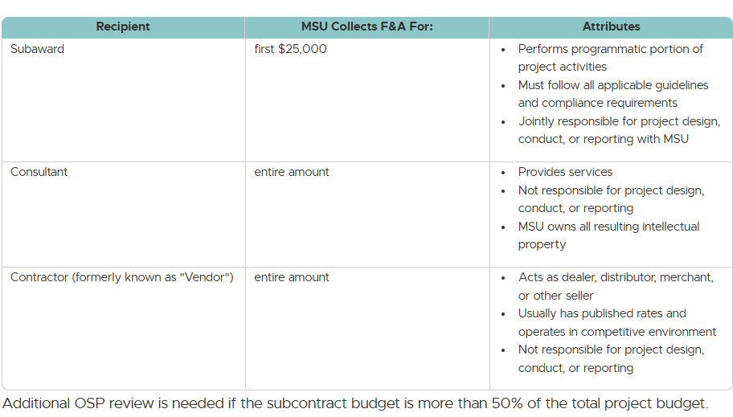

Adding a foreign subaward: <https://grants.nih.gov/grants/policy/nihgps/HTML5/section_8/8.1.2_prior_approval_requirements.htm?Highlight=foreign%20component#Foreign>

Additional information can be found at:

<https://osp.msu.edu/PL/Portal/356/DevelopBudget>

<https://grants.nih.gov/grants/policy/nihgps/HTML5/introduction.htm>