Child Development Laboratories COVID Protocol
(Based on guidance from State Licensing, MDHHS, and CDC)*

For those who are infected/diagnosed with the COVID-19 virus:
- Report to Haslett or East Lansing CDL office if you have tested positive (per our state licensing requirements)
- Stay home until you are fever free (without use of medication) for 24 hours and your symptoms are improving (feeling better). Then return to school
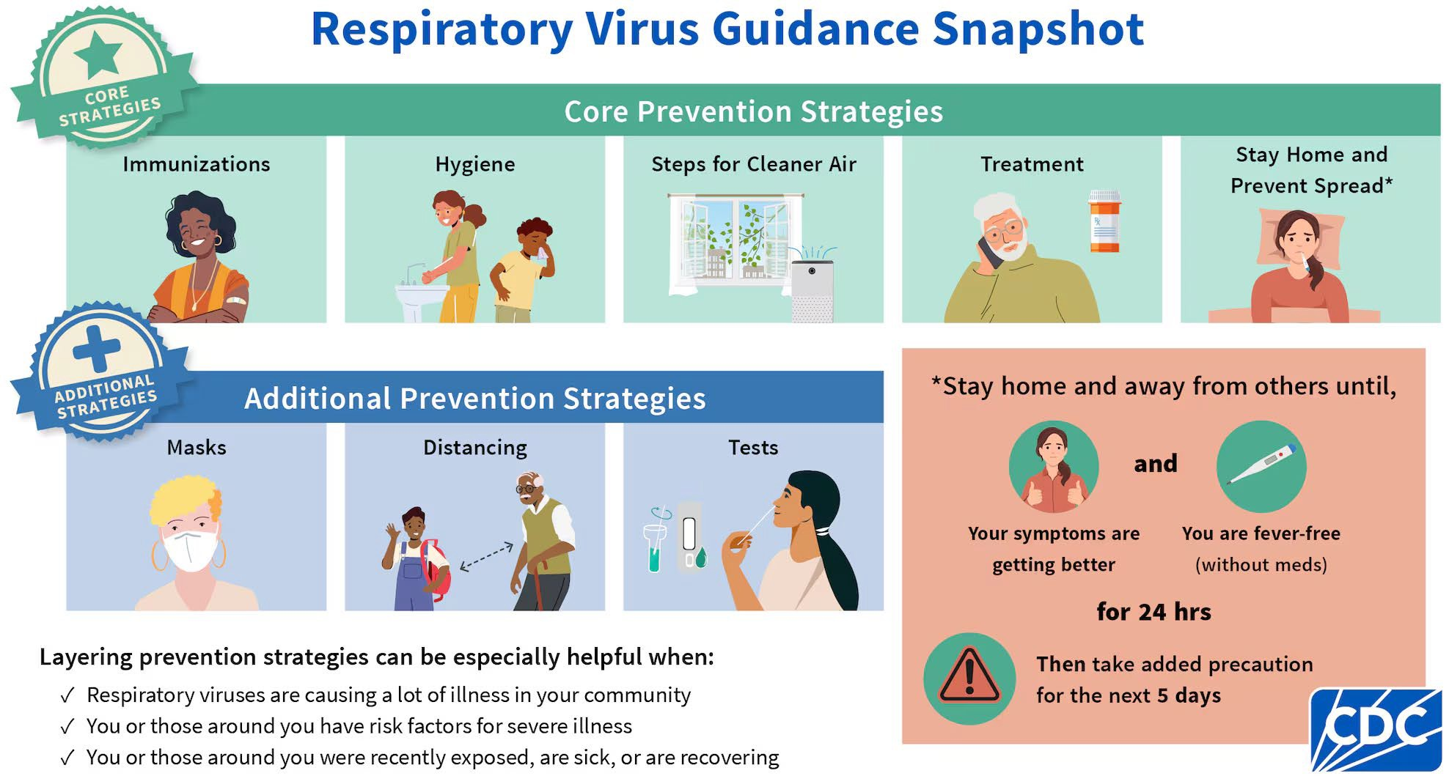
- Take added precautions for the next 5 days after positive test (wear a mask, etc.) while at school
*as of 9/6/2024

