NURSE ANESTHESIOLOGY SUPPLEMENTAL HANDBOOK

Table of Contents

PROGRAM OVERVIEW 3
Purpose of the Nurse Anesthesiology Supplemental Handbook 3
Program Mission, Philosophy, Strategies,and Accreditation 3
Program Description and Trajectory 4
Transfer Credits 4
ACADEMIC STANDARDS 5
Reasonable Time Commitment 5
Faculty Advisors 5
Annual Progress Reports 6
In-Course Communication 6
Grading Scale 6
Progression in the Program 6
Dismissal 7
Reinstatement Process 7
academic grievance policy 7
Leave of Absence 8
Reinstatement After Lapse in Enrollment 8
Program Extension 9
BSN to DNP Program: Concentration Change Policy 9
GRADUATION CRITERIA 10
PROGRAM POLICIES AND PROCEDURES 10
Compliance Requirements 10
Responsibility Conduct of Research, Scholarship, and Creative Activities (RCRSA) 10
Program Attendance 10
Attendance for on-campus classes 11
AANA and MANA Meeting Attendance Policy 11
Time Off for NAP Related Educational Activities Procedure 12
Employment Policy 12
Communications Policy 12
Self-Evaluation Exam 12
Inclement Weather Policy 12
CLINICAL EDUCATION POLICIES AND PROCEDURES 13
Clinical Attendance 13
Rescheduling or Altering Clinical Days 13
Dress Code 14
Clinical Practicum Rotations and Travel Requirements 14
Clinical Supervision 15
Clinical Supervision Ratios 15
On-Call Experiences 15
Affiliate Clinical Site Policies and Procedures 16
Management Plan and Clinical Evaluation Instruments 16
Nurse Anesthesia Student Tracking System™ (NAST) 16
Prior to a Clinical Rotation - Check List 16
Daily Clinical Rotation - Check List 17
End of Rotation - Check List 17
Student Time Logs 17
Malpractice Insurance 17
Out of Pocket Expenses 17
STUDENT AND PROGRAM EVALUATION 17
POST MASTER’S DNP STUDENTS: 18
APPENDIX A 19
APPENDIX B 20
APPENDIX C 24
APPENDIX D 32
APPENDIX E 33
APPENDIX F 35
APPENDIX G 36
APPENDIX H 38
APPENDIX J 40

Program Overview

Purpose of the Nurse Anesthesiology Supplemental Handbook

The DNP Nurse Anesthesiology Supplemental Handbook contains information, policies, and procedures specific to the Michigan State University (MSU) Nurse Anesthesiology Program (NAP). Nurse anesthesia students enrolled in the NAP are also subject to the policies and procedures contained within the College of Nursing Core Handbook and the Michigan State University Spartan Life Handbook. An electronic copy of the Nurse Anesthesiology Supplemental Handbook is located on the College of Nursing (CON) website under “Student Resources”.

The policies and procedures in the NA Supplemental Handbook may be subject to change. If change occurs, students will be notified via MSU e-mail. Please direct questions specific to content within the Nurse Anesthesiology Supplemental Handbook to the NAP Director.

Program Mission, Philosophy, Strategies, and Accreditation
Philosophy
The practice of nurse anesthesiology rests upon a sound foundation of arts and sciences that prepares graduates to excel in a rapidly changing, diverse, and technologically advanced society. Active participation in MSU’s Land Grant Mission provides opportunity for a student’s personal and professional growth. The program’s teaching and learning activities are evidence-based, patient-centered, and driven by projected changes in anesthesia practice. The NAP faculty serve as a students’ guide, mentor, and role model.

Mission
The NAP is committed to providing an innovative, scientifically founded, quality education and preparing nurse anesthesia leaders who deliver and advocate for ethical, safe, competent, cost-effective anesthesia services in an ever-changing, diverse health care environment.
This mission is accomplished through the following strategies as defined by the acronym “SPARTY”:
S tudent-centered education
P ractice/learning opportunities that reflect the ever-changing healthcare landscape needs of our patient populations
A ttitudes that are positive, empathetic, inclusive and foster a culture of belonging
R etention initiatives that support individual academic growth, wellness and well-being
T eaching excellence that is innovative, scientifically founded and forward thinking
Y ear-round faculty and resource accessibility

Accreditation
The MSU College of Nursing’s programs are accredited by the Commission on Collegiate Nursing Education (CCNE). The NAP is accredited by the Council on Accreditation of Nurse Anesthesia Educational Programs (COA), a specialized accrediting body recognized by the Council for Higher Education and the United States Depart of Education. The NAP its 10 year accreditation in 2013 and its next accreditation review is scheduled for April 2024.
Contact information for COA: 10275 W. Higgins Rd., Suite 906
Rosemont, IL 60018-5603
Phone: 224-275-9130

Program Description and Trajectory
The NAP is a rigorous, 36-month, full-time program that exceeds the clinical and didactic requirements set by the COA (see Appendix A for minimum didactic requirements and Appendix B for minimum clinical requirements) and the American Association of Colleges of Nursing’s Essentials of Doctoral Education for Advanced Nursing Practice (2006). The nurse anesthesia curriculum combines didactic and clinical experiences that emphasize critical thinking, scientific inquiry, and effective interpersonal, interprofessional, and psychomotor skills (see Appendix C for curriculum crosswalk). The curriculum is sequenced to build on previously acquired knowledge and skills (see Appendix D for the program trajectory). Content is delivered through face-to-face, online, simulated, and clinical instruction.

Doctoral students enrolled in the NAP are required to complete a scholarly project (DNP project). The DNP project is embedded in the NUR 995, 996 and 997 courses. More information on the DNP project can be found in the DNP Project Handbook available in the project courses.

Transfer Credits
Up to 25% of graduate coursework (excluding DNP project credits) may be transferred into the
DNP program from an accredited program. In accordance with MSU policy, these credits:
- Must have been obtained from an accredited educational institution;
- Have been completed no more than 3 years prior to program matriculation.
The transfer of course credits from other institutions may be completed through the following procedure:
- When possible, obtain written permission from the faculty advisor and program director before enrolling in a course at another university.
  - Send a copy of this written permission to: College of Nursing Student Affairs, located in the Bott Building for Nursing Education and Research:
1355 Bogue Street, Room C120 East Lansing, Michigan 48824-1317

- When the course is completed at another institution, request that official transcript of the grade(s) be sent to the College of Nursing Student Affairs.
- Students must submit the course syllabi and an official transcript for review when requesting credit for transfer courses completed without prior approval.
- Materials should be submitted to the College of Nursing, Office of Student Affairs

Academic Standards

Reasonable Time Commitment
The nurse anesthesia student must be able to devote the time necessary to be successful in the NAP. In accordance with the COA’s definition of “Reasonable Time Commitment” and Clinical Site Standards (criterion F-9), a reasonable number of hours to ensure patient safety and successful student learning should not exceed 64 hours per week (clinical and class time) averaged over 4 weeks. Additional time is required for study, pre/post-operative visits, formulating anesthesia management plans, and completion of the doctoral project.
In programs across the United States (including the MSU NAP) students report an average commitment of 50-60 hours per week.

Faculty Advisors
All students in the NAP will be assigned a NA faculty advisor. The Michigan State University Graduate School defines the duties of CON faculty advisors in the MSN and DNP degree programs. Faculty advisors are expected to:
- Be a mentor for their advisees
- Demonstrate professional role modeling
- Serve as DNP project faculty mentors
- Develop a plan of study in collaboration with the program director
Faculty advising provides an opportunity for mentoring and professional guidance in a collegial and safe environment. Socialization and mentoring are best achieved in a mutually responsive relationship. Students are expected to:
- Make regular contact with their faculty advisor, at least once per semester
- Respond to all faculty advisor communication within a reasonable timeframe
- Communicate any changes in circumstances that may impede ability to complete coursework as required
All university communication between student and faculty advisor must be done through MSU email (@msu.edu). Students may initiate a change of advisor assignment by contacting the Office of Student Affairs and completing the CON Request to Change Faculty Advisor Form

(Appendix I). The CON re-assigns the faculty advisor after consultation with the appropriate parties.

Annual Progress Reports
All students complete an annual progress report in collaboration with their faculty advisor, in fulfillment of MSU’s Graduate School requirements. The annual progress report is a part of the electronic student academic file and needs to be completed and submitted to the Office of Student Affairs by April 1st.

In-Course Communication
When a student has a concern related to a course, it is expected that the student contact and seeks resolution with the course faculty first. Use the faculty’s preferred method of contact as identified in the course syllabus. Respectful and professional communication between peers and course faculty is expected. An email template and communication flow diagram is available to assist students in Appendix E.

Grading Scale
The standard College of Nursing graduate program grading scale will be used for all NUR courses:
% | GRADE
100 - 94 | 4.0
93-87 | 3.5
86 – 80 | 3.0  (Minimum passing grade)
79 – 75 | 2.5
74 – 70 | 2.0
66 – 65 | 1.5
64 – 60 | 1.0
Below 60 | 0.0

Progression in the Program
Progression in the NAP requires:
  - A 3.0 cumulative GPA;
  - A minimum of a 3.0 in each required NUR course
If a grade below a 3.0 is attained, the dismissal process will be initiated. Students may request permission to repeat a course in which a grade of 2.5 was received by following the reinstatement process outline under the Dismissal and Reinstatement Process Heading.
NOTE: NAP Clinical Courses (NUR 975, 976, 077, 978, 979 & 980) cannot be repeated.

Dismissal
Nurse Anesthesiology students may be dismissed from the NAP for deficiencies in didactic course work, clinical performance, falsification of documents, loss of or restriction placed on their Registered Nurse license, behavior inconsistent with the American Nurses Association and American Association of Nurse Anesthesiology Code of Ethics, the University and College’s Code of Conduct and nonadherence with the University, College, Program and affiliate clinical site’s policies and procedures.

Reinstatement Process
Any student seeking reinstatement to the College of Nursing must write a letter to the Associate Dean for Academic Affairs (ADAA) which includes the following:
- Explanation of the student’s withdrawal or dismissal
- Reason for seeking reinstatement to the student’s respective Program Director
- For students who have withdrawn from their program: an explanation of how the circumstances that led to their withdrawal have changed
- For students who have been dismissed from their program: a detailed plan for success in their program moving forward, including recommendations from their academic advisor.
- Which semester the student wishes to return
Upon receipt of request for reinstatement the ADAA or designee will respond to the student through MSU email to inform them that their request has been received and is being processed.

The ADAA or designee will contact the course faculty, program director, and faculty advisor (if applicable) to receive input on the student’s potential for success and recommendation regarding reinstatement. Upon reaching a decision in collaboration with program faculty, the ADAA or designee will inform the student of their reinstatement decision. All final reinstatement decisions are dependent on course space availability.

Academic Grievance Policy
The Michigan State University College of Nursing (CON) is committed to maintaining a fair, respectful, and supportive academic environment. Graduate nursing students have the right to learn, to be heard, and to receive equitable treatment in all academic matters. To support these rights, the College follows the formal procedures outlined in the Graduate Student Rights and Responsibilities (GSRR) and Academic Freedom for Students at MSU (AFR).

Students may pursue a grievance when they believe there has been:
• A dispute with an instructor
• An unfair or improper grade
• A violation of academic rights as defined in University policy

Step 1: Informal Resolution
Before submitting a formal grievance, students must make a good faith effort to resolve the issue informally. This includes:
1. Discussing the concern directly with the instructor, and
2. Consulting with the appropriate program administrator or unit leader.
(Students may refer to the CON reporting algorithm for guidance.)

Step 2: Consultation
Students who are unsure how to proceed or who need confidential support are encouraged to contact the Office of the University Ombudsperson for assistance in understanding the process and their options.

Step 3: Formal Grievance Hearing
If the issue is not resolved informally, the student may file a written request for an academic grievance hearing. Formal hearings are conducted according to the procedures outlined in the Student Disputes and Grievances Policy and the College of Nursing’s grievance guidelines. The hearing process ensures:

• Due process
• Impartial review
• Decisions based on evidence and policy
• Protections consistent with student rights

Additional Information
The College of Nursing upholds clear expectations, transparent procedures, and proportional responses to disputes in order to maintain an academic environment that supports teaching, learning, research, and service.

For full policy details and the CON reporting algorithm, please visit:
Student Disputes & Grievances (CON)

Leave of Absence
Students who have completed courses in the program may submit a request for a leave of absence for no more than one year (three academic semesters). A new plan of study should be developed in collaboration with the faculty advisor and program director. The decision to approve/disapprove leave requests is at the discretion of the ADAA.
Students who stop academic progress for more than three semesters without an approved and current plan of study are subject to dismissal from the program. Reinstatement in the program is based on compliance with the plan of study and availability of space and resources in the required courses.

Reinstatement After Lapse in Enrollment
Graduate students who have stepped away for three academic semesters or
more must request readmission in a letter to the ADAA by February 1 for Fall semester, August 1 for Spring semester, or December 1 for Summer semester addressing the following:
- Reason for seeking readmission
- Reason for withdrawal/dismissal
- How his/her situation has changed in the interim
- Response to any recommendations that may have been made at the time of

withdrawal/dismissal
- Which semester the student wishes to return
Requests for reinstatement should be sent to the Office of Student Affairs and ADAA. The final decision for readmission will be determined by the dean and ADAA who will notify the student in writing of the final decision.
Students who have failed to enroll for more than one academic year must also
- Complete and submit a University Application for Readmission (available online
at www.reg.msu.edu, click on Readmissions) at least two months prior to the first day of registration.
- Complete and submit necessary compliance documentation including completion of a new background check and drug screen.

Program Extension
Students enrolled in the NAP are expected to complete all graduation requirements in 36 months. At the discretion of the NAP Director and ADAA, a student’s course of study may be extended beyond the 36 months if a student, who is in good academic standing, does not complete the graduation criteria, academic coursework, or COA required minimal case requirements as recorded in the Typhon Nurse Anesthesia Student Tracking SystemTM.

BSN to DNP Program: Concentration Change Policy
This policy applies to students currently enrolled in the Clinical Nurse Specialist, Nurse Practioner or Nurse Anesthesiology programs who wish to change to another advanced practice concentration:
- Students wishing to change to the Nurse Anesthesiology concentration need to follow the complete admissions process outlined on the MSU College of Nursing website.
- Students considering a concentration change must be in good standing in their current program, maintaining a 3.0 GPA or higher in every course.
- The following process will be followed:
- The student will arrange a meeting with their faculty advisor and current program director to discuss their interest in changing their current program concentration.
- The student will compose an essay documenting their rationale for why they would like to make a program change.
- The student will submit their essay to the program director of the desired concentration and the graduate advisor in the Office of Student Affairs
- The student will complete an interview with the program director of the desired concentration.
- The request to change concentrations will be submitted by the program director of the desired concentration for review by the Advanced Practice Program Committee (APPC) for final approval. All decisions made by the APPC are final.

Graduation Criteria
A student will be eligible to take the Nation Certification Examination (NCE) administered by the National Board of Certification and Recertification for Nurse Anesthetists (NBCRNA) only after they have met the NAP End of Program Outcomes (Appendix F), the COA Doctoral Graduate Standards (Appendix G), and minimum case requirements (Appendix B). The NAP Director initiates the National Certification Exam process at the completion of the 36-month program.
Students will not be released to take the NCE prior to MSU’s graduate commencement.

Program Policies and Procedures

Compliance Requirements
In addition to the compliance requirements listed in the CON Core Handbook, nurse anesthesia students must complete an annual drug screen and possess a current American Heart Association Advanced Cardiac Life Support (ACLS) and Pediatric Advanced Life Support (PALS) certification. Any student who is out of compliance with the CON and NAP compliance policies will be disenrolled from classes and removed from clinical.

Responsibility Conduct of Research, Scholarship, and Creative Activities (RCRSA): Michigan State University requires that all graduate students be trained in the RCRSA basic educational requirements. The CON’s plan to meet the RCRSA requirements can be found in Appendix H. This plan includes completion of the Collaborative Institutional Training Initiative (CITI) training modules and a minimum of six hours of discussion-based training. In accordance with the MSU policy, all RCRSA education requirements are to be completed by the end of the spring semester of year two. More information can be found
at: https://grad.msu.edu/researchintegrity
- CITI Training Modules available at: https://ora.msu.edu/train/
- Human Research Protection and IRB Certification available at: https://hrpp.msu.edu/training/index.html

Program Attendance
Students begin the program on the opening day of summer semester according to the MSU academic calendar and are enrolled for nine semesters (36 months) on a full-time basis. During the first three semesters of the program (summer, fall, spring), time off occurs in accordance with the MSU academic calendar.
Except for MSU designated holidays (see MSU academic calendar) second and third-year students will be continuously enrolled (no breaks between semesters) in clinical courses for the last 6 semesters. Second and third-year students are given 10 (8 hour) days per year (20 days total) for personal or sick time.
- These days cannot be rolled from one year to another (banked)

- These days cannot be used the last 4 weeks of the program
- No more than two days of personal or sick time can be taken per clinical rotation without approval by the Program Director or Assistant Program Director
- Students enrolled in NUR 976 (Clinical Practicum II) can only take 1 personal day per month
- Sick or personal days that extend beyond the 10 allotted days will be made up at the end of the program.
Process for using sick or personal time:
- When possible, collaborate with the clinical course faculty to schedule personal days prior to release of the clinical schedule
- To use personal or sick days on an assigned clinical day:
  - Follow the clinical site’s call-in procedure
  - Notify the Assistant Program Director through the MSU E-mail system.
- Failure to follow the call-in procedure is considered a serious offense as students assigned to surgical cases are considered an integral part of the surgical team. Unexcused absences impact patient care and anesthetic workflow.

Attendance for on-campus classes
Attendance for on-campus courses is mandatory. A student who is unable to attend an on-campus class will:
- Notify the course faculty before the start of the class (see course syllabus for the faculty’s preferred method of contact)
- In the event of an emergency in transit to class, notify the course faculty or a cohort member by any means possible (text, call) if feasible.
- Be solely responsible for acquisition of missed course content

Observed Holiday Policy
MSU permits students to observe holidays set aside for their chosen religious faith. More information can be found at https://inclusion.msu.edu/hiring/religious-observance-holidays.html. Students are asked to communicate with their faculty to facility compliance with the policy.

AANA and MANA Meeting Attendance Policy
Students are required to attend two Michigan Association of Nurse Anesthetist state meetings and at least one American Association of Nurse Anesthesiologists-sponsored meeting (Mid-Year Assembly, Annual Congress, Assembly of Didactic and Clinical Educators) while in the program.

Students are also expected to attend Michigan Association of Nurse Anesthetist Student meetings. Participation in additional educational, community, program, or political opportunities is part of professional development and is expected.

Time Off for NAP Related Educational Activities Procedure
To request time off for educational offers that impact clinical or didactic schedules, the student will:
- Seek approval from the Program Director or Assistant Program Director
- Request time off via MSU e-mail at least 45 days prior to the scheduled event Approved educational time does not require time withdrawal from a student’s personal or sick-time bank.

Employment Policy
NA students who engage in outside employment while in the program are encouraged to keep NAP time commitment factors in mind when scheduling work shifts. Nurse anesthesia students are required to have at least eight (10) hours off between work and class or a nurse anesthesia program clinical shift.

Under no circumstances may a NA student seek employment as a Nurse Anesthetist by title or function before successful completion of the program. This practice is prohibited not only by program policy but by law.

Communications Policy
All NA students are required to check Desire2learn (D2L), MSU’s official course management system, and MSU e-mail daily (except during authorized time off) and follow directives in the message. Correspondence sent through personal e-mail outside of the MSU e-mail system will not be answered and is considered “no communication”.

Self-Evaluation Exam
NA Students will purchase and complete the NBCRNA Self Evaluation Exam (SEE) twice during the program.
  - The first exam will be taken in May-June of year two. Students are required to score a 400 or better in the following categories: Basic Sciences, Equipment, Instrumentation, Technology & Basic Principles of Anesthesia.
  - The second exam will be taken in January of year three. Students are required to score a 430 or better in all exam categories.
  - Students who do not meet these benchmarks will participate in a remediation process that includes the development of clearly defined review plan, internal exams, scheduled study time and a third SEE.

Inclement Weather Policy
The Inclement Weather Policy is located in the Core CON Handbook. The following NAP guidelines will aid in the student and program’s administrative decision-making process:
- In the event the university closes prior to the start of the class or clinical, students should remain home. Students will not be required to make up clinical shift.

- In the event the university closes during a didactic class, students will be sent home. If the University closes during a clinical shift, students will consult with the course faculty and clinical site coordinator to determine if it is safe for the student to remain at the clinical site and finish the case or shift. Students will not be required to make up the shift.
- In the event the university is open, but a clinical facility is closed due to weather or other conditions, the student is not required to report to the facility nor any other open clinical facility. The student is required to notify the clinical course faculty who, in collaboration with the clinical site coordinator, will reschedule the missed clinical shift.
- In the event the university is open and a clinical facility is open but not operating an elective surgical schedule, the student should contact the clinical site coordinator to determine if he or she should report to the clinical site. The student is required to notify the clinical course faculty if they have been advised to stay home or leave the clinical site early. If the student is dismissed from the clinical site, the clinical day will not be rescheduled. If the student remains home, the course faculty, in collaboration with the clinical site coordinator, will reschedule the clinical shift.
- In the event the university and the clinical facility are open during inclement weather, students should use their best judgment to ensure personal safety. Notify the clinical course faculty if a personal decision is made to not attend clinical. Follow the clinical site’s call-in procedure. Students may choose to use a personal day or these days will be rescheduled by the course faculty in collaboration with the clinical site coordinator

Clinical Education Policies and Procedures

Clinical Attendance
Clinical attendance is mandatory. See the Program Attendance Policy for more information on how to use personal / sick time and the procedure (page 10).
At no time may students arrange for clinical experiences in non-affiliate clinical sites, outside of their designated rotation schedule or during designated time off.

Rescheduling or Altering Clinical Days
Clinical site coordinators may not reschedule clinical make-up days. Instead, the clinical course faculty and the affiliate clinical site’s coordinator will collectively determine when the student will make up the missed clinical day(s).

Under no circumstances may a student alter the distributed clinical schedule or schedule clinical make-up time without the Assistant Director’s approval. Requests for changes in the clinical schedule must be generated through MSU e-mail and approved by the clinical course

faculty. Altering the clinical schedule without approval is impacts the program’s affiliation relationship and is considered a serious offense.
If a student wishes to extend their clinical shift more than 3 hours beyond the assigned time, the student should notify the course faculty. This can be done via e-mail, phone call, or text.

Dress Code
NA students are expected to dress consistent with the professional image of a registered nurse in an advanced practice graduate program while at the university. In the clinical setting:
- Students are responsible for following the clinical site’s dress policies and procedures
- Proper surgical attire must be worn in any situation that involves perioperative patient contact
- Students shall follow the clinical site’s policy on wearing jewelry, artificial fingernails, facial hair, body art, and personal scrub attire
- MSU or facility-issued identification badges must be worn while in the hospital/clinic setting.
- Students must use personal protective equipment in accordance with hospital or clinic policies and procedures.

Clinical Practicum Rotations and Travel Requirements
To optimize the time spent during the clinical practicum, the NA student must actively seek learning experiences and function in a self-directed manner to acquire the knowledge, skills, and abilities necessary to practice as a graduate CRNA. The program will consider geographical proximity to the student’s home residence when developing the clinical schedule. However, students will be required to travel to clinical sites to obtain required clinical experiences.
Students are responsible for the expenses incurred for clinical travel and lodging.
The following list indicates current clinical affiliate sites:
- Ascension St John Hospital, (Moross) Detroit Michigan
- McLaren Greater Lansing, Lansing, Michigan
- St. John Macomb-Oakland Hospital, Macomb Center, Warren, Michigan
- Ascension Providence Hospital, Southfield, Michigan
- Ascension Providence Hospital – Novi Campus, Novi, Michigan
- Henry Ford Allegiance Health, Jackson, Michigan
- Henry Ford West Bloomfield, West Bloomfield, Michigan
- Henry Ford Health System, Detroit, Michigan
- Sparrow Medical Center, Lansing, Michigan
- Mercy Health St Mary’s Campus, Grand Rapids, Michigan
- Trinity Health Muskegon Hospital, Muskegon, Michigan
- Corewell – Trenton, Trenton, Michigan
- Gerber Memorial Hospital, Fremont, Michigan
- Bronson Hospital, Kalamazoo, Michigan
- Oaklawn Hospital, Marshall, Michigan

- Hillsdale Community Hospital, Hillsdale, Michigan
- Owasso Memorial Hospital, Owasso, Michigan
- Hurley Medical Center, Flint, Michigan
- Henry Ford Macomb, Macomb, Michigan
Other clinical sites may be added to meet the needs of the program.

Clinical Supervision
Supervision at clinical sites is limited to CRNAs and anesthesiologists who are institutionally credentialed to practice and immediately available for consultation. Clinical supervision in non-anesthetizing areas is restricted to experts who are credentialed and authorized to assume responsibility for the student.

Clinical Supervision Ratios
During the student’s junior year, the student to clinical instructor ratio is 1:1. At the discretion of the clinical instructor and in accordance with the clinical site’s policies, students in their second semester of clinical practicum may be left alone however, theclinical instructor must always be readily available to the student.

During the student’s senior year, the student to clinical instructor ratio may increase to 2:1 if the students has demonstrated competency in safely managing an anesthetic, the complexity of the anesthetic and surgical procedure is appropriate for the student’s skill level, and the supervising CRNA or anesthesiologist is immediately available. At no time may the number of students directly supervised by an individual clinical instructor exceed 2:1. At no time may the student be used to augment anesthesia staffing due to an anesthesia provider shortage.

On-Call Experiences
On-call is defined as a planned clinical experience outside the normal operating hours of the clinical facility. Call experiences in the NAP include:
- Hours that fall between 5pm – 7am
- Weekend shifts

Students may be assigned to a 24-hour call experience. At no time may a student provide direct patient care for a period longer than 16 continuous hours. Students must have a 10-hour rest period between scheduled clinical duty periods.
- When there is potential conflict between the call experience and the next morning’s scheduled surgery, the supervising anesthesia provider will determine which experience is more beneficial to the student and provide time off as described above.
- Students may contact the Program Director or Assistant Program Director for direction if conflict between on-call and scheduled shifts occur.

When a student is “called in” during an on-call shift, there must be a qualified nurse anesthetist or anesthesiologist present on site and immediately available to the student. At no time may a student initiate anesthetic care without supervision.

Affiliate Clinical Site Policies and Procedures
Students rotating through an affiliate clinical site must complete the facility’s on-boarding processes and follow the policies and procedures of the institution and department. Failure to follow the clinical site’s policies and procedures may result in dismissal.

Management Plan and Clinical Evaluation Instruments
The Anesthesia Management Plan will be used as a guide to formulate an anesthesia plan of care for patients to whom students are assigned. The Anesthesia Management Plan will be discussed with the clinical preceptor prior to the beginning of each case. Students are expected to come to clinical prepared to discuss their proposed plans of care for each assigned patient.
The daily Clinical Evaluation Form will be used to assess the progression of each student during the practicum experiences. Students are responsible for assuring completion of the Clinical Evaluation.

Nurse Anesthesia Student Tracking System™ (NAST)
The NA Program uses a web-based clinical student tracking system developed and maintained by the Typhon Group. The NAST serves two purposes. First, it documents student progress toward completing the required clinical experiences, end of program outcomes, and COA graduate standards. Second, it assists the faculty and student in selecting the most appropriate clinical experiences.
- Students will be provided an orientation to the NAST and Guidelines for Counting Clinical Experiences located on the Council on Accreditation Webpage prior to clinical emersion.
- Clinical experiences must be entered and recorded in the NAST within 72 hours.
- Questions regarding on clinical data entry should be directed to the Program Director or Assistant Program Director
- Students should check the accuracy of the personal information and clinical experiences monthly
- Falsification of clinical documentation is a serious offense and grounds for immediate dismissal.

Prior to a Clinical Rotation - Check List
- Complete clinical site on-boarding documents
- Review the clinical site’s policies, procedures, parking, and dress code information
- Initiate contact with the clinical coordinator at least 7 days before the rotation begins (some sites require contact before 7 days – see onboarding documents for each site)

- If there is no response from the clinical coordinator within 48 hours of an attempt to contact, notify the course faculty
- Obtain clinical badge, parking, department access codes, and medication codes (if required)

Daily Clinical Rotation - Check List
- At beginning of the day, provide the clinical instructor with Anesthesia Management Plan and Clinical Evaluation Instrument
- Pre-brief each case
- De-brief each case
- Complete the student self-evaluation and goals section of the Clinical Evaluation Instrument (required)
- Enter clinical experiences into NAST
- Return completed evaluations to the assistant program director

End of Rotation - Check List
- Thank clinical coordinator and instructors
- Return hospital property (identification badges, parking)

Complete an End-of-Rotation site evaluation located in NAST

Student Time Logs
Intermittently during the program, students may be required to complete time logs documenting the number of hours they spend in didactic and clinical activities. This information will be used to monitor program demands on student time.

Malpractice Insurance
Michigan State University provides malpractice insurance for students enrolled in the Nurse Anesthesia Program.

Out of Pocket Expenses
In addition to block tuition, students may encounter out-of-pocket expenses associated with living costs, travel, clinical site rotations and professional conference travel. The program is committed to limiting these out-of-pocket costs when possible. An estimate of out-of-pocket expenses can be found in Appendix J.

Student and Program Evaluation
Both formal (summative) and informal (formative) feedback is an important component of student and program performance improvement.

Students will receive feedback from the faculty and program administration in the following ways:

- Semester progress report if demonstrating deficiencies (summative)
- Daily clinical evaluations (summative)
- Simulation performance feedback (formative and summative)
- Self-Evaluation Exam (SEE)
- Summative Semester Evaluation
- Annual Progress Report (summative)
Students will self-evaluate in the following ways:
- Semester Progress report if demonstrating deficiencies
- Self-evaluation on the Clinical Evaluation Form
- Review of in-course assignment work test scores and faculty feedback
- Self-evaluation on the Semester Summative Evaluation
- Self-evaluation on the Annual Progress Report
- Self-evaluation of performance on the SEE

Program effectiveness and quality is measured by the students in the following ways:
- Mid-semester surveys (formative)
- End-of-semester Student Perceptions of Learning Survey [summative]
- End of Clinical Rotation Evaluation (summative)
- End of Program Evaluation (summative)
- Six-month Alumni Survey (summative)
- Employer Survey (summative)
- SEE and NCE test scores

Post Master’s DNP Students:
All students completing the post-masters DNP program must have a minimum of 1000 faculty supervised clinical hours by the end of the program. Graduates from COA accredited NA programs will verify their acquired clinical hours during their master’s anesthesia program. As the required clinical hours for the masters anesthesia programs exceeded the 1000 supervised clinical hour requirement, CRNAs will not be required to obtain additional supervised clinical hours.

The DNP project hours will be tracked by the student on an Excel sheet with a brief description of the project activity. These hours will be reviewed by the faculty advisor. Project hours may include the following activities:
- Observational and/or meeting time with project team
- Organizational planning (meetings, development of meeting materials)
- Attending seminars, meetings with consultants related to project
- Leadership development activities
- Evaluating evidence that supports the project
- Producing educational materials related to the project

- Developing assessment and evaluation tools for the project
- Developing presentations
- Engaging in policy development
- Presentation of findings
Additional activities may qualify as DNP project hours. Students may consult with their faculty project advisor for questions and clarification.

Appendix A
Council on Accreditation Minimal Academic Curriculum
The COA has a minimal academic curriculum for nurse anesthesia programs that includes:
- A minimum of 120 contact hours in Advanced Physiology and Pathophysiology
- A minimum of 90 contact hours in Advanced Pharmacology
- A minimum of 120 contact hours in Basic and Advance Principles of Anesthesia
- A minimum of 45 contact hours in Research / Scholarship
- A minimum of 45 hours in Advanced Health Assessment
- And content that includes:
- Human Anatomy
- Chemistry, Biochemistry
- Physics
- Genetics
- Acute and Chronic Pain Management
- Radiology, Ultrasound, Anesthesia Equipment
- Professional Role Development
- Substance Use Disorders and Wellness
- Informatics, Health Policy, Leadership
- Business Models, Practice Management, Healthcare finance
- Clinical Correlation and Integration

Appendix B
Council on Accreditation Minimal Clinical Experiences
The minimum number of clinical hours is 2,000. Clinical hours include time spent in the actual administration of anesthesia and other time spent in the clinical area. This includes:
- Time spent administering an anesthetic
- In-house call
- Pre- and post-anesthetic assessment
- Patient preparation
- Operating room or procedure room preparation
- Clinical rounds
As a program, we strive to meet or exceed the preferred number of clinical case experiences. The minimum required cases for graduation from any accredited program include:

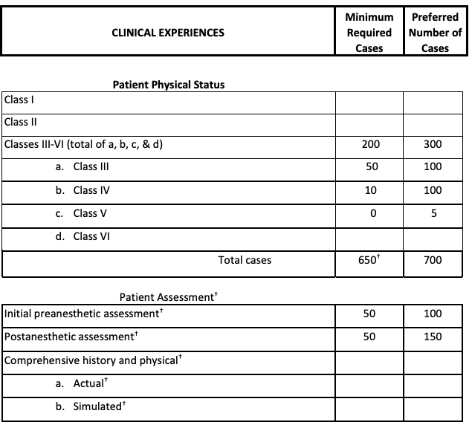
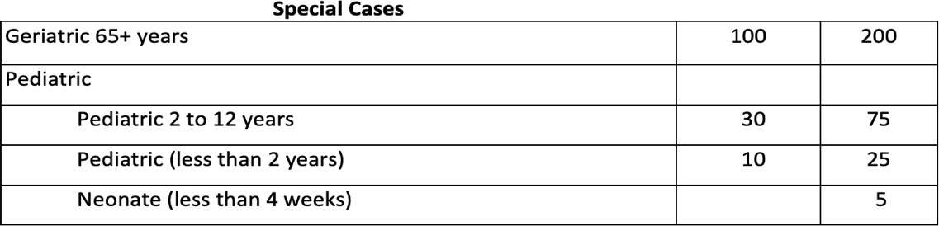

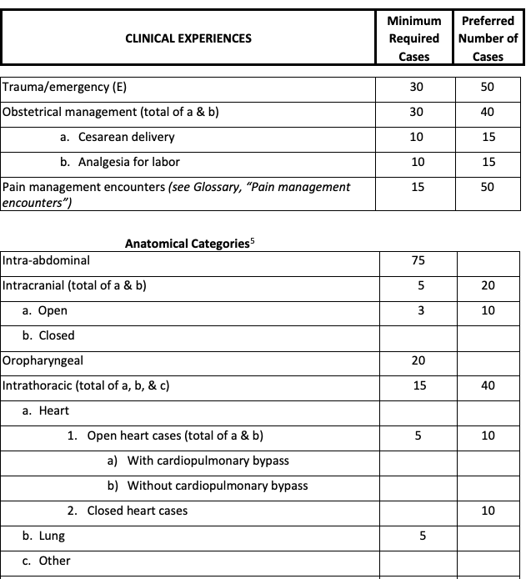
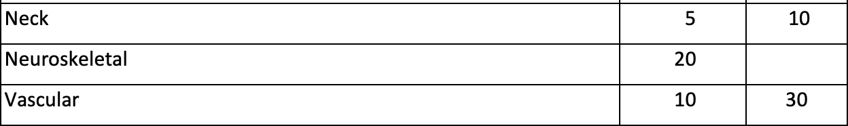

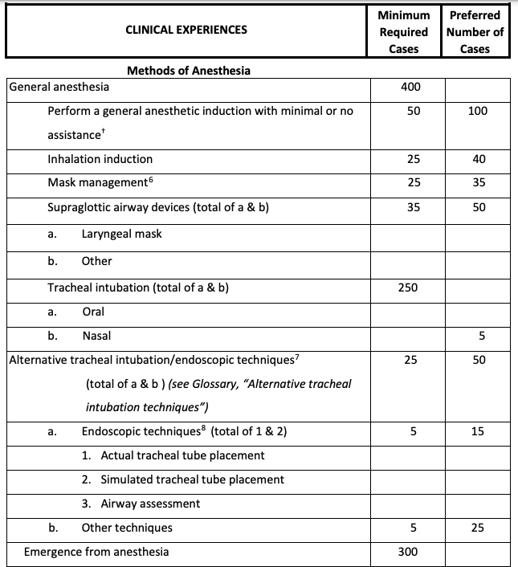

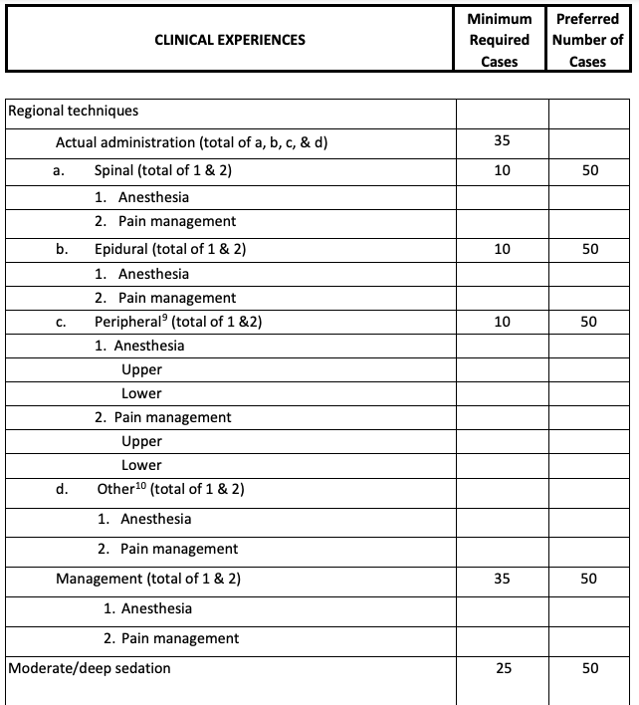

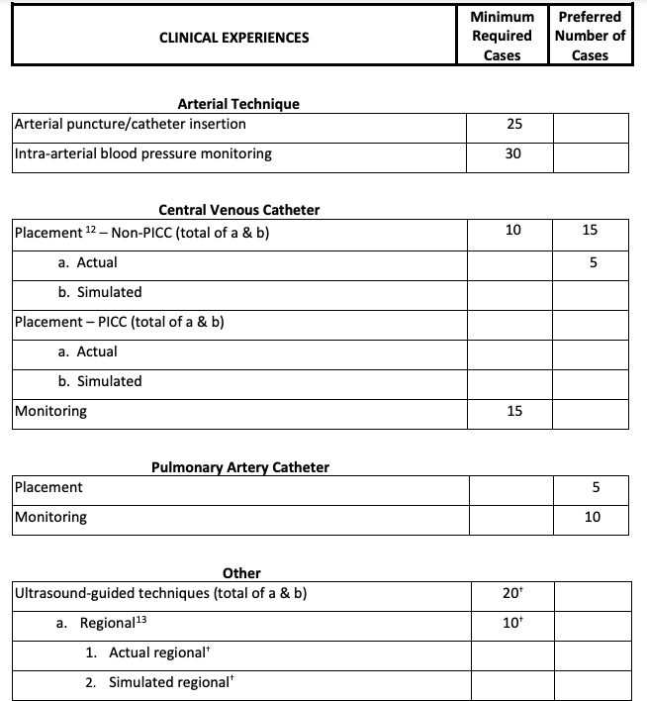
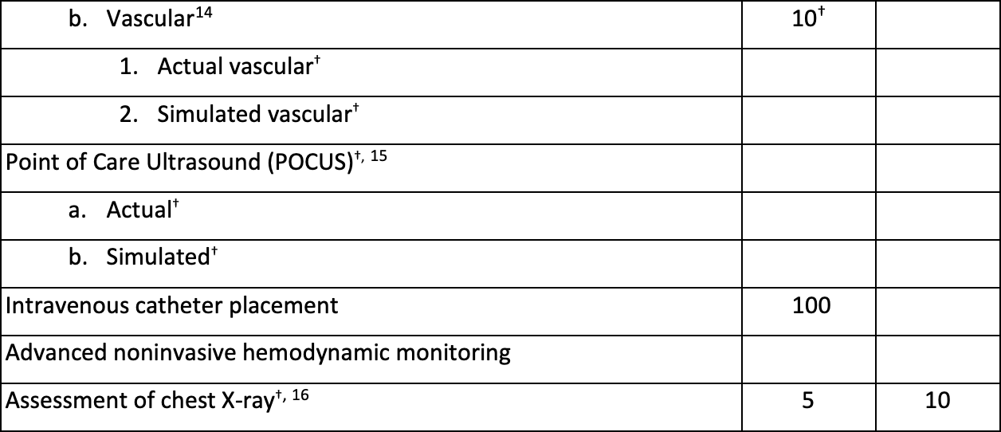

Appendix C
Nurse Anesthesia Program Curriculum Crosswalk
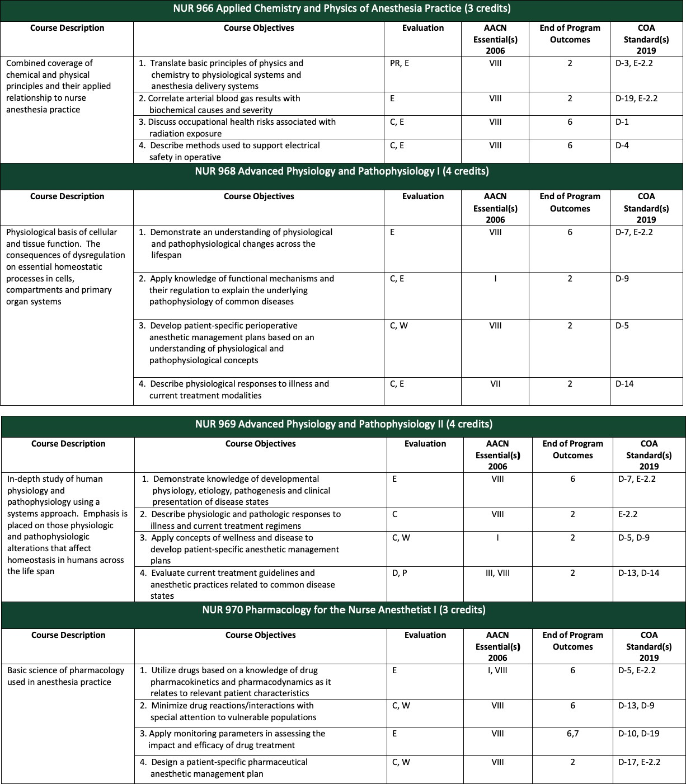

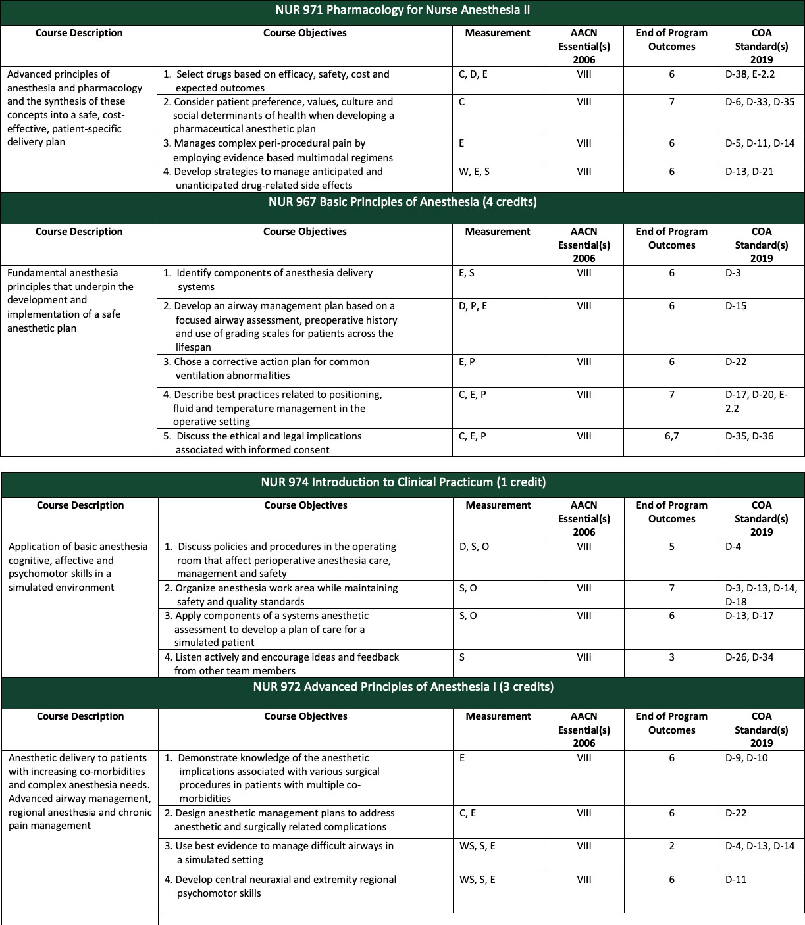

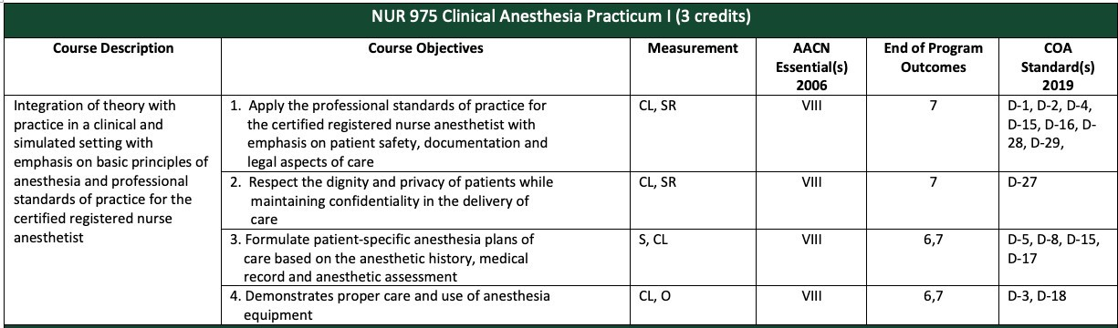
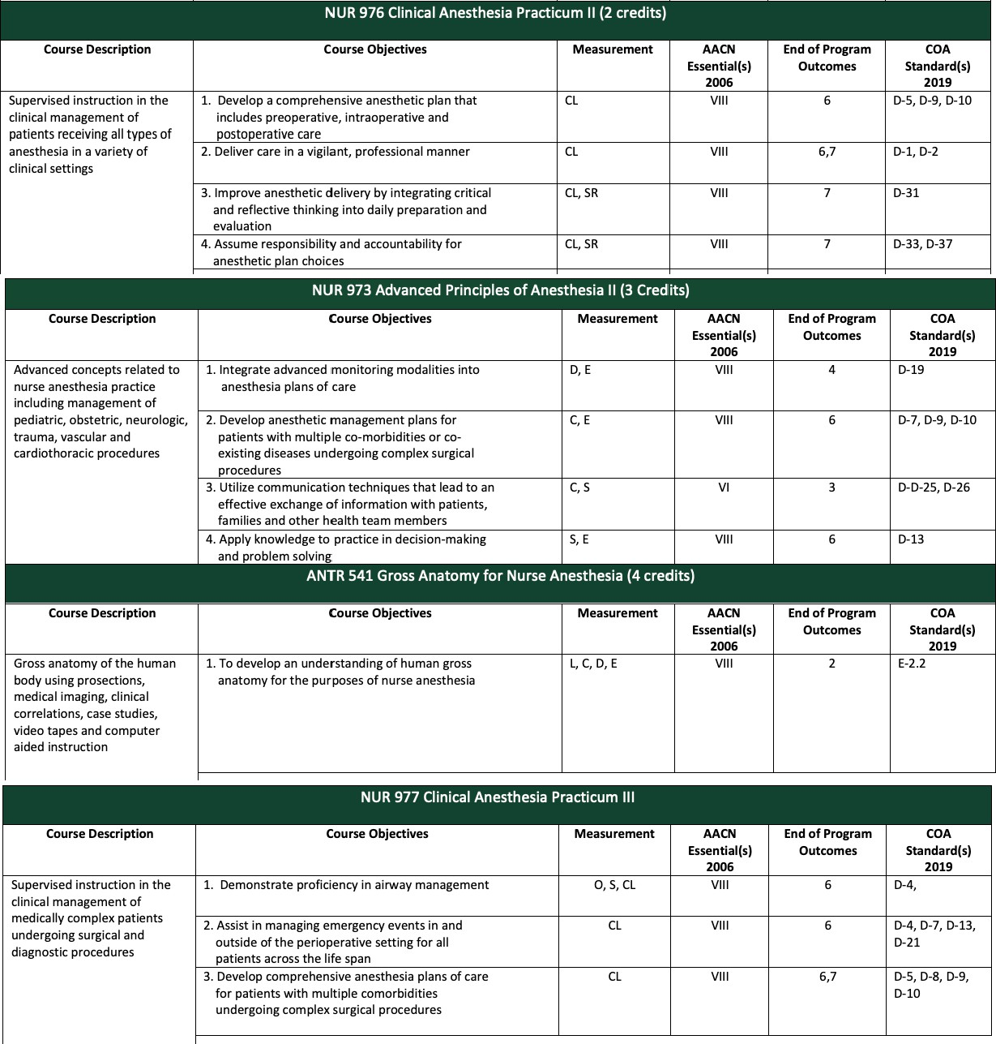

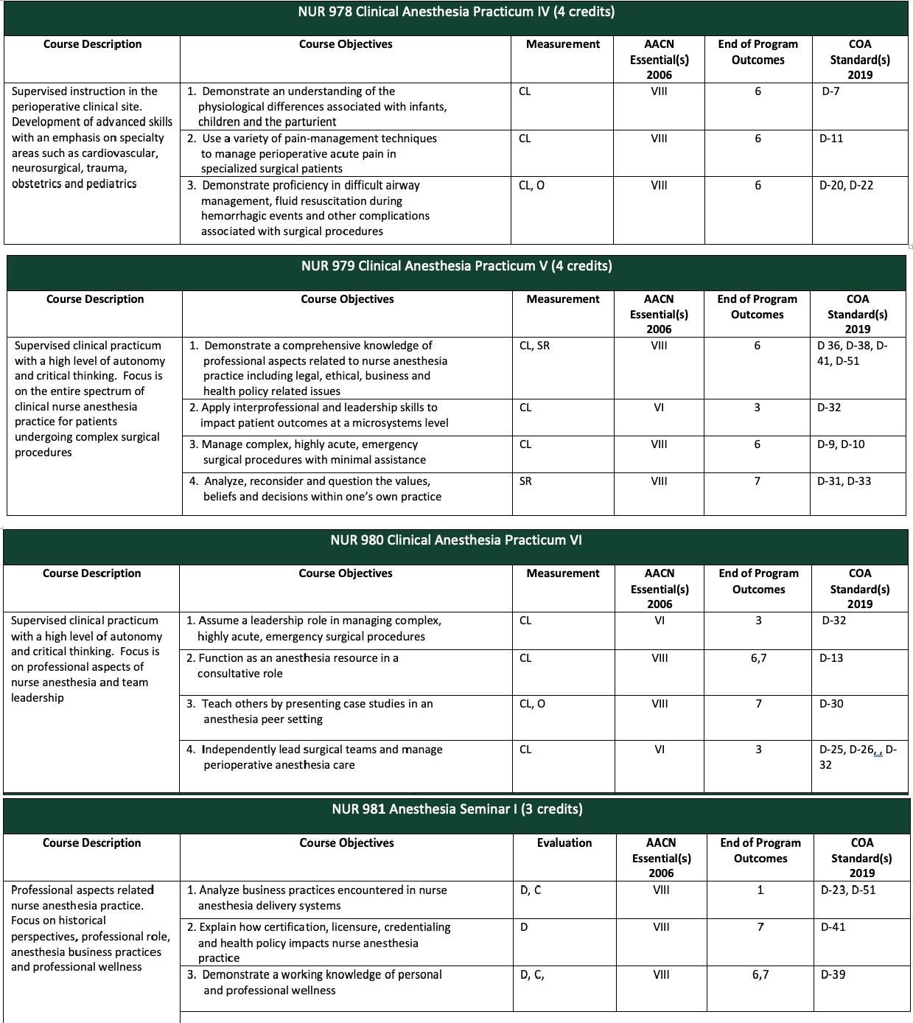

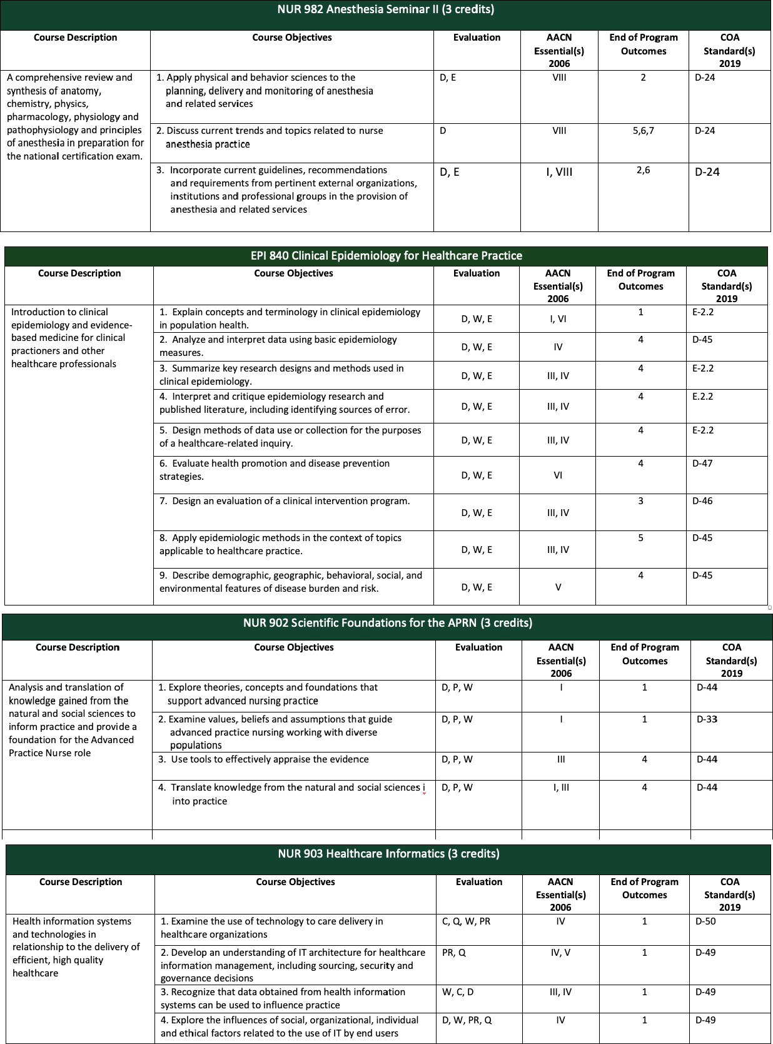

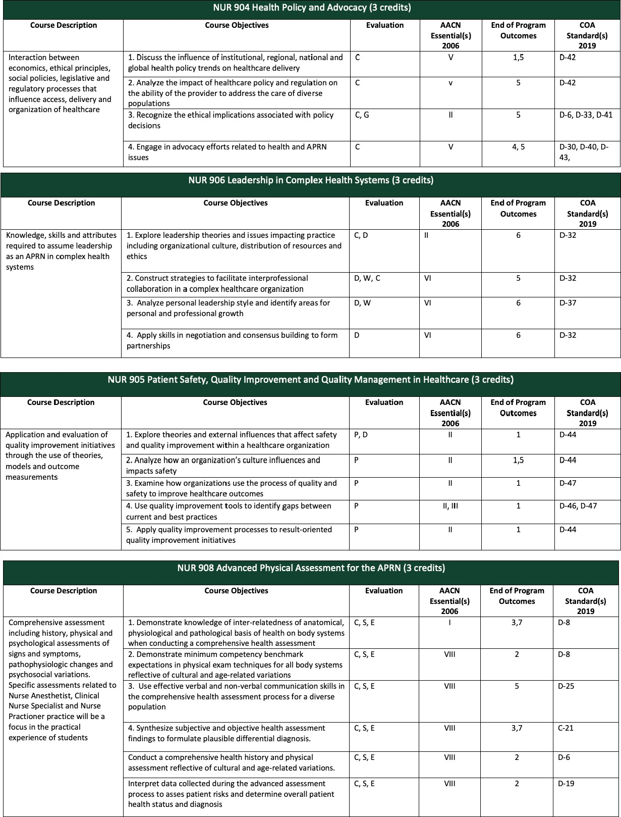

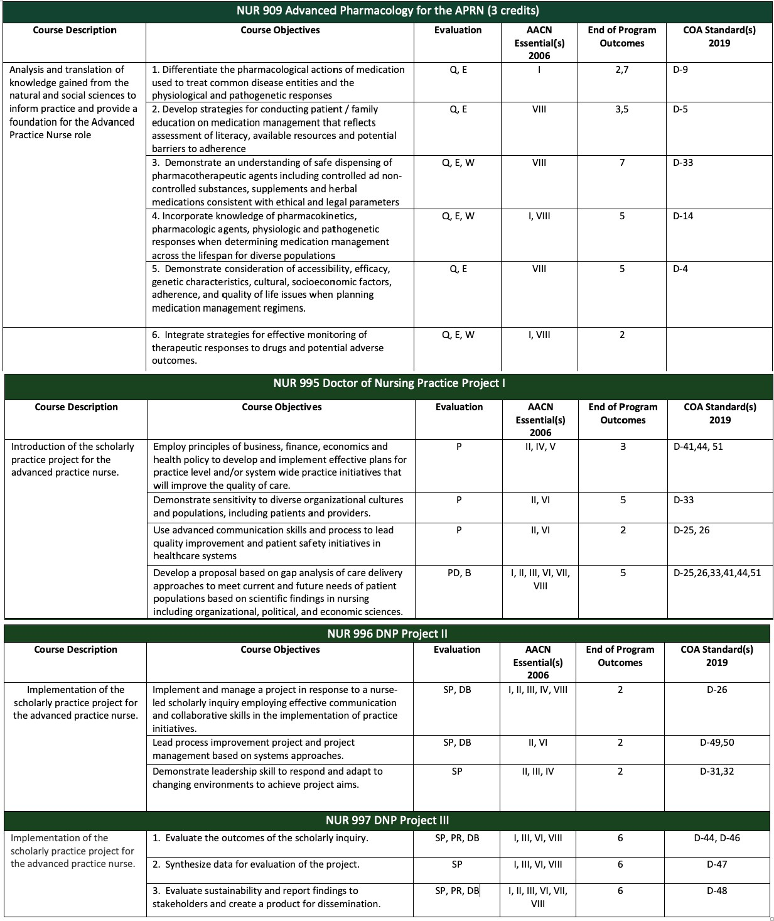

Appendix D
Nurse Anesthesia Program Trajectory
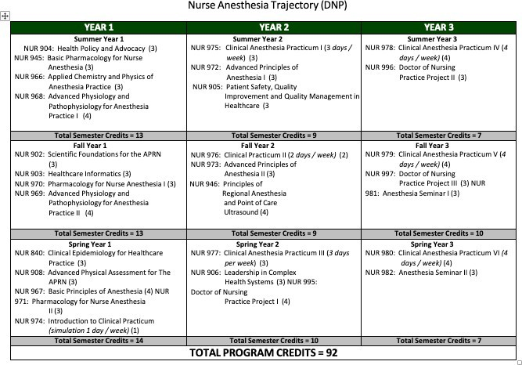

Appendix E
Communication Algorithm and Template

Note: Please allow 48-hours during regular weekdays for a response.
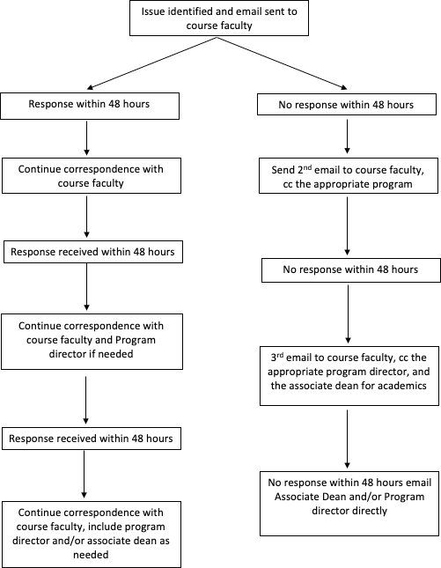
assigned advisor

It is expected that students communicate professionally with peers, faculty and program administrators. Below is a template that may be used or modified to guide your correspondence:

Dr.

My name is and I am a student in NUR .

I am having difficulty with and am (asking or guidance, seeking clarification, requesting feedback) on . I have (specify what you have done to resolve the challenge, concern, question).
I would greatly appreciate (any feedback, guidance, setting up a time to meet). Sincerely, Respectfully
Your name
Note: Faculty often oversee many students and have academic obligations in addition to teaching. Arranged times to meet should be at the convenience of the faculty when possible.
Note: If faculty have provided you with a personal phone number, please text or call within business hours unless the communicated concern is an emergency. It is good practice to follow up a conversation with an e-mail.

Appendix F
NAP End of Program Outcomes
At the end of the program, graduates will be able to:
- Evaluate phenomenon related to the practice of anesthesia by to facilitate strategies that impact and advance anesthesia-related health outcomes.
- Demonstrate leadership and care competencies that combine cognitive, affective, and psychomotor skills to facilitate anesthesia practic.
- Apply the major critical thinking and analytic skills to effectively practice nurse anesthesia in a cost-effective and accountable manner.
- Evaluate and utilize anesthesia-related research that enhance and advance the specialty and disseminate outcomes to improve patient care.
- Integrate interdisciplinary, evidence-based problem-solving and education strategies in the delivery of care to diverse populations with a variety of health conditions.
- Analyze leadership skills utilized in the evaluation of the quality of anesthesia care
- Integrate practice and education to expand the profession and practice of nurse anesthesia.

Appendix G
Council on Accreditation of Nurse Anesthesia Programs Doctoral Graduate Standards

Council on Accreditation of Nurse Anesthesia Programs Graduate Standards: Patient safety is demonstrated by the ability of the graduate to:
  - Be vigilant in the delivery of patient care
  - Refrain from engaging in extraneous activities that abandon or minimize vigilance while providing direct patient care
  - Conduct a comprehensive and appropriate equipment check
  - Protect patients from iatrogenic complications

Perianesthetic management is demonstrated by the ability of the graduate to:
  - Provide individualize care throughout the perianesthetic continuum
  - Deliver culturally competent perianesthesia care
  - Provide anesthesia services to all patients across the lifespan
  - Perform a comprehensive history and physical assessment
  - Administer general anesthesia to patients with a variety of physical conditions
  - Administer general anesthesia for a variety of surgical and medically related procedures
  - Administer and manage a variety of regional anesthetics
  - Maintain current certification in ACLS and PALS

Critical thinking is demonstrated by the graduate’s ability to:
  - Apply knowledge to practice in decision-making and problem solving
  - Provide nurse anesthesia care based on evidence-based principles
  - Perform a preanesthetic assessment before providing anesthesia services
  - Assume responsibility and accountability for diagnosis
  - Formulate an anesthesia plan of care before providing anesthesia services
  - Identify and take appropriate action when confronted with anesthetic equipment-related malfunctions
  - Interpret and utilize data obtained from noninvasive and invasive monitoring modalities
  - Calculate, initiate, and manage fluid and blood component therapy
  - Recognize, evaluate, and manage the physiological responses coincident to the provision of anesthesia services
  - Recognize and appropriately manage complications that occur during the provision of anesthesia services
  - Use science-based theories and concepts to analyze new practice approaches
  - Pass the Council on Certification of Nurse Anesthetists’ (NCE) certification examination

Communication skills are demonstrated by the graduate’s ability to:
  - Utilize interpersonal and communication skills that result in the effective exchange of information and collaboration with patients and their families
  - Utilize interpersonal and communication skills that result in the effective

interprofessional exchange of information and collaboration with other healthcare professionals.
  - Respect the dignity and privacy of patients while maintaining confidentiality in the delivery of interprofessional care.
  - Maintain comprehensive, timely, accurate, and legible healthcare records.
  - Transfer the responsibility for care of the patient to other qualified providers in a manner that assures continuity of care and patient safety
  - Teach others

Leadership is demonstrated by the graduate’s ability to:
  - Integrate critical and reflective thinking in his or her leadership approach
  - Provide leadership that facilitates intraprofessional and interprofessional collaboration

Professional role is demonstrated by the graduate’s ability to:
  - Adhere to the Code of Ethics for the Certified Registered Nurse Anesthetist.
  - Interact on a professional level with integrity
  - Apply ethically sound decision-making processes
  - Function within appropriate legal requirements
  - Interact on a professional level with integrity
  - Accept responsibility and accountability for his or her practice
  - Provide anesthesia services to patients in a cost-effective manner
  - Demonstrate knowledge of wellness and substance use disorder in the anesthesia profession through completion of content in wellness and substance use disorder
  - Inform the public of the role and practice of the CRNA
  - Evaluate how public policy-making strategies impact the financing and delivery of healthcare
  - Advocate for health policy change to improve patient care
  - Advocate for health policy change to advance the specialty of nurse anesthesia
  - Analyze strategies to improve patient outcomes and quality of care
  - Analyze health outcomes in a variety of populations
  - Analyze health outcomes in a variety of clinical settings
  - Analyze health outcomes in a variety of systems
  - Disseminate scholarly work
  - Use information systems/technology to support and improve patient care
  - Use information systems/technology to support and improve healthcare systems
  - Analyze business practices encountered in nurse anesthesia delivery settings

Appendix H
MSU College of Nursing Responsible and Ethical Conduct of Research (RECR) Plan

Requirement | Year 1 | Year 2 | Year 3+
CITI Modules  (4 in Year 1, 3 in Year 2) | Complete prior to Orientation:  Year 1 CITI Modules:  - Introduction to the Responsible Conduct of Research  - Authorship  - Plagiarism  - Research Misconduct | Complete prior to Second Year: Year 2 CITI Modules:  - Conflicts of Interest  - Data Management  - Mentoring
Discussion Hours  (6 hours required) | 3 Discussion Hours at Orientation:  - Authorship  - Plagiarism  - Mentoring  1 Discussion Hour in NUR 903: Data Management | 1 Discussion Hours in NUR 905: Human Research Protection/IRB Certification  1 Discussion Hour in Concentration-Specific Course (NUR 934, 918, 928, 954, or 972)
Refresher Training  (3 hours per Year for Years 3+) |  |  | DNP Students:  - 1 Hour in NUR 995: Human Research Protection/IRB Certification  - 1 Hour in NUR 996: Data Management  - 1 Hour in NUR 997: Intellectual Property  MSN Students:  Any CITI modules not previously completed and/or Grad School RECR workshops
Doctoral and Master’s Students are required to complete according to University Responsible Conduct of Research https://grad.msu.edu/researchintegrity

- CITI Training Modules available at: https://bit.ly/RCR-CITI. These are online modules that can be accessed at any time.
- Discussion hours are face-to-face, discussion-based education led by a facilitator on a topic related to research integrity.
- Students who bring in transfer credit for courses or have courses waived may need to complete Grad School workshops to achieve the required discussion hours.
- Students will review RECR requirements with their faculty advisor during the Annual Progress Report meeting.

Appendix I
College of Nursing Request to Change Faculty Advisor

Student Name: | Student PID: | Student MSU Email:
Section 1: To be completed by student
Current Program |  |  | Current Degree
□ Adult Gerontology Primary Care Nurse Practitioner |  |  | □ MSN
□ Clinical Nurse Specialist |  |  | □ DNP
□ Family Nurse Practitioner |  |  | □ Certificate
□ Psychiatric Mental Health Nurse Practitioner
□ Nurse Anesthesia
Section 2: To be completed by student
Current Advisor: Proposed Advisor:
Please provide reasoning for the requested change (500 words or less)
Section 3: To be completed by specialty director
□ Approve | □ Deny
Student Signature: Date:

Current Faculty Advisor Signature: Date:

Proposed Faculty Advisor Signature: Date:

Specialty Director Signature: Date:

Appendix J

Michigan State University Nurse Anesthesiology Program

Student Additional Out-of-Pocket Expenses

The following is a list of possible NAP Out-of-Pocket Expenses. This list does not include tuition and textbook cost.
  - Professional Conferences (national): Students attend one AANA conference in the program. This may include one of the following:

American Association of Nurse Anesthetist Conference Costs – Required by Program (2023)
      - $600 for airline ticket
      - $1600 for 5 nights hotel costs
      - $575 conference fee (student)
      - $500 miscellaneous travel expenses (airport parking, cab, food)

American Association of Nurse Anesthetists Mid-Year Assembly – Required by Program (2023)
      - $400 for airline ticket to Washington DC
      - $1400 for 4 nights in Washington DC (conference rate)
      - $225 conference fee (student)
      - $400 miscellaneous travel expenses (airport parking, cab, food)
  - Professional Conferences (state): Students attend two MANA conferences while in the program:

Michigan Association of Nurse Anesthetists Conference – Required by Program (Fall and/or Spring)
      - $100 conference fee (student)
      - $400 two-night hotel stay
      - $100 miscellaneous expenses (vehicle parking, food)
  - American Association of Nurse Anesthetists Membership and AANA number application
o $250
NBCRNA Self Evaluation Exam (SEE) x 2 (Required by Program)
o $ 265 ($265 x 2)
Nursing License Renewal (Required to maintain status as a nursing student; students may be required to do this twice depending on cycle):
- $ 131 (every 2 years)

Advanced Cardiac Life Support Renewal (Required to attend clinical – students may be required to do this twice depending on cycle)
- $250
Pediatric Advanced Life Support Renewal (Required to attend clinical- students may be required to do this twice depending on cycle)
- $250

Health Insurance (student only)
- $7,200 (36 months in program x $250/ month)

Annual Drug Screen
- $100 per year ($300)

Anesthesia Board (NCE) Review Course
- $500 (depending on review course selected)

National Certification Exam
- $1045

Clinical Supplies (Required for clinical)
- $250 (stethoscope, eye protection, footwear)
- Clinical rotations in remote sites (> 100 miles from East Lansing); all students do 1-2 one month long remote site rotations
  - $1500 / month; apartment or hotel costs
  - $300 (569 miles total for 5 clinical sites x 53.5 cents per mile)

*Most textbooks are available on-line for free

*Tuition and living expenses not included in total costs
Total Expenses (Approximate) $10,000 (over three years)

