PSY 302 Sensation and Perception Fall 2026
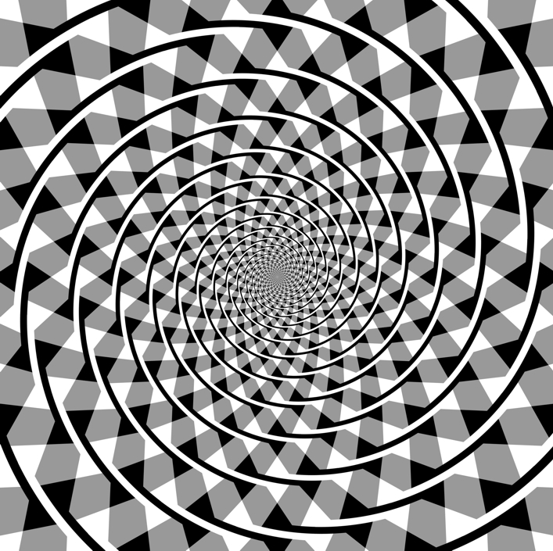
The external world seems immediately available to our senses. Unlike other “higher” cognitive functions like memorizing or problem solving, the act of perceiving does not seem to require any effort. Yet the feat achieved by the perceptual system becomes immediately clear when one tries to build an artificial system that can perceive. Today, artificial vision systems have made great strides toward a high level of functionality in certain domains (e.g., autonomous driving), yet we are still far away from a truly general vision system like ours. Why is it so?
Through this course, we will gain some appreciation of the enormous task of perception and the underlying processes that realize it. The central question we investigate is the following: how do our senses transform the external world into information that our brains/minds can understand and reliably interpret?
Sensation and Perception is an area of scientific inquiry that spans psychology, biology, physics, and computer science. We will examine the perceptual process at a number of different levels, from the sensory signal, to single neurons and neural systems, to behavior and subjective experience. You will have the opportunity to find answers to many questions about yourself and the world around you. Most of all, you will have the opportunity to gain practical knowledge about perception that can enrich your everyday life.

Basic information
Time: Monday & Wednesday 10:20-11:40am
Place: Psychology Bldg 118
Textbook: Sensation and Perception, Goldstein & Cacciamani, Cengage Learning, 11th Edition (2021), MindTap course bundle accessed via D2L (paid subscription necessary)
Assignment: Online interactive activities via MindTap

Instruction Team
Instructor: Taosheng Liu PhD
Email: tsliu@msu.edu
Office: 289A Psychology Bldg, Zoom link
Office hours: Tuesday 1 – 3pm, and by appointment
Office hour sign-up: https://calendly.com/tsliu-msu/30min

Teaching assistant: Jamie Shi
Email: shijiami@msu.edu
Office: 4044 ISTB, Zoom link
Office hours: Thursday 3 – 5pm (and by appointment)

Undergrad assistant: Keira Niles
Email: nileskei@msu.edu
Office: Zoom link (passcode: 868308)
Office hours: Friday 12 – 1pm (and by appointment)

Evaluation criteria
Raw grades (total=100%) are calculated based on a weighted average of the following components:

- Exams (3 exams, 25% per exam) 75%
- Assignments (participation only) 16%
- Quizzes (3 quizzes, 3% each) 9%
- Attendance extra credit 5%
Note attendance provides extra credit (beyond 100%); it will be taken as frequently as possible. The conversion from attendance rate to credit is the following:
Attending percentage | Credit
>=80% | 5%
70 – 79% | 4%
60 – 69% | 3%
50 – 59% | 2%
40 – 49% | 1%
<40% | 0

Exams:
There will be three non-accumulative exams. Each exam will be composed of multiple choices and short answers. Exams will be in-person during scheduled class times (see schedule table below).

Assignments:
You will complete 16 interactive activities on MindTap. These hand-on activities reinforce the concepts introduced in the class. There are multiple choice questions at the end of each assignment. However, we only count your participation, not your performance on these questions. For each assignment, you earn 1% toward the final grade. Note there are three due dates for the assignments and no late submissions are allowed.

Quizzes:
There will be 3 online quizzes with multiple choice questions. You will earn points based on your actual performance. Quizzes are available on D2L on the designated dates (see schedule below) for a 48-hr period (0:00 on Day 1 to 23:99 on Day 2). You have 15 min to complete it once you start. Late quiz will incur a 25% deduction per 24 hr period.

Grade scale:
Final numeric grade is based on a weighted sum of the four components listed above, and the conversion from the raw score to the numeric grade follows the scale below:
Raw percentage | Numeric grade
>=90 | 4.0
85.00 – 89.99 | 3.5
80.00 – 84.99 | 3.0
75.00 – 79.99 | 2.5
70.00 – 74.99 | 2.0
65.00 – 69.99 | 1.5
60.00 – 64.99 | 1.0
<60 | 0
You’re encouraged to use the grade simulator to evaluate/forecast your own grade. The simulator is an Excel sheet with built-in calculations and is available on D2L (in Exam module).

Class schedule (tentative, subject to change)

Date |  | Topic | Reading | Assignment and due
8/31 |  | Introduction | Chap 1
9/2 |  | Physiology | Chap 2
9/7 |  | Labor day, no class
9/9 |  | Psychophysics | Appendix
9/14 & 16 |  | Eye and Retina | Chap 3
9/21 & 23 |  | Visual cortex (I & II) | Chap 4
9/28 & 30 |  | Object recognition (I & II) | Chap 5
10/5 |  | Catch up & Review
10/5 - 10/6 |  | Quiz 1 |  | 10/6: A1-A5
10/7 |  | Exam 1 (in-class)
10/12 & 14 |  | Color perception (I & II) | Chap 9
10/19 & 21 |  | Depth perception (I & II) | Chap 10
10/26 |  | Fall break, no class
10/28 & 11/2 |  | Motion perception (I & II) | Chap 8
11/4 |  | Attention | Chap 6
11/9 |  | Catch up & Review
11/9 - 11/10 |  | Quiz 2 |  | 11/10: A6-A10
11/11 |  | Exam 2 (in-class)
11/16 & 18 |  | Sound and auditory system | Chap 11
11/23 & 30 |  | Hearing in the environment | Chap 12
12/2 |  | Speech | Chap 14
12/7 |  | Body and chemical senses | Chap 15, 16
12/9 |  | Catch up & Review
12/9 - 12/10 |  | Quiz 3 |  | 12/10: A11-A16
TBD |  | Exam 3 (Time TBD)
* Fall break: 10/26 – 10/27
* Thanksgiving break: 11/26 – 11/27
* Final exam week: 12/14 - 12/18

List of Assignments

A1 | Exploration: Visual Path Within the Eyeball (Chap 3)
A2 | Exploration: Lateral Inhibition in the Hermann Grid (Chap 3)
A3 | Exploration: Pyramid Illusion (Chap 3)
A4 | Concept Clip: Impossible Motion: Antigravity Ramps (Chap 5)
A5 | Concept Clip: Newborn Hearing and Vision (Chap 5)
A6 | Concept Clip: Gestalt Principles Exploited by Magicians (Chap 6)
A7 | Exploration: Change Detection: Gradual Change (Chap 6)
A8 | Exploration: Motion Binding (Chap 6)
A9 | Exploration: Corollary Discharge Model (Chap 8)
A10 | Exploration: Biological Motion 2 (Chap 8)
A11 | Exploration: Frequency Response of the Ear (Chap 11)
A12 | Exploration: Periodicity Pitch: Eliminating the Fundamental and Lower Harmonics (Chap 11)
A13 | Exploration: Interaural Level Difference as a Cue for Sound Localization (Chap 12)
A14 | Exploration: Layering Naturalistic Sounds (Chap 12)
A15 | Exploration: Timbre of a Piano Tone Played Backward (Chap 13)
A16 | Concept Clip: Phonemic Restoration (Chap 14)

Course Communication:

I strongly encourage you to come to our office hours to discuss any issues related to the course. Asking us before and after a class session is also welcome. Other than in-person interaction, you are also welcome to contact us via email. Please following appropriate email etiquette (if not sure, google “email etiquette for students”). We will try our best to respond within 24 hrs.

Course Policies:

Make-up Exams: Make-up exams can be granted under special circumstances. This can include, for example, 1) schedule conflict with travel for MSU events (e.g., sports, band), 2) a religious holiday, 3) grief/mourning (file Grief Absence Request here) or 4) accidents/medical emergencies etc. For 1) and 2), please inform me early in the semester. For medical issues, you should obtain approval from the Associate Dean of Undergraduate Studies in your college. When emailing me, do not assume I have gotten your email unless I have responded to you.

Dues for Quizzes and Assignments: Both the quizzes and assignments are available online for extended period of time. The 15 min quizzes are available for a 48 hr period, while the assignments are always available until the due date. You have ample time to complete both activities, and hence will not accommodate extensions/exceptions by default. Technological problems (e.g., computer, network) are not considered legitimate causes because you can always find alternatives for use (e.g., library, computer lab, McDonald’s).

Academic Honesty: The Psychology Department adheres to the policies on academic honesty as specified in General Procedures and Regulations, Protection of Scholarship and Grades, General Student Regulations 1.00 and the all-University Policy on Integrity of Scholarship and Grades. Therefore, unless authorized by your instructor, you are expected to complete all course assignments, including homework, lab work, quizzes, tests and exams, without assistance from any source. You are expected to develop original work for this course; therefore, you may not submit course work you completed for another course to satisfy the requirements for this course. Contact your instructor if you are unsure about the appropriateness of your course work. (See also https://www.msu.edu/~ombud/academic-integrity/index.html).

Accommodations for Students with Disabilities: Michigan State University is committed to providing access and inclusion in all programs, services and activities. Disabled persons should contact the Resource Center for Persons with Disabilities at 517-884-RCPD or by visiting RCPD’s website to request accommodations. Additional communication between the student, instructor, and RCPD specialist may be necessary to ensure an accessible classroom experience.
Please send your Accommodation Letter to me as soon as possible so I can ensure proper facilitation of accommodations. Accommodation Letters are generated and sent from within the AccessMSU student portal. Accommodations are not required to be provided prior to me receiving the letter. Students affiliated with RCPD prior to June 1, 2026 may have existing Accommodation Letters that were previously sent via email communication with instructors. I can still accept these letters, but you will need to also send your Accommodation Letter via AccessMSU. Requests received without sufficient lead time may not be honored due to logistic issues that can arise.

Course materials and dissemination: It is important to promote a vibrant exchange of ideas while respecting the privacy of students taking this class. Comments taken out of context are often misleading and undercut the environment of trust and respect that is essential for learning. Given these factors and the importance of supporting one another, recordings of the class, lecture notes, other materials created by the instructor, and screenshots of the class (including online discussions) should not be uploaded to other online environments. Impermissible use of class recordings and lecture notes or other material may violate the rights of other students and the MSU Student Rights and Responsibilities Policy (https://ossa.msu.edu/srr).

