STOMP System User Guide

Table of Contents

STOMP Overview & User Platforms….………………………………………………………….………………………………………….3

STOMP Access………………………………….………………………………………………………………………….……………….……..3-4

STOMP Entries…………..………………………………………………………………………………………………………………………...4-5

Administrator Incident Notifications……….…………………………………………………………………………………..………….5

Entering New Miles and Hours.....................................................................................................................5

Dashboard……………………………. …………….......................................................................................................6

System Issues…………………………………………………………………………………………………………………………….…………….6

Attachments…………………………………………………………………………………………………………………………………..…….7-9

Overview & User Platforms
The Safety Tracking for ONEOK Major Projects (STOMP) is a web-based, Environmental, Safety & Health reporting and analysis system. STOMP enables users to enter hours worked, miles driven and events such as near misses, injuries, spills, etc. STOMP also provides users the ability to identify trends and produce analysis that lead to recommendations and incident prevention.
Users are currently able to access STOMP on desktop and laptop computers. In the future, users will be able to utilize STOMP on tablets and mobile phones. The application will be available for download on mobile devices via the application store. Compatible operating systems include Microsoft Windows, iOS, and Android, to name a few.
Note: Devices will need to have connectivity in order to input information.

STOMP Access
Users will be given a link and password to the applicable project to request STOMP access. The link will allow users to enter their information and request access to the project(s). Below is an example of the information needed in order to gain access to STOMP:
Venture: Knox Plant and Infrastructure
Project: SCOOP
Spread: Knox Gas Processing Plant

STOMP Access Request Link:
http://www.oneok.com/stomp

Upon opening the STOMP Access Request Link, the user will enter his/her first name, last name, organization, title, email address, phone number and the selected project information. After all the information is entered, the user will then select the “Submit Request” tab located at the bottom of the screen below the “Comments” section. Users will receive an email stating that the request has been submitted.
An example of the Request for Access to STOMP screen can be found in Attachment 1.
The system administrator will receive the request for access and either accept or reject it. If accepted, the requester will receive an auto generated email with the STOMP link and their username and password. The user will enter his/her username (e.g. joe.smith; all lowercase) and password.
Users are highly encouraged to change passwords to something that can be easily remembered. To change a password, click on the change password icon at the top of the STOMP homepage (as indicated at the top of page 4) then follow the instructions.
Note: Six (6) unsuccessful attempts to log into STOMP will result in the user being locked out of the system which may take up to several days to correct. If the copy and paste method is used to enter passwords, users should copy and paste all password characters but avoid copying spaces before or after the password.

STOMP Entries
Creating a New Incident
In order to create a new incident, the user will need to select the “New Incident” tab in the upper left corner of the main screen. The system will direct the user to a new screen where he/she will input information regarding the incident.
The user will select the applicable “Form Type” by selecting one of the “option buttons” (i.e. Good Catch, Near Miss, Event) located to the right of the form type display.
Note: When selecting Event, enter the appropriate event type as shown in the drop box menu in Attachment 2.
Enter the Joint Venture, Project, Spread and Contractor by selecting each from the drop down menu on the right side of the entry tabs. The user will need to input the date and time the incident occurred along with the date and time the incident was reported.
Enter the details of the incident into the description box and, at a minimum, answer the questions that are presented in the box. Users will need to be thorough and enter corrective actions taken to prevent similar incidents from happening in the future. The user has the option to spell check after the description narrative is complete. The spell check option can be utilized by clicking on the green checkmark at the bottom right corner of the description box. Users will need to select the appropriate type of work from the drop down menu when clicking on the “Function of Work” tab.
Depending on which event type is selected, the incident form will populate and additional form fields will need to be completed. For example, upon selecting “Injury” in the event type drop down menu, an additional page will be added below to enter specific information regarding the injury.
Users also have the option to upload files from their computer. This option is in the box in the lower left hand corner of the incident entry screen.
Note: Users will need to click the save button in the top left corner of the screen after the entry is complete.
Example of an acceptable incident description:
IR-00000
Description (who, what, when, where, and initial action taken):
A forklift operator over extended the boom on a forklift while a load of pipe was on the forks. The rear tires came off the ground approximately 1’ 6” and the load of pipe struck the floor of the shop. The inspectors checked the pipe and, fortunately, no damage was noted. The forklift operator and his spotter were counseled on the limitations and safe operations of forklifts. No injuries occurred and no property was damaged. Both employees (operator and spotter) received verbal warnings.
Click HERE to log into STOMP.

Administrator Incident Notifications
Once an event has been entered and saved, an initial notification will be sent out to approved users associated with each particular project. The entry will be reviewed by the administrator and assigned a risk level (low, medium, high). A finalized risk ranked event notification will be distributed to all approved personnel based on their user rights.

Entering New Miles and Hours
The “New Miles/Hours” tab is in the top left corner of the home screen as indicated below.
The user will need to select the “New Miles/Hours” tab on the main screen in the upper left hand corner. The system will direct the user to another screen to input information regarding miles driven and hours worked for a particular project.
The user will enter the Date/Time Reported. Select Joint Venture or Business Unit by clicking on the icon next to either option. The remaining information can be entered by selecting from the drop down menu tab located to the right of the Joint Venture, Project, Spread, etc. The hours, miles and good catches will need to be entered manually in the appropriate boxes.
Note: Users must click on the save button in the top left corner of the “New Hours/Miles” screen after the entry is complete.
An example of the New Hours/Miles entry screen can be found in Attachment 3.

Dashboard
The Dashboard feature allows users the ability to view the ESH performance for any given ONEOK project. Users can filter performances by contractor, venture, spread and date.
The left side of screen is the select options section. The user can select the projects they are approved to access. The user can also enter a specific date and view all events submitted by each contractor across the project. Only access to approved projects will be visible. This option is located above the graphs in the Dashboard screen. The viewable charts depict the data that was submitted for a particular project.
An example of the Dashboard View can be found in Attachment 5.

System Issues
In the event users have trouble with any STOMP function, the system administrators are available to assist. Some issues can be resolved quickly while others may require further troubleshooting. The contact information for the system administrators are below:

Aaron Folsum
System Administrator for the Mont Belvieu/Houston, TX area
aaron.folsum@oneok.com

Clint Dietz
System Administrator for the Midcontinent area (OK, KS, TX)
clint.dietz@oneok.com

Phillip Brewer
System Administrator for the Northern area (MT, WY, ND & ORM)
phillip.brewer@oneok.com

Attachment 1 – Example of the Request for Access to STOMP screen

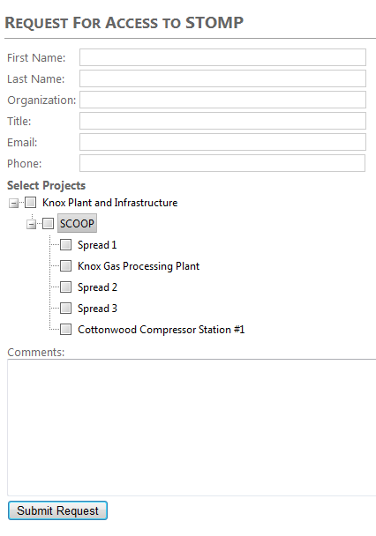

Attachment 2 – Example of the STOMP Entry Screen

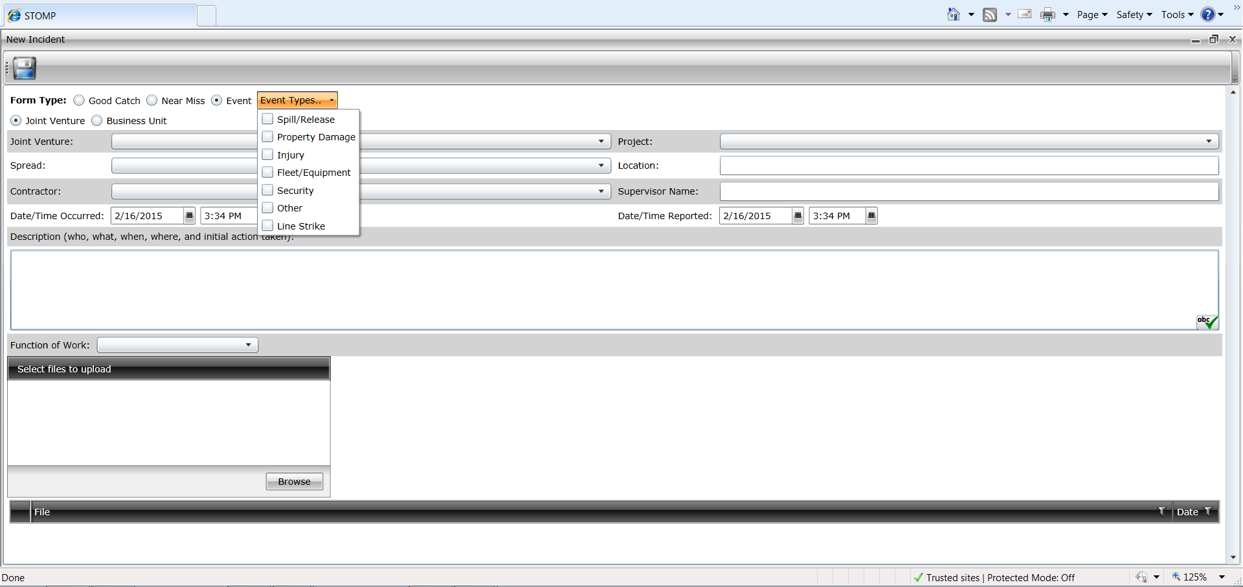

Attachment 3 – Example of the New Hours/Miles Entry Screen

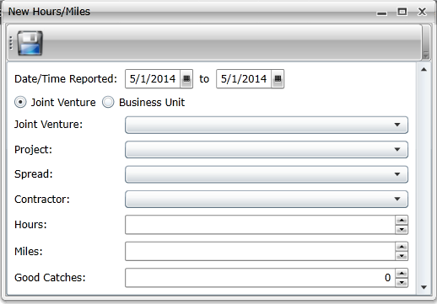
Attachment 4 – Dashboard View

