PROJECT CLOSEOUT REPORT USER GUIDE
A fillable Project Closeout Report template is available at the end of this user guide.
Description
Formally summarizes a completed project's performance, results, and lessons learned.

Purpose
- Provides a clear summary of the project outcomes.
- Captures valuable insights and encourages continuous improvement.
- Organizes and preserves project knowledge.
- Formally closes and marks the end of a project.

User Guide
Instructions for completing each section are outlined below.

Section 1: Project Details

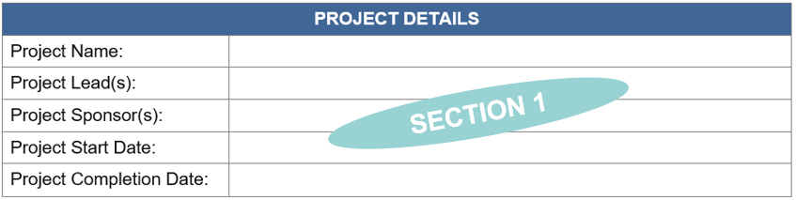

Project Name
The “Project Name” section includes the project title. If a formal project name has not been identified, use a brief description to clearly identify the project.

Project Lead(s)
The “Project Lead(s)” section includes the names of the stakeholders responsible for overseeing, managing, or coordinating the project. This can include project manager(s) or anyone who is the main person responsible for executing the project.
Project Sponsor(s)
The “Project Sponsor(s)” section includes the names of the individuals, typically management level, who provide support for the project. These are the leaders responsible for authorizing, guiding, and championing the project.
Project Start Date
The “Project Start Date” section includes the official date when the project work begins, which may include planning, kickoff activities, or the first major task.

Project Completion Date
The “Project Completion Date” section includes the date by which all project activities, deliverables, and project was completed.

Section 2: Project Summary

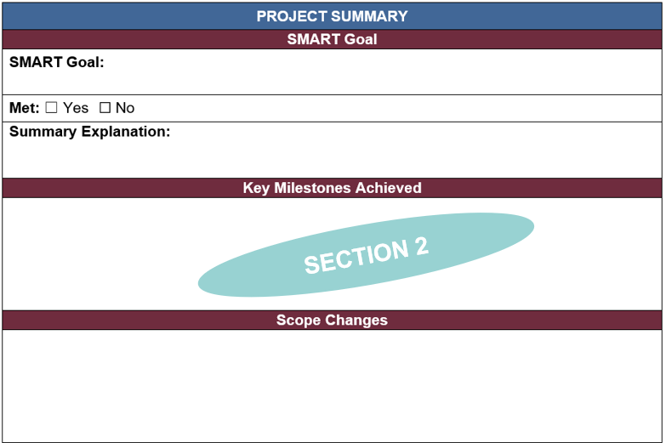

SMART Goal
The “SMART Goal” section includes the goal that was initially outlined at the start of the project on the Project Charter, stated in a SMART goal format: specific, measurable, achievable, relevant, and timebound.

Met
The “Met” section includes whether the project’s SMART goal was met.

Summary Explanation
The “Summary Explanation” section includes further details of the results to support accountability and future project planning.

Key Milestones Achieved
The “Key Milestones Achieved” section includes a list of all the milestones that were accomplished during the project cycle. It highlights significant accomplishments such as major milestones or phases, critical deliverables, or key decision points.
Scope Changes
The “Scope Changes” section documents any changes from the original project scope, why they were made and how they impacted the project.

Section 3: Project Performance

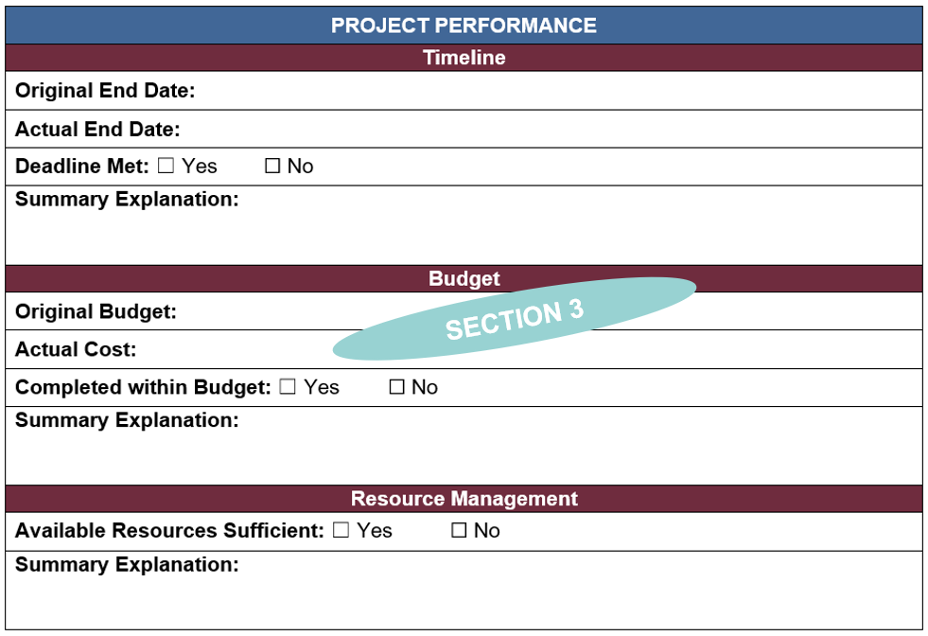

Project Performance
The “Timeline” section includes an overview of the project’s planned timeframe.
- Original End Date: Official target date of when the project was expected to be completed.
- Actual End Date: Official date the project was completed.
- Deadline Met: Indicate whether the initial project deadline was met.
- Summary Explanation: Highlight key factors that contributed to delays or on-time completion.

The “Budget” section includes an overview of the project’s planned budget.
*Note: Not all projects will include a budget.
- Original Budget: Approved funding amount at the start of the project.
- Actual Cost: Total cost of the project at close.
- Completed within Budget: Indicate whether the project stayed within budget.
- Summary Explanation: Summary of key reasons for any budget variances or highlight factors that contributed to budget adherence.

The “Resource Management” section includes an overview of the project’s resources.
- Available Resources Sufficient: Indicate whether the resources available were sufficient to meet project needs.
- Summary Explanation: Summary of key factors affecting shortages or surpluses and how this impacted project outcomes.

Section 4: Stakeholder Engagement Summary

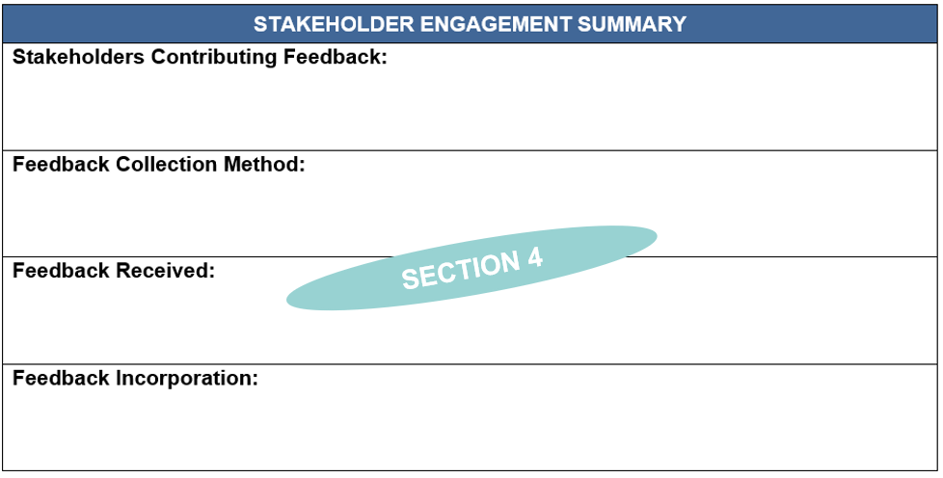

Stakeholders Contributing Feedback
The “Stakeholders Contributing Feedback” section includes all the stakeholders that provided feedback for the Project Closeout Report.

Feedback Collection Method
The “Feedback Collection Method” section includes how the feedback was received (feedback survey, meeting, emails, written reports, etc.).

Feedback Received
The “Feedback Received” section includes the key feedback shared by stakeholders.

Feedback Incorporation
The “Feedback Incorporation” section includes how the feedback was analyzed and incorporated in the project or will be in future projects.

Section 5: Lessons Learned

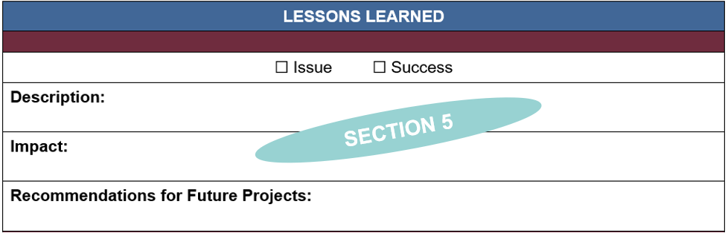

Lessons Learned
The “Lessons Learned” section identifies key learnings from the project - what worked well, what did not, and recommendations for future improvement.
- Indicate if the lesson learned was an issue or a success.
- Description: Include details about the issue or success and what can be learned to improve future projects.
- Impact: Describe how the situation affected the project, e.g., delays, cost changes, quality of deliverables, etc.
- Recommendations for Future Projects: Summarize project experiences that can lead to practical recommendations which strengthen performance of future projects.

Section 6: Acknowledgement

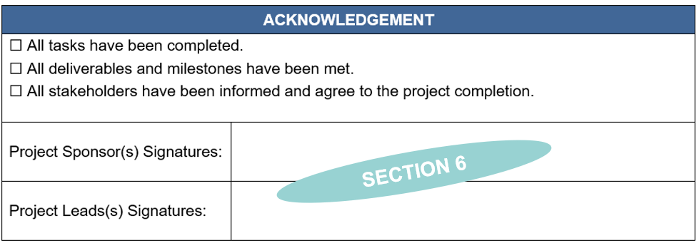

Acknowledgement
The “Acknowledgement” section includes:
- Check the boxes to acknowledge that all parts of the project have been completed.
- The project sponsor(s)’ signature acknowledging the completion of the project.
- The project lead(s)’ signature acknowledging the completion of the project.

Pro-Tips
Best Practices
- Add more rows for lessons learned as needed.

Adding Additional Rows to Sections
- Highlight by right clicking the row that you want to add a row above or below.
  - To add more than one row at a time, highlight the number of rows that you want to add.
- Select “Insert”.
- Select “Insert Rows Above” or “Insert Rows Below”.

PROJECT CLOSEOUT REPORT

PROJECT DETAILS
Project Name:
Project Lead(s):
Project Sponsor(s):
Project Start Date:
Project Completion Date:

Completion of this Project Closeout Report serves as acknowledge that all operational, administrative, financial, and logistical aspects of this project have been documented and completed for project closeout.

PROJECT SUMMARY
SMART Goal
SMART Goal:

Met: ☐ Yes ☐ No
Summary Explanation:

Key Milestones Achieved
Scope Changes

PROJECT PERFORMANCE
Timeline
Original End Date:
Actual End Date:
Deadline Met: ☐ Yes ☐ No
Summary Explanation:

Budget
Original Budget:
Actual Cost:
Completed within Budget: ☐ Yes ☐ No
Summary Explanation:

Resource Management
Available Resources Sufficient: ☐ Yes ☐ No
Summary Explanation:

STAKEHOLDER ENGAGEMENT SUMMARY
Stakeholders Contributing Feedback:

Feedback Collection Method:

Feedback Received:

Feedback Incorporation:

LESSONS LEARNED
☐ Issue ☐ Success
Description:

Impact:

Recommendations for Future Projects:

☐ Issue ☐ Success
Description:

Impact:

Recommendations for Future Projects:

☐ Issue ☐ Success
Description:

Impact:

Recommendations for Future Projects:

ACKNOWLEDGEMENT
☐ All tasks have been completed.
☐ All deliverables and milestones have been met.
☐ All stakeholders have been informed and agree to the project completion.

Project Sponsor(s) Signatures:
Project Leads(s) Signatures:

