PROJECT STATUS REPORT USER GUIDE
A fillable Project Status Report template is available at the end of this user guide.
Description
A high-level overview of a project’s progress, accomplishments, current issues, risks, and next steps.

Purpose
To keep stakeholders informed and aligned.

User Guide
Instructions for completing each section are outlined below.

Section 1: Project Details

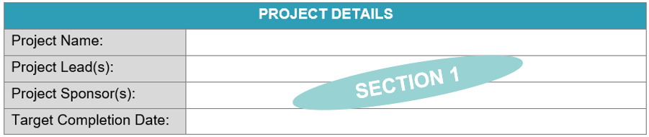

Project Name
The “Project Name” section includes the project title. If a formal project name has not been identified, use a brief description to clearly identify the project.

Project Lead(s)
The “Project Lead(s)” section includes the names of the stakeholders responsible for overseeing, managing, or coordinating the project. This can include project manager(s) or anyone who is the main person responsible for executing the project.
Project Sponsor(s)
The “Project Sponsor(s)” section includes the names of the individuals, typically management level, who provide support for the project. These are the leaders responsible for authorizing, guiding, and championing the project.

Target Completion Date
The “Target Completion Date” section includes the expected date by which all planned project activities, deliverables and project will be completed.

Section 2: Project Status

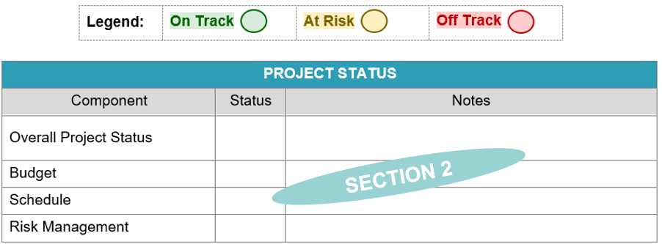

Overall Project Status
The “Overall Project Status” section includes the current state of the project.
*Use the legend to identify the Overall Project Status.
- Off Track: The project is experiencing critical issues that are impacting its progress and likely to cause delays or failure to meet objectives.
- At Risk: The project is experiencing potential issues or challenges that could delay the project or impact its objectives.
- On Track: The project is progressing as planned, within budget, and on schedule.

Component
The “Component” column includes the key metrics of a project.
*Additional components can be added as applicable.

Status
The “Status” column includes the current state of the component.
*Use the legend to identify the Component’s Status.
- Risk: The component is experiencing critical issues that are impacting its progress and likely to cause delays or failure to meet objectives.
- Concern: The component is experiencing potential issues or challenges that could delay the project or impact its objectives.
- On Track: The component is progressing as planned.

Notes
The “Notes” column includes any details regarding the progress and status of the component.

Section 3: Accomplishments and Activities

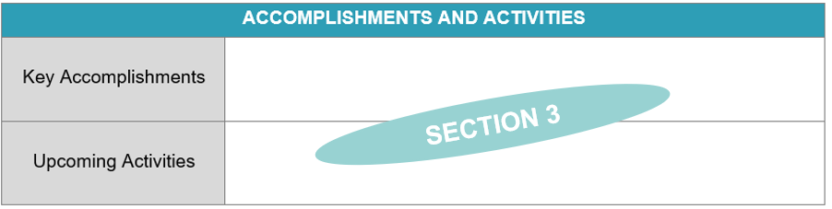

Key Accomplishments
The “Key Accomplishments” section includes what has been completed since the last update.

Upcoming Activities
The “Upcoming Activities” section includes the next big steps that will be worked on.

Section 4: Critical Items

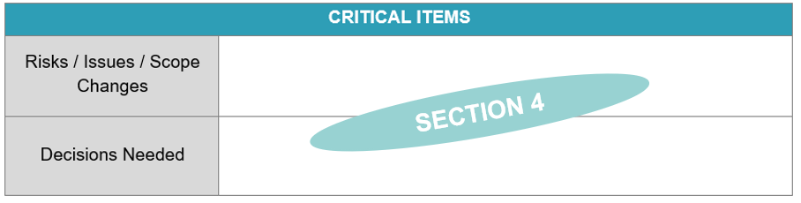

Risks / Issues / Scope Changes
The “Risk / Issues / Scope Changes” section includes any delays, bottlenecks, or challenges that require attention.

Decisions Needed
The “Decisions Needed” section includes key items that require input or approval to move forward.

Pro-Tips
Adding Additional Rows to Sections
- Highlight by right clicking the row that you want to add a row above or below.
  - To add more than one (1) row at a time, highlight the number of rows that you want to add.
- Select “Insert”.
- Select “Insert Rows Above” or “Insert Rows Below”.

PROJECT STATUS REPORT
Date of Report:
PROJECT DETAILS
Project Name:
Project Lead(s):
Project Sponsor(s):
Target Completion Date:

Legend: | On Track | At Risk | Off Track

PROJECT STATUS
Component | Status | Notes
Overall Project Status
Budget
Schedule
Risk Management

ACCOMPLISHMENTS AND ACTIVITIES
Key Accomplishments
Upcoming Activities

CRITICAL ITEMS
Risks / Issues / Scope Changes
Decisions Needed

