PROJECT CHARTER USER GUIDE
A fillable Project Charter template is available at the end of this user guide.
Description
A formal document that sets the foundation and authorizes the project outlining the key project goals, objectives, scope, timeline, stakeholders, and benefits of the project.

Purpose
• Provides a clear outline of the project purpose and timeline to all stakeholders ensuring alignment with organizational goals.
• Used to secure formal approval from project sponsors to initiate the project.

User Guide
Instructions for completing each section are outlined below.

Section 1: Project Details

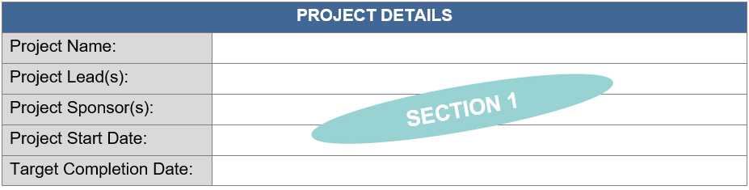

Project Name
The “Project Name” section includes the project title. If a formal project name has not been identified, use a brief description to clearly identify the project.

Project Lead(s)
The “Project Lead(s)” section includes the names of the stakeholders responsible for overseeing, managing, or coordinating the project. This can include project manager(s) or anyone who is the main person responsible for executing the project.
Project Sponsor(s)
The “Project Sponsor(s)” section includes the names of the individuals, typically management level, who provide support for the project. These are the leaders responsible for authorizing, guiding, and championing the project.

Project Start Date
The “Project Start Date” section includes the official date when the project work begins, which may include planning, kickoff activities, or the first major task.

Target Completion Date
The “Target Completion Date” section includes the expected date by which all planned project activities, deliverables and project will be completed.

Section 2: Project Overview

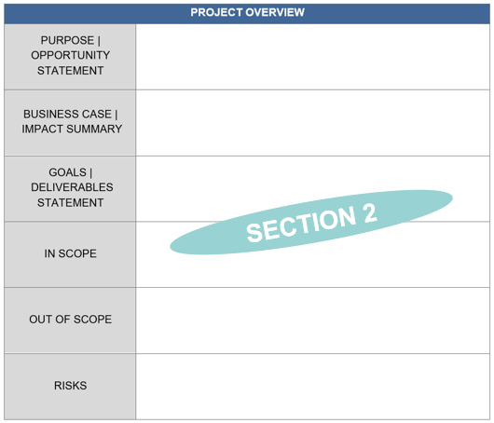

Purpose | Opportunity Statement
The “Purpose | Opportunity Statement” section outlines:
- The problem or opportunity the project addresses (the “what”).
- The importance of the project and reasons it matters (the “why”).
- The strategy or approach the project will take to address the objective and how the project supports and aligns with organizational goals (the “how”).

Business Case | Impact Summary
The “Business Case | Impact Summary” section outlines:
- The expected benefits the project will deliver and the value it brings.
- The importance of the project and the impact it will have on stakeholders or processes.

Goals | Deliverables Statement
The “Goals | Deliverables Statement” section defines what will be accomplished with the project and is delivered in a SMART goal format: specific, measurable, achievable, relevant, and timebound.

In Scope
The “In Scope” section specifies the tasks, activities and deliverables associated with the project.

Out of Scope
The “Out of Scope” section identifies areas that fall outside the boundaries of the project.

Risks
The “Risks” section outlines potential risks that could impact the project’s objective, scope, schedule, budget, or outcome.

Section 3: Stakeholders

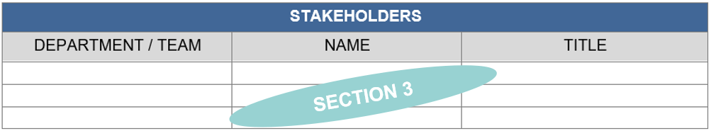

Stakeholders
The “Stakeholders” section defines key individuals, teams, departments, and others that have an interest in – or are affected by – the project. They can also be decision makers and subject matter experts who influence or are impacted by the outcome the project (the “who”).
- Under the “Department / Team” column, identify the department/teams contributing to the project.
- Under the “Name” column, identify each individual stakeholder belonging to that department/team if known.
- Under the “Title” column, list the title of the listed stakeholder.

Section 4: Timeline

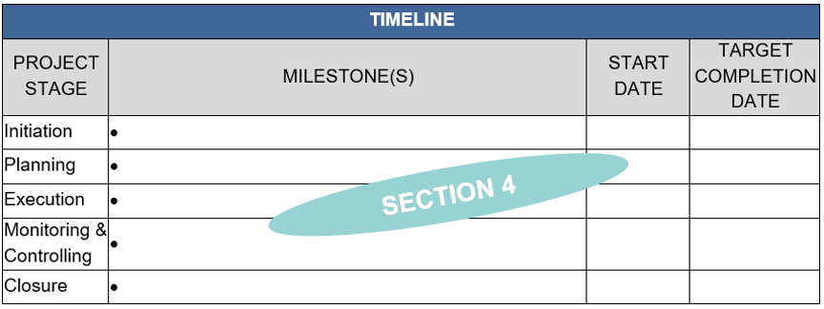

Timeline
The “Timeline” section outlines the milestone(s) that will be completed during each of the five (5) project stages, along with the start date and target completion date. List all milestones within each project stage.

Section 5: Project Charter Approvals

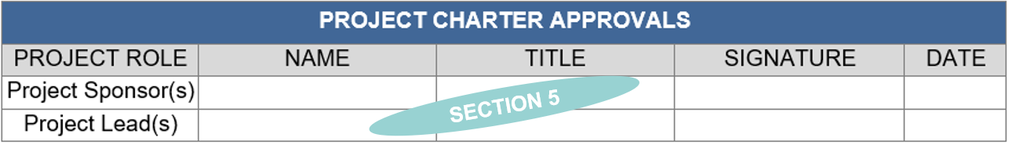

Project Charter Approvals
The “Project Charter Approvals” section includes:
- The project sponsor(s)’ signature approving the charter and agreeing to move forward with the project as described in the charter.
- The project lead(s)’ signature agreeing to lead the project to completion as defined by the charter.

Pro-Tips
Adding Additional Rows to Sections
- Highlight by right clicking the row that you want to add a row above or below.
  - To add more than one row at a time, highlight the number of rows that you want to add.
- Select “Insert”.
- Select “Insert Rows Above” or “Insert Rows Below”.

PROJECT CHARTER

PROJECT DETAILS
Project Name:
Project Lead(s):
Project Sponsor(s):
Project Start Date:
Target Completion Date:

PROJECT OVERVIEW
PURPOSE |
OPPORTUNITY STATEMENT
BUSINESS CASE |
IMPACT SUMMARY
GOALS |
DELIVERABLES STATEMENT
IN SCOPE
OUT OF SCOPE
RISKS

STAKEHOLDERS
DEPARTMENT / TEAM | NAME | TITLE

TIMELINE
PROJECT STAGE | MILESTONE(S) | START DATE | TARGET COMPLETION DATE
Initiation
Planning
Execution
Monitoring & Controlling
Closure

PROJECT CHARTER APPROVALS
PROJECT ROLE | NAME | TITLE | SIGNATURE | DATE
Project Sponsor(s)
Project Lead(s)

