Reid Health  Gastroenterology | Reid Outpatient Endoscopy  & Surgery Center
1050 Reid Parkway, Suite 110 | 1100 Reid Parkway, Suite 235
Richmond, IN 47374 | Richmond, IN 47374
(765) 935-8923 | (765) 935-8731

Procedure: Colonoscopy | Procedure Date: ___________________
Arrival Time: __________________ | Physician: Naeem Raza, MD

Important Information:
- A nurse will call you 5 days before the procedure to obtain your medical history and give instructions. Please discuss any questions you have at this time.
- If you have not received a call by noon, 5 days prior, please call Reid Outpatient Endoscopy & Surgery Center at (765) 935-8731.
- It is very important that you review and keep these instructions you have been given. This ensures that any questions you may have can be answered prior to your procedure.
- If you have NOT received your prep instructions 2 days prior to your procedure, please call the office immediately at (765) 935-8923.
- Because you will be receiving sedation, you must have a responsible adult, (this cannot be any community transport or a cab), take you home after your procedure. You will need someone to stay with you for 24 hours after your procedure. If you do not have a driver, or you do not have someone that can stay with you, your procedure will be canceled.
- Driving a car, operating any machinery or power tool is prohibited for 24 hours after your procedure.

Colonoscopy Bowel Preparation Instructions
Dulcolax – MiraLAX Prep

7 Days Before the Procedure
- If you take Glucagon-like peptide-1 receptor agonists (Mounjaro, Zepbound, Bydurean, Trulicity, Tanzeum, Ozempic, or Wegovy) for either weight-loss or diabetes, STOP taking ONE WEEK prior to your procedure. This applies to both the weekly injections AND if taking a daily dose.
  - If taking for diabetes, consult with your Primary Care Provider to manage antidiabetic therapy and hyperglycemia.
5 Days Before the Procedure
- If you take Aggrenox (Aspirin/Dipyridamole), Brilinta (Ticagrelor), Coumadin (Warfarin), Effient (Prasugrel), Eliquis (Apixaban), Plavix (Clopidogrel), Pletal (Cilostazol), Pradaxa (Dabigatran), Savaysa (Edoxaban), or Xarelto (Rivaroxaban), we will contact your prescribing provider to obtain instructions about stopping this medication. It is not safe to stop these medications without your doctor’s advice.
- Do not stop taking Aspirin.
- Arrange for a responsible adult to drive you home from your procedure and be with you for 24 hours after your procedure.
- Purchase items for your prep. Items are listed below.
  - 12 Dulcolax Tablets
    - These can be given to you by our office. You may also purchase these at any pharmacy.
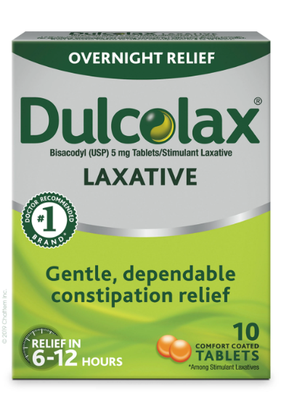
  - 1 - 238g Bottle of MiraLAX.
    - This can be purchased at any pharmacy.
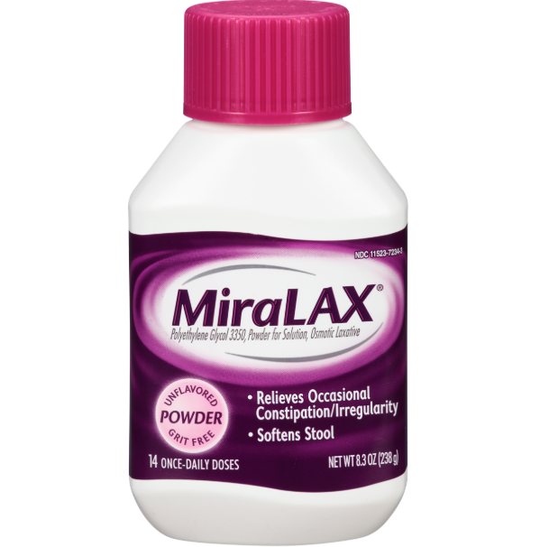
  - 2 – 32oz Bottles of Gatorade or Powerade (no red, blue, or purple)
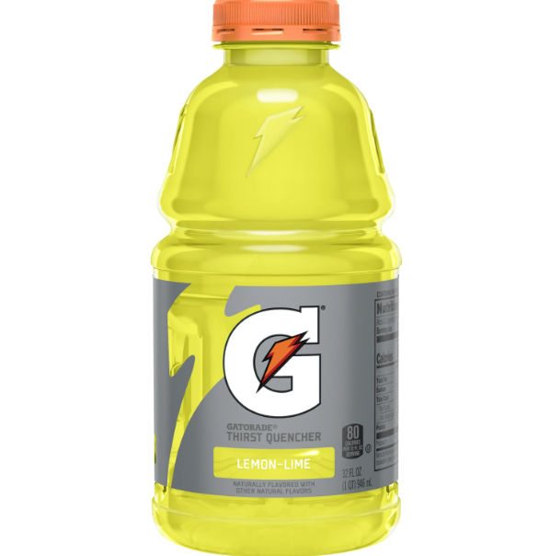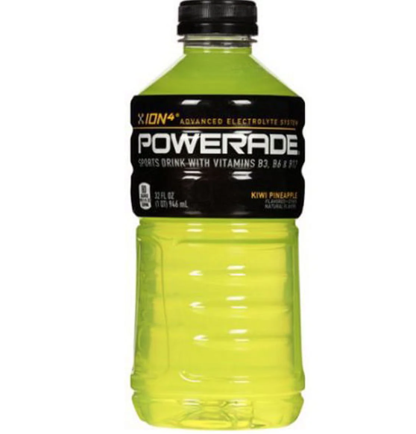
4 Days Before the Procedure
- If you take Glucagon-like peptide-1 receptor agonists Steglatro (Ertugluflozin) for either weight-loss or diabetes, STOP taking FOUR DAYS prior to your procedure. This applies to both the weekly injections AND if taking a daily dose.
  - If taking for diabetes, consult with your Primary Care Provider to manage antidiabetic therapy and hyperglycemia.
3 Days Before the Procedure
- If you take Glucagon-like peptide-1 receptor agonists Brenzavvy (Bexaglifloxin), Invokana (Canagliflozin), Farxiga (Dapagliflozin), Jardiance (Empagliflozin), Sotagliflozin (Inpefa), Canagliflozin/Metformin (Invokana/Metformin), Empagliflozin/Metformin (Synjardi, Jardiance/Metformin), Dapagliflozin/Metformin (Xig duo, Farxiga/Meformin), Empagliflozin/Linaglipton (Glyxambi, Jardiance/Trajenta) for either weight-loss or diabetes, STOP taking THREE DAYS prior to your procedure. This applies to both the weekly injections AND if taking a daily dose.
  - If taking for diabetes, consult with your Primary Care Provider to manage antidiabetic therapy and hyperglycemia.
1 Day Before the Procedure
- If you take Glucagon-like peptide-1 receptor agonists Liraglutide (Victoza or Saxenda), Exenatide (Byette), Lixisenatide (Adlyxin), or Semaglutide (Rybelsus) for either weight-loss or diabetes, STOP taking ONE DAY prior to your procedure. This applies to both the weekly injections AND if taking a daily dose.
  - If taking for diabetes, consult with your Primary Care Provider to manage antidiabetic therapy and hyperglycemia.
- Breakfast:
  - Only clear liquids.
- Lunch:
  - Only clear liquids.
- 12:00 PM (Noon):
  - Take 6 Dulcolax tablets with clear liquid.
- 3:00 PM:
  - Take 6 Dulcolax tablets with clear liquid.
- Dinner:
  - Only clear liquids.
- 7:00 PM:
  - Mix 7 caps full of MiraLAX with a 32oz bottle of Gatorade or Powerade. Drink solution at a rate of 8oz every 15-20 minutes (over 1-2 hours) until it is gone.
- 10:00 PM:
  - Mix 7 caps full of MiraLAX (this should be the rest of the MiraLAX bottle) with a 32oz bottle of Gatorade or Powerade. Drink solution at a rate of 8oz every 15-20 minutes (over 1-2 hours) until it is gone.
- Ensure you are drinking plenty of clear liquids the evening before your procedure.
- If you become nauseated or too full, take a short break then restart drinking the prep solution at a slower rate.
- 11:59 PM:
  - Nothing by mouth. This includes any liquid.
The Morning of the Procedure
- DO take medications (with a sip of water) for seizure disorders, cardiac arrhythmias, or psychiatric disorders. Do not eat or drink anything else.
- DO NOT eat any food or drink any liquids the morning of your procedure.
- You may wear weddings rings and/or religious medallions. Please leave money and all other valuables at home. The surgery center cannot accept responsibility for them.
  - Arrive at the surgery center 1 hour prior to your scheduled procedure time, unless advised otherwise.
  - Bring a list of all the medications you are taking along with dosage/quantity.
  - Please have your driver stay in the Outpatient Surgery waiting room.
- If you cannot keep your scheduled appointment, please call the office at (765) 935-8923 or the surgery center at (765) 935-8731 prior to your procedure day/time. Your procedure may be cancelled/rescheduled if you consume any solid foods within 1 day of your procedure, the prep is not completed correctly, or you arrive late to your appointment.

What to Expect During Your Endoscopy or Colonoscopy.
- We want you to feel informed and prepared for your upcoming procedure. Below is a summary of what you can expect before, during, and after your endoscopy or colonoscopy.
Before Your Procedure (Pre-op)
- Check-In and Preparation:
- Please arrive at the time provided by our PAT nurse during your Pre-op call. This is typically 1hr prior to your scheduled procedure time.
- You will check in at the front desk and be taken to the pre-op area.
- A nurse will review your medical history, medications, take your vital signs, and start an IV to administer fluids and sedation during your procedure.
- You’ll speak with your care team, including your nurse, the physician performing the procedure, and the anesthesia provider, if applicable.
- If you are having a colonoscopy, it is very important to complete your bowel prep exactly as instructed to ensure a clear view of your colon.
Important Reminders:
- Do not eat or drink anything after the instructed time (liquids: usually midnight before your procedure, solids: defined in your prep instructions).
- Arrange for a responsible adult to drive you home and stay with you following your procedure. You will not be permitted to drive.
During Your Procedure (Intra-Op)
- In the Procedure Room:
- You will be taken to a specialized procedure room and positioned on your Left side.
- Sedation will be given through your IV to help you relax and prevent discomfort.
- The doctor will perform the procedure using a thin, flexible scope equipped with a camera:
  - Endoscopy examines the upper digestive tract (esophagus, stomach, and part of the small intestine).
  - Colonoscopy examines the lower digestive tract (colon and rectum).
- The procedure typically lasts between 15-30 minutes depending on the type and findings.
After Your Procedure (Recovery)
- Post-Procedure Care:
  - You’ll be monitored in a recovery area as the sedation wears off. Recovery typically lasts 30 minutes from the time you enter the recovery room. Patients with sleep apnea may require a longer stay up to 1 hour.
  - A nurse will check your vital signs and assess your comfort.
  - Your physician will speak with your family/responsible adult to review the findings and explain any next steps or recommendations.
  - You may experience mild bloating, gas, or a sore throat (endoscopy), which typically resolves quickly.
- Discharge Instructions:
  - You’ll receive written instructions regarding procedure findings, diet, activity, and any medications or follow-up needed.
  - Rest at home for the remainder of the day. Avoid driving, operating machinery, or making important decisions until the next day.
  - Resume your regular diet unless otherwise instructed.

Clear Liquid Diet for Gastroenterology Procedures

You Can Have: | - Gatorade or Powerade (no red, blue, or purple)  - Water  - Clear Broth or Bouillon (no noodles, meat, vegetables, etc.)  - Popsicles (no red, blue, or purple; no fruit pieces)  - Black Coffee or Tea (no sugar, milk, creamer, etc.)  - Soft Drinks (no red, blue, or purple)  - Jell-O (no red, blue, or purple; no fruit pieces)  - Flavored Water (no red, blue, or purple)  - Fruit Juices (no pulp)  - Italian Ice (no red, blue, or purple)
You Cannot Have: | - No Alcohol  - No Sherbert or Ice Cream  - No Solid Foods  - No Tomato or Cream Soups  - No Milk or Milk Products  - Nothing with Red, Blue, or Purple Dyes

Diabetic Information Sheet for Gastroenterology Procedures
If you have diabetes, any procedure that causes you to miss a meal or change your usual meal plan requires special planning to safely manage your blood glucose level
Check your blood glucose level before all meals and at bedtime the day before your procedure and the morning of your procedure.
Check your blood glucose any time you experience any symptoms listed below.
Low Blood Sugar |  | Very High Blood Sugar
- Hunger  - Shakiness  - Nervousness  - Difficulty Speaking  - Anxiety | - Sweating  - Dizziness  - Sleepiness  - Confusion  - Weakness | - Dry Mouth  - Thirst  - Frequent Urination  - Increased Appetite | - Blurry Vision  - Fatigue  - Drowsiness  - Weight Loss
You can call the surgery center at (765) 935-8731 or the office at (765) 935-8923 with any questions.
Food Items without Carbohydrates | Food Items with Carbohydrates
- Fat-free broth, bouillon, or consommé | - Apple Juice (4 oz) -- 15 grams carbohydrate
- Diet clear soda | - White Grape Juice (4 oz) -- 20 grams carbohydrate
- Coffee | - Sports Drinks (8 oz) -- 14 grams carbohydrate
- Tea, unsweetened or diet | - Jell-O, Regular, Sweetened -- 15 grams carbohydrate
- Seltzer, Flavored water | - Popsicles (refer to product label -- 15 grams carbohydrate
 | - Italian Ice not Sherbet (refer to product label) -- 30 grams carbohydrate
 | - Sugar (1 teaspoon or packet) -- 4 grams carbohydrate
Aim for 45 grams of carbohydrates at meals and 15-30 grams of carbohydrates for snacks

