# FAQ’S: obtaining an annual permit for a prime mover/dolly/low loader

## WHAT INFORMATION DO I REQUIRE?

Before an annual scheme permit can be issued, the operator needs to provide the following:

* A correctly filled out Class 1 application form
* Mass on each axle groups
* The internal dimensions between each axle group

Information regarding **rear overhang** and the **S-dimension** are critical in determining whether certified pilots are required.

## WHERE DO I PUT THE S-DIMENSION INFORMATION?

There is no specific area on the application form to include the S-dimension. However, Information regarding the S-dimension can be included in section 4 of the application form (see below).

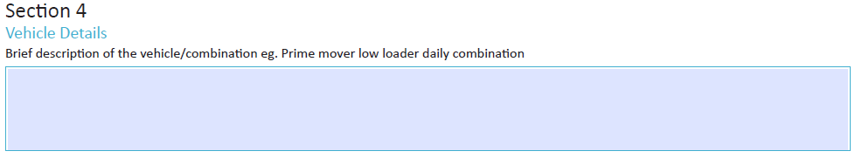

## DO I NEED TO DETERMINE THE COMBINATIONS’ PERMITTED MASS?

Yes. Your permit will include four mass and dimensions charts that need to be complied with when operating your combination. These charts set out the minimum distance between axle groups on your combination, such as the distance between the drive group and a dolly group. If you’re unsure as to how to apply these tables, please contact a permit officer.

## WHERE CAN I FIND THE REGULATIONS FOR OVERSIZE SIGN AND WARNING DEVICES?

These are covered in Schedule 8 (page 89) of the [*Heavy Vehicle (Mass, Dimension and Loading) National Regulations*.](https://www.legislation.qld.gov.au/LEGISLTN/CURRENT/H/HeavyVehMDLNR.pdf)

## WHAT DO I DO IF MY COMBINATION EXCEEDS THE DIMENSION?

The combination can still operate however it will need to be assessed on a case by case basis. This might include a geometric check of the combination on the network, such as swept path and tail swing.

## HOW ARE BRIDGE CROSSINGS DEALT WITH IN THE NEW ANNUAL PERMIT?

A combination operating under this Annual Permit may only cross once inbound and once outbound per day.

## WHAT ARE THE OPERATING CONDITIONS INCLUDED IN THE NEW ANNUAL PERMIT?

Operating conditions have been designed to mitigate the risk that might result from increasing the mass and dimensions of these combinations. In particular:

* Risk based assessment has been used to determine when a certified pilot is required
* The mass limits require that the combination meets minimum axle spacings limits to protect bridges and culverts
* Travel time restrictions have been set to ensure that longer and wider combinations do not operate during peak traffic periods of the day.

Vehicles operating under this Annual Permit must comply with the operating conditions set out in Schedule 8 of the *Heavy Vehicle (Mass, Dimension and Loading) National Regulations*. These conditions include:

* Correct warning devices and signs
* Distance between vehicles – there are minimum spacings in relation to the mass allowed on the drive/dolly axle group and the minimum distance between the drive/ dolly group and the trailer group
* Travelling at night time and in low visibility
* Use of warning lights (including LED)
* Necessity for a certified pilot in metropolitan Melbourne and regional Victoria – with and without a dolly