How should a long cane user cross the road?

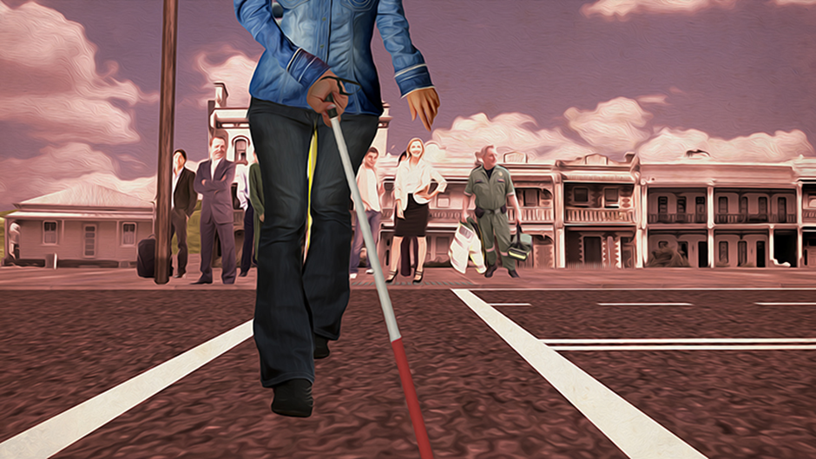

Step 1

Locate the curb

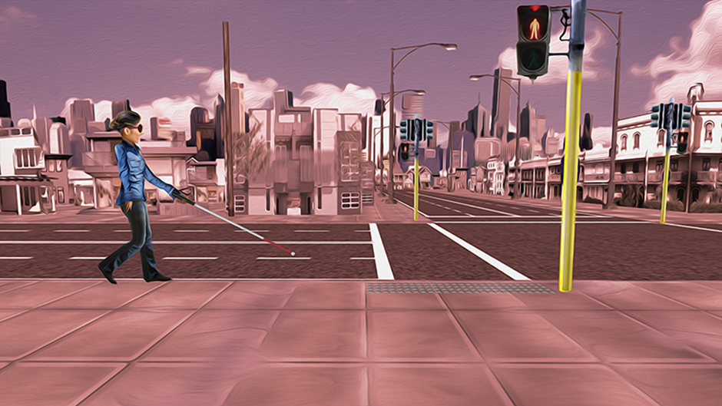

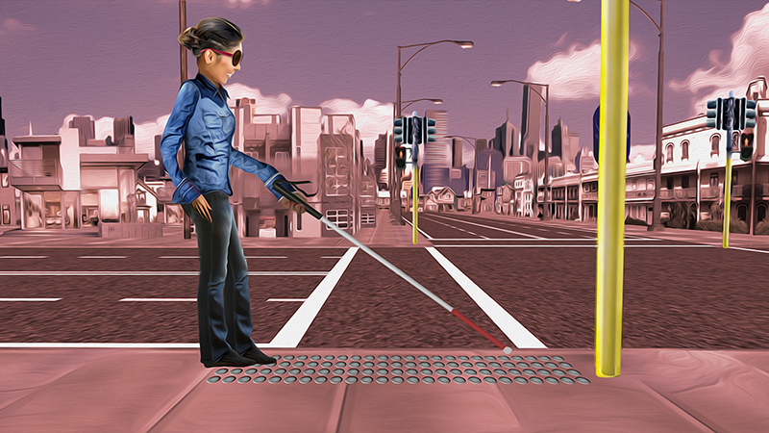

Step 2

Stop

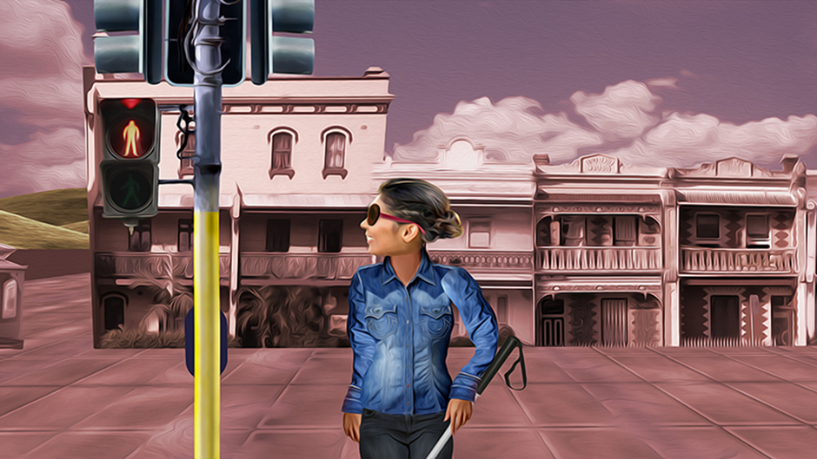

Look



Listen

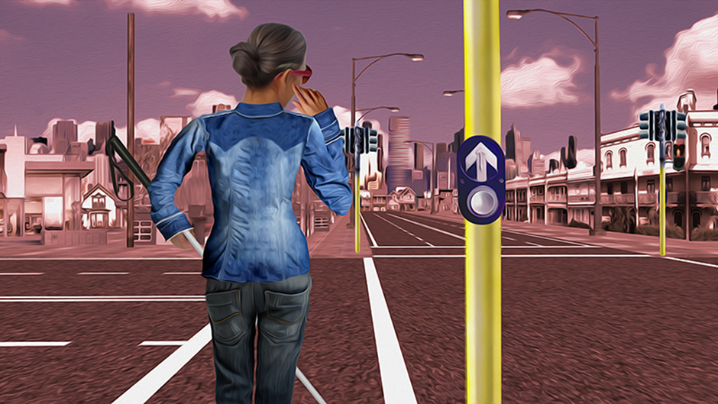

Think

Step 3

Hold the cane diagonally across your body. Stand confidently.

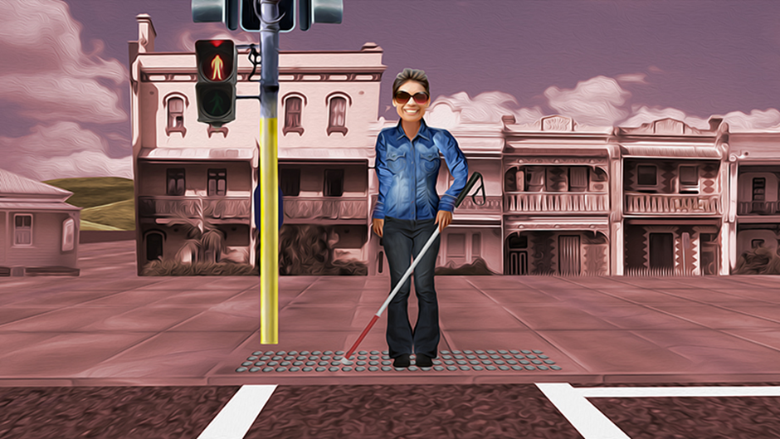

Step 4

When safe, swing cane in front. Pause briefly, then cross

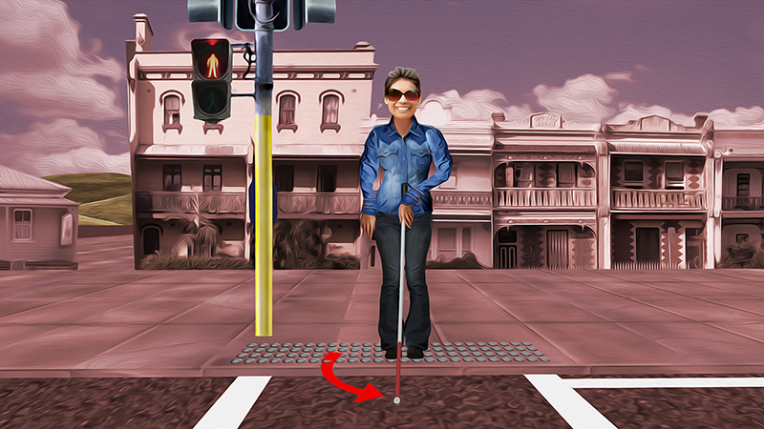

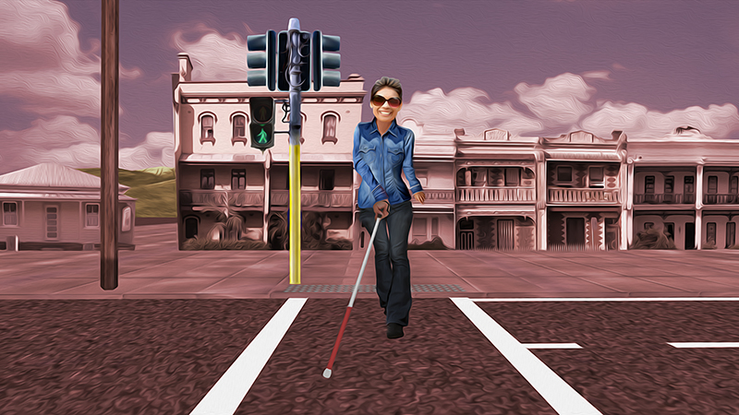

More information:
Vision Australia
Telephone: 1300 847 466 or go online to www.visionaustralia.org

Guide Dogs Victoria
Telephone: (03) 9854 4444 or go online to www.guidedogsvictoria.com.au

“I might not see you, but you can always see me”
Road safety for people who are blind or have low vision.

Vision Australia and Guide Dogs Victoria, with the support of the Victorian Community Road Safety Partnership Program, are working together to increase pedestrian and road safety.

