Sticks, dogs and road safety

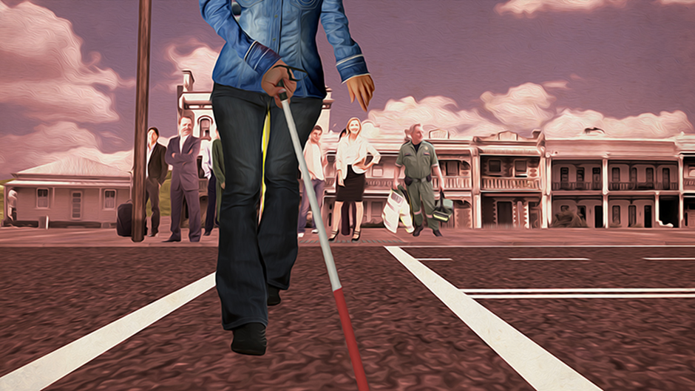

These sticks are called canes

- Long cane
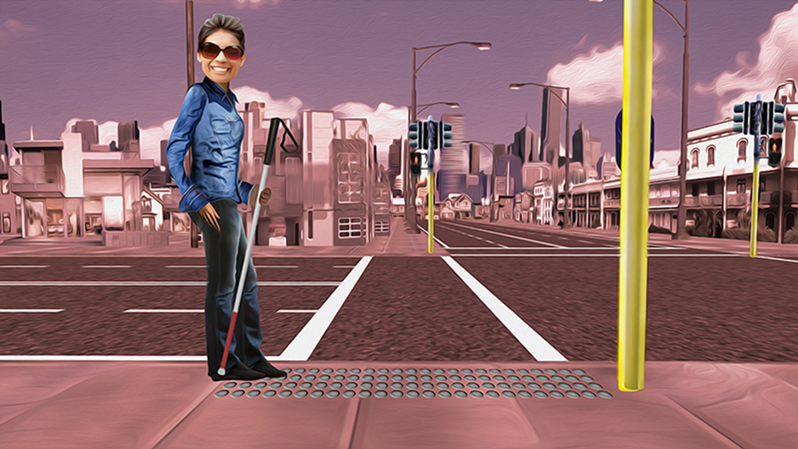

- Identification cane
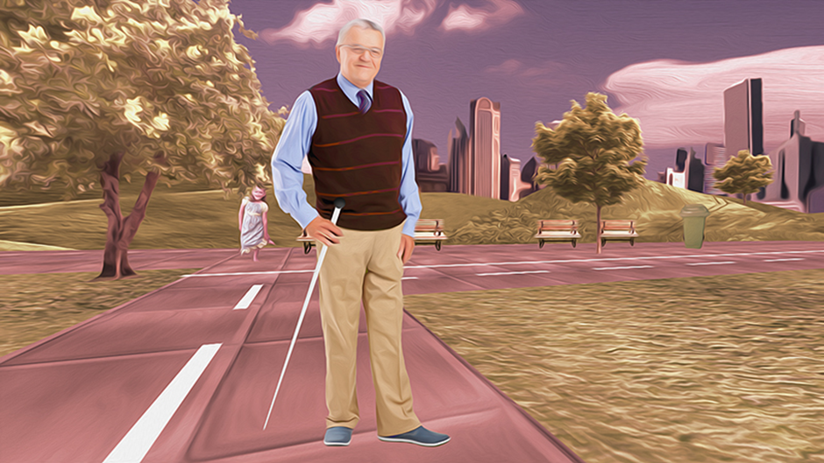

- Support cane
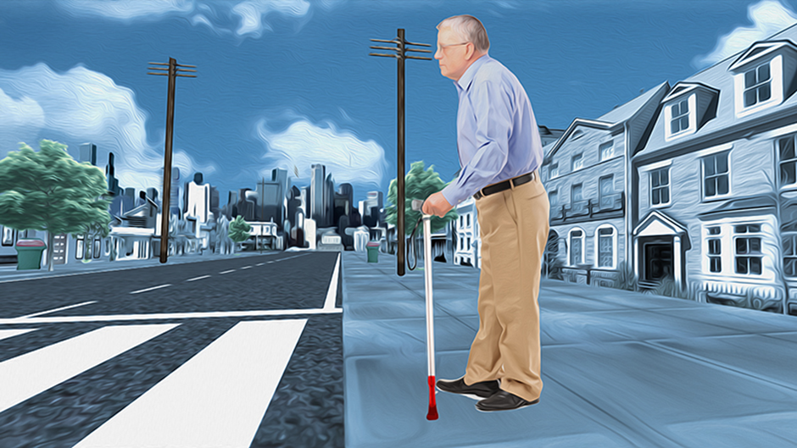

These are working dog guides

- Guide dog
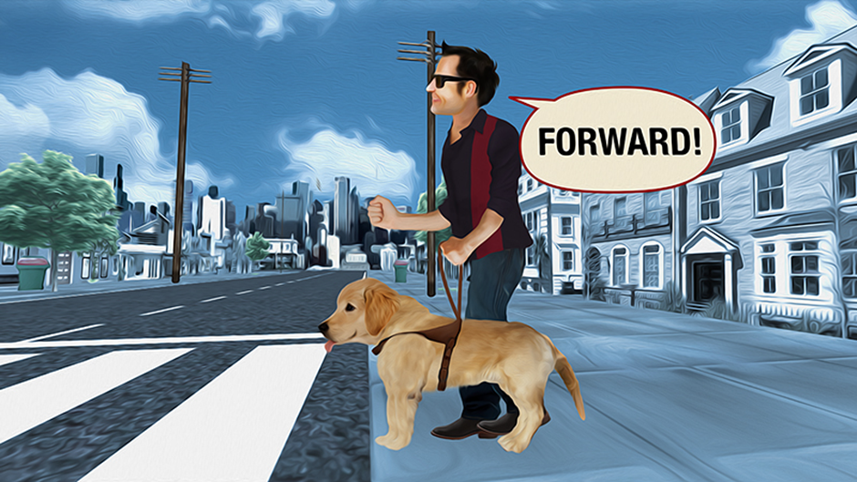

- Seeing eye dog
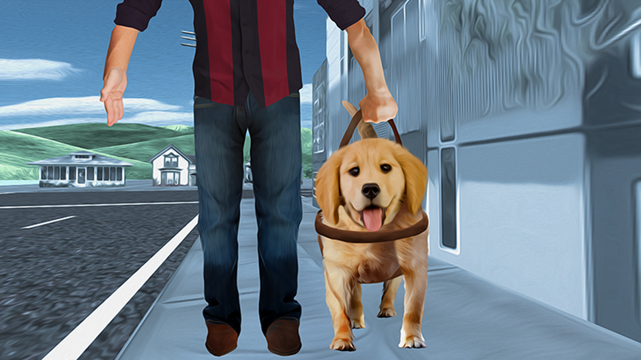

A white cane or a dog guide helps people who are blind or have low vision move around safely

Please be patient!

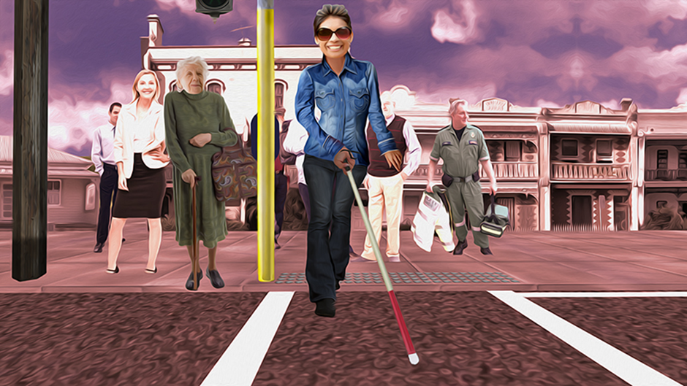

People who use a cane or dog may take longer to cross the road.

All drivers!
Be aware of pedestrians.

More information:
Vision Australia Telephone: 1300 847 466 or www.visionaustralia.org
Guide Dogs Victoria Telephone: (03) 9854 4444 or www.guidedogsvictoria.com.au
VicRoads Telephone: 131 171 or www.vicroads.vic.gov.au

“I might not see you, but you can always see me”
Road safety for people who are blind or have low vision.

Vision Australia and Guide Dogs Victoria, with the support of the Victorian Community Road Safety Partnership Program, are working together to increase pedestrian and road safety.

