# What to do when I see a person with vision loss crossing the road?

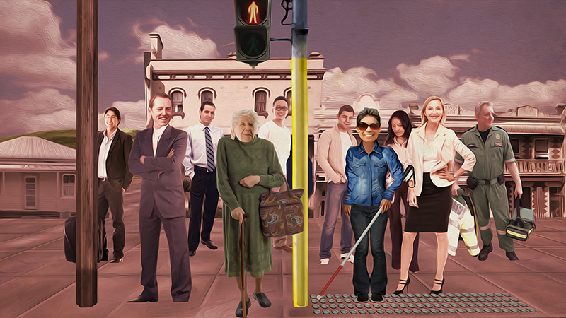

## Be cool

### Remain patient

### Always drive within the road rules

### If the pedestrian waves you on and it is safe to do so, please go.

## Don’t be reckless

### Don’t drive too fast or too slow

### Don’t yell or honk your horn

### Don’t wave or flash your headlights

### Don’t leave your car to help someone cross.

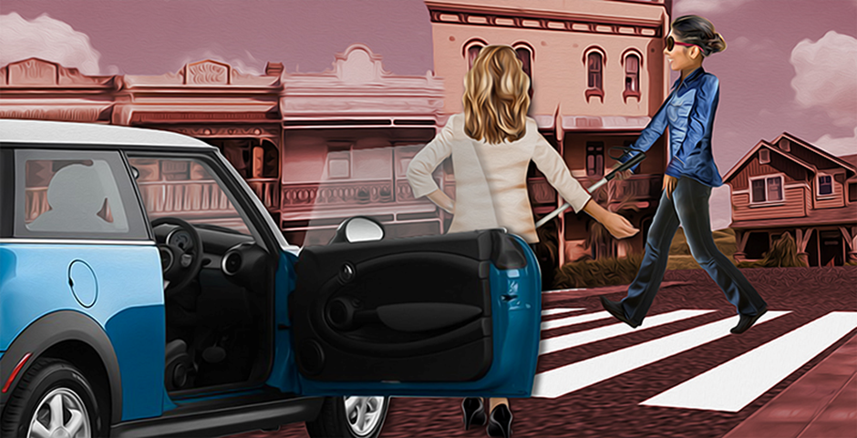

**For further information**

Vision Australia

Telephone: 1300 847 466 or go online to [www.visionaustralia.org](http://www.visionaustralia.org)

Guide Dogs Victoria

Telephone: (03) 9854 4444 or go online to [www.guidedogsvictoria.com.au](http://www.guidedogsvictoria.com.au)

**“I might not see you, but you can always see me”**

Road safety for people who are blind or have low vision.

Vision Australia and Guide Dogs Victoria, with the support of the Victorian Community Road Safety Partnership Program, are working together to increase pedestrian and road safety.