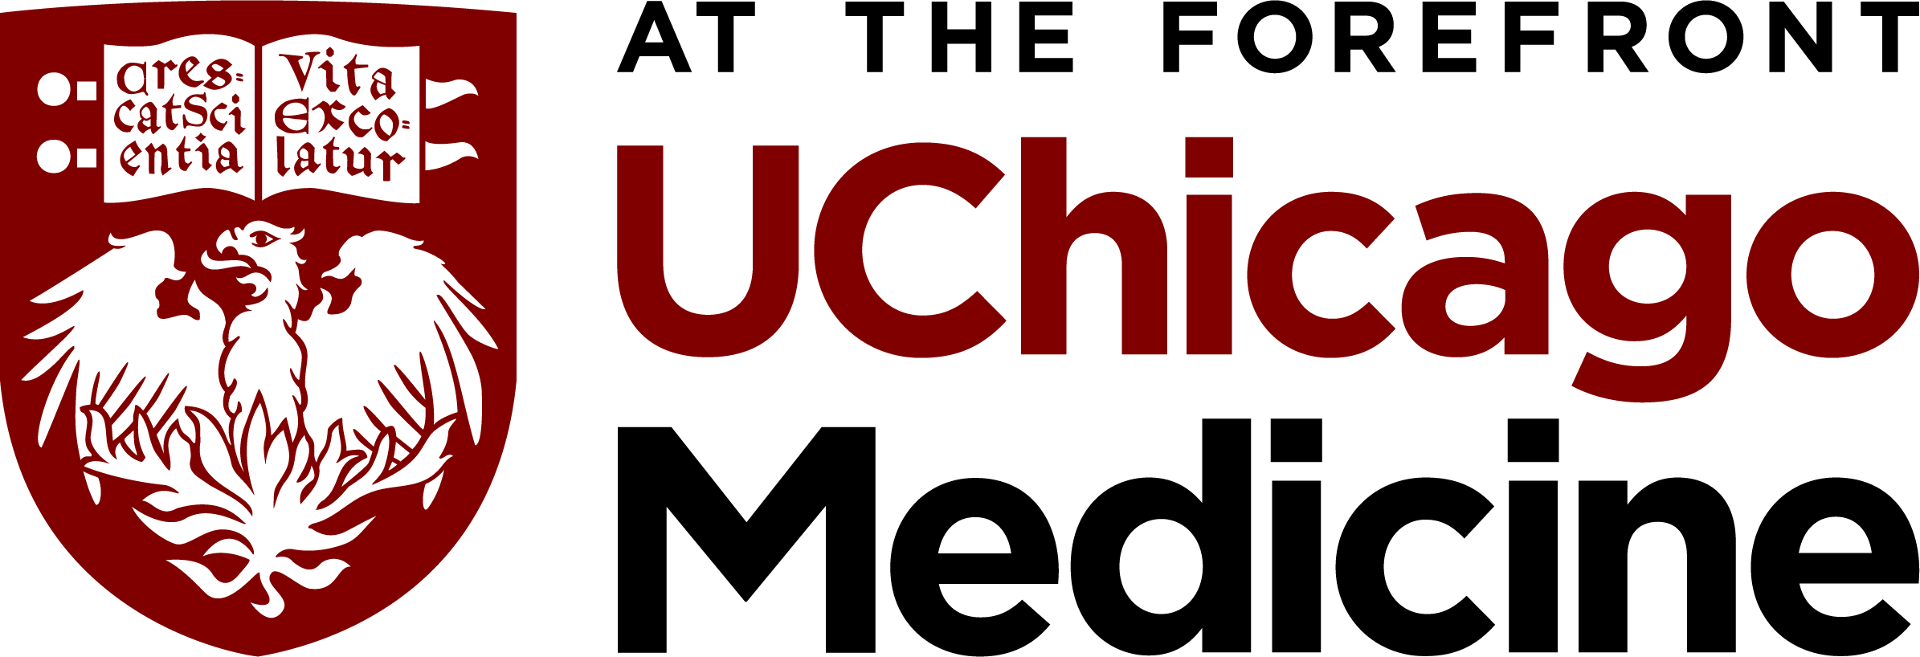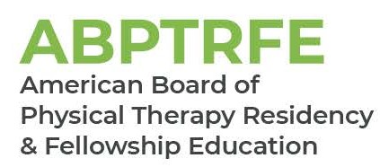

Physical Therapy Orthopaedic Residency Program

Naomi Bloch, PT, DPT
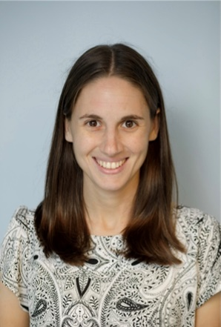
- Doctorate of Physical Therapy, Hunter College –2017
- Certified Vestibular Rehabilitation Specialist via Duke University
- APTA Credential Clinical Instructor
- Associate Faculty member for the University of Chicago Physical Therapy Orthopaedic Residency Program
- Member of the American Physical Therapy Association- Neurology Section
- Teaches: Vestibular lecture

Donald Ciancio, PT, DPT
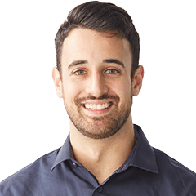
- Doctorate of Physical Therapy, Northwestern University Feinberg School of Medicine – 2017
- Residency-trained through the Mayo Clinic Physical Therapy Orthopaedic Residency
- ABPTS Board Certified Orthopaedic Clinical Specialist
- APTA Credential Clinical Instructor
- Faculty member for the University of Chicago Physical Therapy Orthopaedic Residency Program
- Member of the American Physical Therapy Association – Orthopaedic Section
- Teaches: Lumbar Spine module, Tendinopathy

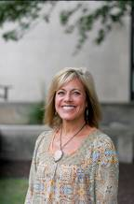
Jennifer Gilbertson, PT, DPT, MHS
- Doctorate of Physical Therapy, Arcadia University – 2016
- Masters of Health Sciences degree in Physical Therapy, Krannert School of Physical Therapy in Indianapolis –1995
- Bachelor of Science Degree in Physical Therapy, Northwestern University –1987
- Bachelor of Arts Degree, Southern Illinois University – 1986
- ABPTS Board Certified Orthopaedic Clinical Specialist
- Faculty member for the University of Chicago Physical Therapy Orthopaedic Residency Program
- Director of Outpatient Therapy Services for University of Chicago Medicine and Ingalls Memorial Hospital
- Member of the American Physical Therapy Association – Orthopaedic Section

Steph Groth, PT, DPT

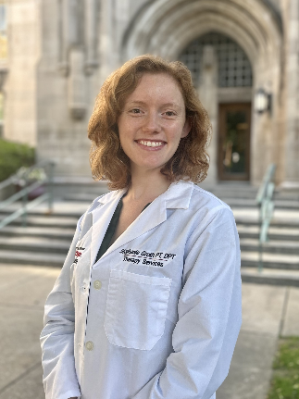
- Doctorate of Physical Therapy, Saint Louis University, 2018
- Residency-trained through the University of Chicago Physical Therapy Orthopaedic Residency
- ABPTS Board Certified Orthopaedic Clinical Specialist
- APTA Credential Clinical Instructor
- Member of the American Physical Therapy Association – Orthopaedic Section, Foot/Ankle Special Interest Group, Performing Arts Special Interest Group
- Faculty member for the University of Chicago Physical Therapy Orthopaedic Residency Program
- Teaches: Foot and Ankle module, Endocrinology

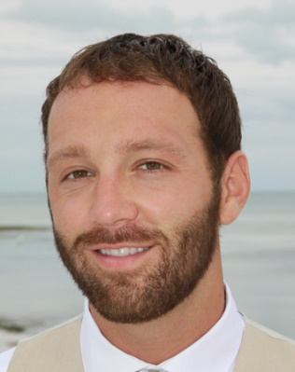
Roy Horton, PT, DPT
- Doctorate of Physical Therapy, Midwestern University – 2017
- Residency-trained through the University of Chicago Physical Therapy Orthopaedic Residency
- Fellowship-trained at the University of Chicago Orthopaedic Manual Physical Therapy Fellowship
- Fellow of the American Academy of Orthopaedic Manual Physical Therapists
- ABPTS Board Certified Orthopaedic Clinical Specialist
- APTA Certified Clinical Instructor, Level I and II
- Program Director and Faculty of the University of Chicago Medicine Orthopaedic Residency Program
- Program Coordinator for Outpatient Physical Therapy Professional Development
- Site Clinical Coordinator of Education, Outpatient Therapy Services
- Adjunct Faculty at Midwestern University
- Member of the American Physical Therapy Association – Orthopaedic Section, and American Academy of Orthopaedic Manual Physical Therapists
- Teaches: Clinical Reasoning, TMJ, and Knee module

Isabelle Houser, PT, DPT

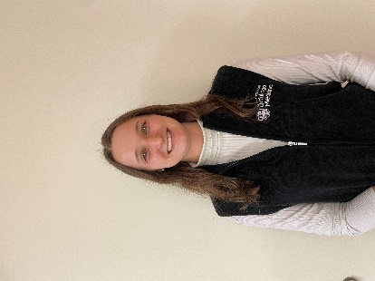
- Doctorate of Physical Therapy, Arcadia University, 2022
- Residency-trained through the University of Chicago Physical Therapy Orthopaedic Residency
- ABPTS Board Certified Orthopedic Clinical Specialist
- APTA Credential Clinical Instructor
- Faculty member for the University of Chicago Physical Therapy Orthopaedic Residency Program
- Teaches: Hip module

Rachel Hunt, PT, DPT

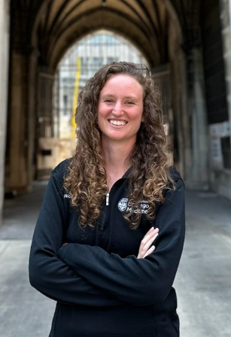
- Doctorate of Physical Therapy, Ohio University – 2020
- Residency-trained through the University of Chicago Physical Therapy Orthopaedic Residency
- Fellowship-trained at the University of Chicago Orthopedic Orthopaedic Manual Physical Therapy Fellowship
- Fellow of the American Academy of Orthopaedic Manual Physical Therapists
- ABPTS Board Certified Orthopedic Clinical Specialist
- APTA Certified Clinical Instructor
- Faculty of the University of Chicago Medicine Orthopaedic Residency Program
- Annual guest speaker at Ohio University
- Member of the American Physical Therapy Association – Orthopaedic Section, and American Academy of Orthopaedic Manual Physical Therapists
- Teaches: Thoracic spine module, Concussion, Running

Sarah Macaraeg, PT, DPT
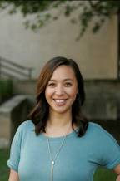
- Doctorate of Physical Therapy, Saint Louis University – 2012
- Residency-trained through the University of Chicago Physical Therapy Orthopaedic Residency
- Fellowship-trained at the University of Chicago Orthopaedic Manual Physical Therapy Fellowship
- Fellow of the American Academy of Orthopaedic Manual Physical Therapists
- PhD candidate Arcadia University
- ABPTS Board Certified Orthopaedic Clinical Specialist and Women’s Health Clinical Specialist
- Certified – Integrative Dry Needling
- Certificate of Achievement in Pelvic Physical Therapy
- APTA Certified Clinical Instructor
- Faculty member for the University of Chicago Physical Therapy Orthopaedic Residency Program
      - Member of the American Physical Therapy Association – Orthopaedic Section and Pelvic Health, and American Academy of Orthopaedic Manual Physical Therapists
      - Teaches: Neurodynamics

Kenarr Matoesian

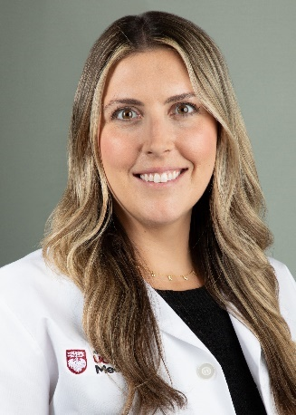
- Doctorate of Physical Therapy, Midwestern University – 2019
      - Residency-trained through the Loyola Medicine Women's Health Residency program
      - ABPTS Board Certified Women's Health Clinical Specialist
      - APTA Certified Clinical Instructor
      - Member of the American Physical Therapy Association –Pelvic Health Section
      - Prior faculty for Loyola Medicine Women's Health Residency program (Modules included pregnancy/postpartum, neurological screening, and coccydynia)
      - Faculty for University of Chicago Physical Therapy Orthopaedic Residency Program
      - Teaches: Sacroiliac Joint/Pelvic Girdle Pain and Pelvic Floor for the Orthopaedic Therapist

Sean McMahon, PT, DPT
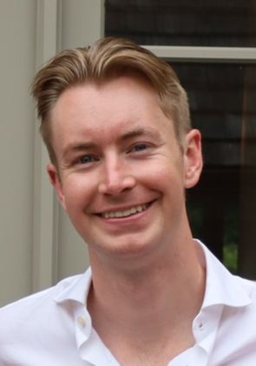
- Doctorate of Physical Therapy, Saint Louis University – 2019
      - ABPTS Board Certified Orthopaedic Clinical Specialist
      - APTA Credential Clinical Instructor
      - Faculty member for the University of Chicago Physical Therapy Orthopaedic Residency Program
      - Myopain Certified Manual Trigger Point and Dry Needling Clinician
      - Member of the American Physical Therapy Association
      - Teaches: Shoulder module, Pharmacology

Ramzi Nakhoul, PT, DPT
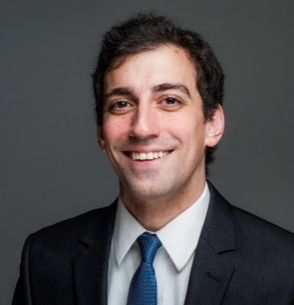
- Doctor of Physical Therapy, University of Illinois at Chicago, 2019
- Residency-trained through the University of Chicago Medicine Physical Therapy Orthopaedic Residency Program
- Fellowship-trained through the Northwestern University Fellowship in Advanced Orthopedic Physical Therapy Practice, Research, and Education
- Fellow of the American Academy of Orthopaedic Manual Physical Therapists
- ABPTS Board-Certified Orthopaedic Clinical Specialist
- APTA Credentialed Clinical Instructor
- Member of the American Physical Therapy Association, Orthopaedic Section, and the Illinois Physical Therapy Association
- Faculty member for the University of Chicago Medicine Physical Therapy Orthopaedic Residency Program
- Teaches: Clinical Reasoning, Cervical Spine

Zach Stapleton, PT, DPT

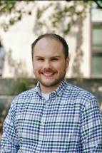
- Doctorate of Physical Therapy, Carroll University – 2016
- Residency-trained through the University of Chicago Physical Therapy Orthopaedics Residency
- Fellowship-trained at the University of Chicago Orthopaedic Manual Physical Therapy Fellowship
- Fellow of the American Academy of Orthopedic Manual Physical Therapists
- ABPTS Board Certified Orthopaedic Clinical Specialist
- APTA Credential Clinical Instructor
- Faculty member for the University of Chicago Physical Therapy Orthopaedic Residency Program
- Member of the American Physical Therapy Association – Orthopaedic Section, Midwest Pain Society, and American Academy of Orthopaedic Manual Therapy Physical Therapists
- Teaches: Chronic Pain, Regenerative Medicine/Genetics, Radiology, and Rheumatology

Megan Stulberg, PT, DPT
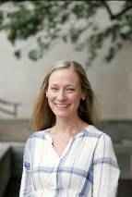
- Doctorate of Physical Therapy, University of Illinois at Chicago – 2008
- ABPTS Board Certified Cardiopulmonary Clinical Specialist
- APTA Credentialed Clinical Instructor
- Faculty member for the University of Chicago Physical Therapy Orthopaedic Residency Programs
- Adjunct Faculty at Northwestern University and Arcadia University
- Member of the American Physical Therapy Association - Section of Acute Care and Cardiopulmonary, and member of the American Association of Cardiovascular and Pulmonary Rehabilitation
- Teaches: Cardiopulmonary

Russ Thompson, OTR/L
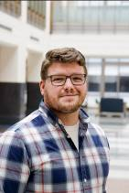
- Masters of Occupational Therapy Governors States University-2012
- Board Certified Hand Therapist
- Member of the Illinois Occupational Therapy Association, Hand Therapy Certification Commission, President – Chicago Metro Hand Study Organization (CMHS)
- Teaches: Elbow, Wrist, and Hand Module


Morgan Zaranec, PT, DPT
- Doctor of Physical Therapy, University of Illinois at Chicago
- Residency-trained through The James Cancer Hospital and Solove Research Institute at The Ohio State University Comprehensive Cancer Center
- Adjunct Faculty at University of Illinois at Chicago
- Faculty member for the University of Chicago Physical Therapy Orthopaedic Residency Program
- Member of the American Physical Therapy Association
- Teaches: Oncology

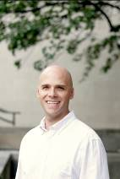
Mike Vitt, PT, DPT
- Doctor of Physical Therapy, Northwestern University – 2012
- Fellowship-trained at the University of Chicago Orthopaedic Manual Physical Therapy Fellowship
- Fellow of the American Academy of Orthopaedic Manual Physical Therapists
- ABPTS Board Certified Orthopaedic Clinical Specialist
- Certified – Integrative Dry Needling
- Registered in Musculoskeletal Sonography
- APTA Certified Clinical Instructor, Level I and II
- University of Chicago Medicine outpatient therapy services supervisor
- Faculty member for the University of Chicago Medicine Physical Therapy Orthopaedic Residency Program
- Member of the American Physical Therapy Association and American Academy of Orthopaedic Manual Physical Therapists
- Teaches: Ultrasound

