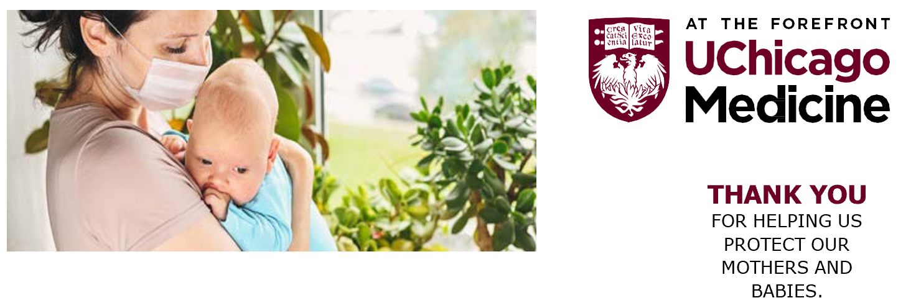

DEAR FRIENDS AND FAMILY,
The flu season will be here soon and we must protect women who are pregnant, new moms and babies from a flu infection. They can easily get sick from contact with visitors, friends and family members who may only have mild flu symptoms.

Here are some ways you can help protect women who are pregnant, new moms and babies:



All pregnant women should get a flu vaccine.

Wear a mask if you think you have flu symptoms.
All family members and caregivers of babies should get a flu vaccine.
Wash your hands right before coming into contact with a pregnant woman or a newborn.

FOR MORE INFORMATION ON THE FLU VACCINES
visit UChicagoMedicine.org/flu
Most vaccine sites are by appointment only.

