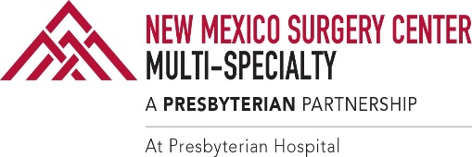

# Please read the following and gather all required documentation *before* submitting the Financial Assistance Application form. This application will apply to any outstanding NMSCMS balances within the 240-day application period (PFS.PDS.115).

## To determine your eligibility for Financial Assistance, along with your completed application, you must supply copies of any additional requested information using one of the following methods:

* Within 10 business days, you can:

o Mail to:

***New Mexico Surgery Center Multi-Specialty***

***Attention: Business Office***

***201 Cedar St SE Ste, 7650***

***Albuquerque, NM 87106***

o Fax to: *(****505) 355-5912***

## Information you must mail, or fax includes:

* A completed financial assistance application
* Prior year's tax return(s)
* Minimum of two most recent pay stubs
* Other proof of income as defined by Family Income **
* Notarized Affidavit (only if above documentation is absent/non-applicable)

## Persons who apply for financial assistance must first explore other sources of funding.

**You must indicate on the form which of the following you have applied for, and mail/fax documentation of the reasons you were not eligible.**

* Information about any types of group and/or employee insurance
* Medicaid status
* State or county assistance details
* COBRA coverage

## The form also requires you to fill in:

* Reasons why you cannot pay your account balance
* Members of your household: name, dob, relationship

Should you need further assistance, you may reach our Customer Service Center, Monday-Friday 8:00am to 5:00pm at (505) 317-9444; or fax all completed documentation to (505) 355-5912.

**\*\*Family Income:** Family Income is the income of all members 15 years old and over in a family, summed and treated as a single amount, as defined by the Census Bureau, including pre-tax earnings, unemployment compensation, workers’ compensation, Social Security, Supplemental Security Income, public assistance, veterans’ payments, survivor benefits, pension or

retirement income, interest, dividends, rents, royalties, income from estates, trusts, educational assistance, alimony, child support, assistance from outside the household, and other miscellaneous sources. Noncash benefits (such as food stamps and housing subsidies) are not included. Earned income of a dependent child will be excluded if it does not exceed $5,450 annually.