Table of Contents

Introduction 2
Overview 2
Getting Started 3
Overview 3
Introducing ZLPRS 4
System Requirements 5
How to Log On 6
The ZLPRS Home Page 12
Using Location Maintenance 13
Overview 13
How to Use Location Maintenance 14
Key Location Maintenance Fields 16
How to Add a New Location 18
How to Search On Locations 24
How to Modify Location Information 26
How to Modify Premium Information 28
How to Cancel Locations 33
How to Extend Locations 36
How to Renew Locations 39
How to Rescind Endorsements 41
How to Reinstate Endorsements 43
Using Reports 45
Overview 45
How to Use Reports 46
How to Run a Standard Report 48
Standard Reports 50
Contact 56

Introduction

Overview
Introduction | Welcome to ZLPRS training!  This course provides:  - An overview of ZLPRS  - An explanation of ZLPRS features and functionality: Getting Started using LPRS, Location Maintenance and Reports

Objectives | After completing this course, you will understand how to:  - Access ZLPRS on the Zurich web site  - Use Location Maintenance to add and search on locations  - Use Reports to run ZLPRS standard reports

Getting Started

Overview
Introduction | Before beginning, it is important to gain a general understanding of the system.  This chapter:  - Provides an overview of ZLPRS  - Lists ZLPRS system requirements  - Describes how to log on  - Explains the ZLPRS Home Page

In this Chapter | This chapter contains the following topics.

Topic | See Page
Introducing ZLPRS | 4
System Requirements | 5
How to Log On | 6
The ZLPRS Home Page | 12

Introducing ZLPRS
Introduction | This topic provides an overview of ZLPRS.  This includes:  - Describing what ZLPRS is  - Detailing the benefits of ZLPRS

What Is ZLPRS? | Zurich’s Lender Property Reporting System (ZLPRS) is a Web-based Policy Maintenance system for Zurich’s Lender Placed Policy processing.  The user portion of the software consists of two main features:  - Location Maintenance  - Reports  There are three other features that will be used internally by Zurich. These sections include:  - Extract Maintenance  - Policy Maintenance  - Security Maintenance
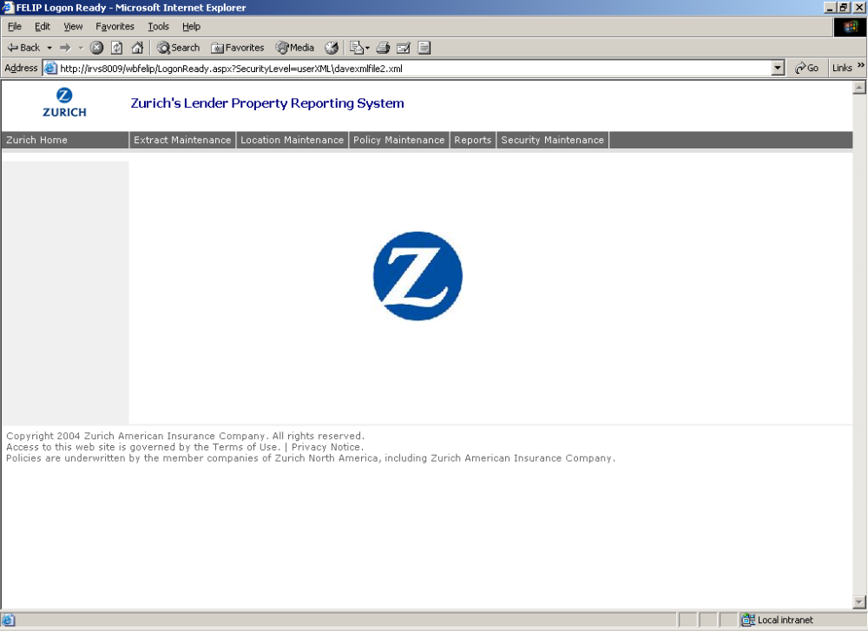
Maintain individual Locations issued by each client

Add and Maintain Policies by Zurich employees
View real-time LPRS Standard Reports
Add and Modify Users by Security Administrators
Manage and Maintain ZLPRS Data Extract Process

System Requirements
Introduction | In order to begin, you must first check if your PC meets the system requirements.  This topic details:  - General system requirements

ZLPRS System Requirements | Recommended software requirements:  - Operating System: Windows 2000  - Internet Access: Internet Explorer 6  Recommended hardware requirements:  - Internet Connection: 28K modem or greater  - Computer/Processor: 133 MHz or higher Pentium-compatible CPU  - Memory: 64 megabytes (MB) of RAM

How to Log On
Introduction | Once your system is ready, you can log on.  This topic:  - Explains how to log on for the first time  - Explains how to log on following the first time  - Explains how to log out of the system

Accessing the Zurich web site | To access the ZLPRS, go the Zurich in North America website at www.zurichna.com.  - On the blue navigation bar, at the top of the web page, click on Login.  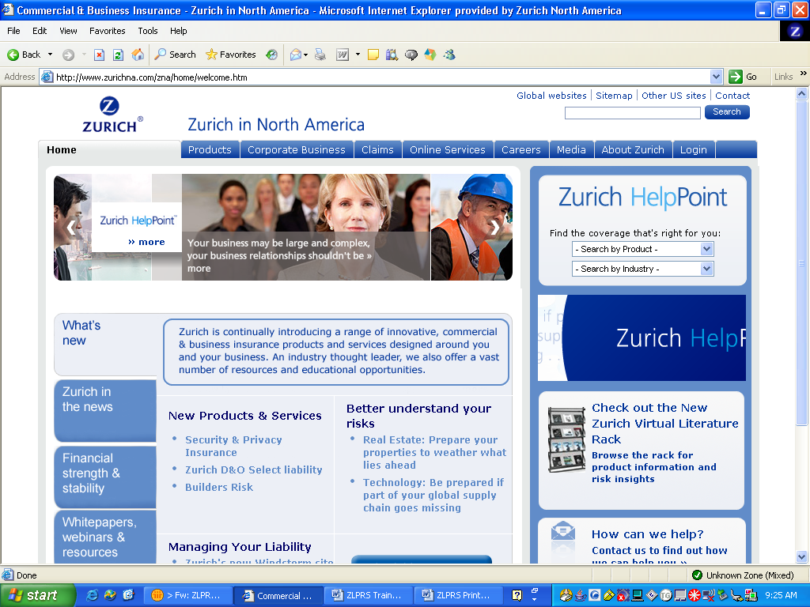  - Type in your user name and password, then click on login. You will automatically return to the Zurich homepage.  - On the blue navigation bar, at the top of the page, click on Online Services.  - Click on Customers.  - Scroll down the list of On Line Services until you find ZLPRS. Click on ZLPRS.  - Once in the Zurich Lenders Property Reporting System page, click on Access ZLPRS.  - The ZLPRS logon information screen will appear.
How to Log On for the first time | To log on to ZLPRS for the first time, complete the following steps.
 |  | Step | Action
 |  | 1 | Open your internet browser.
 |  | 2 | The login screen appears. The User field will be pre-populated through the ZNA web site and therefore will not require reentry in ZLPRS.  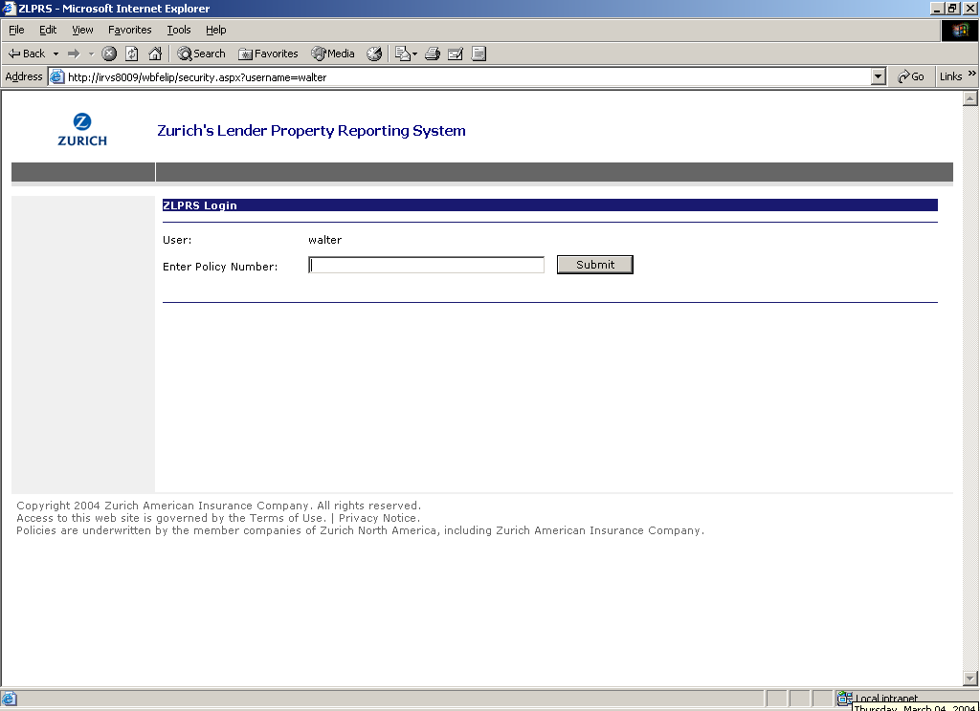
 |  | 3 | In the Policy Number field, type an LPR Policy Number that you need to access. Click Submit.  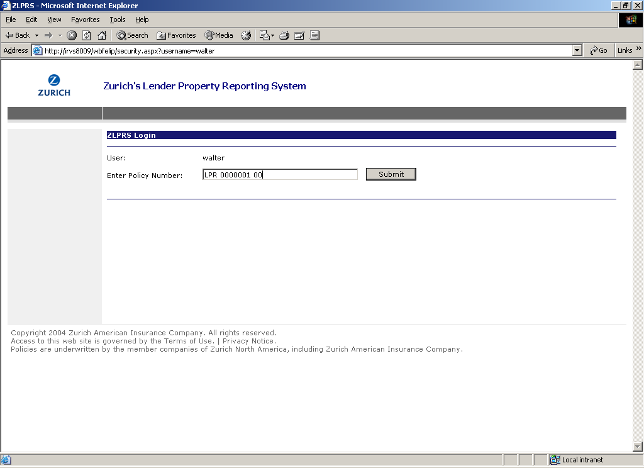
 |  | 4 | During your first login, you will have the opportunity to associate additional policy numbers to your User ID. If you only need to access a single policy number, click Continue.  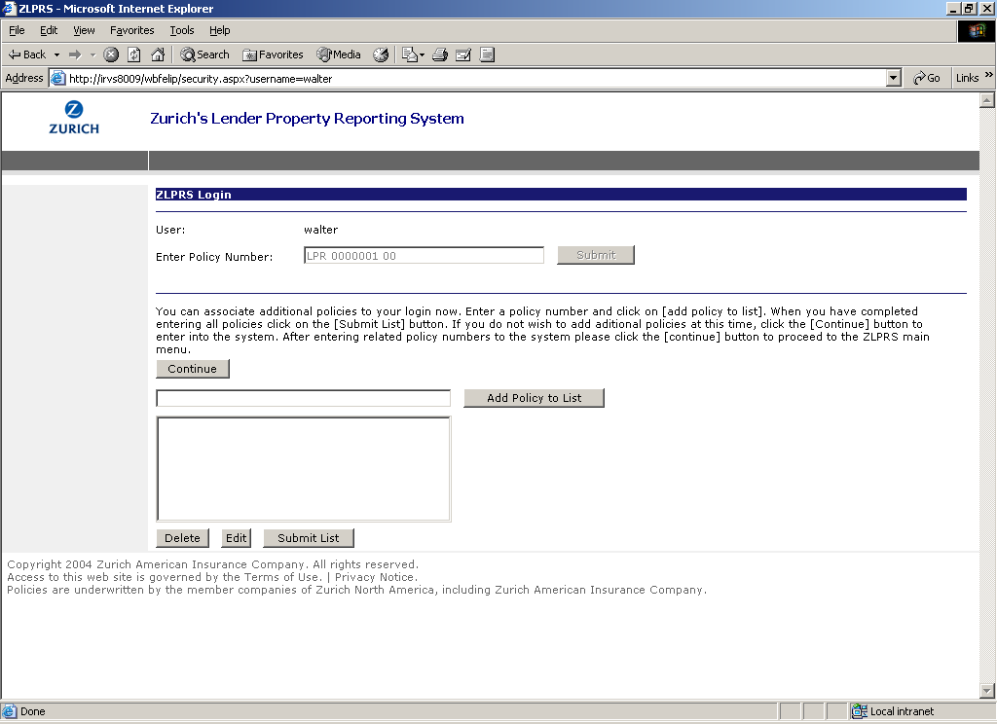
 |  | 5 | If you need to access additional policy numbers, type in each policy number and click Add Policy to List. This will populate the list box with all of the LPR policy numbers assigned to you. Click Submit List to relate the listed policy numbers to your User ID, and click Continue to proceed in ZLPRS.  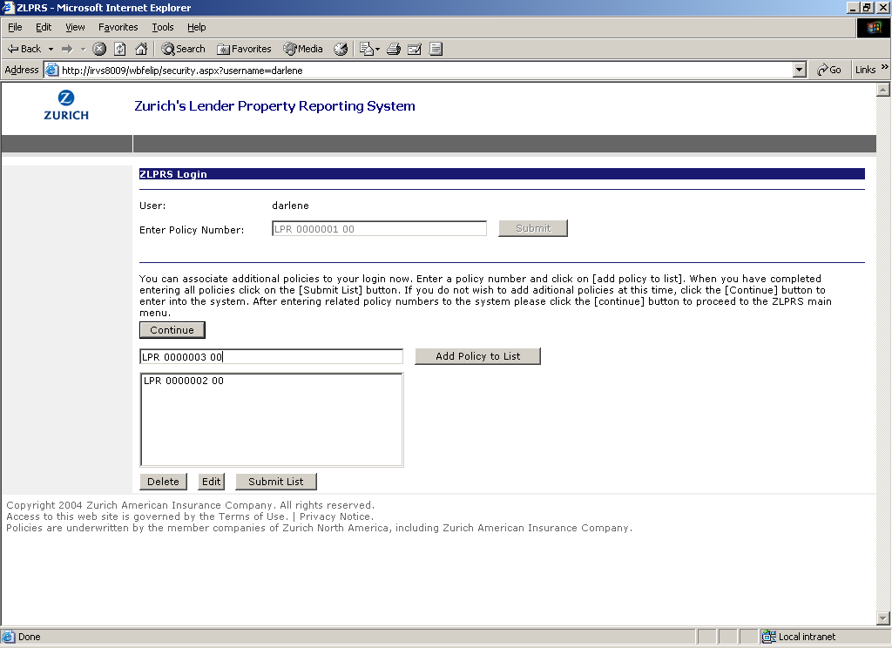

How to Log On following the first time | To log on to ZLPRS, complete the following steps.

Step | Action
1 | Open your internet browser.
2 | The login screen appears. The User field will be pre-populated through the ZNA web site and therefore will not require reentry in ZLPRS.  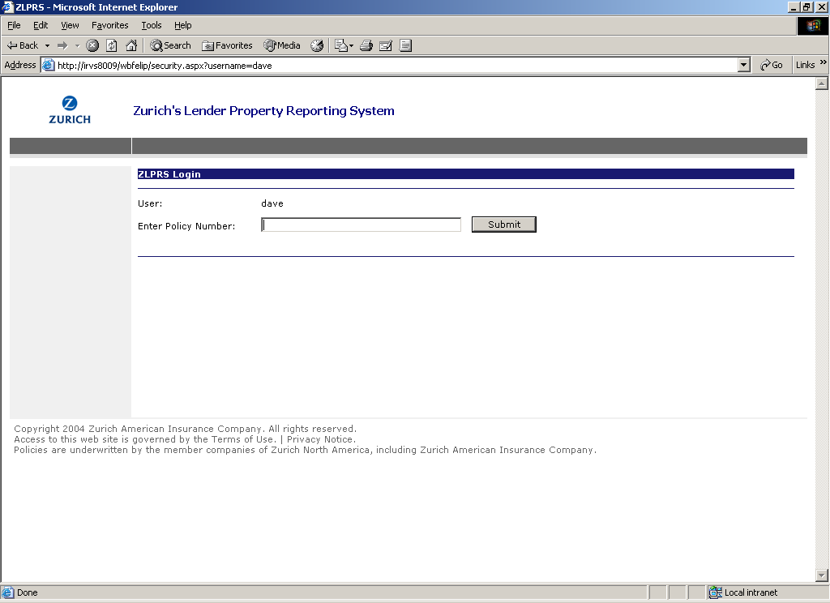
3 | In the Policy Number field, type the LPR Policy Number and Click Submit. Note: although you may be associated with multiple policy numbers, only a single policy number will be entered to log in to ZLPRS.  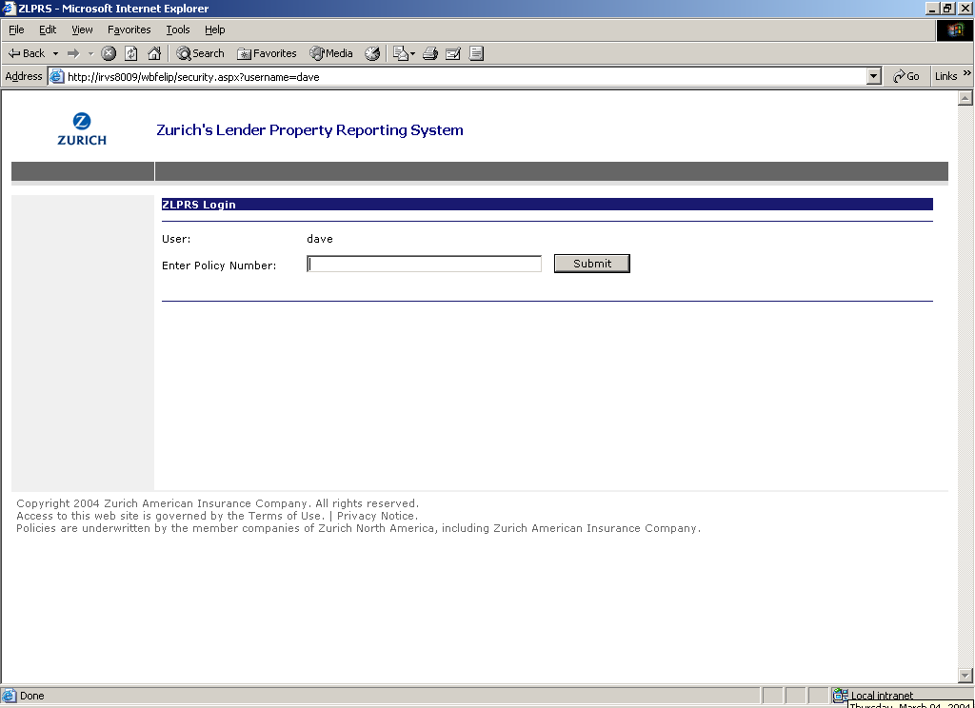
4 | The ZLPRS home page appears…  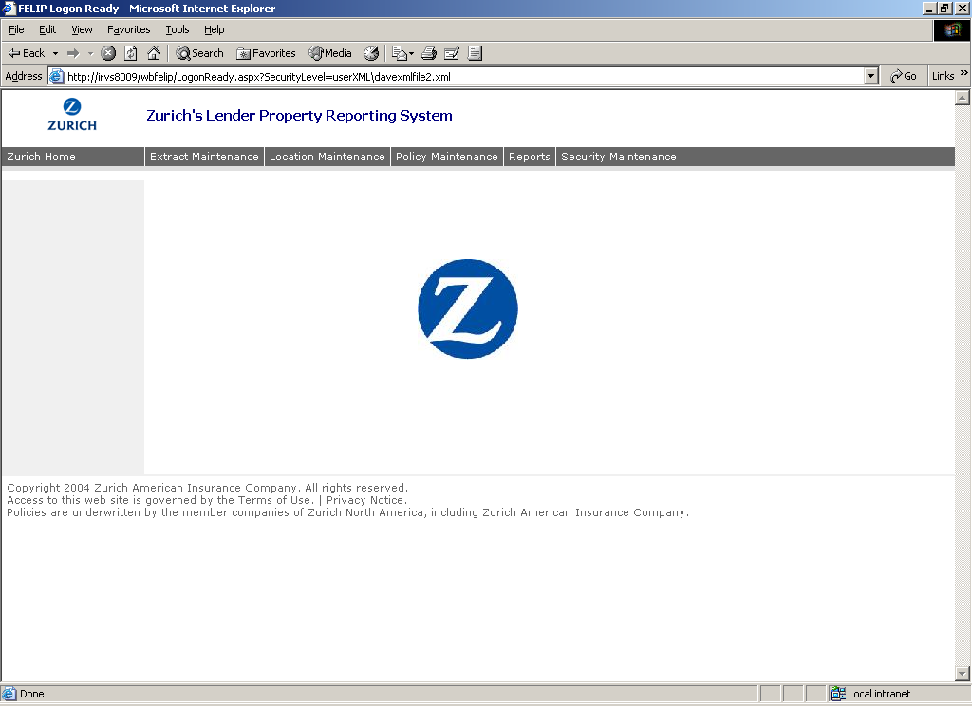
How to Log On, Continued

How to Log Out | There are no special steps required to log out of ZLPRS. To log off, simply exit out of Internet Explorer by selecting the Close option from the File menu, or clicking the X button at the top, right side of the window.

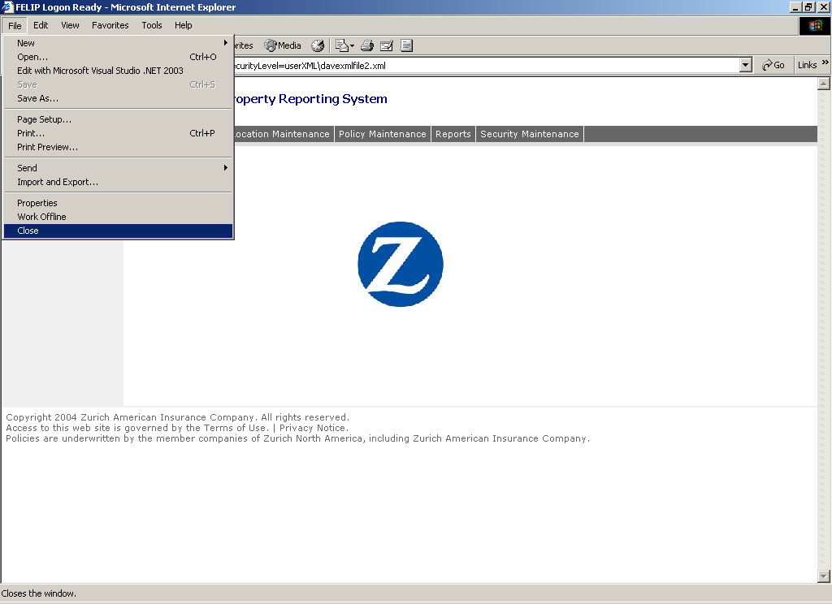

The ZLPRS Home Page
Introduction | This topic describes each component of the ZLPRS home page.

Components of the ZLPRS Home Page | The ZLPRS home page can consist of one to many of the main ZLPRS features based on defined user access:  - Extract Maintenance  - Location Maintenance  - Policy Maintenance  - Reports  - Security Maintenance  For example, if you have access to Location Maintenance and Reports, those tabs would be visible on the navigation bar. The example illustrated in the graphic below shows what a user with full system access would be presented.  In addition, all users would have access to the Zurich Home link.

ZLPRS functions (based on defined User access): Click to access one of the main functions of ZLPRS.

Zurich Home Link: Click to visit the Zurich Home web site
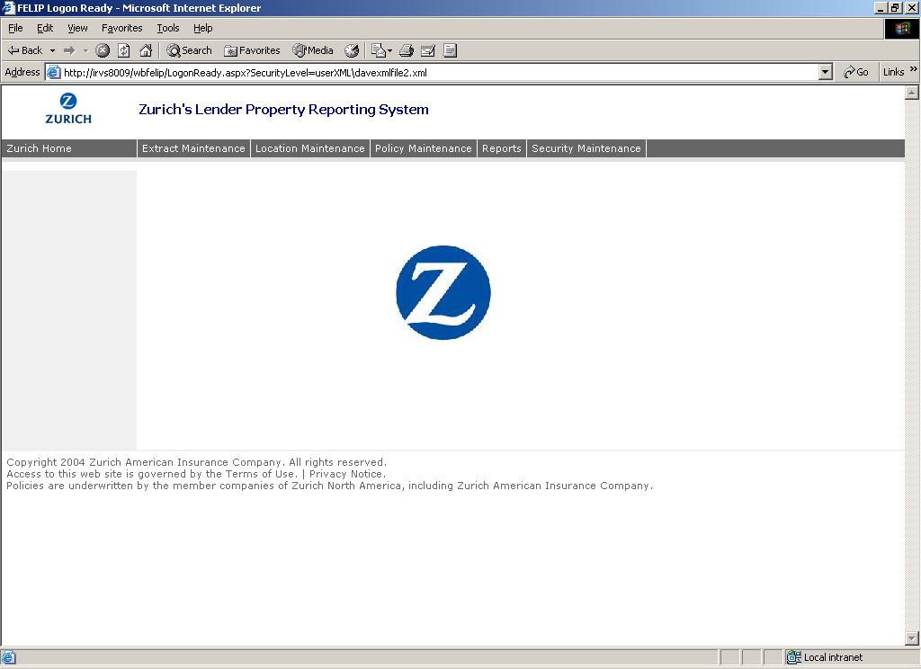

Using Location Maintenance

Overview
Introduction | Location Maintenance allows ZLPRS users to maintain the location data for Policy Numbers to which they have access. Functionality for this system includes the ability to: add new locations, endorse existing locations, rescind endorsements, extend locations, reinstate endorsements, cancel locations, renew locations, and search for existing locations.  This chapter:  - Explains how to use Location Maintenance and therefore pertains to ZLPRS users who have access to the Location Maintenance function  - Describes key Location Maintenance fields  - Explains how to add a new location  - Explains how to search on locations  - Explains how to modify location information  - Explains how to modify premium information  - Explains how to cancel locations  - Explains how to extend locations  - Explains how to renew locations  - Explains how to rescind endorsements  - Explains how to reinstate endorsements

In this Chapter | This chapter contains the following topics.

Topic | See Page
How to Use Location Maintenance | 14
Key Location Maintenance Fields | 16
How to Add a New Location | 18
How to Search on Locations | 24
How to Modify Location Information | 26
How to Modify Premium Information | 28
How to Cancel Locations | 33
How to Extend Locations | 36
How to Renew Locations | 39
How to Rescind Endorsements | 41
How to Reinstate Endorsements | 43

How to Use Location Maintenance
Introduction | This topic describes how to use Location Maintenance to maintain individual locations issued by each user.

How to Use Location Maintenance | To maintain ZLPRS locations, complete the following steps.

Step | Action
1 | From the ZLPRS Main Screen, click Location Maintenance.
2 | The main page of the Location Maintenance subsystem appears. The menu on the left hand side of the screen shows the two main functions of Location Maintenance: Add Location and Search.  Before performing any specific location transactions, you must select a Policy Number. You may be associated with more than one policy number and have access to all information related to those policies. The dropdown list provided contains the policy numbers that you can access and select. For additional clarity, policy related information is displayed on each Location Maintenance screen. This displayed information includes: Policy Number, Client Name, Policy Effective Date, Policy Expiration Date, and Insurance Limits.  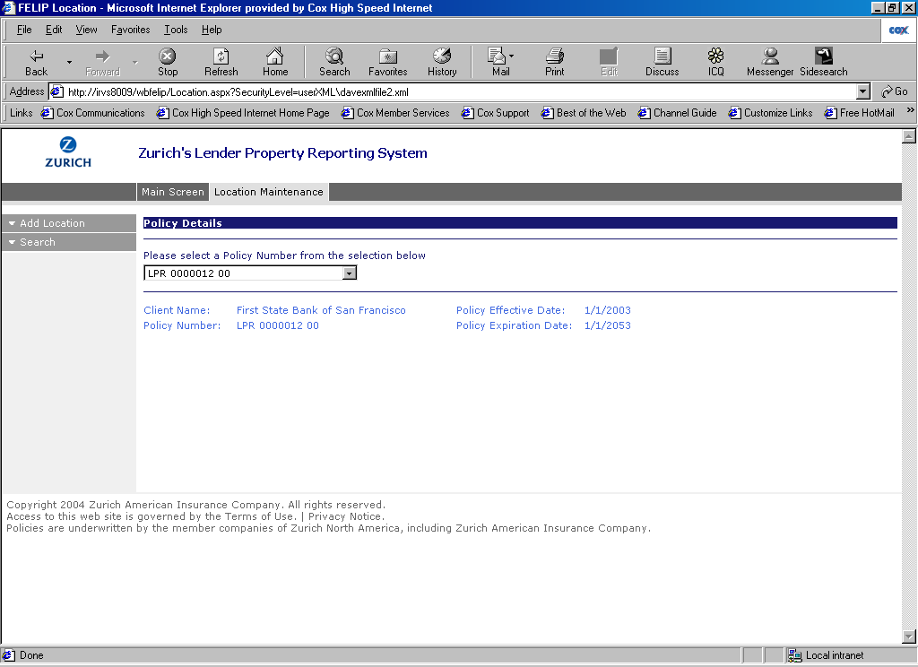

Key Location Maintenance Fields
Introduction | Regardless of the location maintenance function being performed, it is important to define some of the key location maintenance fields.  This section details the key location fields that appear on Location Maintenance screens.

Description of Settings | The following defines the loan and property level information to be entered by a user or generated by the system while maintaining locations. The first graphic focuses on coverage/pricing fields, while the second explains the key location information fields.

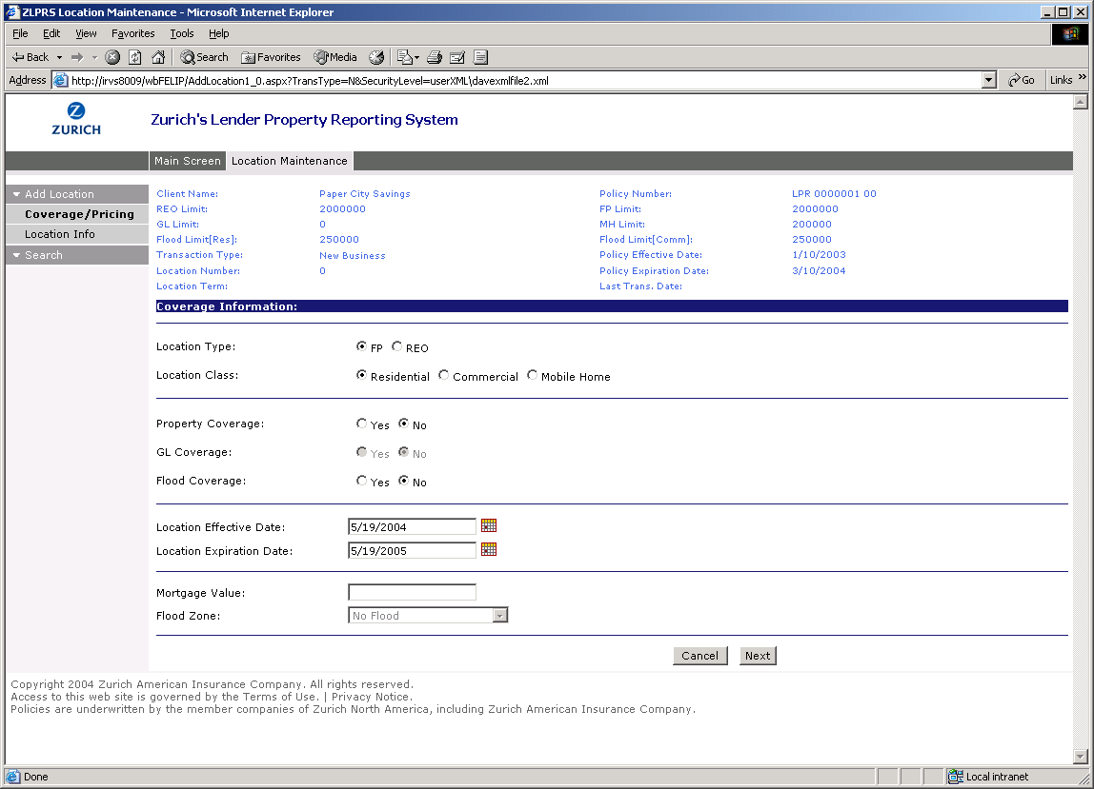
Mortgage Value is a required field whose whole number value must be greater than 0.
Location Class is a mandatory selection that can either be Residential, Commercial, or Mobile Home
Property Coverage is a mandatory selection that can either be Yes or No.
GL Coverage can either be Yes or No. This selection is disabled and defaulted to No if the Location Type is FP.
Location Type is a mandatory selection that can either be Forced Placed properties (FP), or Real Estate Owned properties (REO)

Transaction Type is a read-only text field specifying the type of transaction being performed.
Flood Coverage can either be Yes or No. This selection is disabled and defaulted to No if the Policy Type is REO.
Policy Effective Date is a read only text field and is presented for informational purposes only.
Policy Expiration Date is a read only text field and is presented for informational purposes only.
Location Effective Date will default to the current date, can be any date greater than or equal to the policy effective date, and cannot exceed the policy expiration date.
Location Expiration Date will default to the location effective date + 1 year, cannot be before the location effective date, and cannot exceed the policy expiration date.
Flood Zone is an enabled and required field if the Flood Coverage option is selected. Flood Zones contained within the drop down list include: A99 (1% or > chance of flood), All V zones (High Risk – Coastal), All A zones (High Risk Area), D (Undetermined), B, C, X (Moderate).

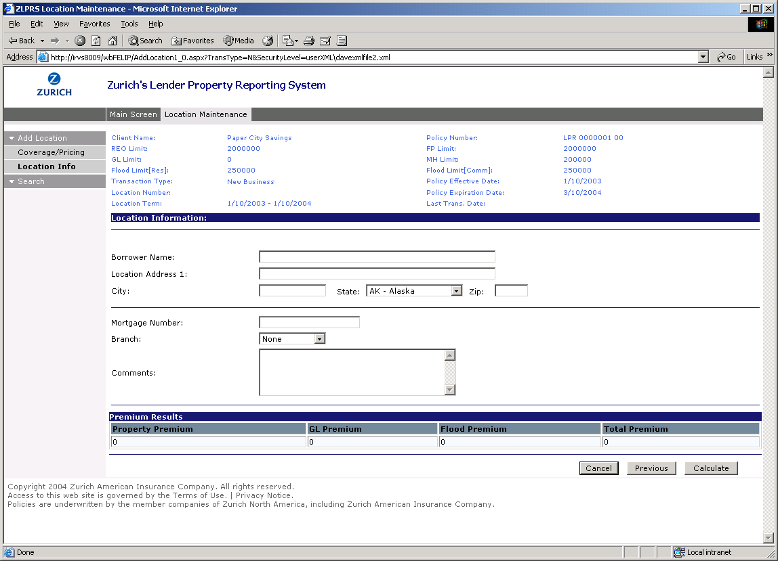
Location Number is a read-only, auto-generated, unique identifier for the location created under the policy.
Mortgage Number is a required field in Location Maintenance.
Policy Number is a read-only text field containing the related policy number for the location being created.
Borrower Name is simply the name of the borrower. Entry of this value is optional.
Location Address 1, City, State and Zip are required fields that contain the Borrowers Property Address.
Branch is a drop down list containing the branches defined for the policy (this is defined in the Policy Maintenance function). Entry of this value is optional and used for Reporting purposes only.
Comments is optional, free-format text entered by users to note the location.

How to Add a New Location
Introduction | This topic describes how to use Location Maintenance for individual location creation.

How to Add a New Location | To add a new Force Placed or REO location for specific properties, complete the following steps.

1 | After choosing a Policy Number from the Location Maintenance subsystem, click the Add Location menu option.  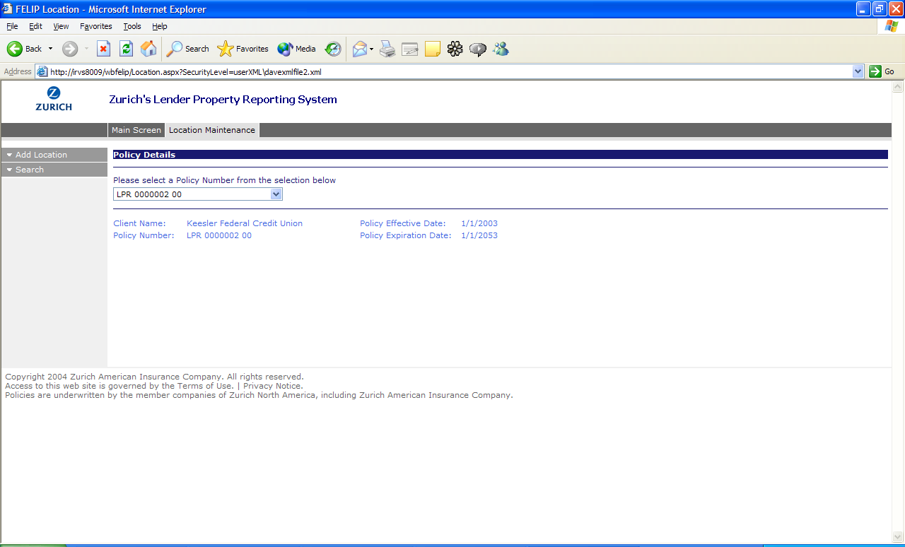
2 | You will notice that the Add Location menu at the left of your screen has expanded to show the steps available for adding a location. Coverage/Pricing is highlighted since this is the current screen that is displayed. As you populate the coverage and pricing information for the new location, you can use the scroll bar on the right to navigate down the page. Notice the default values chosen, and that the GL Coverage drop down list is not accessible since the default Location Type and Class selections do not allow modification of this option.  Based on your selections in this screen, other fields may become pre-populated and/or disabled. You should be aware of the following rules that will apply based on user selection:  - Location type  - The default will be FP.  - If FP is selected, all the other fields will be enabled for selection, except for GL Coverage.  - If REO is selected, all the other fields will be enabled for selection, except for Flood Coverage.  - Selection, whether through the default selection or manual selection, will be required.  - Location Class  - The default option will be Residential.  - If a location class of Residential or Mobile Home is selected and the location type is REO, then the GL coverage field will remain enabled. In all other instances, GL coverage will be disabled for selection.  - If a location class of Residential, Mobile Home, or Commercial is selected and the location type is FP, then the Flood Coverage will be enabled. In all other instances, Flood Coverage will be disabled for selection.  - Selection, whether through the default selection or manual selection, will be required.  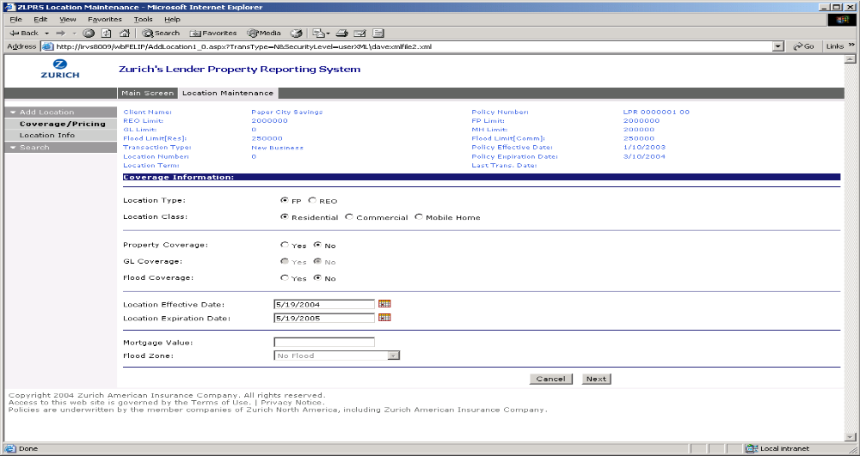
3 | Make your location Type, Class and Coverage selections by clicking on the desired option buttons. Select the Location Effective Date and Expiration Date from the calendar that appears when you click on the calendar icon, or enter valid dates in these fields. Enter a valid Mortgage Value, and select a Flood Zone from the drop down list (provided that the location type is “FP” and the Flood Coverage option is selected). Select Next to proceed.  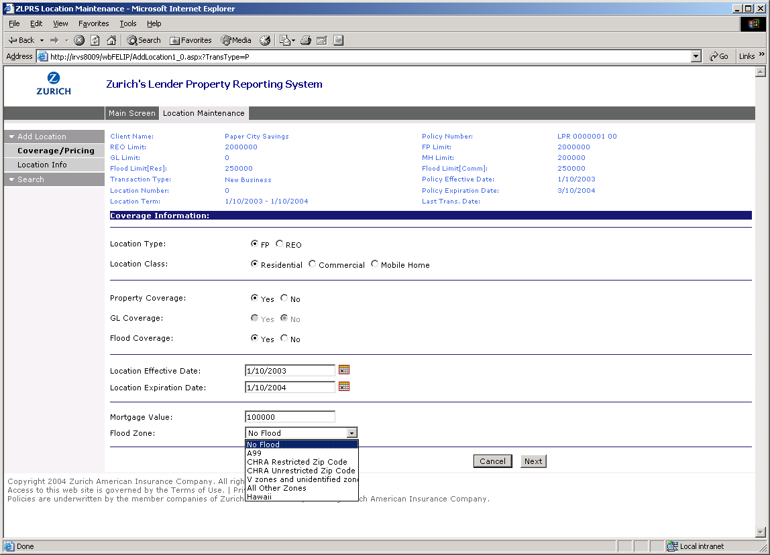
4 | Mortgage Value must be a whole number greater than zero, not a decimal number. An error message appears, and a red asterisk is marked next to the field(s) involved in the error.  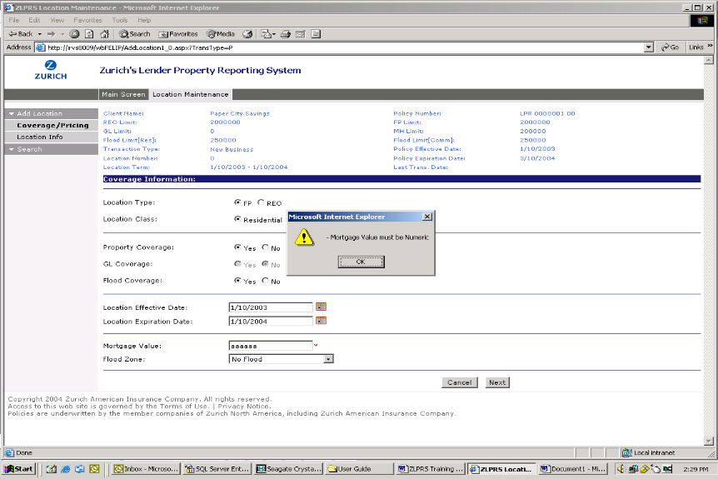
5 | By fixing the error and clicking Next, you are able to proceed with populating the general location information for the new location.  You will notice in the Add Location menu at the left of your screen that Location Info is now highlighted since this is the current screen that is displayed. Enter in the Borrower’s Name, Property Address and Mortgage Number. You can select a Branch (if available) and add Comments if needed, but these are not required fields. When you are done entering in the Location Info, click Calculate.  The Calculate button will only be enabled when all required pricing information is entered for the location. For example, Mortgage Value, Flood Zone (if applicable), Location Effective Date, and Location Expiration Date. This will invoke the premium rating routine behind the scenes, and the appropriate premiums will be returned.  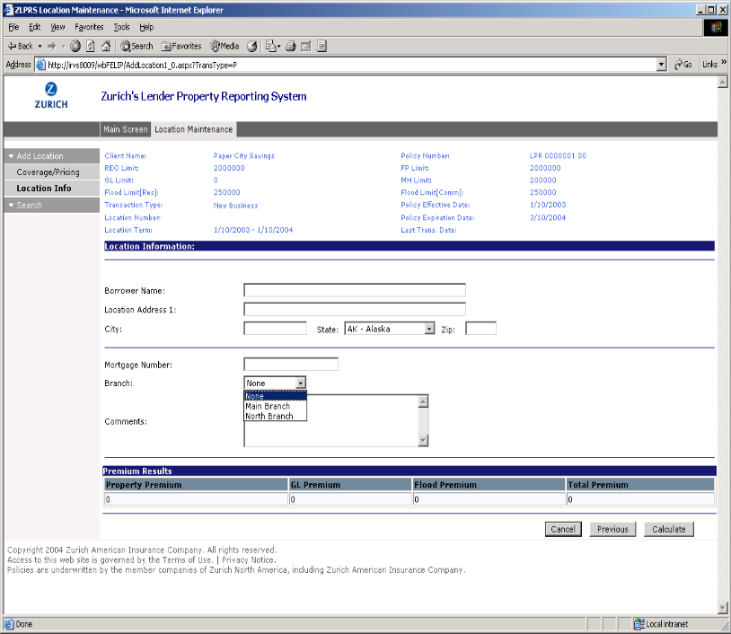
6 | You will now notice that the Premium Results values in the table at the bottom of your screen now contain the calculated values. To finish adding your location click Save. Like all other maintenance screens in ZLPRS, click Cancel if you wish to abandon the new location.  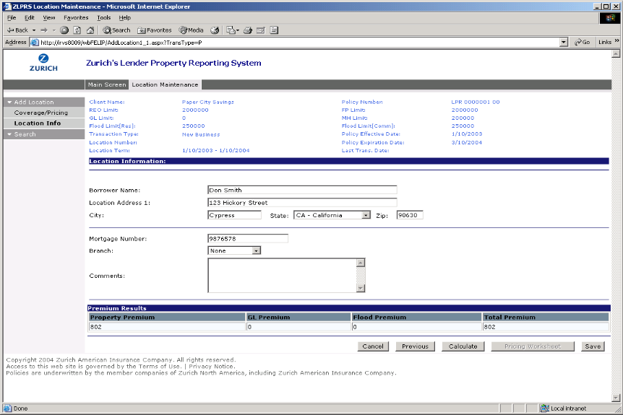
7 | Upon saving your new location successfully, a message will appear that will display the new location number. You now have access to view the Pricing Worksheet for that location.  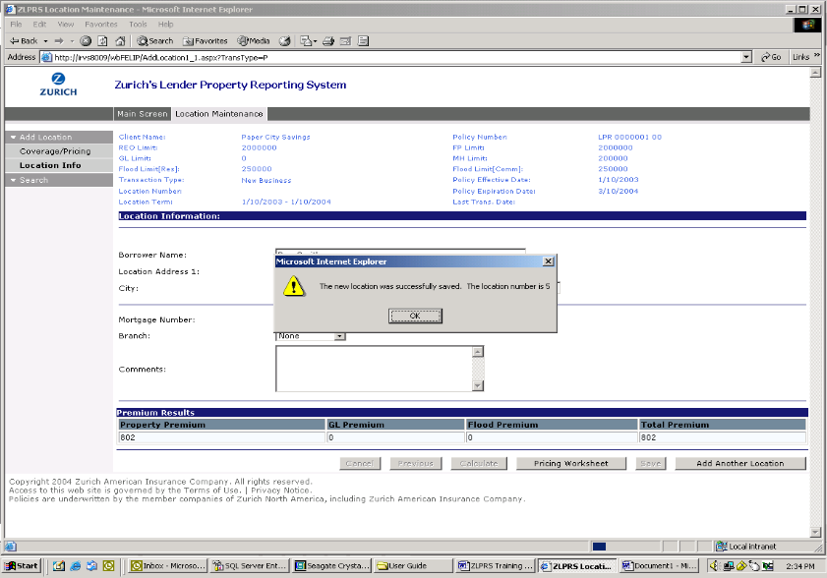
8 | The Pricing Worksheet is a report showing the coverage, location, and pricing information for a location.  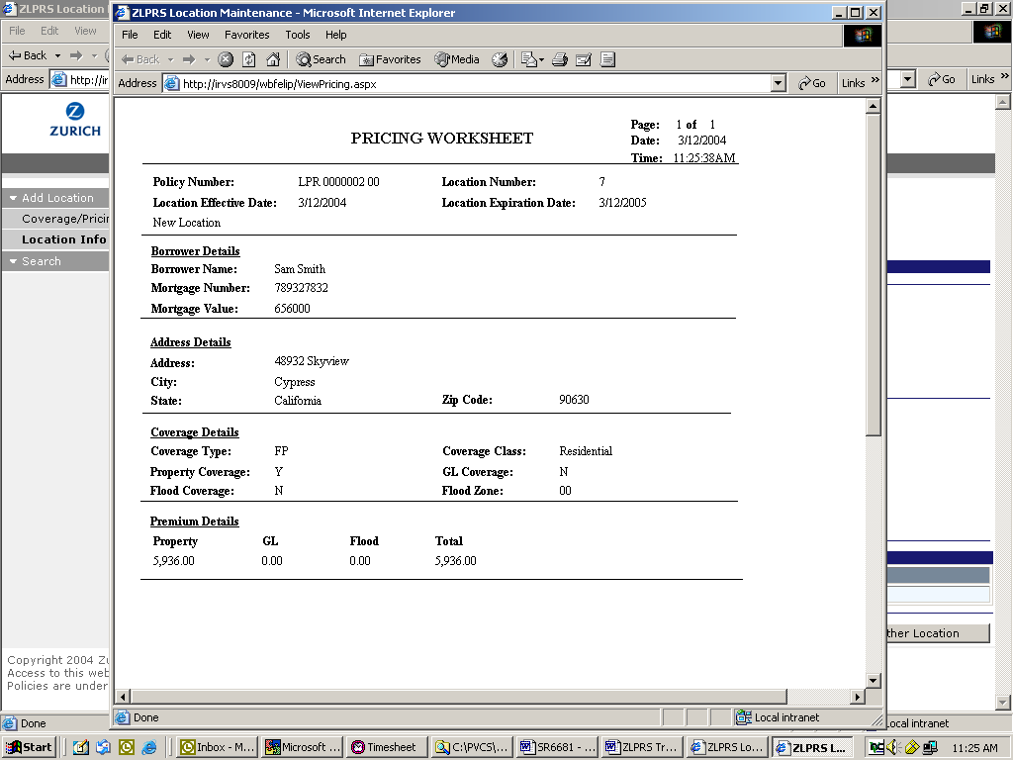

How to Search On Locations

Introduction | This topic describes how to use Location Maintenance to look up a Location.

How to Search On Locations | To search for a Location, complete the following steps.
 |  | 1 | In the Location Maintenance subsystem, click on the Search menu item. You have 3 search types to choose from: Starts With, Contained In, or Exact Match. In the Search Criteria text box, type in the full or partial value of the Search By field. From the drop down list, you can search by Borrower Name, City, Location Effective Date, Location Expiration Date, Location Number, Mortgage Number, State Code or Zip Code.  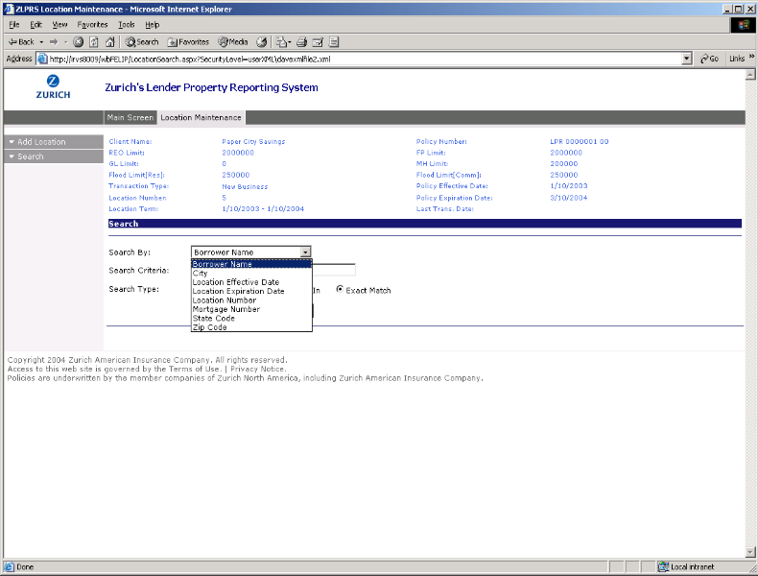
 |  | 2 | In the search below, we want to find a location for Policy Number “LPR 0000001 00” where the Borrower Name contains “Smith.” Click the Search button to start the search.  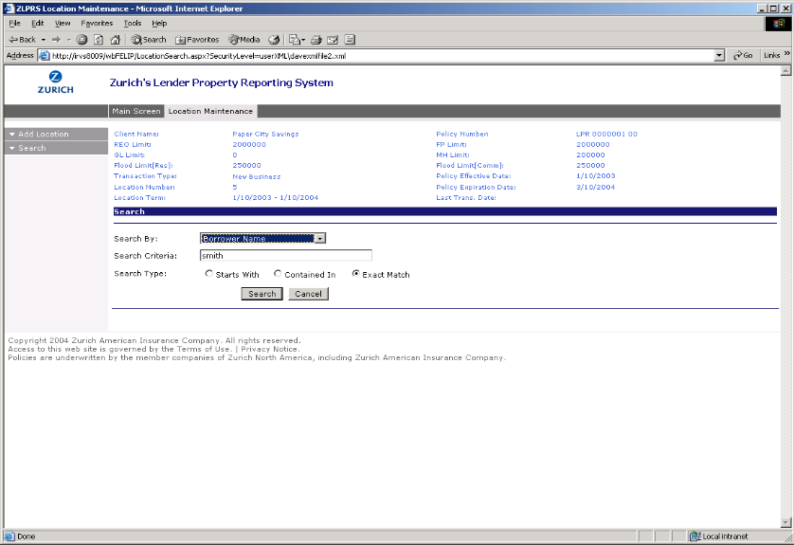
 |  | 3 | One location matching our search criteria is returned. Simply click on the Location No if you would like to view the Location transaction history and/or perform maintenance functions on the location such as Location Endorsement, Location Cancellation, Location Renewal, Location Extension, or Endorsement Rescinding.  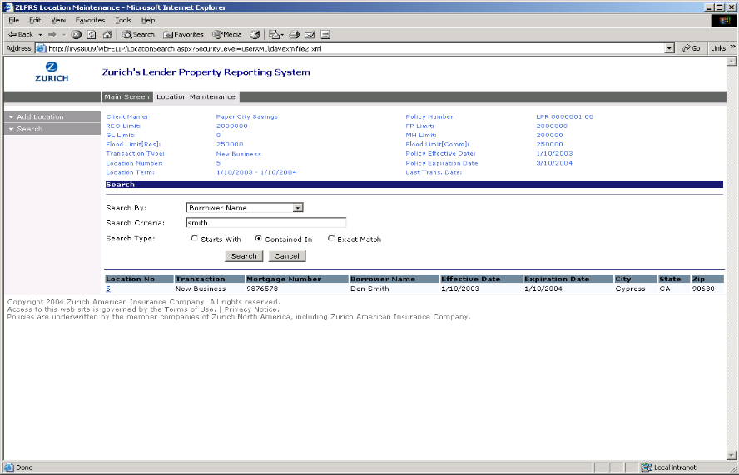

How to Modify Location Information
Introduction | This topic describes how to use Location Maintenance to modify general Location information.

How to Modify Location Information | To modify existing location information, complete the following steps.

1 | In the previous section which discussed how to Search on Locations, you learned that you need to find a location using the Search function in order to perform maintenance tasks on that location. Click on the Location No in the search results table that you wish to modify, and you will be able to access the maintenance menu and view location history. In the example below, we just created this location and therefore only have a single history record to view showing when the location was created, who created it, and the calculated premium amount. If you would like to make changes to the general location information, click on the Info Change option.  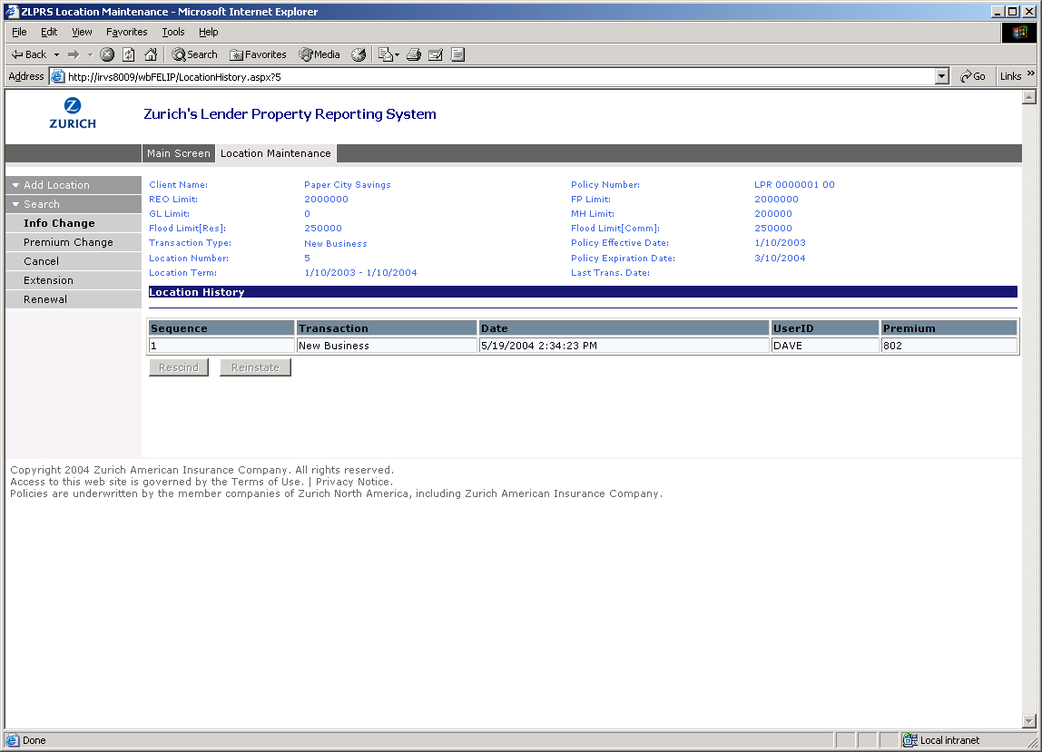
2 | You will recognize this screen from when you first added the Location. The only difference is you now can also modify the Endorsement Date. The Endorsement Date will default to today’s date and represents the date the modification to the location is to occur. Since we made a mistake to the address when we entered this location, we will fix it here. Click Save to update the location.  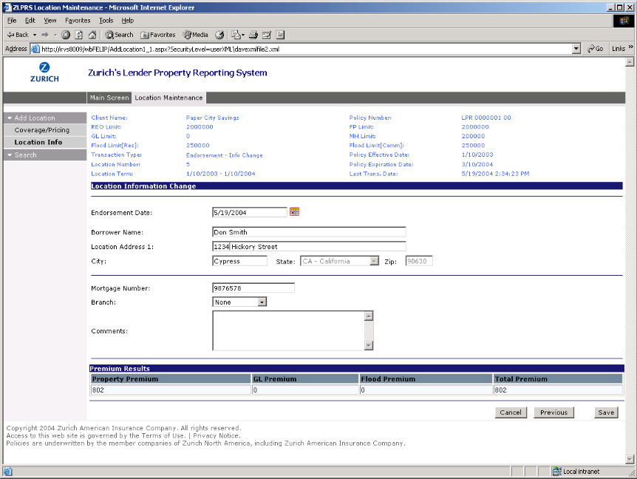
3 | The same validation rules are enforced as were when we added the policy. An additional check will make sure that the Endorsement Date is within the location term. A message will appear if the location was successfully updated…  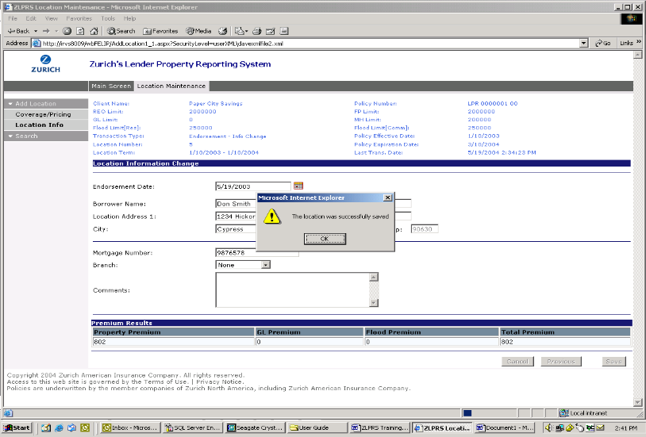

How to Modify Premium Information
Introduction | This topic describes how to use Location Maintenance to modify Premium information.

How to Modify Premium Information | To modify premium information for a location, complete the following steps.

1 | In a previous section which discussed how to Search on Locations, you learned that you need to find a location using the Search function in order to perform maintenance tasks on that location. If, while in the Location Maintenance subsystem, you would like to perform location maintenance on a different Policy that you have access to, simply click the Location Maintenance tab…  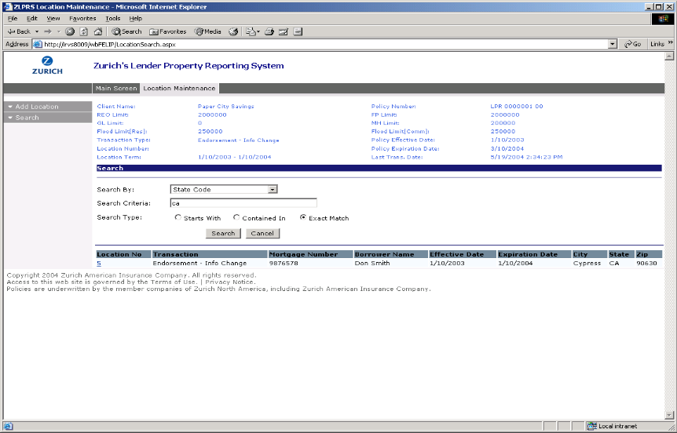
2 | Choose a Policy Number from the drop down list, and proceed to find the Location whose premium information you wish to modify by clicking the Search menu option  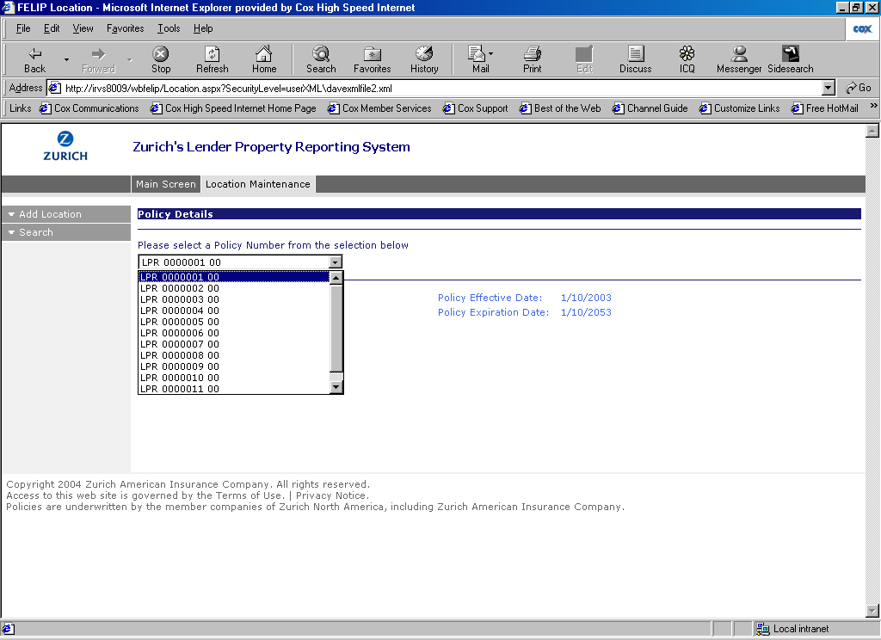
3 | This time we’ll search for a Location where the State Code = “CA.” Notice that we’re returned 3 locations to choose from in the results table. Click on the Location No of the location you would like to change premium information.  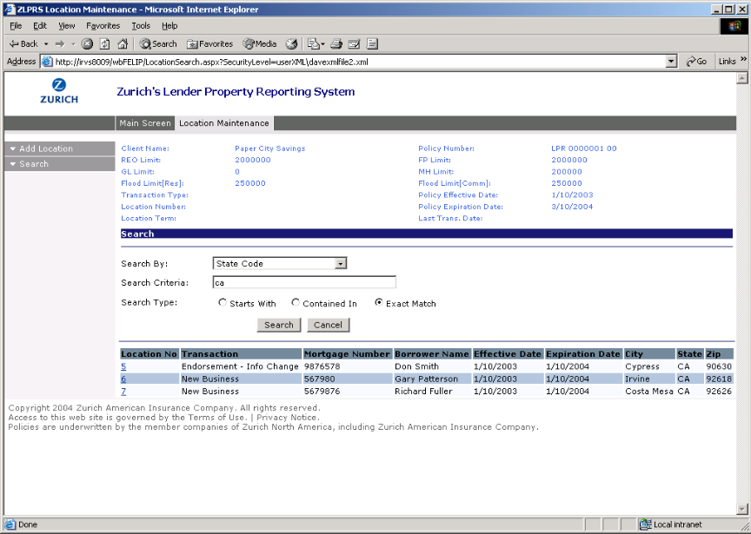
4 | To modify Premium Information for this Location, click the Premium Change menu option on the left hand side of your screen.  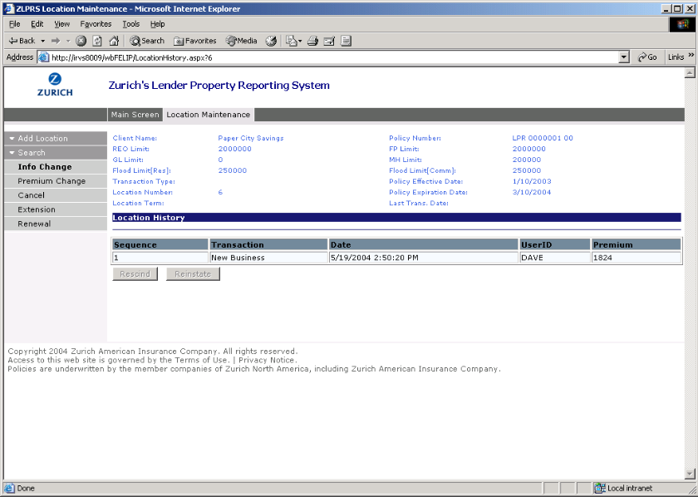
5 | Modifying any one of these fields will require recalculation of the Premium. In our example, we will change the Location Expiration Date and Mortgage Value, and click Next to proceed.  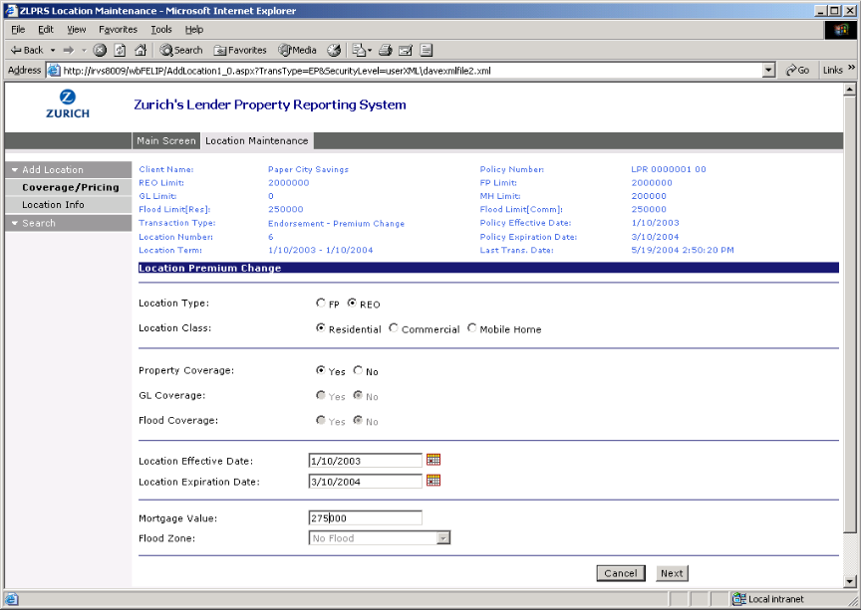
6 | This brings us to the Location Info screen. The Premium Change option also allows us the ability to change all editable Location Information fields. When you’re done with your Location modifications, click Calculate to recalculate the Premium.  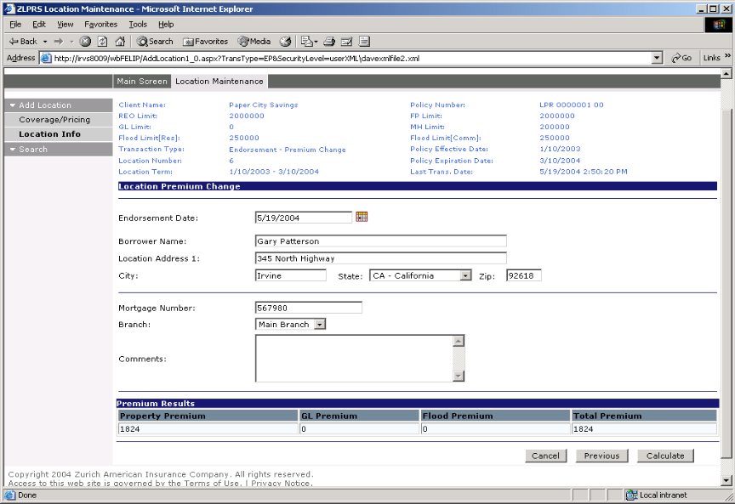
7 | Notice the Premium changes in the Premium Results table. If you are ready to finish your transaction, click the Save button that now appears on the screen.  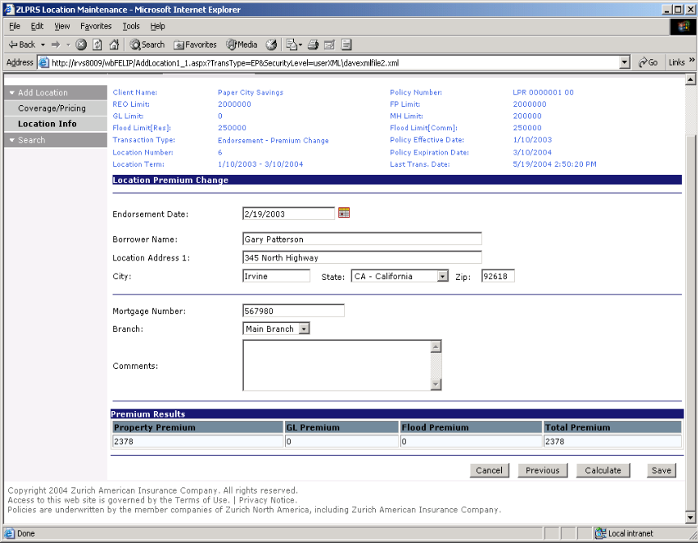
8 | A message appears indicating that your Premium Change was successfully saved.  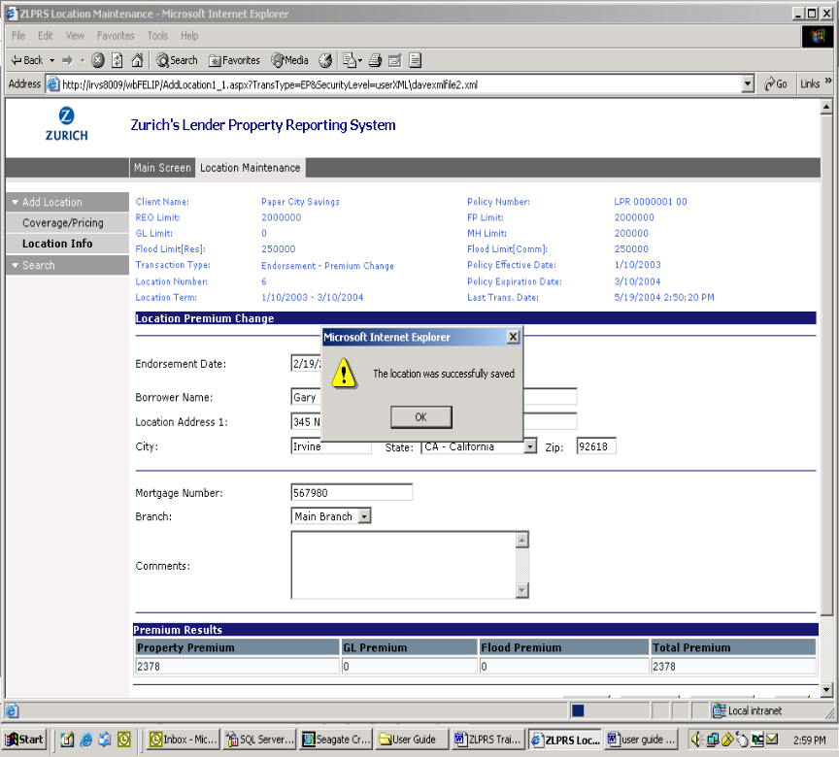

How to Cancel Locations
Introduction | This topic describes how to use Location Maintenance to Cancel an existing location

How to Cancel Locations | For Location Cancellations, complete the following steps.

1 | In a previous section which discussed how to Search on Locations, you learned that you need to find a location using the Search function in order to perform maintenance tasks on that location. Once you click on the Location No you would like to Cancel, you will be able to view the Location History of the Location and have access to the Cancel menu option on the left hand side of your screen.  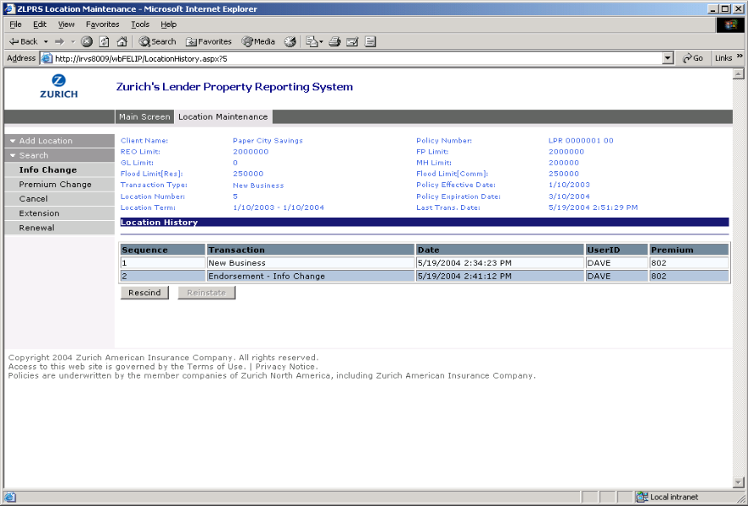
2 | There are 2 Cancellation Types available:  - Flat Cancellation  - A cancel date will automatically be generated as being equal to the location effective date.  - The cancellation date field will remain disabled.  - The cancellation premium will be the same as the location total premium.  - Pro Rata Cancellation  - The cancel date will be enabled.  - Entry of the cancel date will be mandatory for this type of cancellation.  - The cancel date cannot be before the location effective date or later than the location expiration date.  - The cancellation premium will be recalculated based on the date selected.  Choose a Cancellation Type and click Calculate to proceed…  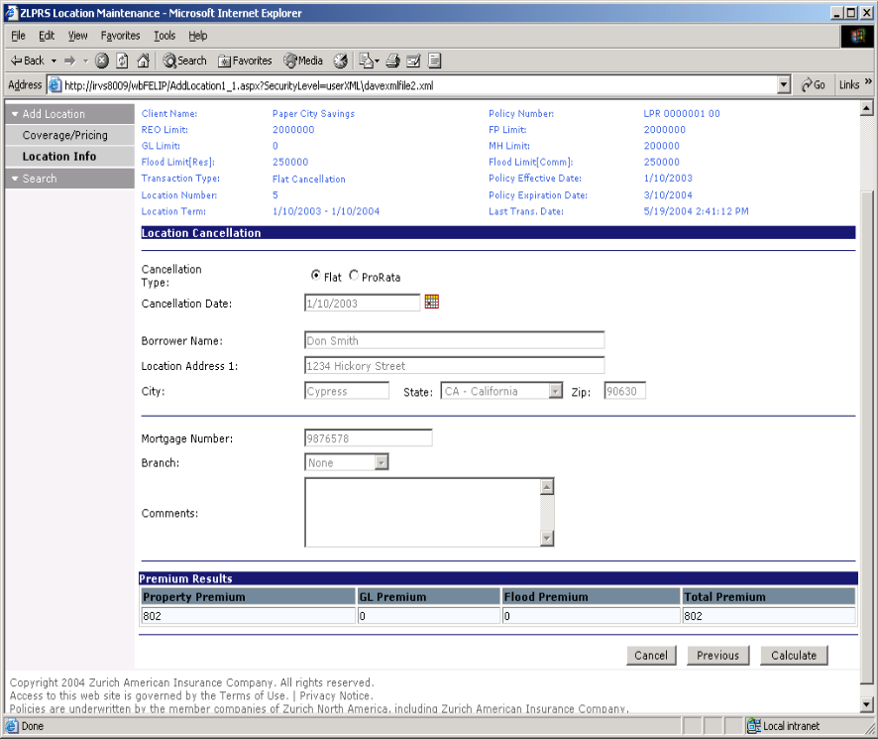
3 | The Premium Results field now reflect the changes to the Premium and show the Endorsement. Click Save to execute the Cancellation transaction.  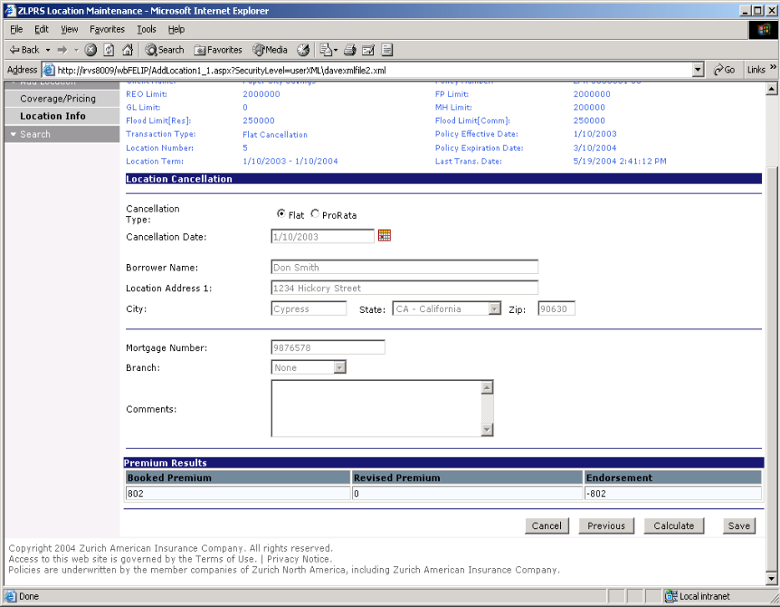
4 | A message appears indicating that your Cancellation was successfully saved.  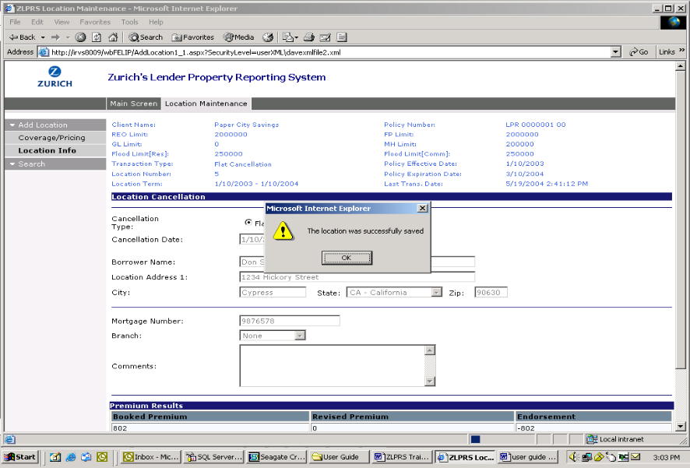

How to Extend Locations
Introduction | This topic describes how to use Location Maintenance to extend an existing location

How to Extend Locations | For Location Extension, complete the following steps.

1 | In a previous section which discussed how to Search on Locations, you learned that you need to find a location using the Search function in order to perform maintenance tasks on that location. Once you click on the Location No you would like to Extend, you will be able to view the Location History of the Location and have access to the Extension menu option on the left hand side of your screen.  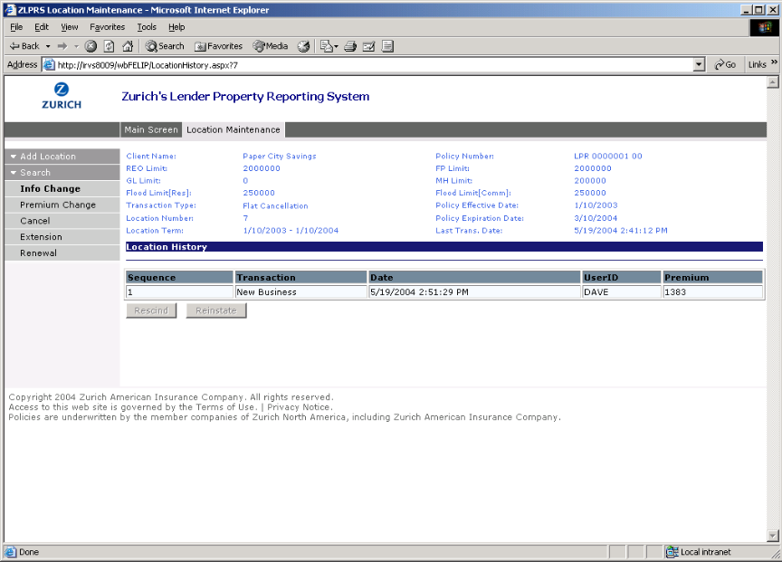
2 | Clicking on the Extension menu option will bring you to the Location Extension screen. This is where you can extend a location’s Expiration Date. Two important rules to follow when extending a location term are:  1) The system will only allow a maximum of 78 months for extension (i.e. new location expiration date is greater than 78 months from the locations original effective date). Exceeding this will result in an error message. You will be instructed to perform a renewal rather than an extension.  2) If a renewal has occurred for the location, the extension will not be allowed and an error message will be returned.  Select or Enter a valid Extension Date and click Calculate to proceed…  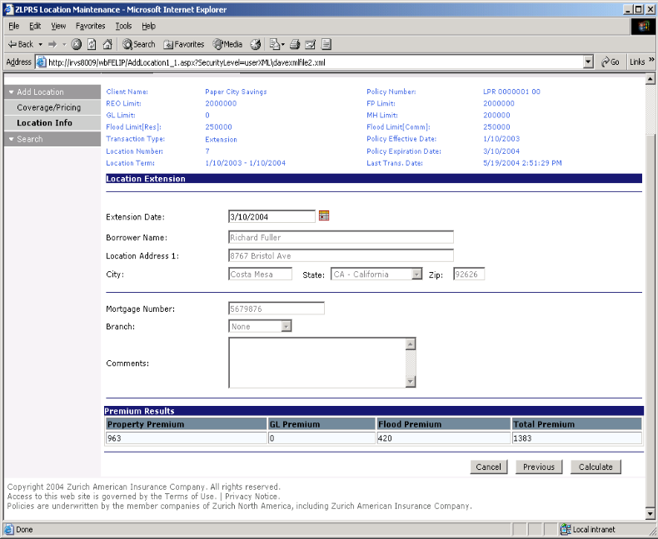
3 | The Premium Results field now reflect the changes to the Premium and show the Extra Premium. Click Save to execute the Extension transaction.  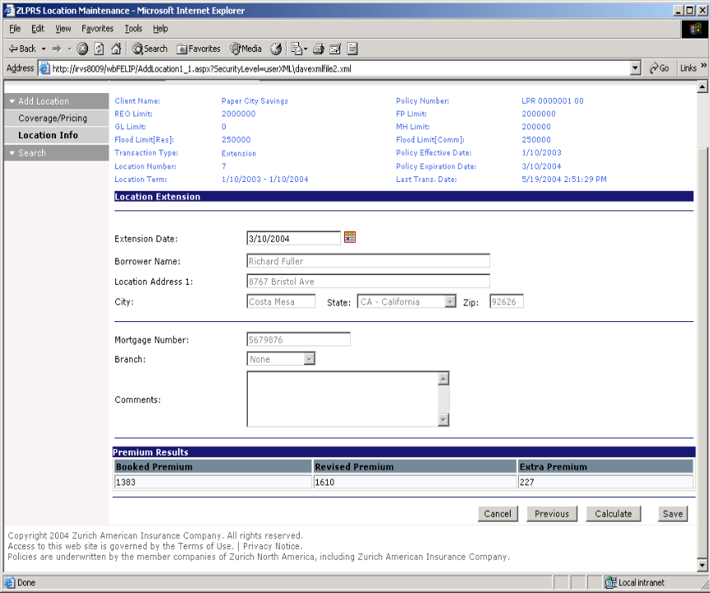
4 | A message appears indicating that your Extension was successfully saved.  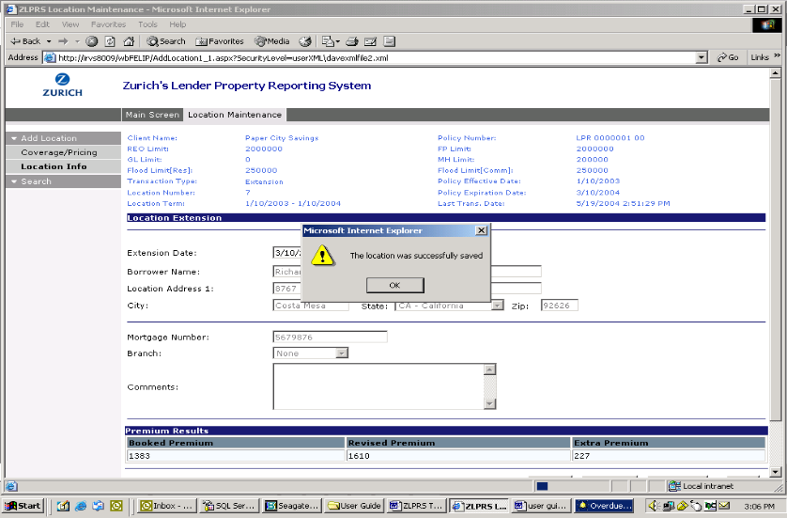

How to Renew Locations
Introduction | This topic describes how to use Location Maintenance to Renew a location.

How to Renew Locations | For Location Renewal, complete the following steps.

1 | In a previous section which discussed how to Search on Locations, you learned that you need to find a location using the Search function in order to perform maintenance tasks on that location. Once you click on the Location No you would like to Renew, you will be able to view the Location History of the Location and have access to the Renewal menu option on the left hand side of your screen.  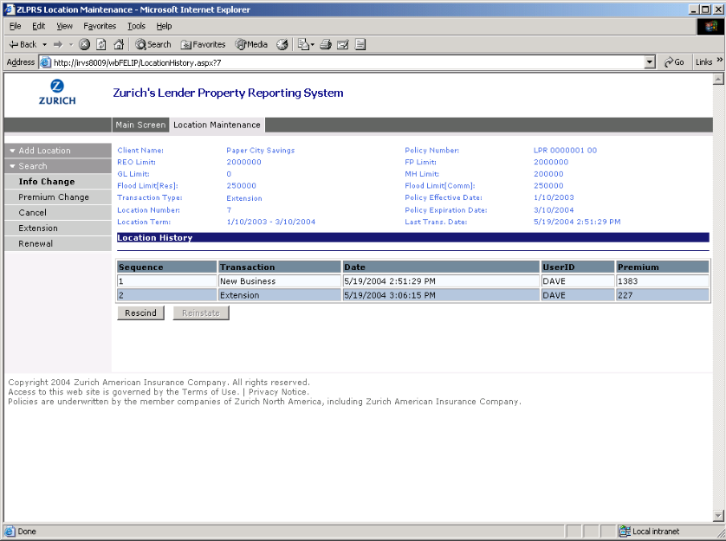
2 | Clicking on the Renewal menu option will bring you to the Location Renewal screen. The user is presented with the same screens as specified in the How to Add a New Location section of this chapter. Please refer to this section for step-by-step instructions. Some minor differences to note regarding Renewals are:  - Entry of the Location Effective Date will not be allowed as this will always default to the previous location’s expiration date.  - A renewal flag will be set on the original location will prevent extension on the location term (both auto and manual extensions).  - The Premium Results grid will reflect the changes to the premium and will show the revised booked premium.  - When the Renewal is saved, you will be presented with warning messages indicating that if an Auto Extend feature has been selected, location will no longer automatically extend.  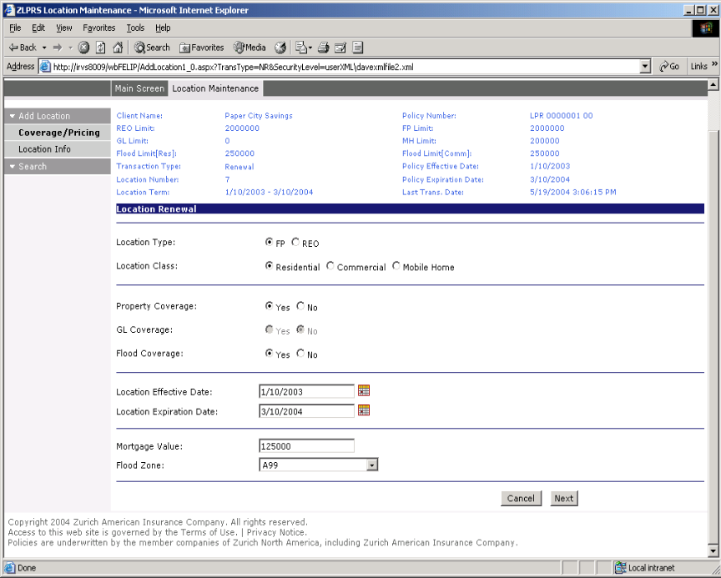

How to Rescind Endorsements
Introduction | This topic describes how to use Location Maintenance to Rescind Endorsements.

How to Rescind Endorsements | For rescinding an endorsement, complete the following steps.

1 | In a previous section which discussed how to Search on Locations, you learned that you need to find a location using the Search function in order to perform maintenance tasks on that location. Once you click on the Location No, you will be able to view the Location History of the Location. You will also notice a Rescind button that appears below the Location History table.  Some important things to understand when rescinding an endorsement are:  - The ability to rescind an endorsement (i.e. revert to the previous version of the location) will be available for any endorsements entered.  - When the Rescind option is selected, the last endorsement will be rescinded. Once the last endorsement is rescinded, the user can rescind the next (last) endorsement.  - You will not have an option to select which endorsement to rescind; it will always be the last endorsement that is rescinded.  Click on the Rescind button to revert to the previous version of the location…  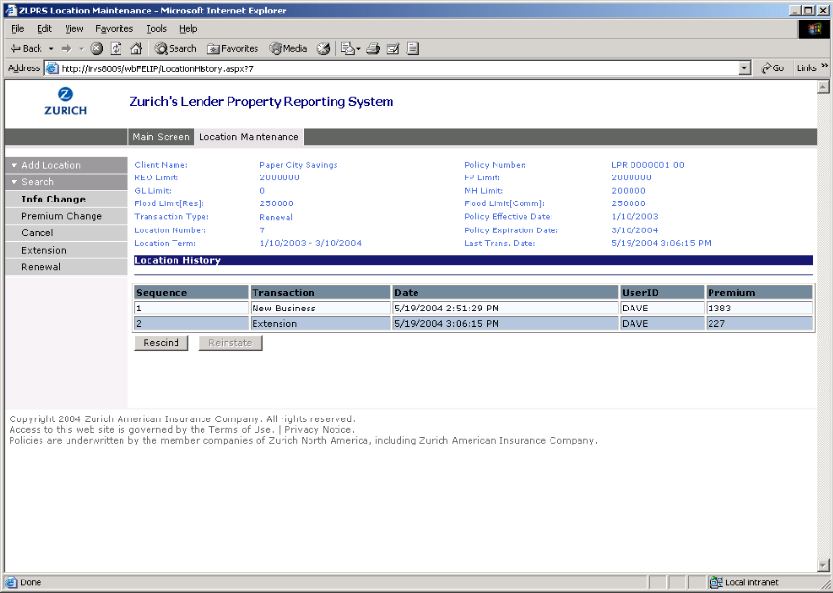
2 | The resulting Location History shows that the most recent transaction was a Rescind. The number in parentheses indicates the resulting current version of the Location.  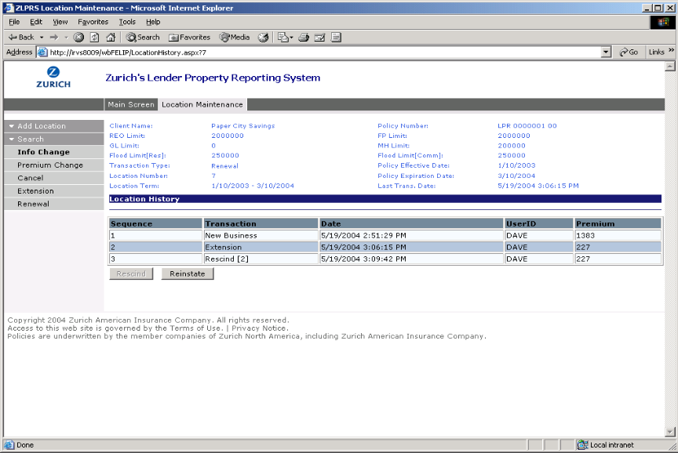

How to Reinstate Endorsements
Introduction | This topic describes how to use Location Maintenance to Reinstate Endorsements.

How to Reinstate Endorsements | For reinstating an endorsement, complete the following steps.

1 | In a previous section which discussed how to Search on Locations, you learned that you need to find a location using the Search function in order to perform maintenance tasks on that location. Once you click on the Location No, you will be able to view the Location History of the Location. You will also notice a Reinstate button that appears below the Location History table.  Some important things to understand when reinstating an endorsement are:  - Reinstatements can only be performed on rescinds.  - When an endorsement is reinstated, the original endorsement information will become active.  Click on the Reinstate button to revert to the previous version of the location…
2 | The resulting Location History shows that the most recent transaction was a Reinstate transaction. The number in parentheses indicates the resulting current version of the Location.  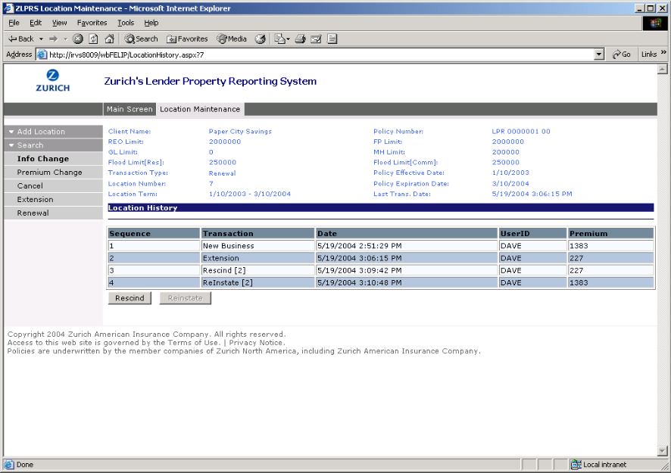

Using Reports

Overview
Introduction | Reports allows users to access and run the standard reports available in ZLPRS.  This chapter:  - Explains how to use Reports and therefore pertains to only users with Reports access  - Explains how to run a standard report  - Describes the standard reports available

In this Chapter | This chapter contains the following topics.

Topic | See Page
How to Use Reports | 46
How to Run a Standard Report | 48
Standard Reports | 50

How to Use Reports
Introduction | This topic describes how to use the Reports subsystem in ZLPRS

How to Use Reports | To access ZLPRS standard reports, complete the following steps.

Step | Action
1 | Click Reports from the ZLPRS Main Screen.
2 | This brings you to the Report Selection screen. Here you can choose from 5 standard ZLPRS reports to run. Click on the Report Names drop down list to view the reports available for selection. Bank Name, Location Number, Location Type, Begin Date, and End Date are Report Parameters that can be available for selection based upon the Report Name you choose.  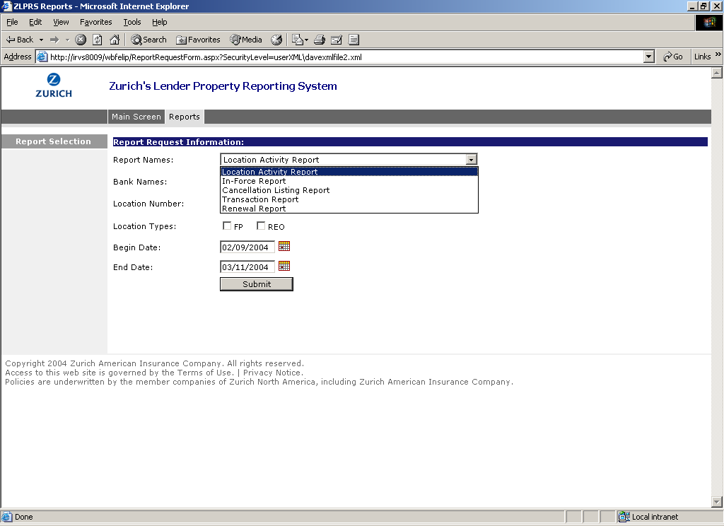

How to Run a Standard Report
Introduction | This topic describes how to run a standard report in ZLPRS

How to Run a Standard Report | To run a standard report, complete the following steps:

Step | Action
1 | In the Reports subsystem you are presented with the Report Selection screen. Selection of a Report Name will drive what parameters are available for selection. In the Bank Name drop down list you can choose a specific bank or “All Banks”. Location Type is a required parameter for many of the reports (see Standard Reports section of this chapter for report specifics). Date parameters can be entered by keying in a valid date or choosing a date from the calendar by clicking on the calendar icon. Simply click Submit when you are ready to run your report.  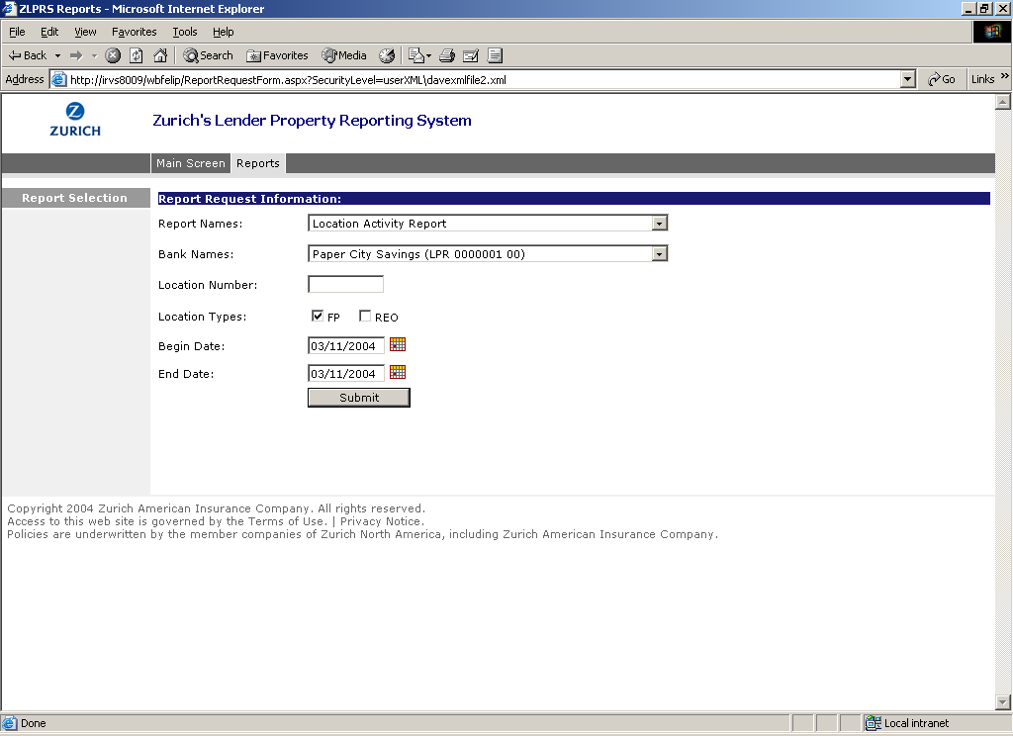
2 | The report output is presented to you. Notice that you have several navigation options from which to choose. In the Report menu at the left hand side of the screen you can choose to: Print Report, Print in Browser, Export to Adobe, or go back to the Report Selection screen. The Crystal Report tool options at the top of your screen allow you to easily navigate pages with the arrow buttons provided or by specifying a page number and clicking the go to button. The tool options also provide you with a Search feature by entering text you would like to search for in the report and clicking the binocular button. You can also alter your viewing size of the report by increasing or decreasing the percentage value.  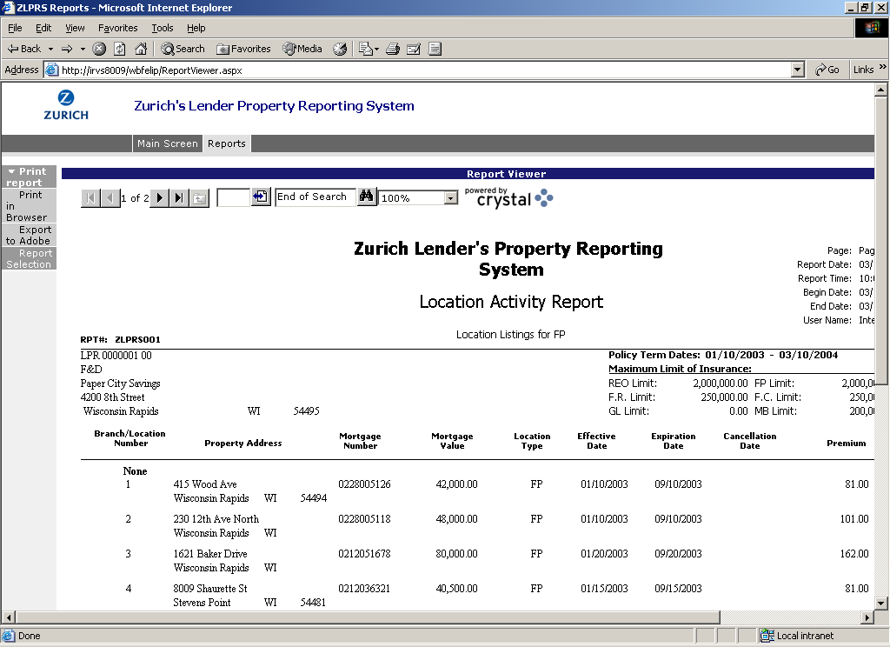

Standard Reports
Introduction | This topic describes the Standard Reports that can be requested in ZLPRS.

Standard Reports | The following five reports can be requested in the Reports subsystem:  - Location Activity Report  - In-force Report  - Cancellation Listing Report  - Transaction Report  - Renewal Report

Location  Activity Report | The Location Activity Report reports on all activity that occurred on locations during a selected period. This report lists transactions that are immediately effective, effective for a past date, or set to be effective for a future date. The date range and coverage types reported on are determined by the reporting parameters you enter. The report can be generated using the following criteria:  - Locations with a transaction timestamp that fall within the Begin Date and End Date parameters will be extracted and presented on the report. Transactions that have occurred within the parameter date range will be shown, regardless of the effective date of those transactions, which will allow for past and future effective transactions.  - All report parameters (Bank Name, Location Number, Location Type, Begin Date, and End Date) are available for selection to modify the report output scope. Location Type is a mandatory parameter for this report.
Sample Location Activity Report:
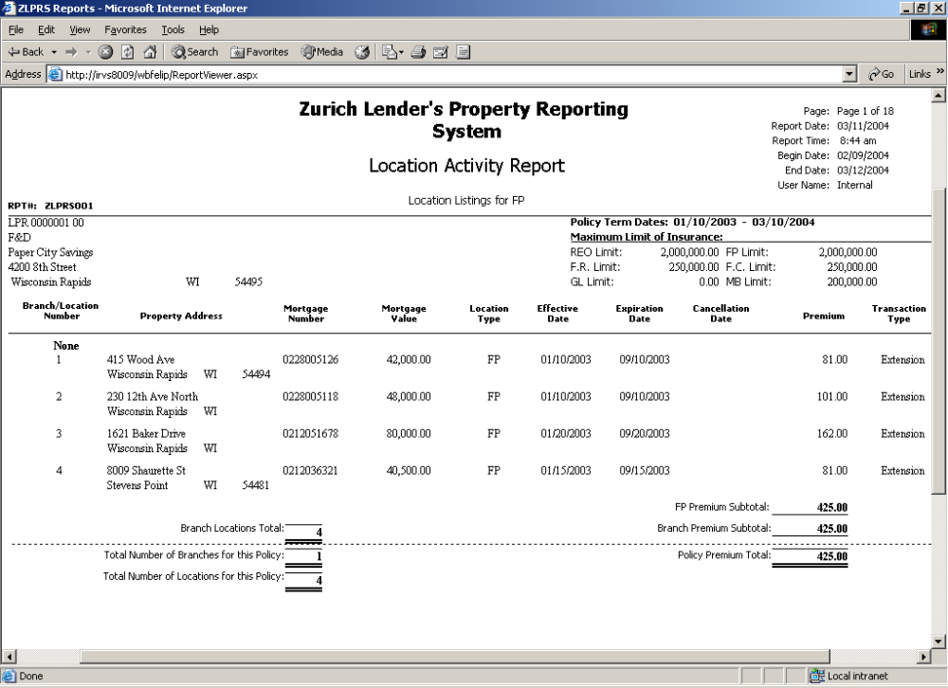

In-Force Report | The In-Force Report shows all locations currently in-force as of the date of the report request, grouped by policy, where applicable. This report allows for selection of clients allowed by the user’s security profile and does not automatically retrieve data for all accessible policies. This report does not allow selection of a Begin Date but is based on the End Date entered to determine the effective locations at that point in time. The report can be generated using the following criteria:  - Return locations where their Effective Date is earlier than the date of the report request (End Date specified) and where expiration date or cancellation date is greater than report request date (End Date specified).  - With the exception of Begin Date all other report parameters are available for input, and Location Type is required.

Sample In-force Report:
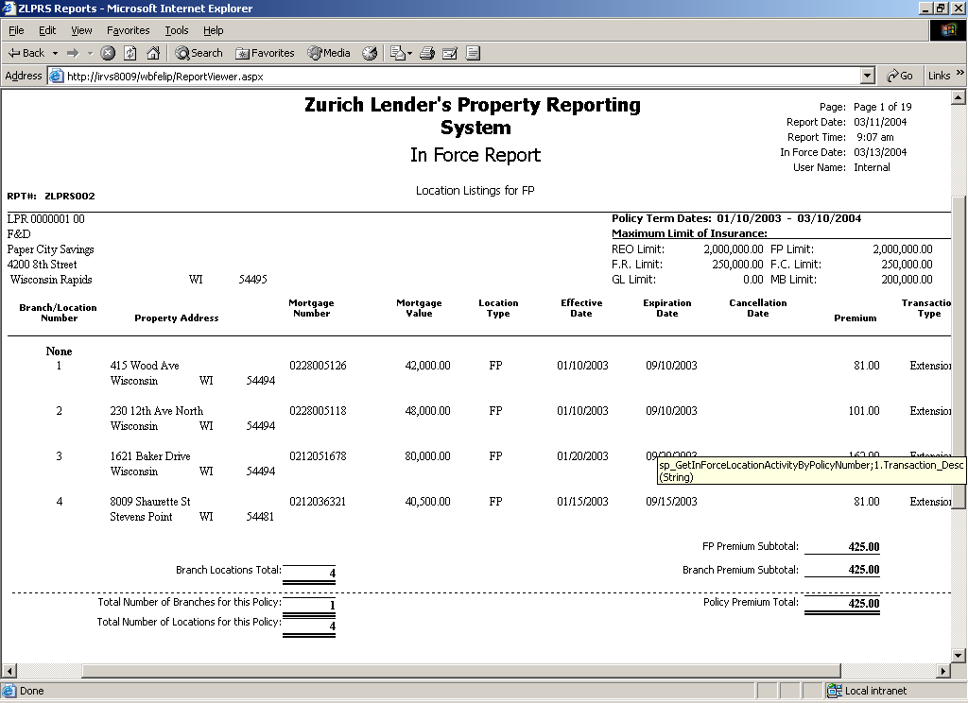

Cancellation Listing Report | The Cancellation Listing Report lists all locations that have been cancelled during the parameter date range specified, grouped by policy. This report allows for selection of policies allowed by the user’s security profile and does not automatically retrieve data for all accessible policies. The report can be generated using the following criteria:  - Return locations where the Cancellation Date falls within the requested date range (between Begin Date and End Date).  - All report parameters (Bank Name, Location Number, Location Type, Begin Date, and End Date) are available for selection to modify the report output scope. Location Type is a mandatory parameter for this report.

Sample Cancellation Listing Report:
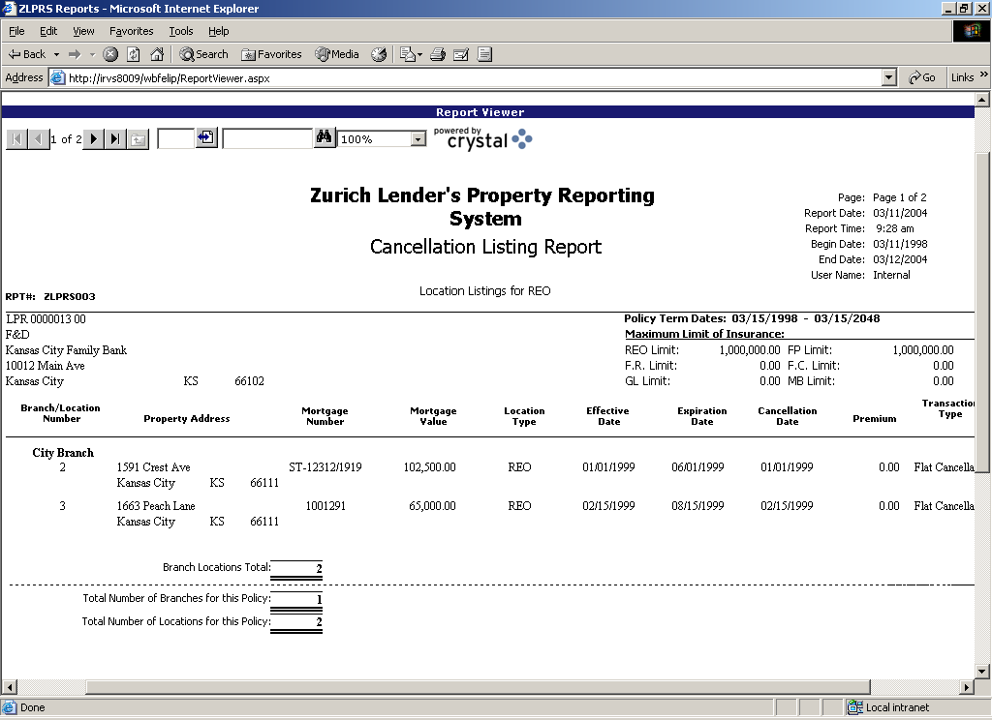

Transaction Report | The Transaction Report lists detailed information pertaining to all transactions for a particular Location. The required report parameter for this report is Location Number. Location Type, Begin Date and End Date are not available parameters for this report.

Sample Transaction Report:
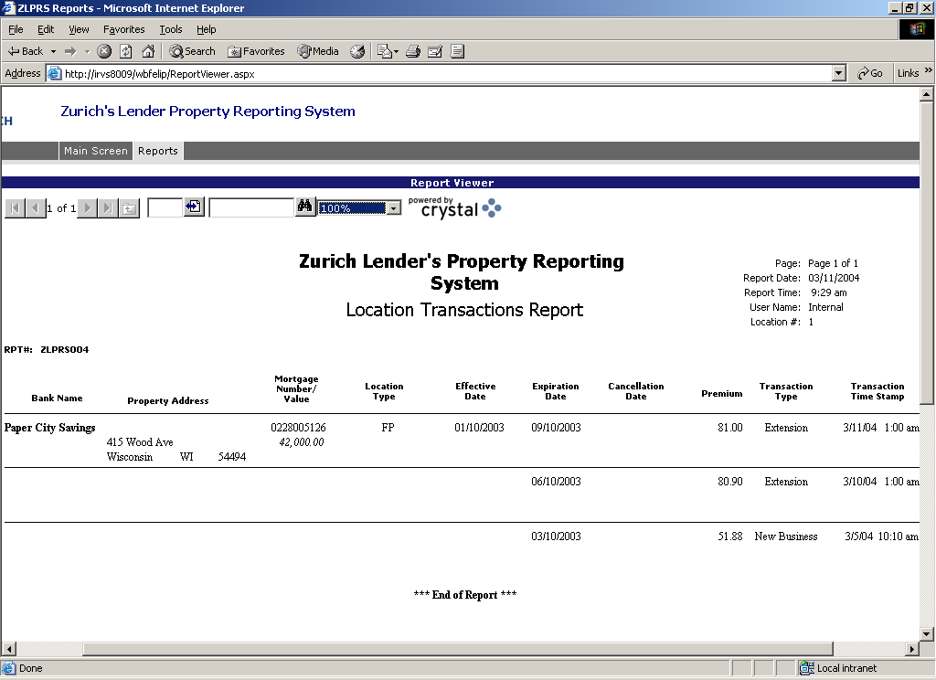

Renewal Report | The Renewal Report extracts all locations where the expiration date or cancellation date is within the requested date range, grouped by branch. This report allows for selection of policies allowed by the user’s security profile and does not automatically retrieve data for all accessible policies. The report can be generated using the following criteria:  - Return locations with their expiration/cancellation date falling within the specified parameter date range (between Begin Date and End Date).

Sample Renewal Report:
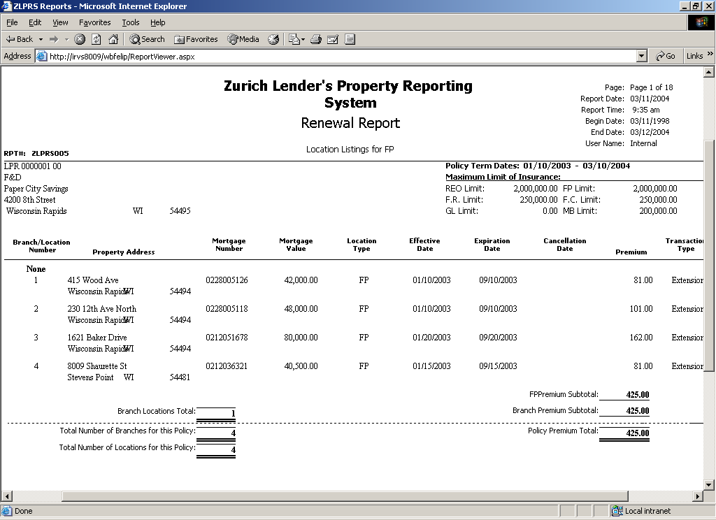

Technical Support
Contact information | If you have any questions about using the new ZLPRS software, please call our Application Support Center at 1-800-462-5541

