
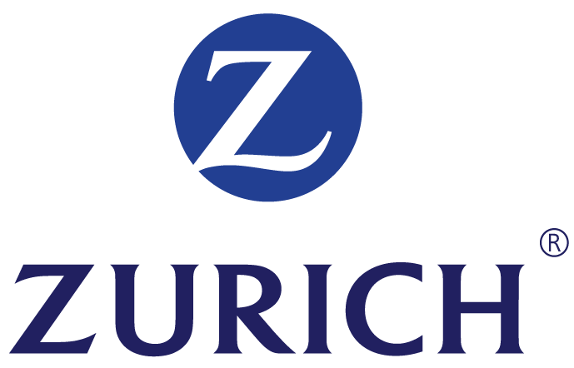

AUTHORIZATION FORM

FOR ACCOUNT HOLDER’S COMPLETION
IMPORTANT NOTE: ALL FIELDS WITH (*) ARE MANDATORY. PLEASE USE CAPITAL LETTERS, BLACK INK AND ON THE RELEVANT BOXES.

Maintenance

Type of Application *
New Application

Termination

Account Holder’s Name (Primary) *

ID Number
(without ‘-‘ or ‘/‘) *
New IC

Passport

Old IC

Business
Reg.

Savings, Current or Card Account No (without ‘-‘ or ‘/‘) *

Telephone Number
Bank Abbreviation *
(Refer to Guideline for abbreviation list)

E-Mail

I
N
S
U
R
A
N
C
E
Pp
R
E
M
I
UM
M
Purpose of Payment *

-

Maximum amount to debit per transaction (RM)*

(Subject to maximum limit specified by
the DD Operator)

0
0
5
Yearly

Weekly
x
Monthly

Maximum frequency *

Mode of frequency *
Daily
D

D

M

M

Y

Y

Declaration:
I/We hereby acknowledge that the information in this form will be disclosed or released to the Corporation, Corporation’s bank and the Direct Debit Operator for the purpose of the Direct Debit collection.
I/We hereby acknowledge that a fee/charge will be charged to me/us in the event my/our Account has insufficient balance to make Direct Debit payment instruction(s). I/We hereby agree the Bank to debit related fees/charges from my/our Account as a consequence of having insufficient fund for Direct Debit payment(s).
I/We hereby confirm that I/we have checked the accuracy and correctness of the details furnished by me/us in this application form and I/we are aware of the content and the scope of the services provided therein.
I/We hereby declare that all information provided is to the best of my/our knowledge true and correct.
I/We hereby agree to be bound by the Terms and Conditions.
This Direct Debit authorization will remain in force until terminated by I/we with prior written notice sent to Bank/Corporation.
I/We hereby authorise the Bank to debit my/our Account for the Direct Debit payment(s) including the relevant transaction fees/charges not payable by the Corporation.

D
D
M
M
Y
Y
Effective Date * (DDMMYY)

Expiry Date
(DDMMYY)

D
D
M
M
Y
Y
__________________________________________
Account Holder’s Signatures as per Bank’s record
(For Joint Account - Signature as per Bank’s signing condition)

Signature / Company Stamp*

Date* (DDMMYY)

FOR CORPORATION’S COMPLETION
D
D\
00
0
0
09=1
09
0
0
9
D
D
M
M
Y
Y
Date* (DDMMYY)
Biller ID *

Payment Reference No. (e.g. Policy No., etc.)
(Must be unique) *

Please tick appropriate box (applicable for Maintenance only)
- Change of payer bank
- Change of account number
- Change of maximum amount
- Change of telephone number
- Change of email
- Others (please specify)…………………………………………………………………………………………………………..

500-40/2/0010904 | 500-10/2/0000853 |  | Confidential
Version 2.2 | 24/07/2012 – Version 1.3 |  | 3390/4/P/L/S/M

Personal Data Protection Declaration
I/We understand and agree that by signing up for any products offered by Zurich Life Insurance Malaysia Berhad ("the Company"), interacting with the Company and submitting my/our information to the Company, I/we have consented on the collection, processing, using and sharing of my/our personal data including my/our sensitive personal data by and for the Company.
Saya/Kami memahami dan bersetuju bahawa dengan mendaftar untuk mana-mana produk yang ditawarkan oleh Zurich Life Insurance Malaysia Berhad ("Syarikat"), berinteraksi dengan Syarikat dan mengemukakan maklumat saya/kami kepada Syarikat, saya/kami telah bersetuju dengan pengumpulan, pemprosesan, penggunaan dan perkongsian data peribadi saya/kami termasuk data peribadi sensitif saya/kami oleh dan untuk Syarikat.
I/We understand and agree that the personal data provided may be used, processed and disclosed by the Company to individuals/organization related to and associated with the Company or any appointed third party (within or outside of Malaysia, including reinsurance, claims investigation companies and industry associations and federations) for the obligatory purposes of processing this application and providing subsequent service for this product and/or communicate with me/us for such purposes; as described in the Company’s Personal Data Protection Notice published at https://www.zurich.com.my/en/customer-hub/show-me-more-info/personal-data-protection-notice.
Saya/Kami memahami dan bersetuju bahawa data peribadi yang diberikan boleh digunakan, diproses dan didedahkan oleh Syarikat kepada individu/organisasi yang berkaitan dengan Syarikat atau mana-mana pihak ketiga yang dilantik (di dalam atau di luar Malaysia, termasuk insurans semula, syarikat penyiasatan berkenaan tuntutan dan persatuan industri dan persekutuan) untuk tujuan yang diperlukan bagi memproses permohonan ini dan menyediakan perkhidmatan selanjutnya untuk produk ini dan/atau berkomunikasi dengan saya/kami untuk tujuan tersebut; seperti dinyatakan dalam Notis Perlindungan Data Peribadi Syarikat yang dipaparkan di https://www.zurich.com.my/en/customer-hub/show-me-more-info/personal-data-protection-notice.
I/We understand that I/we have the right to access, update, change or opt-out my/our personal data held by the Company concerning me/us. Such requests can be made through forms which can be downloaded at the Company’s website or in writing at the Company’s nearest branches.
Saya/Kami memahami bahawa saya/kami mempunyai hak untuk mengakses, mengemaskini, mengubah atau memilih untuk tidak berkongsi data peribadi saya/kami yang disimpan oleh Syarikat mengenai saya/kami. Permintaan tersebut boleh dibuat dengan melengkapkan borang yang boleh dimuat turun di laman web Syarikat atau secara bertulis di cawangan Syarikat yang terdekat.
I/We understand that inquiries or complaints (such as limiting the processing of certain information, including the withdrawal of consent to receive marketing information) can be made by contacting the Company’s Customer Care Officer at 1-300-888-622, or by visiting/writing to the Company at CallCentre@zurich.com.my.
Saya/Kami memahami bahawa pertanyaan atau aduan (seperti mengehadkan pemprosesan maklumat tertentu, termasuk penarikan balik persetujuan untuk menerima maklumat pemasaran) boleh dibuat dengan menghubungi Pegawai Khidmat Pelanggan Syarikat di 1-300-888-622, atau dengan melawat/menulis kepada Syarikat di CallCentre@zurich.com.my.
I/We understand that the Company’s Personal Data Protection Notice may be updated from time to time in line with the requirement set forth in the Personal Data Protection Act 2010 and Personal Data Protection Code of Conduct for Insurance Industry and the updated Personal Data Protection Notice is being published at the Company’s website.
Saya/Kami memahami bahawa Notis Perlindungan Data Peribadi Syarikat boleh dikemas kini dari semasa ke semasa selaras dengan keperluan yang dinyatakan dalam Akta Perlindungan Data Peribadi 2010 dan Tatakelakuan Perlindungan Data Peribadi untuk Industri Insurans dan Notis Perlindungan Data Peribadi yang terkini adalah dipaparkan di laman web Syarikat.

