Fleet Sample Policy
(Adapted for Aegis Captive Use Only)

This policy may be used as a basis for developing your own fleet policy. The policy should be customized to meet the needs of the individual company. Please note policies need to be written so that they will be followed and enforced consistently. Exposures and regulations change, and while this document is

intended to cover most areas, it cannot be exhaustive to the needs of each individual company. Any and all information contained herein is not intended to constitute advice (particularly not legal advice). We encourage you to work with your legal representatives when creating your policy to ensure compliance with all applicable laws.
Table of Contents
Safety statement 2
Required cooperation with company management and enforcement agencies 2
Driver recruitment, selection, and assessment 2
Minimum driver eligibility 3
Prohibited actions 3
Cell Phone Policy 4
Required use of seat belts 4
Licenses 4
Driver Training and Orientation 5
Defensive driving 6
Motorcycles 6
Company and personal property 6
Drug and alcohol use 7
Company-owned vehicles 7
Personal vehicles on company business 8
Inspection and maintenance 8
Garaging and storage 9
Telematics 9
Driver intervention record 10
Collisions 10
Required reporting of collision and violations 10
Collision scene procedures 11
Offering assistance 12
Appendix A – Example Assessment and/or Peer Evaluation Form 13
Appendix B – MVR Record Evaluation Worksheet 14
Appendix C – Driver Acknowledgement Form 15
Appendix D – Sample IVMS Driver Coaching Form 16
Appendix E – Company Car Personal Use Policies (choose one) 17
Appendix F – Use of personal vehicles on company business policy 18
Appendix G – Driver’s Vehicle Inspection Report 19
Appendix H – Driver intervention record 20
Appendix I – Driver Responsibilities at Accident Scenes 21
Appendix J – Accident Assistance Guide 23
Appendix K – Crash information checklist 25

Safety statement
This driver policy document was designed to establish minimum safety requirements for the operation of vehicles used for company business. We are committed to providing and maintaining a safe working environment for our employees and protecting the citizens of the communities where we conduct business from injury and property loss. Operating a vehicle on company business, whether the company’s or your own, is a privilege and, as such, is governed by our policies and procedures. Your commitment to these policies and procedures is vital to building a safe driving culture within our company and ensuring your own safety, the safety of others, and the success of the business.

Required cooperation with company management and enforcement agencies
Drivers and permitted users, as defined in this policy, must cooperate with company officials and/or law enforcement agencies in matters such as violation of company policies, traffic stops, and/or collision investigations.

Driver recruitment, selection, and assessment
To evaluate employees as drivers, management will complete the following:
- Review the employee's Motor Vehicle Record (MVR) in accordance with applicable privacy laws. Compare the MVR with the guidelines listed in the Driver Eligibility section below. Ensure the employee has a valid driver's license. (Note: MVRs should be ordered and evaluated by the company, not the broker or insurance company.)
- Define the experience required (if applicable) for types of company vehicles. Ensure the employee is qualified to operate the type of vehicle they will drive, including requiring completion of a road test in each type of vehicle. Use the NETS Example Assessment and/or peer evaluation form as a guide for evaluating drivers. See Appendix A.
- Establish job descriptions for each type of position that requires driving and include the type of driver’s license
required for the position.
- Complete an application for employment that includes information specific to the job description related to driving.
- Perform background checks.
- Complete a medical fitness for duty evaluation. Medical conditions and treatments directly affect safety when they impair transportation professionals’ performance. If someone is not medically able to safely operate a vehicle, they should not do so to help reduce the risk to the public.
- The minimum age for operating a company vehicle is (consider 21 or older but Zurich prefers 25 years of age)
- All drivers may be monitored for compliance by the following means:
  - Observation
  - Telematics data
  - Road tests
  - General public feedback
  - Ride-alongs by safety, direct supervision, and/or fleet management
  - In-vehicle training
- Regulated Drivers or state commercial vehicle regulations for intra-state operations.
- For regulated drivers, the company will follow the Federal Motor Carrier Safety Administration (FMCSA) 49 CFR
391.23 requirements.
- Pre-employment Screening Program (PSP) check
Documentation of the qualification of each driver will be maintained, including the driver's training. Please note that the requirements for CDL drivers are mandated by FMCSA. For further information on Driver Qualification Files, please see Zurich’s FMCSA’s Quick Reference Guide. Examples of items to be kept in the driver's and/or personnel files include:
- Job application
- Copy of MVRs
- Previous employer inquiries and reference checks

- Training records
- Copy of current driver's license
- Driver training, coaching, telematics violations, actions taken
- Current certificate of insurance, if approved to operate a personal vehicle on company business
- For CDL drivers, a separate Driver Qualification File will be maintained in accordance with FMCSA

Minimum driver eligibility
The company has established criteria to minimize the “at-risk” behavior that causes collisions, injuries, and property damage. Each current and prospective driver must meet the following standards to qualify and maintain driving privileges in good standing. All drivers in good standing will:
- Possess a valid driver’s license with all necessary endorsements.
- Be able, by reason of experience, training, or both, to operate the type of vehicle required to complete the work task.
- Pass the MVR and driver quality standards as outlined below. MVR standards
Studies have shown past moving violations, and collisions are proven indicators of future crash involvement. For this reason, the company has established criteria to minimize these "at-risk" behaviors. Drivers in good standing will have no more than 4 points as outlined in Exhibit B. Drivers found not "in good standing" will be subject to corrective actions up to and including loss of driving privileges. Evaluations will occur prior to granting driving privileges and at least once every year thereafter, depending on previous driving records. Violations from the prior 36 months and up to five years, depending on severity, will be included in each evaluation.
Driver Quality Standards
- Minimum of 2 years of driving experience in the class of vehicle they will be operating for the company
- Driving skill evaluation
- Training and monitoring period
- Previous employer verification that includes dates of employment, crash history, and type of vehicles operated
- Vehicle-specific road test
- Pre-hire drug screening for all drivers (superintendents, project managers, etc.)

Prohibited actions
The following actions are prohibited and may result in the immediate revocation of driving privileges:
- Driving while distracted: including, but not limited to, use of an electronic device (see cell phone policy) or any other actions such as inputting GPS data, eating, drinking, grooming, etc.
- Driving while impaired: The driver must not operate a vehicle at any time when their ability to do so is impaired, affected, or influenced by alcohol, cannabis (or any derivatives), any drugs prohibited by company policy (illicit, prescribed, or over the counter), illness, fatigue, or injury.
- Reckless driving, racing, retaliatory driving, or other actions that may needlessly endanger the driving public.
- Aggressive driving includes, but is not limited to, speeding, tailgating, failure to signal a lane change, running red lights and stop signs, weaving in traffic, yelling, making obscene gestures, and excessive use of the horn.
- Failure to follow and abide by federal, state, and local traffic laws and regulations.
- Failure to abide by site-specific posted speed limits while operating a vehicle on jobsites or any property owned by customers.
- Failure to report to your supervisor any injury or incident involving a company vehicle, or any non-owned vehicle
operated on the company’s behalf.
- Theft, damage to, or destruction of company property or the property of a co-worker or customer.

- Unauthorized passengers: Drivers of company vehicles must not pick up or transport unauthorized passengers. Unauthorized passengers include those individuals who are not company employees, not affiliated with the company, or not contracted to conduct specific company business.
- Payment for carrying passengers or materials: Drivers of company vehicles must not request or accept payment for carrying passengers or materials. Neither may any company vehicle be used for any enterprise outside the company. For example, company vehicles may not be used for ridesharing or food/package delivery.
- Radar detectors: Drivers operating vehicles on company business may not use any radar detector, laser detector, or similar device.
- Towing: Unless authorized, drivers of company vehicles must not tow, push or pull another vehicle or trailer that is not company owned or authorized.
- Hazardous materials: Unless authorized, drivers of company vehicles must not transport any hazardous materials.
- Employees must not allow cargo or materials such as dirt or mud to obscure the brake lights, license plate, or identification number of their company vehicle.
- Failure to ensure that all tools, equipment, and materials are adequately secured before operating the vehicle.
- Failure to stow all cargo in compliance with OSHA, MSHA, DOT, and any other applicable regulatory standard.
- Transporting any passengers in the bed of a company vehicle.
- Commission of a felony offense while using, operating, or possessing a company vehicle.

Cell Phone Policy
- Employees are not permitted to use any electronic devices, either handheld or hands-free, while they are operating a vehicle, including but not limited to mobile phones, iPods, iPads, GPS units, and other devices, irrespective of whether the device is company-issued or personal.
- Even where hands-free devices are legal and available, employees are not permitted to answer calls while driving. Incoming calls must be directed to voicemail. Consider a voicemail message such as "Hello, this is
(name, title, company). I am either away from my phone, or I am driving, and for safety reasons, I don’t use my phone while driving. Please leave your name, number, and a brief message. I will return your call as soon as I am able. Thank you.”
- Employees are not permitted to read or respond to text messages, emails, or any other electronic messaging while driving.
- If an employee needs to make an emergency call (911), the employee must park the vehicle in a safe location before making the call.

Required use of seat belts
The driver and all authorized occupants are required to wear seat belts when the vehicle is in motion. The driver is responsible for ensuring passengers wear their seat belts. Children are not to be transported in company vehicles without prior written permission. If a child is transported, the driver must comply with the applicable local, state, and federal child safety seat requirements.

Licenses
Any employee operating a vehicle on company business on public roads shall carry on their person a valid US driver’s license with proper endorsements if required. Employees shall display the license upon the request of any supervisor or law enforcement officer.

Driver Training and Orientation
- Drivers hired to operate a motor vehicle will participate in both new hire orientation and continuing education. In some instances, remedial training may also be required. Training may be online, in-class, and in-vehicle/behind the wheel.
- New employees, contractors, and temporary hires will receive a copy of this program as part of their initial orientation. A formal orientation program is established to help ensure all drivers are presented with the company policy, understand their responsibilities, and are familiarized with the vehicle. Training may be online, in-class, and in- vehicle/behind-the-wheel. Areas that will be addressed with the driver include:
  - Review and ensure that the driver understands the Motor Vehicle Safety Policy and the accompanying safety regulations.
  - Have the driver sign the Driver Acknowledgement Form (Appendix C)
  - Permitted use and users of the vehicle
  - Required license type and status
  - Prohibited actions
  - Substance and alcohol abuse
  - Driver training
  - Cellular phone use and distracted and aggressive driving policies
  - Collision scene procedures and incident reporting
  - Vehicle garaging and maintenance responsibilities
  - Security procedures, where applicable
  - Review of emergency equipment
  - Review individual Motor Vehicle Reports (MVR)
  - Operation and controls of the vehicle being assigned
  - Vehicle inspection and maintenance requirements
  - Hours of service requirements, electronic logging, and logbook maintenance (if applicable)
  - Defensive driving techniques and other best management practices.
  - Commodity-specific training (e.g., hazardous materials)
  - License Suspension: Drivers must immediately notify the employer if their license is suspended or revoked
- New Hire Training
  - Drivers will be required to attend initial driver training, which may include:
    - Online courses
    - Classroom training
    - In vehicle training/coaching (See Appendix D)
- Yearly Training:
  - Drivers will be required to attend yearly driver training, which may include:
    - Online courses
    - Classroom training
    - In vehicle training/coaching (See Appendix D)

- Remedial Training:
  - Drivers may be required to attend a company-sponsored training program/course or safe driving school (National Safety Council Defensive Driving course or equivalent) or an alcohol/drug abuse program if a review of the driver's MVR indicates:
    - One or more violation conviction(s) within any one-year period, or
    - A conviction for driving while under the influence of alcohol or drugs.
    - Also, depending on the severity of the conviction, the employee's driving privileges may be suspended, revoked, and/or may result in employment termination.
  - Drivers may be required to take specific training post-incident.

Defensive driving
It is your responsibility to drive defensively and prevent collisions when operating a vehicle for company business. Defensive driving is a positive approach that follows a simple formula:
- Get information (identify potential hazards)
- Give information (let others know your intentions)
- Act appropriately (maintain a safety barrier around your vehicle)
A defensive driver is constantly monitoring and evaluating the driving situation, making necessary adjustments to be prepared for any situation. The following defensive driving habits may help prevent vehicle crashes:
- Constantly scan traffic conditions ahead, to each side, and behind you.
- Use your communication devices, such as brake lights, turn signals, and four-way flashers, to ensure other road users know your intended actions.
- Keep your mind on your driving. Distracted driving is one of the leading causes of highway crashes. Deal with distractions in a safe location while parked.
- Use the accelerator and brakes smoothly.
- Use your horn as a warning signal only. Do not assume it will stop or correct a potentially dangerous situation.
- Slow down before you enter a curve and accelerate gradually as you round it.
- Pre-set temperature and radio controls.
- Clear windows of frost, ice, snow, or debris before driving.
- Comply with all posted signs and speed limits. Zurich defines speed limits as the maximum safe speed in optimal conditions.
- Increase the following distance. Zurich suggests at least four seconds in normal conditions in a sedan and longer in adverse conditions (e.g., traffic, weather events, etc.) When operating a larger vehicle or towing a load, Zurich suggests a minimum of 6 seconds or 1 second following distance for every 10 feet of vehicle length following distance.
- Understand what is occurring ahead of the vehicle. Zurich suggests scanning at least ten seconds ahead.
- Drive for conditions. In inclement weather, slow down and allow for increased stopping distances and poor visibility.

Motorcycles
Employees are prohibited from operating motorcycles, motor scooters, or motorbikes when traveling on company business.

Company and personal property
Employees are expected to ensure “reasonable care” of company property such as computers, work papers, and equipment under their control. Company property left in vehicles must be secured out of sight to prevent theft. The company will not reimburse the employee for the theft of personal property from company vehicles or personal vehicles used for company business.

Drug and alcohol use
The impairment of driving performance associated with drugs and alcohol is well documented and can be severe, resulting in fatal consequences. The use and abuse of banned substances (e.g., heroin, cocaine, amphetamines) and/or alcohol has a very serious, negative effect on the safe operation of vehicles. The use of some prescription or “over-the- counter” medications, including marijuana, can have similar results. Additionally, the use of some consumer products (also known as nutraceuticals), such as non-drowsiness medicines and energy drinks, can impair driving performance.
No employee may operate any vehicle on company business while taking any medication that might impede the
employee’s ability to operate such vehicle safely.
CDL drivers are subject to all the DOT and FMCSA regulations.
Please refer to the company workplace drug policy and DOT drug policy (if applicable) for further information.

Company-owned vehicles
- To be issued a company vehicle, all drivers must read and sign the Driver Acknowledgement Form. See Appendix C.
- Company vehicles may be driven only while on company business. Individuals who are assigned company vehicles are permitted to use them to commute to and from their assigned work reporting location and/or to authorized locations to conduct company business, subject to IRS rules.
- Vehicles operated for company business may only be driven by individuals who are authorized by the company and meet the minimum driver eligibility criteria contained in this document as determined by the proper company officials. No unauthorized passengers are permitted at any time.
- Assigned drivers and other authorized employees will not allow an unauthorized individual to operate a company vehicle. Disciplinary action, up to and including termination, may be taken against the assigned driver for violation of this policy.
- No unauthorized riders are permitted in any company-owned vehicles.
- Commercial vehicles
  - Employees with the appropriate license for the class of vehicle being operated or driven, authorization from the company, and qualified by state and Federal DOT (when applicable) will be permitted to operate a commercial motor vehicle.
  - A commercial vehicle, under Federal definition, may include a pickup truck hauling a loaded trailer.
- Use of company vehicles for personal use
  - Where personal use of company vehicles is granted by senior or executive management, the driver will be required to agree to and sign a Personal Use Policy. See Appendix E.
    - Company vehicles are provided exclusively for business purposes. Only authorized company employees and authorized nonemployees (e.g., spouse/domestic partner) may drive company vehicles if they meet the minimum driver eligibility criteria contained in this document. Children and other family members are not permitted to drive a company vehicle under any circumstances. Those employees authorized or required to take a vehicle home with them are limited to the most direct route between home and the business-related destination, with an allowance of 10 miles off-route to accommodate personal use during their normal commute. Any other non-business use is expressly forbidden.
OR
    - Employees authorized by the company will be permitted to operate a company-owned passenger car, SUV, van, or pickup truck. When provided, company vehicles are a benefit for those employees. Provided all applicable laws are followed, employees are permitted to drive vehicles for personal use as well as company business. Unless authorized, vehicles may not be modified to tow trailers or driven off normal road surfaces. When the vehicle is driven for personal use, only the employee or the employee's spouse/domestic partner will be permitted to operate the vehicle. No one under the age of 21 will be permitted to operate the vehicle. All drivers, including approved spouses/domestic partners, are subject to Motor Vehicle Record review and approval. The company reserves the right to deny driving privileges to any employee or spouse/domestic partner. When driven for personal use, all minor children in the vehicle must be restrained in accordance with state laws regarding car seats. The company does not provide car seats.
  - At no time may an employee use a company vehicle for activities such as ridesharing, product delivery, or other related services. Appropriate legal and disciplinary action may be taken for unauthorized use of the vehicle, including allocation of liability to an unauthorized driver, should any arise.

Personal vehicles on company business
Employees who drive their personal vehicles on company business are subject to the requirements of this program, including:
- Maintain driver eligibility as outlined above.
- Maintain auto liability insurance with minimum limits of $ for bodily injury and $ for property damage with a combined single limit of $ . (NOTE: Companies should consult with their insurance broker or other insurance consultant to determine appropriate levels of minimum insurance for personal vehicles operated on company business.)
- Provide proof of insurance (copy of declaration page) to the Vehicle Safety Coordinator every 6 months.
- Remove any ‘business use’ exclusion on the personal insurance policy.
- Maintain current state vehicle inspections as required.
- Maintain vehicle in a safe operating condition.
- Comply with the policies and rules set forth in this fleet safety program.
- The type of vehicle being used should be of appropriate age, size and capacity for use if transporting customers and other passengers on company business.
- No unauthorized riders are permitted when the personal vehicle is being used for company business.
- Sign the Use of Personal vehicles on company business policy. See Appendix F.

Inspection and maintenance
It is the responsibility of all drivers to ensure the vehicle they are operating is well-maintained and safe to operate. Drivers must ensure that applicable vehicle inspections, registrations, and insurance certifications are current and valid.
All company-owned vehicles will be maintained by qualified technicians, designated service providers, or company maintenance staff.
Records to confirm that all vehicles are being maintained in accordance with manufacturer recommendations will be maintained and monitored by .
Each day, prior to operating a vehicle for company business, drivers should perform an inspection confirming the vehicle is safe to operate. Inspection items should include, but not be limited to:
- Fluid levels and scheduled changes
- Oil or grease leaks around or under the vehicle
- Belts and hoses (cracks, swells, wear, and tear)
- Suspension
- Tires (inflation and tread wear)
- Headlights, brake lights, turn indicators, hazard flashers, reflectors
- Mirrors (condition, cleanliness, adjustment)
- Wipers and washers, A/C, heater, defroster(s)
- Brakes
- Exhaust
- Steering
- Speedometer, fluid gauges, battery gauge
- Appropriate safety equipment (as applicable):
  - First aid kit
  - Flares, cones, and/or reflective triangles
  - Spare fuses/bulbs
  - Seat belts

  - Fire extinguisher
  - Reflective safety vest
  - Cold weather emergency items
  - Flashlight
If defects are noted, drivers must take appropriate action to ensure the defects are corrected. If the vehicle cannot be safely operated, repairs MUST be completed before driving. See Appendix G for the “Driver’s Vehicle Inspection Report.”
No modifications will be made to any company vehicle. This includes but is not limited to trailer hitches, stereo equipment, and window tinting.

Garaging and storage
Employees not able to provide overnight off-street parking will provide a written description of the planned parking practices to their supervisors, who will review and authorize the proposed plan. Vehicles garaged on company property will be parked in designated areas. Parking violations will be the responsibility of the authorized driver.

Telematics
Company vehicles equipped with telematics data are subject to the following:
(ASSIGN person or department) is responsible for the overall management of the vehicle telematics program. Their responsibilities include monitoring of telematics events, ensuring responsible managers are conducting behavior coaching in a timely manner, analyzing trends, developing ongoing training initiatives, and providing progress reports to senior leadership.
(ASSIGN person or department) is responsible for reviewing telematics events, coaching vehicle operators within the specified timeframe, and documenting each instance of coaching.
- Tracking Indicators
  - Speeding
  - Hard Braking
  - Rapid Acceleration
  - Hard Cornering
  - Extended hours of service
  - Nighttime driving
  - Safety Belt Use
Senior or executive leadership should determine the following:
- Determine what data is being captured.
- Establish goals for driver performance.
- Develop a communication campaign to inform drivers of the plan.
- Distribute driver scorecards weekly to identify issues and for coaching purposes.
- Develop training about the plan and what behaviors will be monitored and why.
- Education of all participants in the program and system users.
- Consider a policy that includes recognition (awards) and accountability (penalties).
  - Letters or certificates of appreciation
  - Gift Certificates, plaques, jackets, hardhat stickers, etc.
  - Driver of the month award
  - Newest vehicles in the fleet to higher-scoring drivers
  - Consequences need to be clearly stated in the policy.
  - The driver has been fully informed of the possible consequences
  - The driver is given due process in any situation where a penalty is imposed

- Driver Performance Reports
  - Calculates scores against predetermined settings.
  - Determine the frequency of reporting (suggestions below)
    - Follow up within 24 hours
      - Hard braking
      - Rapid acceleration
      - Speeding in excess of 15 MPH for more than one minute
    - Follow up within 72 hours
      - Speeding in excess of 10 MPH for more than 10 minutes
      - More than 5 instances of hard cornering within a 7-day period
      - Excessive vehicle idling (top 10% of the fleet)
  - Track performance to determine long-term impacts
  - Establish an email alert system to notify managers of events Source – Telematics implementation guide https://www.cdc.gov/niosh/nioshtic-2/20041807.html

Driver intervention record
The company is committed to providing and maintaining a safe working environment for our employees and protecting the citizens of the communities where we conduct business from injury and property loss. For this reason, we may use interventions for drivers exhibiting "at-risk” behaviors. See Appendix H.
Disciplinary actions:
Senior or executive leadership should determine the specifics of the following:
- Failure to comply with all the procedures stated in this policy will result in the following:
  - First offense – verbal warning and coaching
  - Second offense – written reprimand and coaching/training
  - Third offense - loss of driving privileges or termination
  - However, any incident which is severe or willful in nature may automatically go to any level of discipline as deemed necessary by senior or executive leadership
- Employees may be disciplined up to and including termination or driving privileges will be suspended or revoked pursuant to any violation listed in this policy.

Collisions
The following sections provide collision scene and collision review procedures and include the classification of collision types. All collisions, no matter how minor, must be reported to the company immediately or as soon as practically possible. Also, refer to the Driver Responsibilities at Accident Scenes located in your vehicle for additional assistance and Appendix E below.
All drivers may be subject to a post-accident drug test per the company drug and alcohol policy or DOT regulations.

Required reporting of collision and violations
Authorized drivers, as defined in this policy, must meet the following collision, license suspension, and violation reporting criteria:
- A collision involving a company vehicle or while operating a vehicle on company business must be reported to the company as soon as possible, but within 24 hours at the latest.
- License suspension or revocation of driving privileges must be reported to your supervisor upon notification of such suspension/revocation. Operating any vehicle on company business is prohibited until driving privileges are reinstated.

- Moving violations must be reported to your supervisor within three business days of conviction, whether or not the violation occurred in a company vehicle.
- Serious moving violations must be reported to your supervisor within one day of citation issuance. Serious moving violations include, but are not limited to:
  - A preventable accident arising from a lane change, rear-end collision, or intersection incident
  - Driving while impaired/intoxicated
  - Refusal to take a drug/alcohol test
  - Homicide or assault with a vehicle
  - Leaving the scene of a crash (hit and run)
  - Eluding a police officer
  - Any vehicle-related felony
  - Drag racing
  - Reckless driving
  - Speeding that is equal to or greater than 25 mph over the posted speed limit
  - License suspension due to moving violations
  - Driving while license suspended

Collision scene procedures
Employees will take the following actions when there are injuries and/or damage to vehicles or property.
Don’t let it get worse
- Stop immediately, remain calm and courteous.
- Secure the scene, e.g., turn off the ignition, set out warning devices and turn on emergency flashers, and ready your fire extinguisher.
- Stay out of harm’s way, move to a safe place to avoid being struck by oncoming vehicles, and encourage others to do the same. Watch for fuel leaks and spills.
- Don’t move the vehicle from the final resting point unless it presents a hazard to others or until directed to do so by the investigating officer.
Aid the injured
- Determine if you or anyone else needs medical attention and obtain appropriate medical services.
- Drivers operating a vehicle on company business must not assist disabled motorists or collision victims beyond their level of expertise. If a driver is unable to provide the proper medical care, assistance must be restricted to the notification of proper authorities (911).
- Never move an injured person unless there is a danger of fire or another imminent hazard. Call it in
- Contact the police and emergency services.
- Be ready with pertinent information, e.g., injuries, spills, damage, and location.
- Contact your company representative. Collect information
- Use Zurich’s Driver Responsibilities at Accident Scenes and Zurich Accident Assistance Guide located in your vehicle. See Appendix I and Appendix J. Record any relevant details, e.g., number of people in involved vehicles, names (if available), time of day, weather and road conditions, whether citations were issued, responding emergency services, signage, etc.
- If possible, exchange insurance and other vehicle information with the other parties involved, but do not discuss what happened.

- Secure names and pertinent information of other drivers, vehicle occupants, and others involved.
- Get witness information, including names and phone numbers.
- Take photographs if it is safe to do so. Using your personal or company-issued cell phone and/or tablet, take incident scene photographs if it is safe to do so. Ensure to get pictures of all involved vehicles, including license plates and damaged areas. Save all images digitally and place a copy in the crash file. These may be called into evidence.
Make no statements
- Make no admission of fault, and do not discuss blame.
- Do not sign anything or make any statements (other than to police, company officials, and company insurance representatives).
- You need to check on the other people but do not talk about what you think happened until the police or company officials arrive on the scene.
- If a witness or someone else at the scene wants to talk to you, do not volunteer information to them about the facts of the accident.
- Do not apologize for anything.
- Do not sign anything. (The police may request your signature on their report or a ticket. If so, respectfully ask to defer
signing until you’ve had a chance to consult your company or attorney.)
- Employees must never attempt to settle or negotiate with involved parties or responders to the scene. Crash Information Checklist
Be sure to keep a comprehensive file. Please see Appendix K for an example of information that should be collected. Collision review
All collisions will be reviewed by the driver’s immediate supervisor with appropriate support from other company personnel. The review will be based on driver and police reports and available witness accounts. The purpose of the review is to collect the necessary information to defend the company in any litigation proceedings, determine preventability, and consider improvements to avoid such future occurrences. The outcome of the review will never be a determination of fault. (Zurich suggests the National Safety Council’s Guide to Determine Motor Vehicle Collision Preventability, available online). NSC Guide to Determine Motor Vehicle Collision Preventability
Corrective action may be taken for incidents that are determined to be preventable by the driver. Accident Classifications
- Non-preventable accident: Accidents that occurred even though the driver exercised every reasonable precaution to avoid the incident. Examples of non-preventable accidents include, but are not limited to:
  - Animal strikes
  - Struck while legally parked
  - Struck by other vehicle while stopped in traffic
- Preventable accident: An accident, as ruled by the review committee, where the driver failed to exercise every reasonable precaution to avoid the incident
- Major preventable accident: A preventable accident arising from a lane change, rear-end collision, or intersection incident, which resulted in a fatality, injury requiring treatment away from the scene or disabling damage (tow away) to any vehicle(s).

Offering assistance
Drivers operating a vehicle on company business must not assist disabled motorists or collision victims beyond their level of expertise. For example, if a driver is unable to provide the proper medical care, assistance must be restricted to the notification of proper authorities.

Appendix A – Example Assessment and/or Peer Evaluation Form

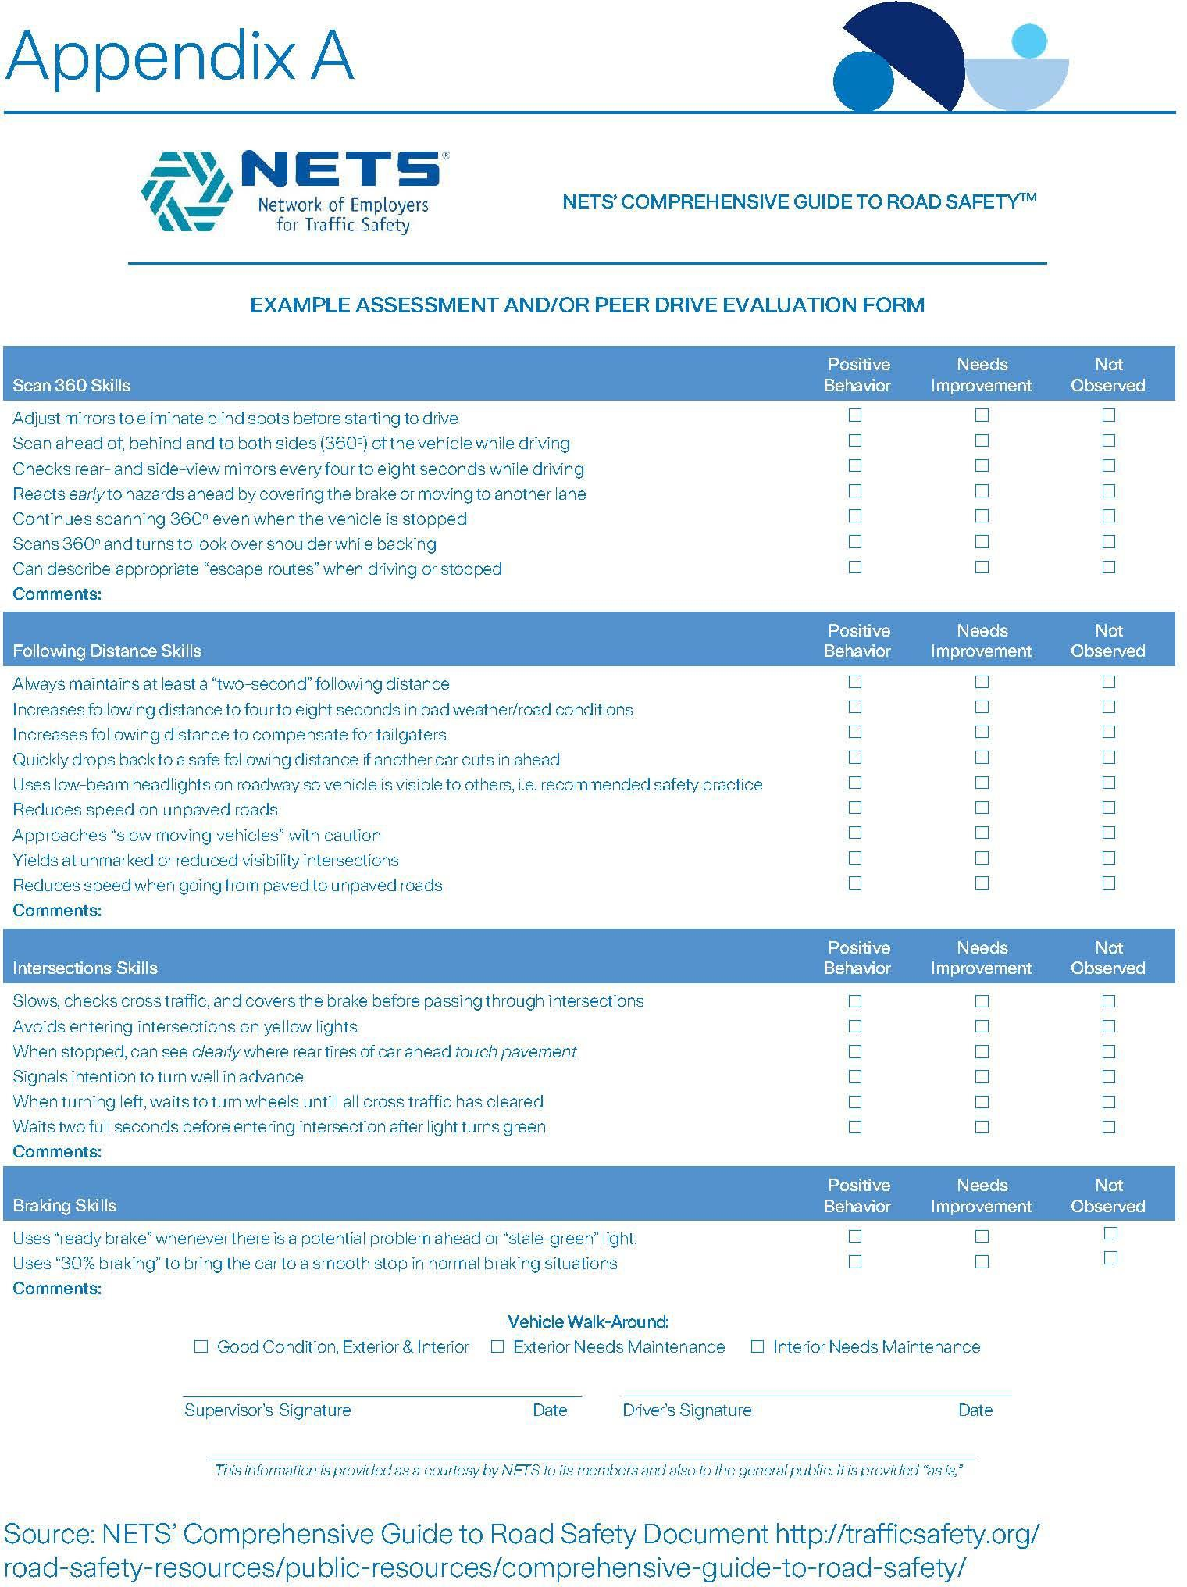

Appendix B – MVR Record Evaluation Worksheet

Motor Vehicle Record Evaluation Worksheet

Driver Name Date of
MVR
Review
Reviewer Name

Violation | Points |  | # of Violations |  | Total Points |  | Notes
Violations within previous 5 years (Serious)
Driving while intoxicated (DUI, DWI) |  | 15
Refuse drug/alcohol test |  | 15
Homicide or assault with a vehicle |  | 15
Leaving the scene of a crash (hit and run) |  | 15
Eluding a police officer |  | 15
Any vehicle related felony |  | 15
Drag racing |  | 6
Reckless driving |  | 8
Speeding 25 MPH or greater over the limit |  | 6
License suspension due to moving |  | 15
Driving while license suspended |  | 15
Other serious violation |  | 15
Major violations within previous 3 years
Speeding 15 MPH to 25 MPH over the limit |  | 6
Improper lane change |  | 6
Failure to yield |  | 4
Running red light |  | 4
Careless driving |  | 8
Texting while driving |  | 8
Other major violation |  | 6
Minor violations within previous 3 years
Speeding <15 MPH over limit |  | 4
Failure to stop at stop sign |  | 4
Improper passing |  | 4
Improper backing |  | 4
Distracted driving (other than texting) |  | 4
Failure to pay toll |  | 4
Other minor violation |  | 4
Vehicle collisions within previous 3 years
Vehicle collision |  | 8
TOTAL VIOLATION POINTS

15 points or more – High Risk (Exception):  Consider revocation or suspension of driving privileges. | 5 – 14 points – Medium Risk (Activity):  Annual driver training, minimum of quarterly MVR or continuous monitoring, driver counseling & coaching to inform drivers of possible future violation and/or accident consequences. Complete violation specific training and re-evaluate after 60 days. | 0-4 points – Low Risk (Clean):  Annual driver training with a minimum of yearly MVR or continuous monitoring.

Appendix C – Driver Acknowledgement Form
Driver Acknowledgement Form
- The company has provided me with a copy of the policies defining use of company vehicles. A company official has reviewed these policies with me, and I understand and agree to comply with them.
- I agree to abide by all maintenance requirements outlined in this policy.
- I have received a copy of the Accident Reporting instructions and have been trained on its use in the event of an accident. I agree to comply with its instructions and understand that it is my responsibility to inform my direct supervisor as soon as possible following any accident or incident. I further understand that it is my responsibility to notify proper law enforcement agencies as soon as possible and to prepare a written report describing the accident events.
- I agree not to operate any vehicle while under the influence of drugs or alcohol. I fully understand that, should I be found operating a company vehicle while under the influence of drugs or alcohol, it shall constitute grounds for immediate revocation of driving privileges.
- I agree to drive only when I am alert and in full control of my assigned vehicle. If I am not, I will not drive or pull over until such time as I am fully in control.
- I agree to abide by all federal, state and local laws and ordinances regarding the operation and storage of the company-assigned vehicle. In addition, I understand that it is my responsibility, as a holder of a driver's license, to remain informed of and to fully comply with current and future laws and ordinances governing the operation and storage of motor vehicles.
- I understand that I must report to the company any suspension, revocation or cancellation of a driver’s license prior to the operation of a company vehicle or any vehicle on company business.
- I agree to allow the company to request copies of my Motor Vehicle Report as often as the company sees fit.
- I understand that my use of any company vehicle or privilege to drive on company business may be revoked or restricted in accordance with the provisions outlined in company policies, which I have read and reviewed.
- Should the revocation or suspension of these privileges affect the performance of my assigned job responsibilities, I understand that this may constitute grounds for suspension without pay or dismissal from my position.
- I understand and agree that using handheld devices are dangerous and distracting and I agree not to operate a company vehicle or my personal vehicle, on company business, while doing so.
- I understand and acknowledge that I have read and understand the electronic tracking technology policy.
Certification

I have read the above and agree to abide by this policy statement.
Employee: | Date:
Supervisor: | Date:

Appendix D – Sample IVMS Driver Coaching Form

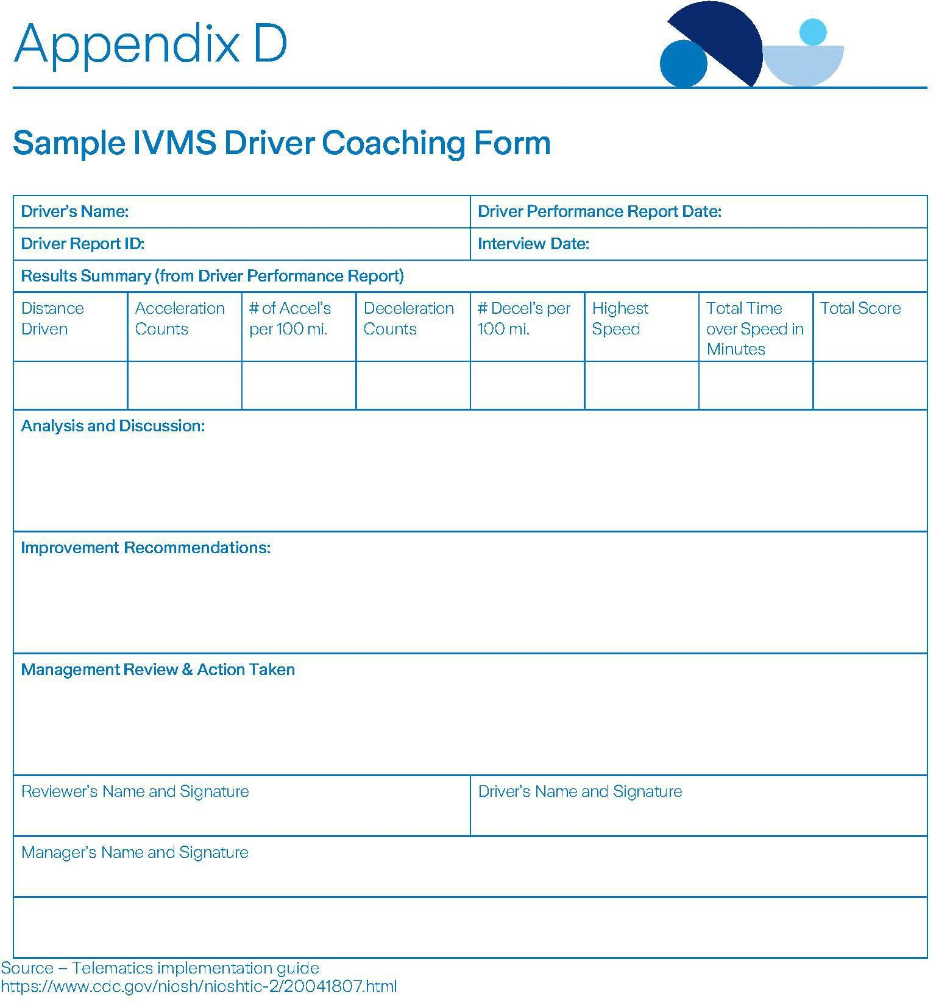

Appendix E – Company Car Personal Use Policies (choose one)

Personal Use Policy
(company car with highly restricted use)
To all employees using company vehicles:

Company vehicles are provided exclusively for business purposes. Those employees authorized or required to take a vehicle home with them are limited to the most direct route between home and the business-related destination, with an allowance of 10 miles off-route to accommodate personal use during their normal commute. Any other non-business use is expressly forbidden.

At no time may an employee use a company vehicle for activities such as ridesharing, product delivery or other related services. Only company employees are authorized to drive or ride in the vehicle. Unauthorized use may be considered as theft, and appropriate legal action may be taken, including allocation of liability to an unauthorized driver should any arise.
Certification
I have read the above and agree to abide by this policy statement in the operation of the company vehicle entrusted to me.
Employee: | Date:

Personal Use Policy
(company car with limited personal use)
Personal use of assigned company vehicles will be limited to travel within a mile radius of
the employee’s residence. Special permission will be required for personal trips farther than a
mile radius, and must be obtained in writing from . The employee, and if properly authorized, the employee’s spouse /domestic partner, are the only authorized drivers of the company vehicle.
It is expected that the operator of the company vehicle will comply with all laws and regulations as well as respect his/her driving use privilege by driving safely and taking proper care of the vehicle assigned to him/her.
Any personal use of a company vehicle, except as specified above, will be considered unauthorized use and is absolutely prohibited. Including, but not limited to: ridesharing, product delivery and other related services.
Certification
I have read the above and agree to abide by this policy statement in the operation of the company vehicle entrusted to me.
Employee: | Date:

Appendix F – Use of personal vehicles on company business policy

Use of personal vehicles on company business policy
(personal car with limited business use)
An employee’s use of a personal vehicle while on company business must be properly controlled to protect both the company and the employee. This certification confirms that employees understand whether they are permitted to drive a personal vehicle on company business and understand company policies related to that use.
I understand that I am not an “authorized driver” for my company and as such am not permitted to operate company vehicles or my own vehicle on company-related business under any circumstances.

OR
- Maintaining auto liability insurance with minimum limits of $ for bodily injury and $ for property damage or combined single limit of
$ .
- Maintaining current state vehicle inspections when required.
- Maintaining my vehicle in a safe operating condition when driven on company business.
- Proof of insurance (copy of declaration page, certificate of insurance) will be sent to
. I agree to submit information concerning any changes or cancellation of that insurance and to provide updated evidence of insurance at any future renewal of my policy within three days of the change.
- If I am pulling a trailer or hauling equipment/materials, the vehicle that I use must be appropriately designed/rated for the work being done for my company.
- Acceptable motor vehicle report (MVR) that meets the policies set by my company (provide company policy reference)
- No ‘business use’ exclusion on personal insurance policy.
- No other use of the vehicle is permitted while I am operating for company-related activity. This includes but is not limited to: ridesharing, product delivery and other related services.
- I understand that my personal auto insurance is meant to be primary in the event I am
involved in a vehicle collision while I am operating my personal vehicle on company business and that I am responsible for liability arising out of the operation of my vehicle.
Certification

I have read the above and agree to abide by this policy statement.
Employee: | Date:

Appendix G – Driver’s Vehicle Inspection Report
Driver's Vehicle Inspection Report
Check ANY Defective Item and Give Details under "Remarks" Date:

Truck/Tractor No:
□ Air Compressor □ Lights - Hazard Flashers □ Safety Equip - Flash Light
□ Air Lines □ Lights - Head Lights □ Safety Equip - Fuses
□ Battery □ Lights - Tail Lights □ Safety Equip - Reflective vest
□ Brake Accessories □ Lights - Turn Indicators □ Safety Equip - Spare Bulbs
□ Brakes □ Mirrors □ Safety Equip - Spare Seal Beam
□ Carburetor □ Muffler □ Seatbelt
□ Clutch □ Oil or Grease Leaks □ Speedometer
□ Defroster □ Oil Pressure □ Springs
□ Drive Line □ On-Board Recorder □ Starter
□ Engine □ Radiator □ Steering
□ Exhaust □ Rear End □ Suspension
□ Fifth Wheel □ Reflectors □ Tachograph
□ Fluid Levels/gauges □ Safety Equip - Cold Weather □ Tires (inflation and wear)
□ Front Axle □ Safety Equip - Cones □ Transmission
□ Fuel Tanks □ Safety Equip - Fire Extinguisher □ Wheels
□ Heater □ Safety Equip - First aid kit □ Windows
□ Horn □ Safety Equip - Flags □ Windshield Wipers and Washers
□ Lights - Brake Lights □ Safety Equip - Flares □ Other
- Lights - Dash Lights
Trailer(s) No (s):
- Brake Connections □ Hitch □ Tarpaulin
- Brakes □ Landing Gear □ Tires
- Coupling Chains □ Lights - All □ Wheels
- Coupling (King) pin □ Roof □ Other
- Doors □ Springs

Remarks:

- Condition of the above vehicle is satisfactory
Driver's Signature
- Above defects corrected
- Above defects need NOT be corrected for safe operation of the vehicle
Mechanic's Signature Date Driver's Signature Date

Appendix H – Driver intervention record

Driver intervention record
Indicate the intervention type:
☐ | Verbal
☐ | Written/training
☐ | Revocation of driving privileges
Intervention and action plan
Part one: Employee
Employee's action plan to resolve the noted safety issue. Specifically, the plan must be filled out by you and state what you intend to do to prevent future occurrences
Part two: Supervisor
Supervisor's action plan to resolve the noted safety issue. Specifically, the plan must be filled out by the manager and state what the manager intends to provide for the employee (e.g. training, information, etc.)
Certification
Employee: |  | Date:
Supervisor: |  | Date:

Appendix I – Driver Responsibilities at Accident Scenes
Page 21 of 28
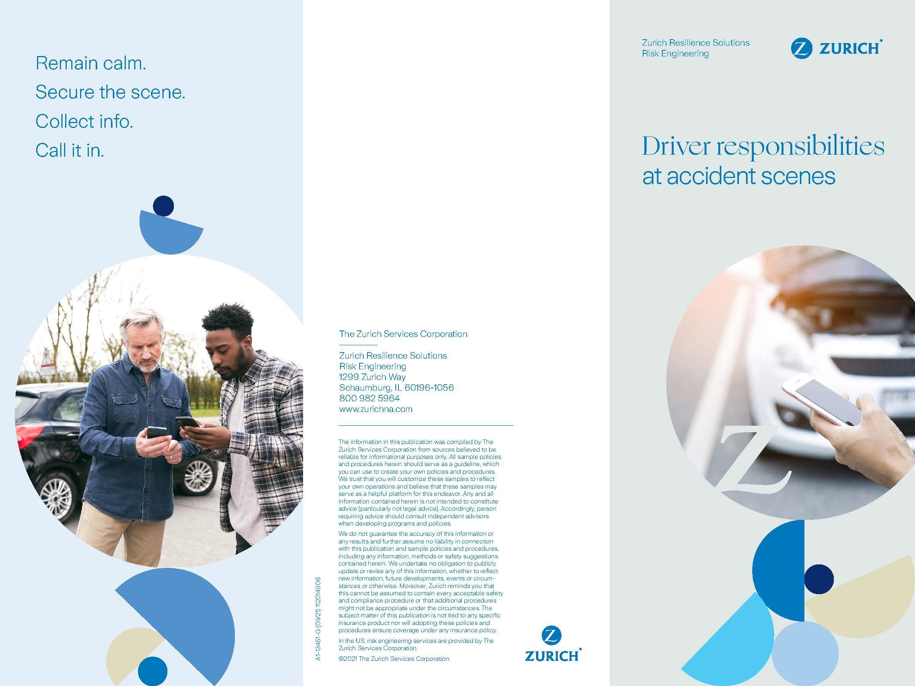

Appendix I - Driver Responsibilities at Accident Scenes (continued)
Page 22 of 28
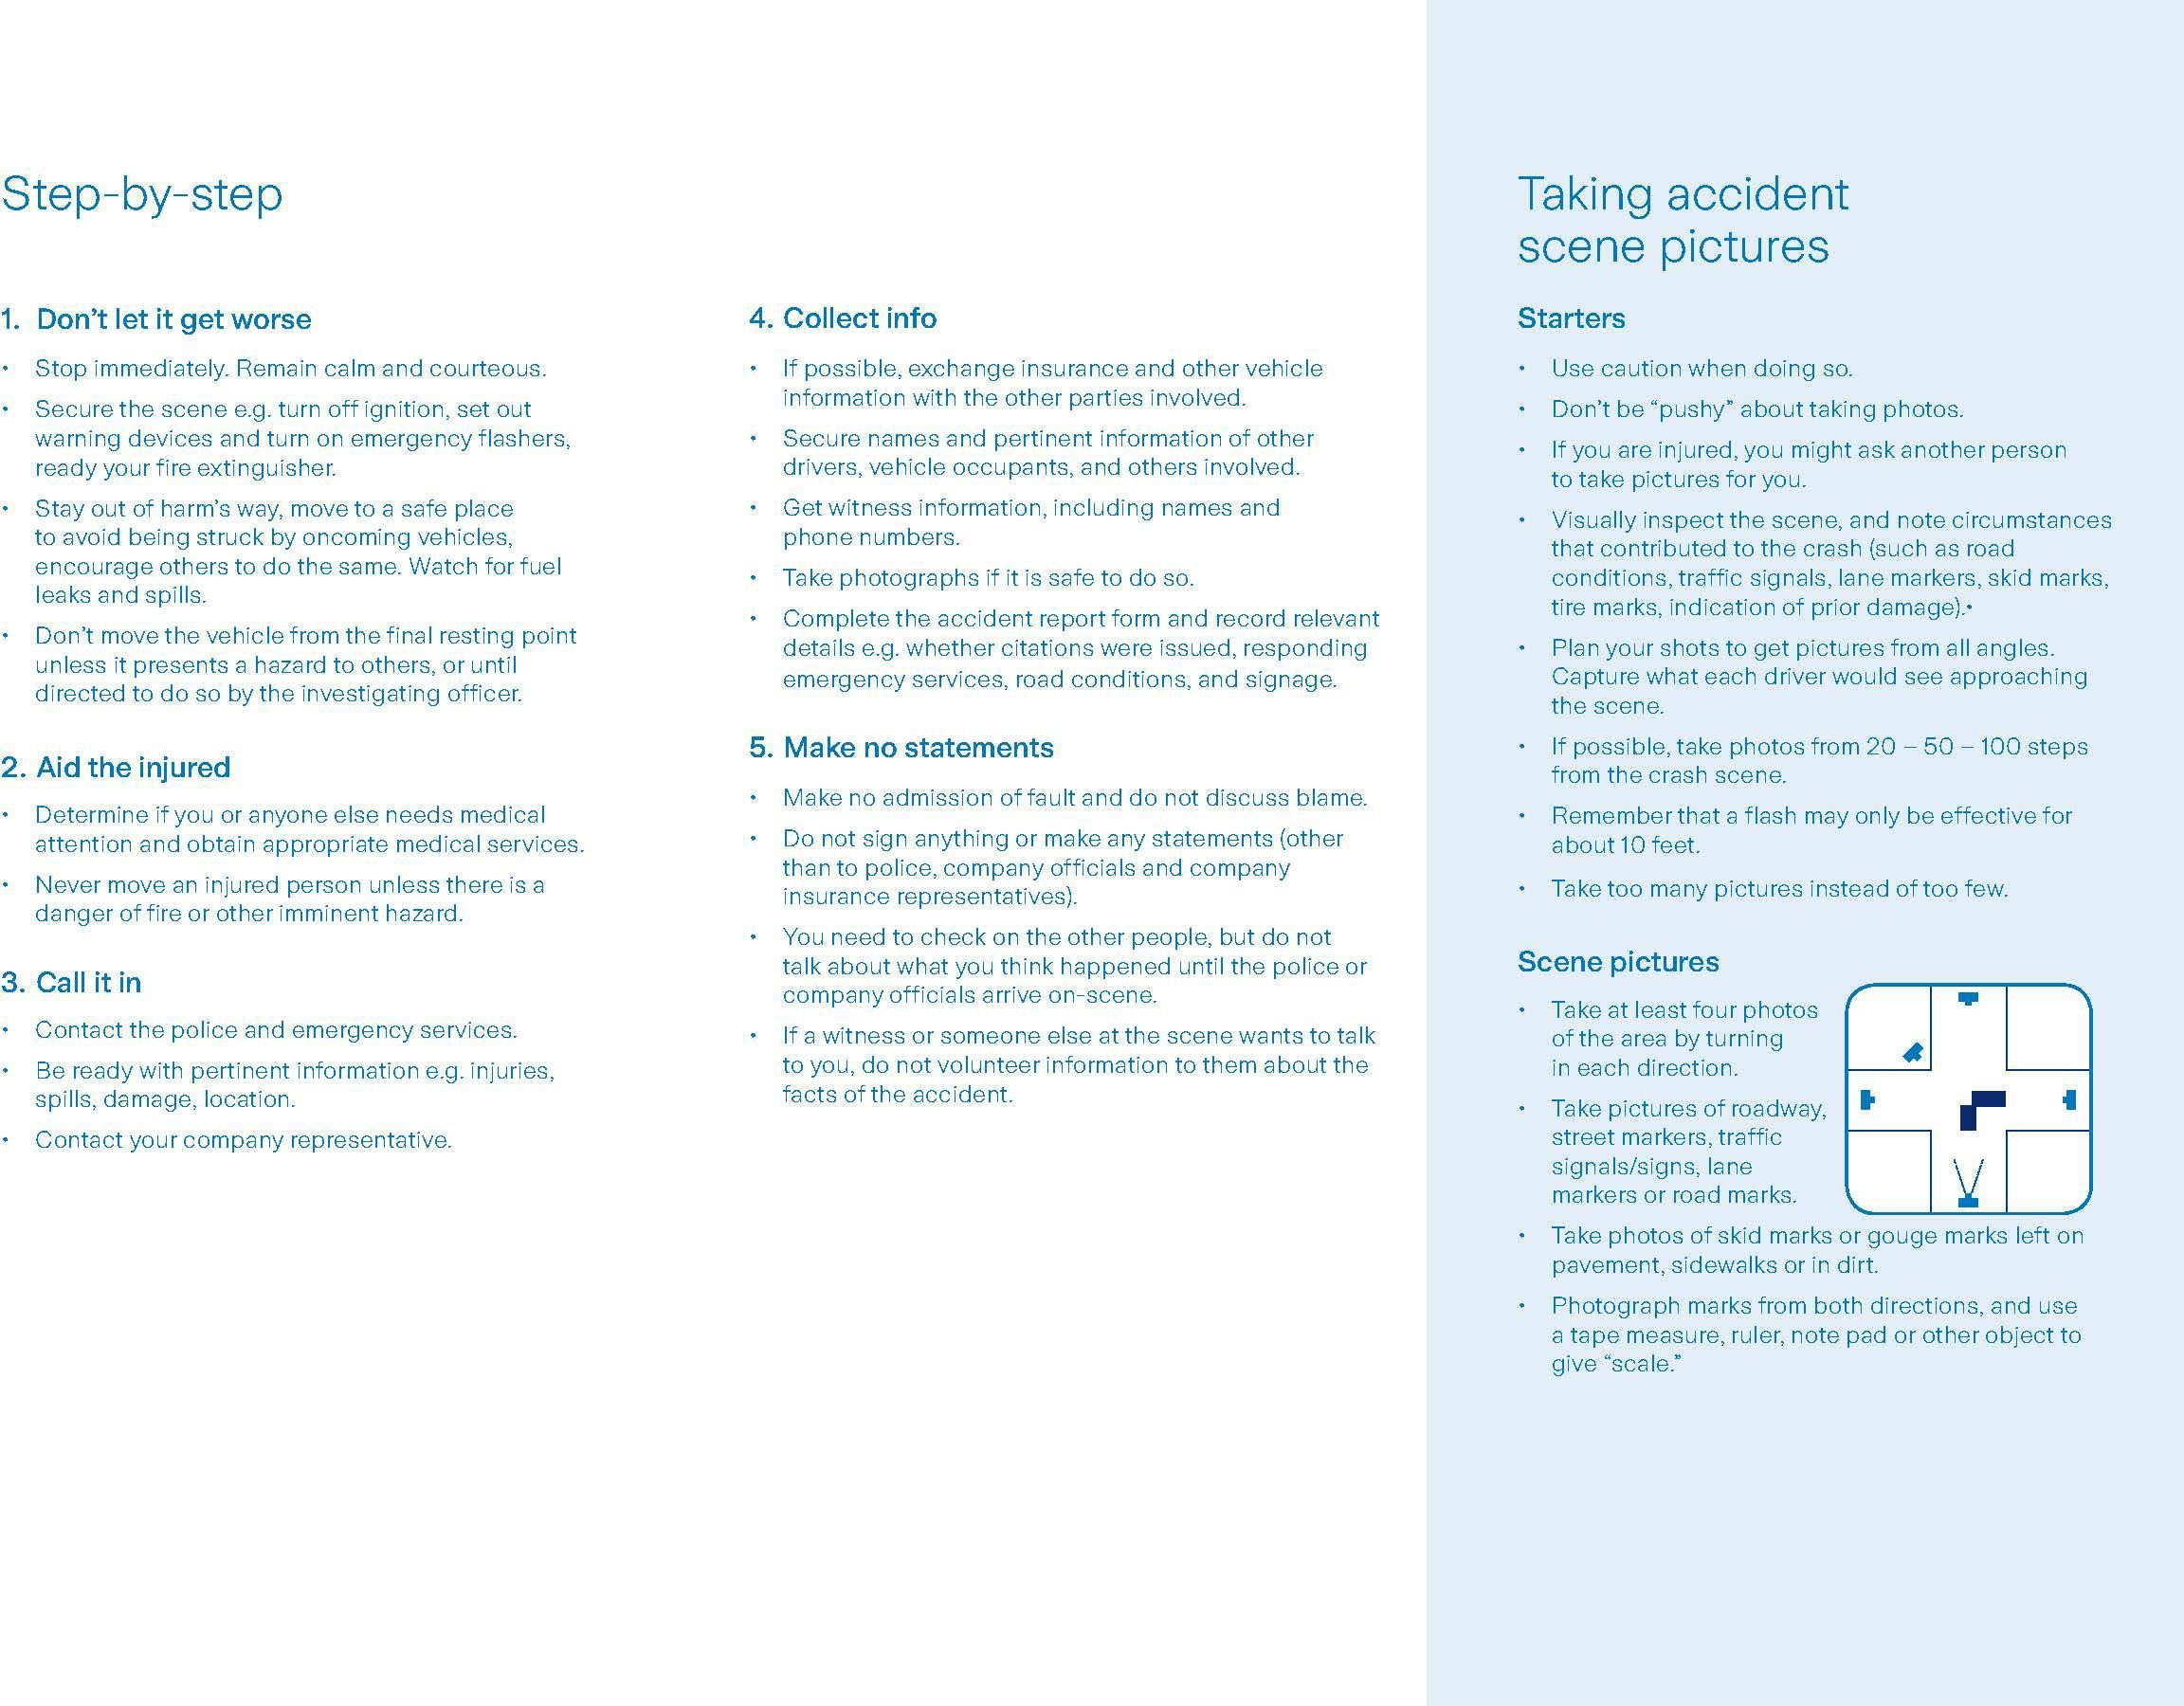

Appendix J – Accident Assistance Guide
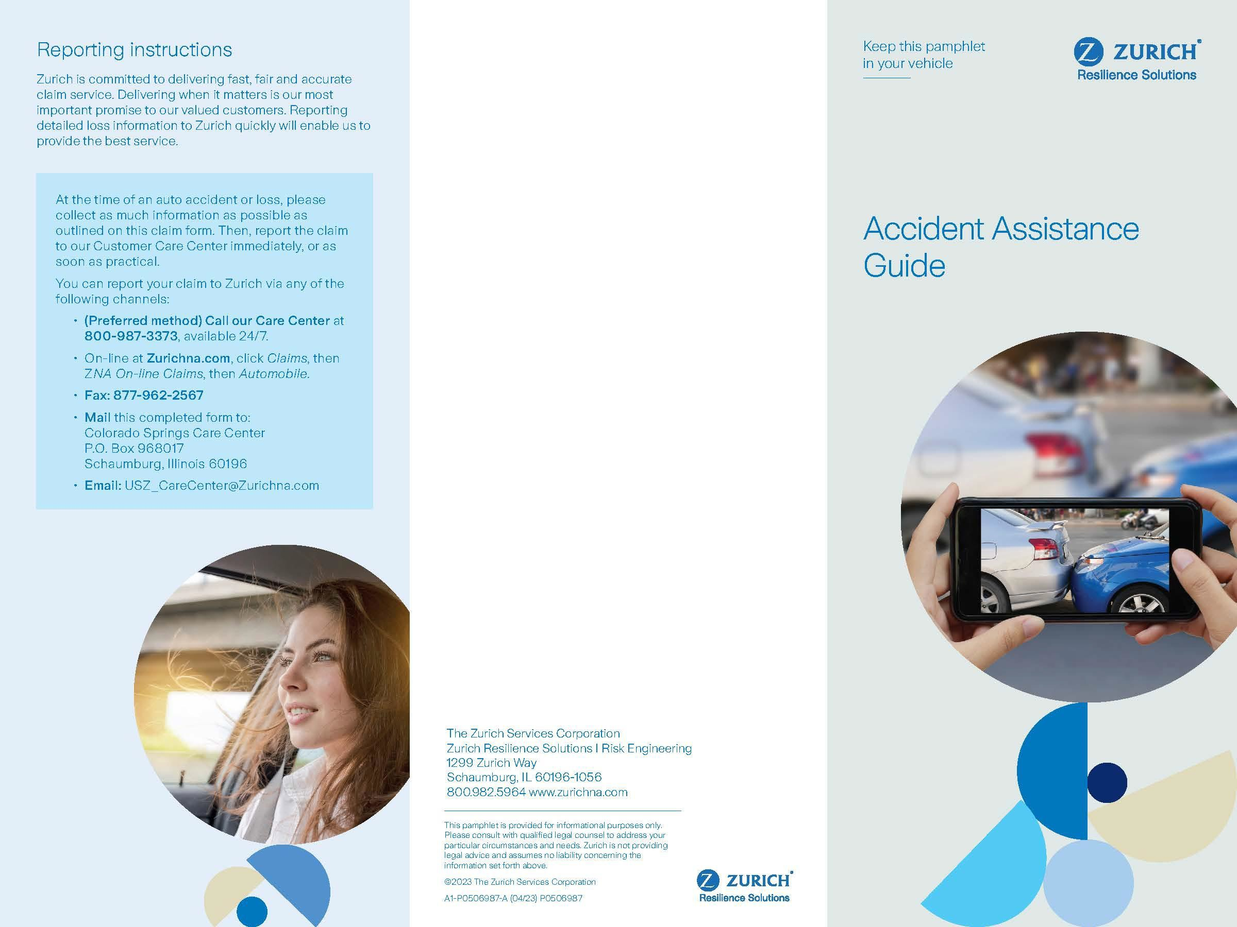

Appendix J – Accident Assistance Guide (continued)
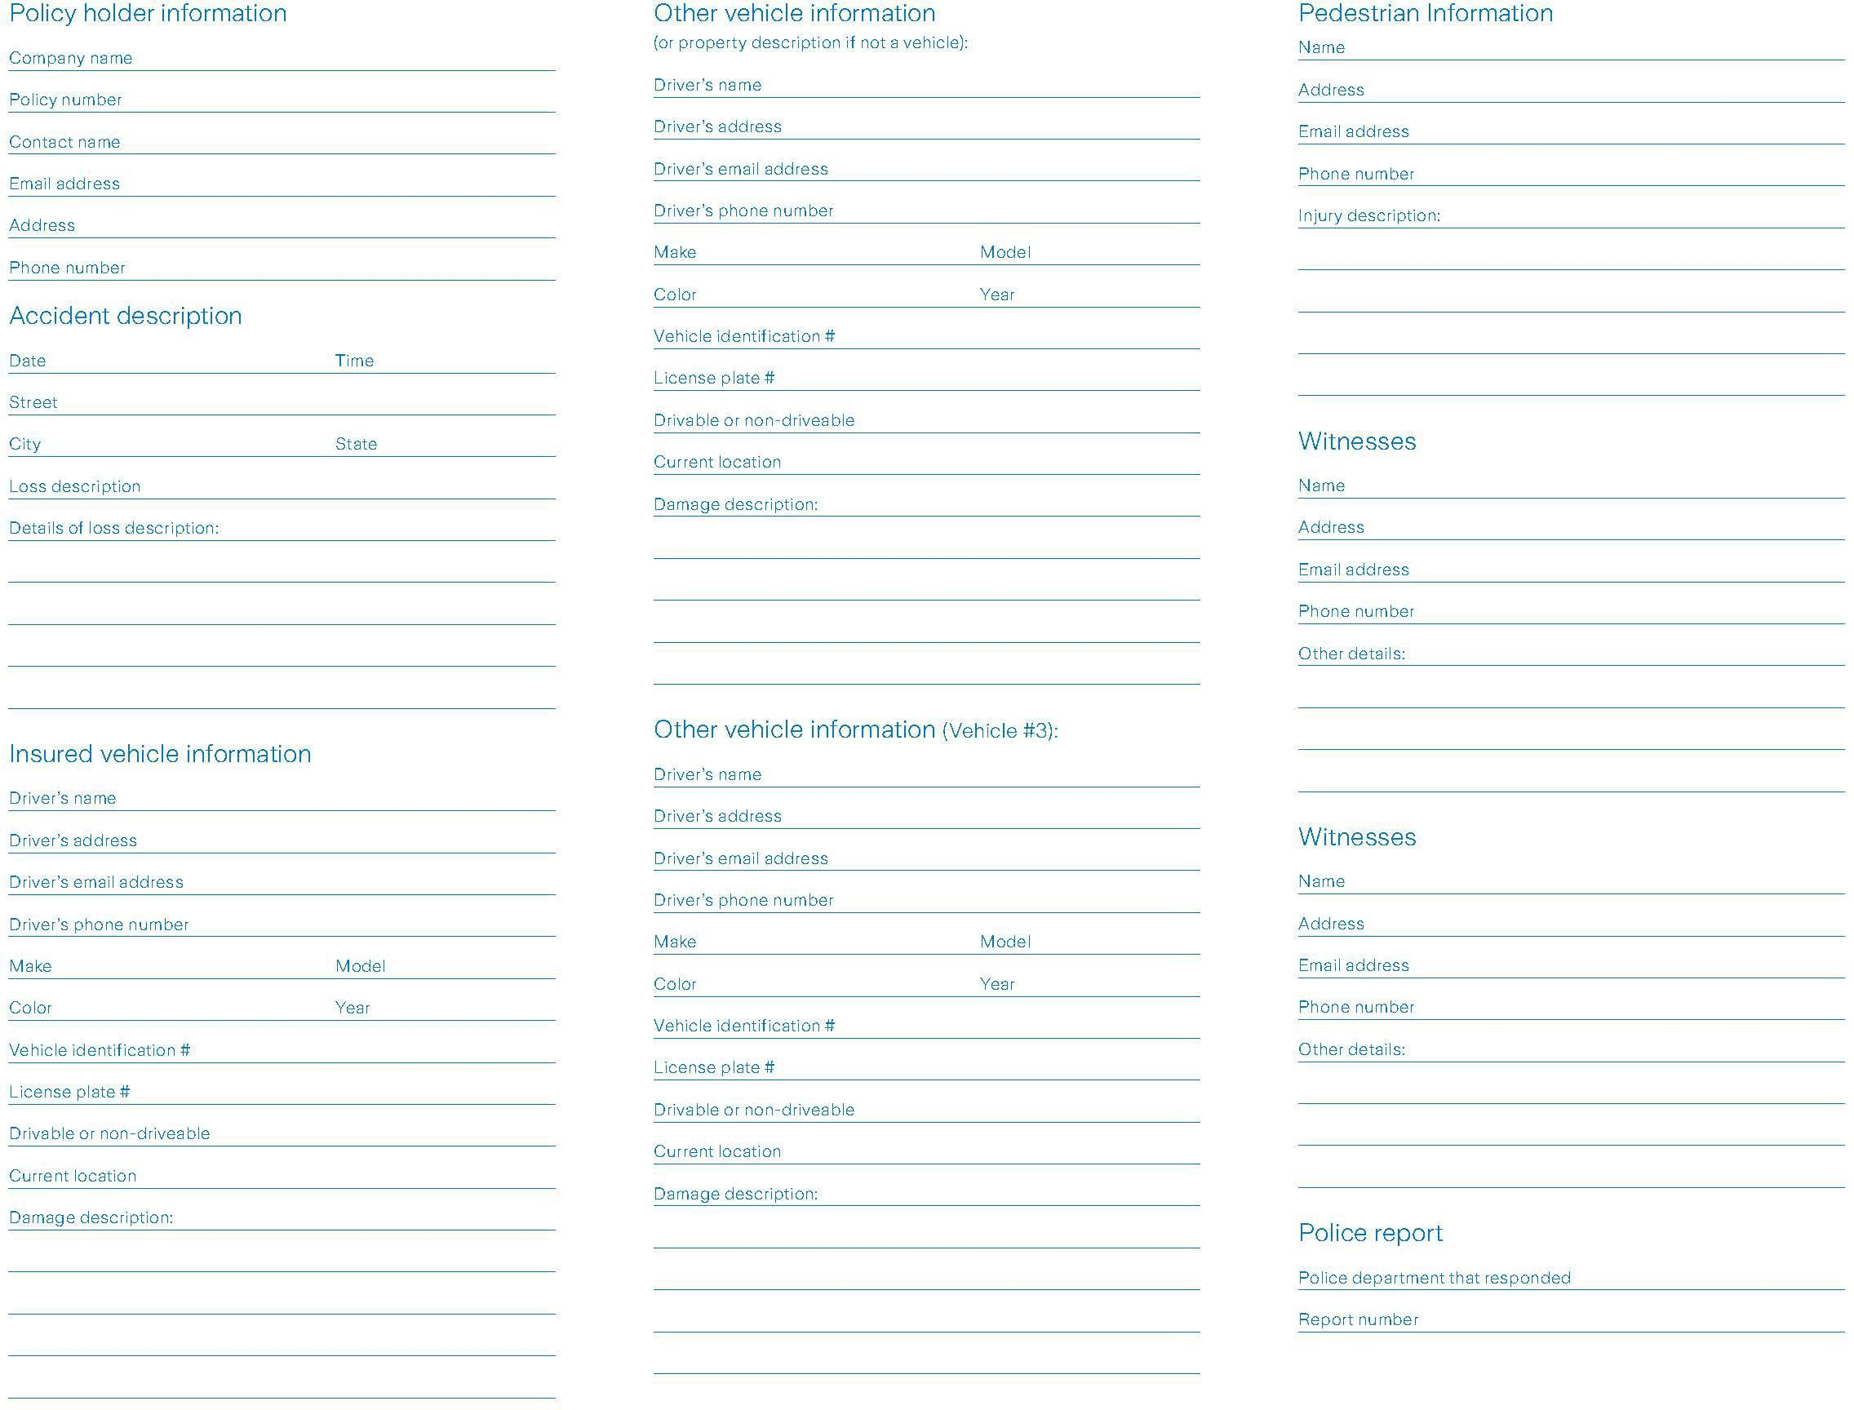

Zurich Resilience Solutions I Risk Engineering RiskTopics US

Appendix K – Crash information checklist
Crash date: Driver involved: Brief description:

In the event of any vehicle crash, Zurich suggests establishing a crash file that includes the following items:

- Employee’s scene report
- Supervisor’s scene report
- Police report (required for DOT recordable crashes.
- Witness information/statements
- Insurance company notified
- Internal notifications (such as safety director or company manager)
- Pictures (or unmodified digital copies)
- Associated bills and invoices
- Preventability determination and follow-up actions
- DOT/OSHA log entry made (as applicable)
- Notification to the proper agency if hazardous substance spilled, records for response and clean-up, and copy of MSDS sheet for materials spilled
- Employee disciplinary or commendation letters

If the collision is more serious where injuries appear likely, copies of the following items should also be maintained in the file (or tasks completed):

Driver activity records
- Dispatch records
- Logs (for at least 8 days)
- Fuel records (for at least 8 days)
- Toll receipts and/or electronic toll record
- Satellite communication messages/data (for 8 days)
- Record of cell phone calls
- Payroll records

Vehicle information
- Equipment specification or factory invoice
- Vehicle registration (to demonstrate it was valid at the time of collision)
- Daily vehicle inspection reports
- Applicable repair records and recent maintenance and repair records (for at least 6 months)
- Annual inspection records

Zurich Resilience Solutions I Risk Engineering RiskTopics US

- Recent DOT roadside inspections (12 months)
- Interchange agreement and trailer inspection (if applicable)

Vehicle systems data
- "Black box" / ECM data (if available/downloaded)
- Telematics, electronic data recording, and video event recorder data
- Antilock brake data (if available/downloaded)
- Collision avoidance system data (if available/downloaded)
- Lane departure warning system data (if available/downloaded)

Driver Information
- Copy of all citations issued to the driver
- Run current motor vehicle record (to document the status at the time of the collision)
- Review driver's qualification file (audit level review)
- Safety training records (at least 12 months)
- Driver's violation/disciplinary record
- Information on all driver's previous crashes
- Drug test results (if applicable)

Independent contractor information
- Owner-operator lease agreement
- Bobtail insurance information
- Occupational accident insurance certificate
- Physical damage certificate
- Interchange agreements
- Equipment interchange inspection forms

Freight/cargo information
- Packing lists
- Weight tickets
- Overage, shortage, and damage records
- Photos of freight and damage
- Towing and storage bills
- Damage claims
- Clean-up and reloading invoices
- Salvage reports and values
- Information on the disposition of damaged goods
- Freight bills for shipment/bill of lading

Zurich Resilience Solutions I Risk Engineering RiskTopics US

- Freight bills for the furtherance of shipment and movement of salvage
- Load confirmation sheets (broker loads)
- Broker contract (broker loads)
- Tariff terms and conditions

April 2024

The Zurich Services Corporation
Zurich Resilience Solutions I Risk Engineering 1299 Zurich Way, Schaumburg, IL 60196-1056
800.982.5964 www.zurichna.com

This is a general description of (insurance) services such as risk engineering or risk management services by Zurich Resilience Solutions which is part of the Commercial Insurance business of Zurich Insurance Group, and does not represent or alter any insurance policy or service agreement. Such (insurance) services are provided to qualified customers by affiliated companies of Zurich Insurance Company Ltd, including but not limited to Zurich American Insurance Company, 1299 Zurich Way, Schaumburg, IL 60196, USA, The Zurich Services Corporation, 1299 Zurich Way, Schaumburg, IL 60196, USA, Zurich Insurance plc, Zurich House, Ballsbridge Park, Dublin 4, Ireland, Zurich Commercial Services (Europe) GmbH, Platz der Einheit, 2, 60327 Germany, Zurich Management Services Limited, The Zurich Centre, 3000b Parkway, Whiteley, Fareham, Hampshire, PO15 7JZ, UK, Zurich Insurance Company Ltd, Mythenquai 2, 8002 Zurich, Switzerland, Zurich Australian Insurance Limited, ABN 13 000 296 640, Australia.
The opinions expressed herein are those of Zurich Resilience Solutions as of the date of the release and are subject to change without notice. This document has been produced solely for informational purposes. All information contained in this document has been compiled and obtained from sources believed to be reliable and credible but no representation or warranty, express or implied, is made by Zurich Insurance Company Ltd or any of its affiliated companies (Zurich Insurance Group) as to their accuracy or completeness. This document is not intended to be legal, underwriting, financial, investment or any other type of professional advice. Zurich Insurance Group disclaims any and all liability whatsoever resulting from the use of or reliance upon this document. Nothing express or implied in this document is intended to create legal relations between the reader and any member of Zurich Insurance Group.
Certain statements in this document are forward-looking statements, including, but not limited to, statements that are predictions of or indicate future events, trends, plans, developments or objectives. Undue reliance should not be placed on such statements because, by their nature, they are subject to known and unknown risks and uncertainties and can be affected by numerous unforeseeable factors. The subject matter of this document is also not tied to any specific service offering or an insurance product nor will it ensure coverage under any insurance policy.

This document may not be distributed or reproduced either in whole, or in part, without prior written permission of Zurich Insurance Company Ltd, Mythenquai 2, 8002 Zurich, Switzerland. No member of Zurich Insurance Group accept any liability for any loss arising from the use or distribution of this document. This document does not constitute an offer or an invitation for the sale or purchase of securities in any jurisdiction.
In the United States, Risk Engineering services are provided by The Zurich Services Corporation. Zurich Resilience Solutions
©2024 The Zurich Services Corporation. All rights reserved.

